Weather API Integration Project
1. Objective:
This project fetches real-time weather data using a Weather API and displays temperature, weather condition, humidity, and wind speed for a given city using Python.
2. Technologies Used:
• Python
• Requests Module
• JSON
• Weather API
3.Code Screenshot:
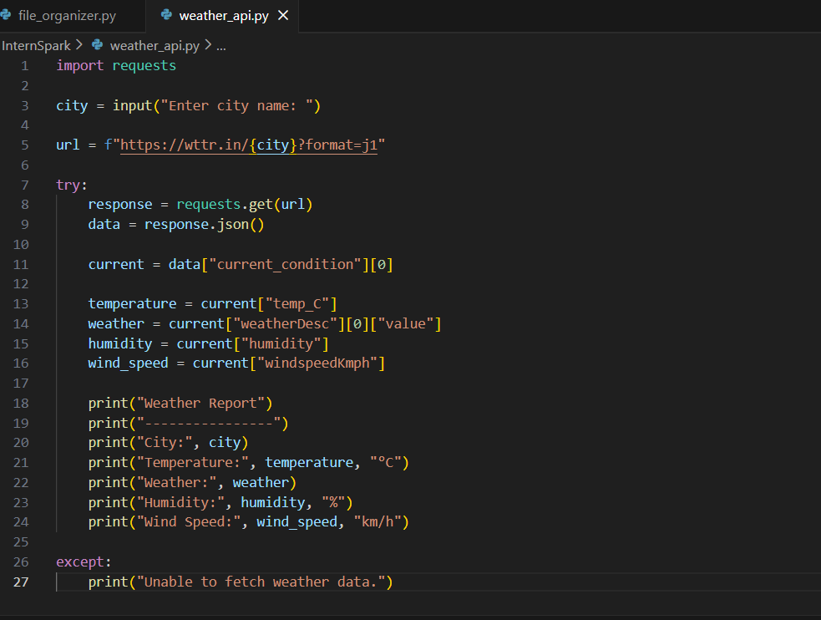

4. Output screenshot:
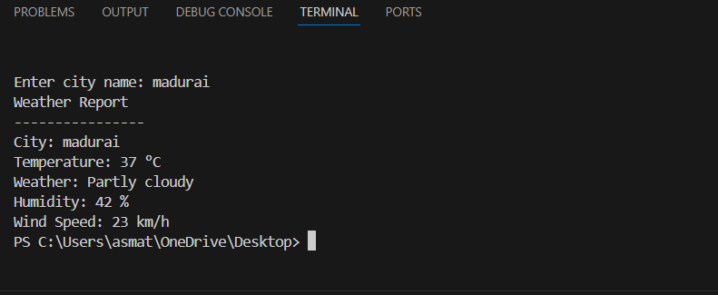
5. Result:
The project successfully fetched and displayed real-time weather information for the entered city using API integration in Python.

