Python File Organizer Automation
1. Objective
This project organizes files automatically into folders based on file type.
2. Technologies Used
Python, OS module, Shutil module
3. Code
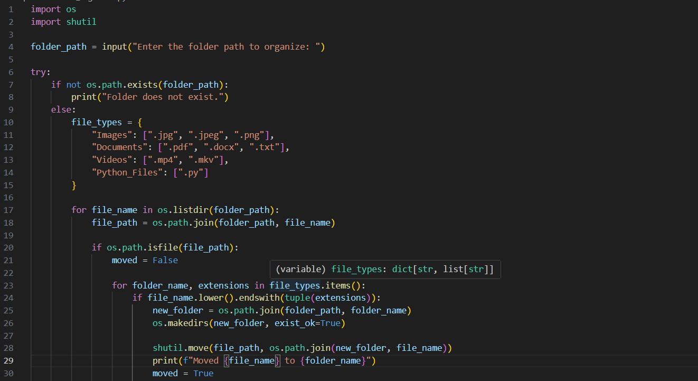
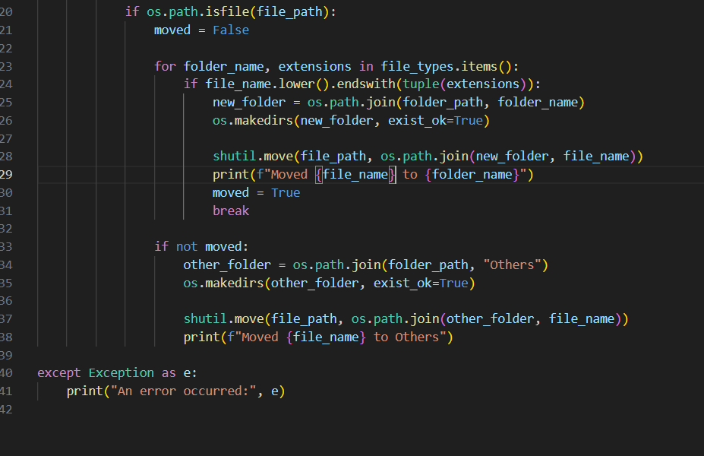
4. Output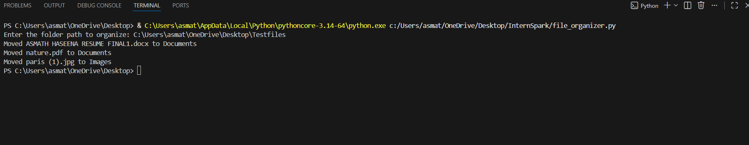
5. Result
