ACTIVITY A
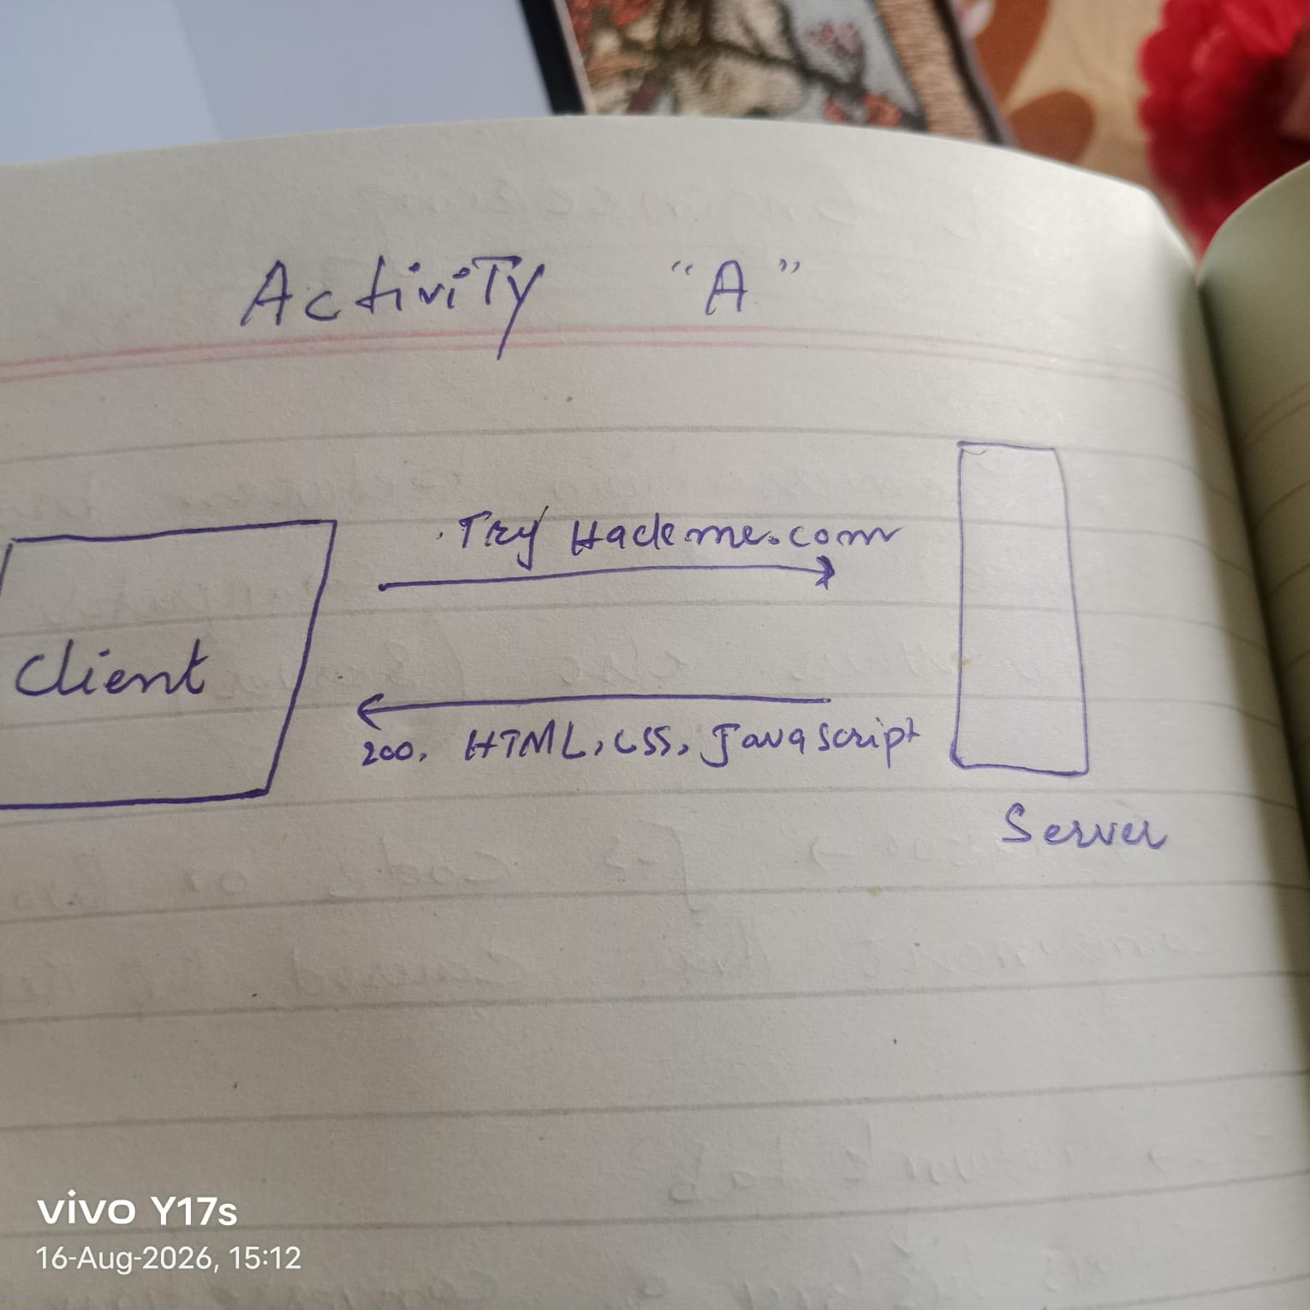

ACTIVITY B
https://shop.example.com:443/products/42?sort=price#reviews
You identified:
- Protocol → https
- Host → shop.example.com
- Port → 443
- Path → /products/42
- Query → sort=price
- Fragment → reviews

ACTIVITY C

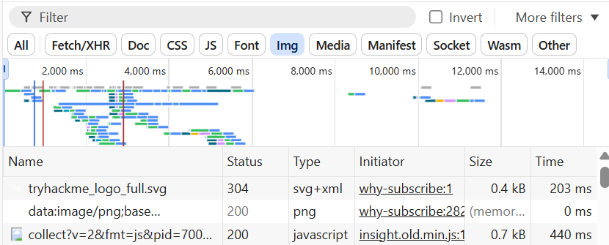

Activity D
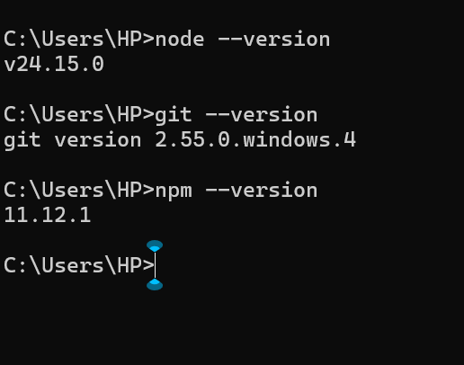

The working of live server
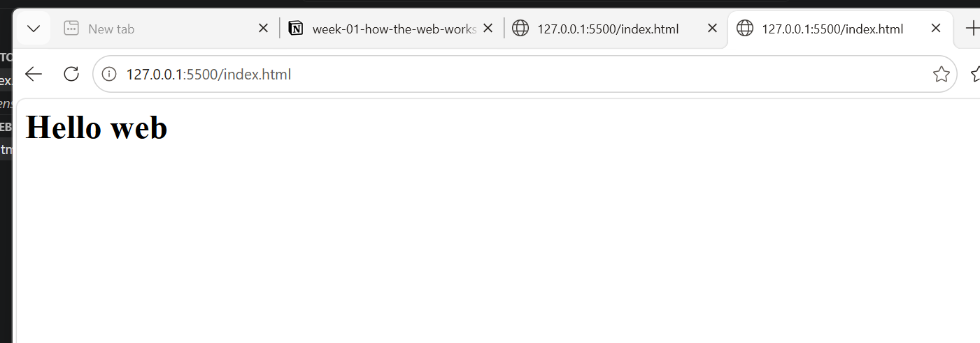

Working of prettier
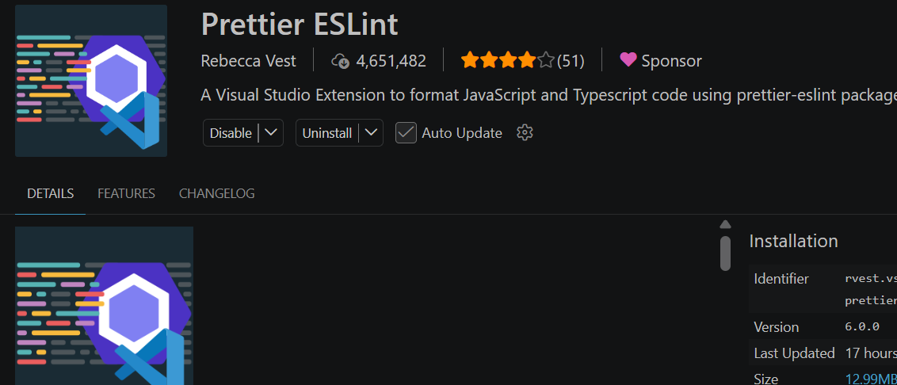

Activity F
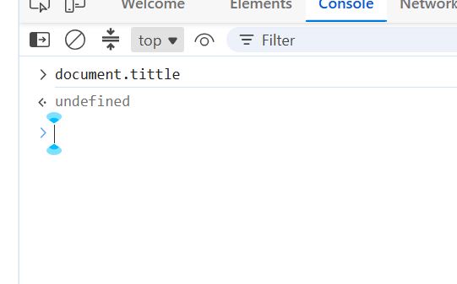
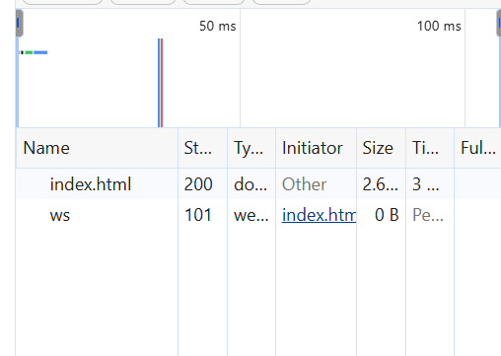

Editing The elements in webpage like h1 means temporarily changing the web page in browser memory it is not permenant it is experiencing how will web page looks like by that change hence after reloading it disappears

Task 2
36 request since last open web page has made

Largest file of javascript size 0.7 kb

304 not found means browser already have that SVG file in its cache when the web page reloads it

