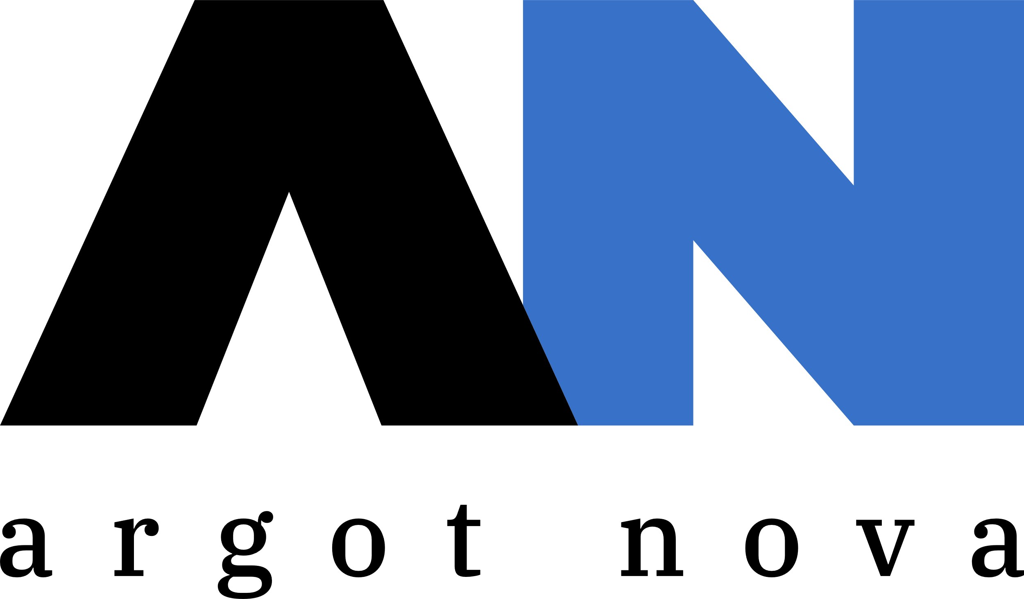

**Argot Nova, LLC**

1221 Wild Hawthorn Way

Reston, Virginia, 20194

**P:** (703) 447-7152

**W:** https://www.argot-nova.com

**TS/SCI Cleared**

**Woman and Veteran-Owned**

CAPABILITY STATEMENT

Company Information

Founded in 2021, Argot Nova is a technical company, run by technical people, serving public and private sector clients in the DC metropolitan area and remotely. Not just another staffing firm, Argot Nova applies expertise in data, intelligence, and language work through agile small teams who embed with the client and develop solutions to meet client requirements, restrictions, and budgets.

## DATA SCIENCE AND VISUALIZATION

Artificial Intelligence, Machine Learning, Statistical Testing, Experimental Design, Time Series Analysis, Forecasting, Custom R Shiny Applications, R, Python, Tableau, Plotly, MS Power BI, Amazon Web Services (SageMaker, Docker, Lambdas, and hosting with EC2)

## DATA MANAGEMENT AND ENGINEERING

Database Design, Data Architecture, Pipelines, Automation, Extract-Transform-Load (ETL), Feature Stores, RESTful APIs, Structured and Unstructured Data Wrangling and Storage, MS SQL Server, PostgreSQL, SQLite, MariaDB, HBase, Databricks Delta Lake, MongoDB, Neo4J, DynamoDB, Amazon Redshift, Pyspark, Apache Airflow

## LANGUAGE ANALYSIS

Pashto, Farsi, Dari, Portuguese, Spanish, French, and more

## INTELLIGENCE, OPEN SOURCE, GEOSPATIAL ANALYSIS

## Network Analysis, ArcGIS, ArcMap, ArcPy, Leaflet, Report Writing, Targeted Research, Intelligence Community Tools

## DATA INTEGRATION AND PROJECT MANAGEMENT

Use of data pipelines and APIs to connect a wide variety of disparate data sources and applications in an accountable and accessible way. Technical professionals lead data modeling, migration, and integration projects while being hands-on participants in the work.

**TIN:** 86-2536408

**DUNS:** 117974095

**CAGE Code:** 8Z0E3

# NAICS Codes:

**541690** Other Scientific and Technical Consulting Services

**541511** Custom Computer Programming

**541512** Computer Systems Design

**541519** Other Computer Related Services

**541930** Translation and Interpretation

Business References

ACLED International

Red Arch Solutions

**Primary Contact**

Aubrey Smiley McAuliffe Managing Director

**E:** [asmcauliffe@argot-nova.com](mailto:asmcauliffe@argot-nova.com)