; ---------------------------------------------------------------------------
; - TITULO : Llamada a rutinas internas de QUICK-BASIC MASM -
; - ********* De momento no funciona bien ********** -
; ----- -----
; - AUTOR : Alfonso Víctor Caballero Hurtado -
; ----- -----
; - VERSION : 1.0 -
; ---------------------------------------------------------------------------

PILA SEGMENT WORD PUBLIC 'STACK'
DW 30h DUP(?)
PILA ENDS

DATA SEGMENT WORD PUBLIC 'DATA' ; Aquí van las variables inicializadas
msg DB 'Hola, Quick Basic!'
Descriptor DW $-msg, OFFSET msg
DATA ENDS

TEXT SEGMENT BYTE PUBLIC 'CODE'
ASSUME CS:TEXT,DS:DATA,SS:PILA
EXTRN B$PESD:FAR ; Esto lo recogemos de BCOM45.LIB
Entrada PROC NEAR
MOV AX, SEG DATA
MOV DS, AX
MOV BX, SS
SUB BX, DX
SHL BX, 1
SHL BX, 1
SHL BX, 1
SHL BX, 1
CLI
MOV SS, DX
ADD SP, BX
STI
; Accedemos al descriptor para escribir el mensaje
MOV AX, OFFSET Descriptor
PUSH AX
CALL B$PESD
MOV AH, 4ch
INT 21h
Entrada ENDP
TEXT ENDS
END Entrada

Prev1
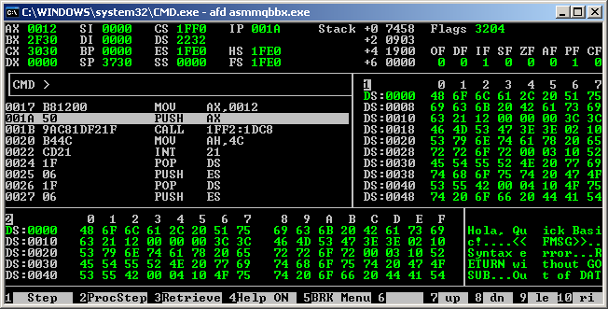

Prev2
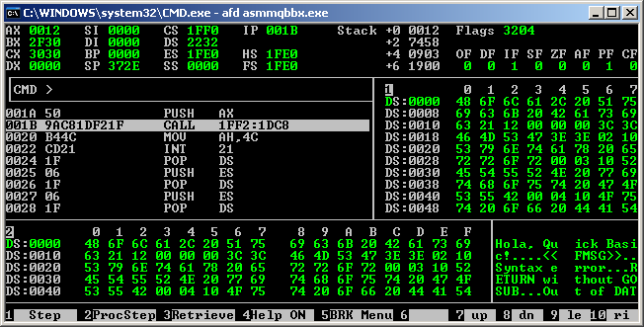

After
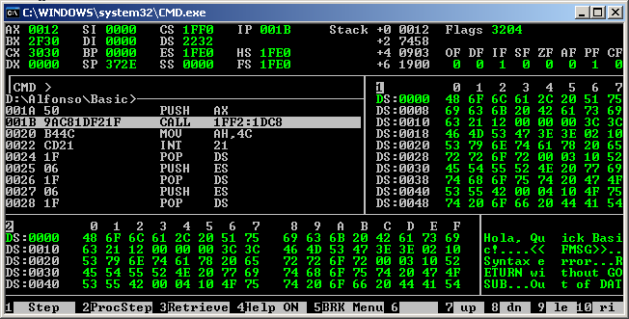

we can see that doesn't return well, have we pointed to the correct place?

With simplified masm directive executable:

Prev1:
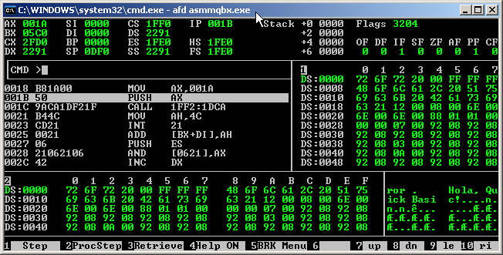

Prev2:
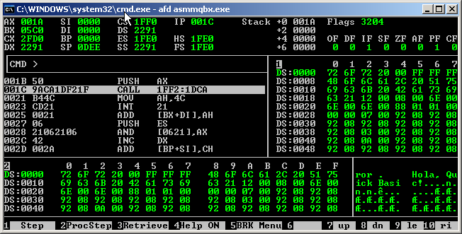

AfterOK:
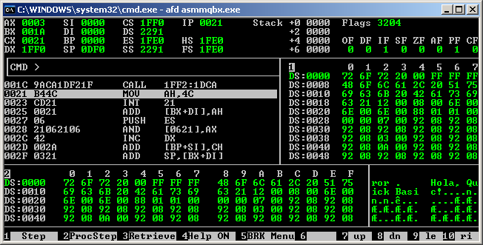

yeah! it returns ok!

