**BHARATIYA VIDYA BHAVAN’S**

**SARDAR PATEL INSTITUTE OF TECHNOLOGY**

MUNSHI NAGAR, ANDHERI (WEST)- MUMBAI- 400058- INDIA

(AUTONOMOUS INSTITUTE AFFILIATED TO UNIVERSITY OF MUMBAI)

**CAFÉ COFFEE DAY**

DOWNFALL OF CAFÉ COFFEE DAY

SUBMITTED TO

 PROF. SPARSH VYAS

SUBMITTED BY

NAME UID

CHETAN GHADI 2024510018

AKANKSHA HAKE 2024510019

OMKAR JADHAV 2024510020

ABHIJEET JADHAV 2024510021

ANJALI MISHRA 2024510030

FEBRUARY 2024

**Introduction** –

Café Coffee Day (CCD), once India’s largest coffee chain and an iconic brand that brought global coffee culture to Indian shores, experienced an unexpected and dramatic downfall in recent years. Established as a pioneer in popularizing coffee culture among Indian youth, CCD provided a vibrant environment for social interactions, casual meetings, and creative endeavours. However, a series of internal mismanagement issues, external pressures, and unforeseen crises significantly contributed to its decline. This report aims to analyse the factors that led to the downfall of CCD, its implications for the coffee and retail sectors, and the lessons that can be learned to avoid similar outcomes in the future.

1. **Background/ Objective**

Café Coffee Day was founded in 1996 by V.G. Siddhartha, a visionary entrepreneur whose aim was to transform India’s coffee industry by making premium coffee experiences accessible to the masses. Over the decades, CCD became synonymous with affordability, accessibility, and quality, providing a comfortable space for customers across all age groups. At its peak, CCD boasted over 1,700 outlets in India and gained a significant foothold in international markets. However, its journey toward success took a sharp turn due to multiple challenges, including financial mismanagement, leadership crises, market competition, and operational inefficiencies.

The ultimate objective of this report is to highlight these issues comprehensively and draw insights that can help businesses mitigate risks, sustain growth, and adapt to evolving market trends.

1. **Purpose**

The purpose of this report is to:

* Analyze the root causes of CCD’s financial and operational struggles.
* Understand how external pressures, including market competition and shifting consumer preferences, influenced its decline.
* Provide a roadmap of actionable recommendations that could have potentially mitigated the challenges faced by CCD and could help businesses in the future.

1. **Procedure**

This report has been compiled through detailed research on Café Coffee Day’s financial history, leadership strategies, operational models, and market competition. Sources include public records, news articles, interviews with industry experts, case studies, and consumer feedback surveys. Information has been organized in order of importance, providing a clear understanding of CCD’s downfall and lessons for the future.

**Body** –

1. **Issues**
2. **Financial Mismanagement**

It was one of the most critical factors leading to Café Coffee Day's downfall. While the brand revolutionized India’s coffee culture, its financial strategies were poorly aligned with sustainable business practices. By 2019, CCD found itself buried under a massive debt of INR 8,881 crore, largely due to its over-reliance on borrowed capital. This debt not only strained the company’s liquidity but also weakened its ability to adapt to external market pressures. Key aspects of financial mismanagement manifested in the following ways:

* **Over-Reliance on Borrowed Capital**

Café Coffee Day heavily depended on loans to fund its aggressive growth and diversification strategies. Borrowed capital was funneled into various ventures, including opening new outlets, diversifying into related industries (such as coffee plantations and technology parks), and maintaining day-to-day operational expenses. This dependency created a domino effect of financial stress:

* **Unsustainable Debt Levels:** The borrowing strategy led to CCD amassing debts far beyond its repayment capacity. By 2019, the company faced a crippling debt burden of INR 8,881 crore, which included financial liabilities from banks, unsecured loans, and other obligations.
* **High Interest Payments:** The company’s income was increasingly being channeled toward servicing interest payments rather than reinvestment or operational improvements. This eroded profitability and cash reserves over time.
* **Aggressive Expansion without Strategic Planning**

CCD's expansion strategy played a significant role in its financial mismanagement. The company aimed to capitalize on the growing coffee culture by rapidly increasing its footprint across India and overseas. However, this expansion was not backed by thorough market research or sustainable financial planning:

* **Unprofitable Locations:** Many outlets were opened in locations with low footfall or weak demand, which led to recurring losses. Instead of consolidating and focusing on high-performing locations, CCD spread its resources too thin.
* **Underutilized Resources:** Fixed costs, including rents for outlets in high-end malls and prime real estate, became a substantial financial burden. These costs often outweighed the revenue generated by the underperforming outlets.
* **Declining Profit Margins**:

CCD struggled with declining profit margins due to its inability to manage rising operational expenses and optimize revenue streams:

* **Operational Costs:** High fixed costs for rent, salaries, and utilities made it difficult for CCD to achieve economies of scale. Many outlets operated at break-even or below, further straining overall profitability.
* **Revenue Leakages:** Poor control over financial processes led to inefficiencies in managing cash flow. Revenue leakage, in the form of wastage, pilferage, and inadequate cost-cutting measures, contributed to reduced profit margins.
* **Diversification Risks**

In addition to coffee retailing, CCD’s parent company, Coffee Day Enterprises Ltd., invested in non-core businesses such as real estate (Global Village Technology Park) and logistics. While these ventures aimed to diversify revenue streams, they diverted crucial resources and capital away from CCD’s core operations:

* **High Capital Allocation:** Significant funds were allocated to these unrelated ventures, leaving insufficient capital for CCD’s operational improvements and innovation.
* **Low ROI:** The returns on these investments were minimal compared to the growing operational needs of CCD, further aggravating financial challenges.
* **Unplanned Expenses and Inefficient Resource Allocation**:

CCD’s financial crisis was exacerbated by unplanned expenses and inefficient allocation of resources. The company spent excessively on initiatives that did not yield proportional returns:

* **Excessive Advertising and Branding Costs:** CCD invested heavily in marketing and advertising campaigns without adequately measuring the ROI. While branding efforts initially helped establish CCD as a household name, the lack of a focused strategy diluted the impact over time.
* **Outdated Infrastructure and Maintenance Costs:** The maintenance of existing outlets and infrastructure was often neglected, leading to higher repair and upgrade expenses later. This reactive approach further strained financial resources.
* **Liquidity Crisis**

As debts mounted and profit margins narrowed, CCD faced a severe liquidity crisis. The company struggled to generate adequate cash flow to meet its immediate obligations, including employee salaries, vendor payments, and loan installments:

* **Delayed Payments:** Suppliers and vendors began reporting delays in payments, leading to strained relationships and disruptions in the supply chain.
* **Eroded Working Capital:** With most revenues tied up in servicing debts or covering operating expenses, CCD lacked the working capital needed to sustain day-to-day operations or invest in growth opportunities.
* **Lack of Financial Transparency**

CCD's financial dealings raised concerns among stakeholders, further complicating the situation:

* **Opaque Financial Practices:** Investors and creditors reported a lack of transparency in CCD’s financial reporting, which led to declining confidence in the company’s management.
* **Alleged Irregularities:** Allegations of financial irregularities, coupled with founder V.G. Siddhartha’s public note hinting at pressure from lenders and tax authorities, created a trust deficit among stakeholders.

1. **Over-Expansion**

CCD’s rapid expansion strategy, aimed at capturing market share, became a double-edged sword. While opening numerous outlets boosted its visibility, it also created unsustainable operational burdens:

* **Non-Profitable Locations**: Several outlets were set up in areas with limited footfall, resulting in consistent losses.
* **High Fixed Costs**: The costs of maintaining underperforming outlets eroded CCD’s profitability.
* **Lack of Focus on Core Strengths**: CCD diverted attention from improving existing outlets and customer experience in favor of expanding its footprint.

1. **Leadership Crisis**

The leadership crisis at Café Coffee Day (CCD) was a pivotal factor in its downfall, with the tragic death of its founder, V.G. Siddhartha, in July 2019 serving as the most critical turning point in the company’s history. As the visionary leader who built CCD from the ground up, Siddhartha’s absence created a vacuum that profoundly impacted the company’s operational stability, strategic direction, and stakeholder confidence. Below is a detailed exploration of the leadership crisis and its far-reaching implications:

* **Lack of Succession Planning**:

One of the most glaring vulnerabilities exposed by Siddhartha’s death was the lack of a well-defined succession plan.

* **Leadership Void:** With Siddhartha at the helm for over two decades, CCD had not identified or nurtured potential successors who could seamlessly take over in the event of a crisis.
* **Instability at the Top:** Following Siddhartha’s demise, the company’s leadership structure became unstable, with interim leaders struggling to regain control and establish strategic direction.
* **Ineffective Crisis Management:** Without a clear chain of command or contingency plan, CCD’s management faltered in its response to the crisis, leading to operational disruptions and poor decision-making.
* **Loss of Stakeholder Confidence**: Siddhartha’s death, coupled with allegations of financial irregularities, caused investors, employees, and customers to lose trust in CCD’s management.

1. **Market Competition**

CCD faced intense competition on two fronts:

* **Global Competitors**: Starbucks, with its premium brand positioning and differentiated offerings, emerged as a strong competitor.
* **Local Coffee Shops**: Independent coffee shops and regional chains offered personalized and affordable experiences, eroding CCD’s customer base.

1. **Operational Inefficiencies**

Operational inefficiencies further compounded CCD’s struggles:

* **Infrastructure Issues**: Outdated interiors and maintenance problems affected the brand’s image.
* **Inconsistent Service**: Customers reported dissatisfaction with service quality and menu offerings, reducing repeat visits.
* **Outdated Menu**: Failure to innovate and introduce trending offerings limited CCD’s appeal.

1. **Shifting Consumer Preferences**

The evolving preferences of Indian consumers presented another challenge:

* **Emergence of Premium Brands**: Customers began gravitating toward brands offering premium experiences and ethically sourced products.
* **Health-Conscious Trends**: Increasing demand for healthier menu options highlighted gaps in CCD’s product portfolio.

1. **Impact of the COVID-19 Pandemic**

The COVID-19 pandemic accelerated CCD’s decline:

* **Reduced Foot Traffic**: Lockdowns and social distancing measures severely impacted in-store sales.
* **Cash Flow Disruptions**: Declining revenues during the pandemic further strained CCD’s already precarious financial situation.

1. **Corporate Issues**

Corporate governance issues undermined CCD’s credibility:

* **Lack of Transparency**: Stakeholders raised concerns about the lack of transparency in financial dealings.
* **Reputation Damage**: Allegations of financial irregularities and the founder’s suicide tarnished CCD’s brand image.

1. **Findings**

The analysis revealed the following key findings:

* CCD’s debt-driven expansion strategy was unsustainable and exacerbated financial challenges.
* Leadership instability following V.G. Siddhartha’s demise highlighted the importance of succession planning.
* Inability to innovate and differentiate itself led to declining market relevance.
* Failure to adapt to changing consumer preferences and address operational inefficiencies eroded customer loyalty.

1. **Observations**

* CCD prioritized growth over sustainability, leading to long-term challenges.
* Operational inefficiencies, such as inconsistent service quality and high maintenance costs, significantly impacted profitability.
* Lack of financial transparency discouraged investors and damaged stakeholder relationships.

**Conclusion** –

The downfall of Café Coffee Day serves as a cautionary tale for businesses operating in competitive markets. While CCD successfully popularized coffee culture in India, its inability to address internal weaknesses and adapt to external challenges ultimately led to its decline. The loss of its visionary founder, coupled with financial mismanagement, operational inefficiencies, and market competition, further accelerated the brand’s downward trajectory. CCD’s story underscores the importance of sustainable growth, effective leadership, and customer-centric strategies in today’s dynamic business landscape.

**Recommendations/ Suggestions (Solutions) –**

1. **Financial Restructuring:**

**Debt Reduction**: Reduce debt through asset liquidation and strategic partnerships with investors.

**Transparency**: Implement robust financial reporting practices to rebuild stakeholder confidence.

1. **Strategic Outlet Management:**

**Focus on Profitability**: Shut down non-performing outlets and channel resources toward high-performing locations.

**Resource Optimization**: Streamline operations to reduce costs and improve efficiency.

1. **Innovative Offerings:**

**Menu Revamp**: Introduce premium offerings, healthier options, and seasonal specials to cater to diverse consumer preferences.

**Technology Integration**: Launch a user-friendly mobile app for loyalty programs, online ordering, and personalized promotions.

1. **Leadership Development:**

**Succession Planning**: Develop a robust succession plan to ensure continuity in leadership during crises.

**Professional Management**: Recruit experienced leaders to strengthen decision-making and strategic planning.

1. **Customer-Centric Approach:**

**Market Research**: Regularly monitor consumer trends to stay relevant.

**Service Excellence**: Invest in staff training programs to enhance customer experiences.

1. **Focus on Branding:**

**Rebuild Image**: Highlight quality, sustainability, and transparency in branding efforts.

**Targeted Marketing**: Launch campaigns to re-engage lost customers and attract younger audiences.

**Appendices:**

1. **Debt Analysis:**

As of 2019, CCD’s total debt amounted to INR 8,881 crore, including financial liabilities and borrowings.

1. **Competitor Comparison:**

**- Starbucks**: Premium brand offering superior ambiance and ethically sourced coffee.

**- Local Coffee Shops**: Affordable and personalized experiences that appealed to niche markets.

1. **Customer Feedback Surveys:**

**- Service Quality**: Customers expressed dissatisfaction with inconsistent service and menu offerings.

**- Brand Perception**: The lack of transparency and financial instability tarnished CCD’s image.

**Revenue Growth Graph of CCD:**

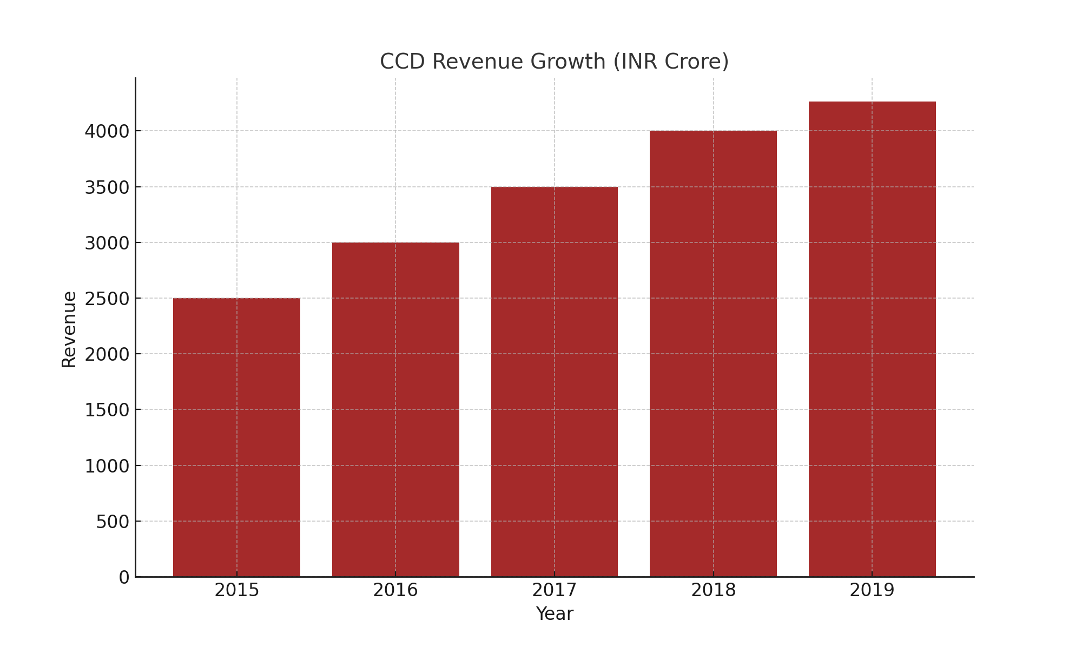

**Declining Profit Graph:**

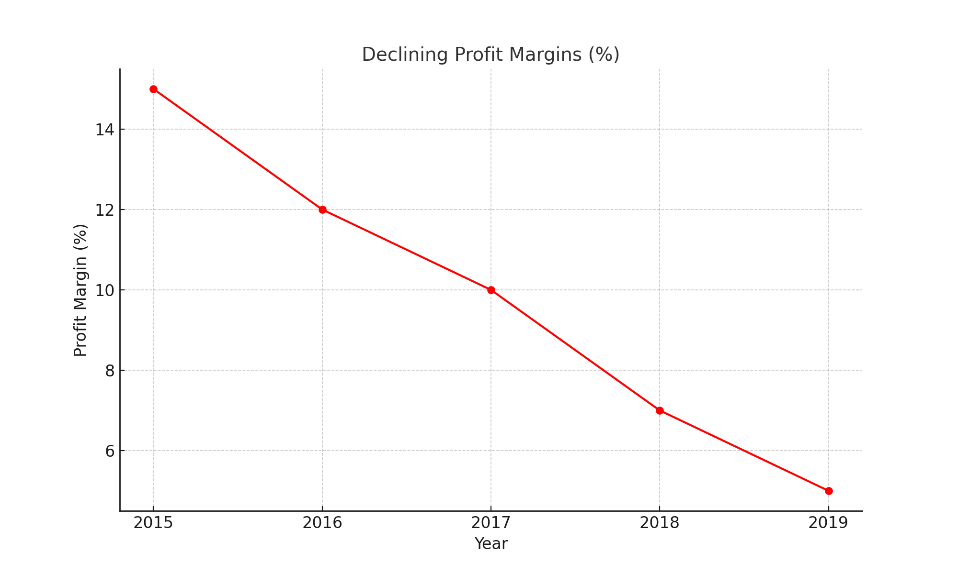

**Market Share Chart:**

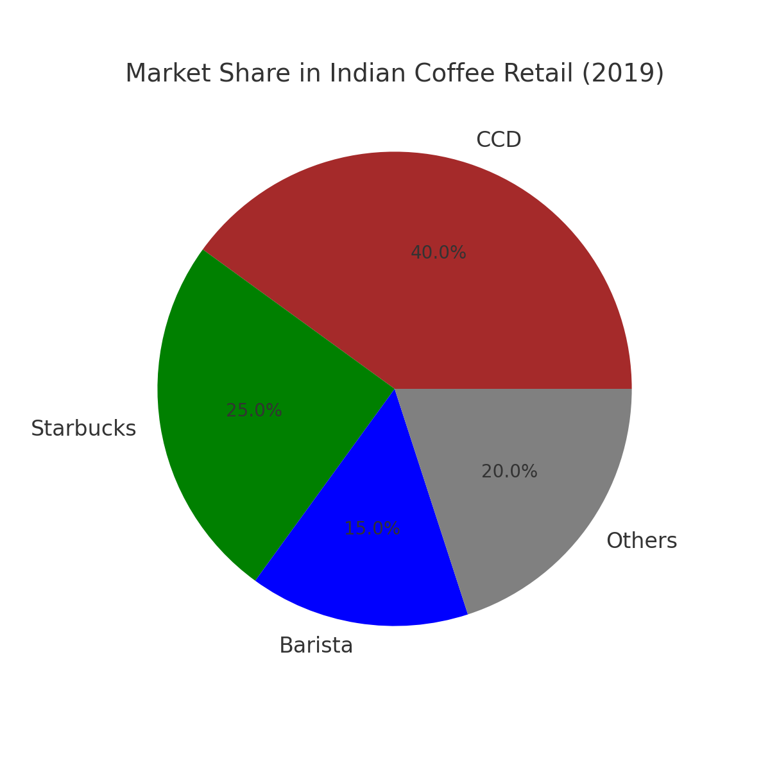

**CCD Revenue vs Debt Graph:**

