EXPERIMENT NO. 11 ( VIRTUAL LAB)

**NAME: ASMI DESAI**

**ROLL NO: 11**

INSERTION OF ELEMENTS: **BATCH: S1**

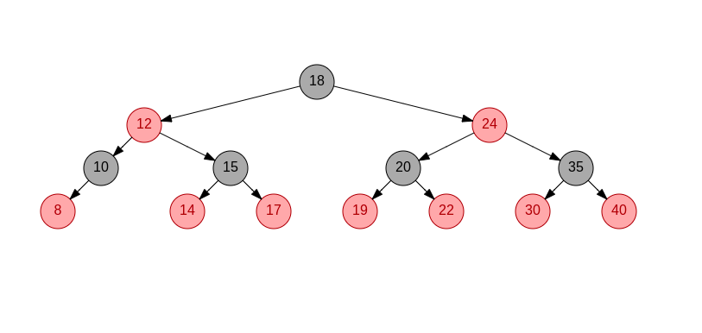

DELETION OF ELEMENT 8:

