PLACEMENT MANAGEMENT SYSTEM
A CRUD-Based Mini Web Application
Project Report
Submitted by
Asmitha.E
Register Number: 922525106034
Department of Electronics and Communication Engineering (ECE)
GitHub Repository: https://github.com/asmie11052008-lab/SOP_Mini-Web-Application-

Table of Contents
1. Project Overview 3
2. Problem Statement 3
3. Objectives 3
4. Technology Stack 3
5. System Architecture 4
6. Database / Entity Design 4
7. User Interface 5
8. CRUD Implementation Details 6
9. Validation Rules Implemented 6
10. Testing Procedure and Results 6
11. Installation and Execution Steps 7
12. Challenges and Solutions 7
13. Future Enhancements 7
14. Repository 8
15. Conclusion 8

1. Project Overview
The Placement Management System is a single-page CRUD web application built for a campus placement cell. It allows staff to manage three core records — Students, Companies, and Applications — and view a live dashboard summarising the current placement drive. The project was developed following the Standard Operating Procedure (SOP) for CRUD-based web application development, covering requirement analysis, design, frontend development, validation, and testing.

2. Problem Statement
Placement cells typically track student registrations, participating companies, and the status of each student's applications (Applied, Shortlisted, Selected, Rejected) using spreadsheets or paper records. This is error-prone, hard to search, and gives no real-time overview of the drive. The system addresses this by providing a structured interface to create, view, update, and delete these records, with validation to prevent bad data (duplicate roll numbers, invalid emails, out-of-range CGPA, etc.) and a dashboard that recalculates key metrics automatically.

3. Objectives
- Design and implement a functional CRUD application for managing placement data.
- Provide a clean, responsive user interface usable on both desktop and mobile screens.
- Enforce client-side validation for all data-entry fields.
- Implement search and status-filtering for quick record lookup.
- Maintain data consistency between related entities (e.g. block deletion of a student who has active applications).
- Structure the data-access layer so it can later be swapped for a real REST backend with minimal UI changes.

4. Technology Stack
Layer | Technology Used | Purpose
Frontend (structure) | HTML5 | Page markup and layout
Frontend (styling) | CSS3 (custom properties, dark-mode media query) | Visual design, theming, responsive layout
Frontend (logic) | Vanilla JavaScript (ES6) | Application logic, rendering, validation
Data layer | Browser localStorage, wrapped in an API object | Persistent client-side storage, structured like a REST client
Editor / Tooling | Visual Studio Code, PowerShell terminal | Development environment
Version control | Git / GitHub (planned) | Source-code management
Note: the current build implements the full frontend and a REST-shaped data-access layer, but persists data to the browser's localStorage rather than a live Django/Spring Boot server and database. Section 12 (Future Enhancements) covers migrating this to a real backend.

5. System Architecture
The application follows a layered structure even though it currently runs entirely in the browser:
- Presentation layer: HTML/CSS rendering the Dashboard, Students, Companies, and Applications views inside a single index.html file.
- Application logic layer: JavaScript functions that render tables, handle form submission, and run validation.
- Data-access layer: a single API object (API.students, API.companies, API.applications), each exposing getAll(), create(), update(id, patch), and delete(id) — deliberately mirroring REST endpoints (GET/POST/PUT/DELETE /api/students/).
- Storage layer: browser localStorage, standing in for a relational database.
Intended production architecture (per the SOP): User → HTML/CSS/JavaScript Frontend → REST API → Django REST Framework or Spring Boot Backend → ORM/JPA → MySQL/PostgreSQL/SQLite Database. Migrating to this only requires replacing the localStorage calls inside the API object with fetch() calls to real endpoints — no change to the rendering or validation code.

6. Database / Entity Design
Three entities are modelled, corresponding to the tables a relational database would use:
Entity | Key Fields | Notes
Student | id (PK), name, rollNo (unique), department, cgpa, email (unique), phone | cgpa constrained 0–10; phone must be 10 digits
Company | id (PK), name, role, package, minCgpa, driveDate | package must be positive
Application | id (PK), studentId (FK → Student), companyId (FK → Company), status, date | status ∈ {Applied, Shortlisted, Selected, Rejected}; duplicate (studentId, companyId) pairs rejected
Relationships: a Student can have many Applications; a Company can have many Applications; each Application links exactly one Student to one Company (many-to-many between Student and Company, resolved through the Application entity). Referential integrity is enforced in the application logic: a Student or Company cannot be deleted while a dependent Application record exists.

7. User Interface
The interface uses a fixed sidebar for navigation (Dashboard, Students, Companies, Applications) and a content area for tables, forms, and the dashboard summary. It supports light and dark themes via CSS custom properties and collapses the sidebar into a top bar on narrow/mobile screens.

7.1 Development Environment
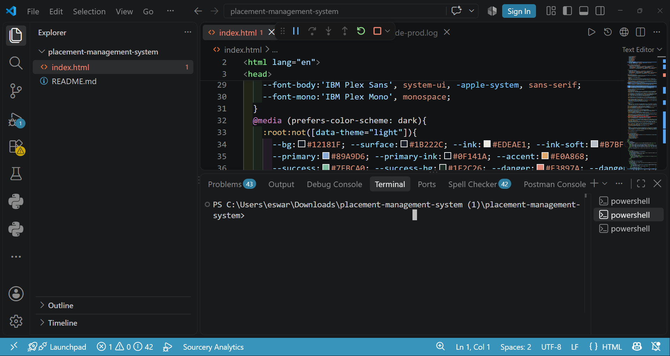
Figure 1: Project opened in Visual Studio Code, showing the single-file index.html and its CSS theme variables.

7.2 Dashboard View
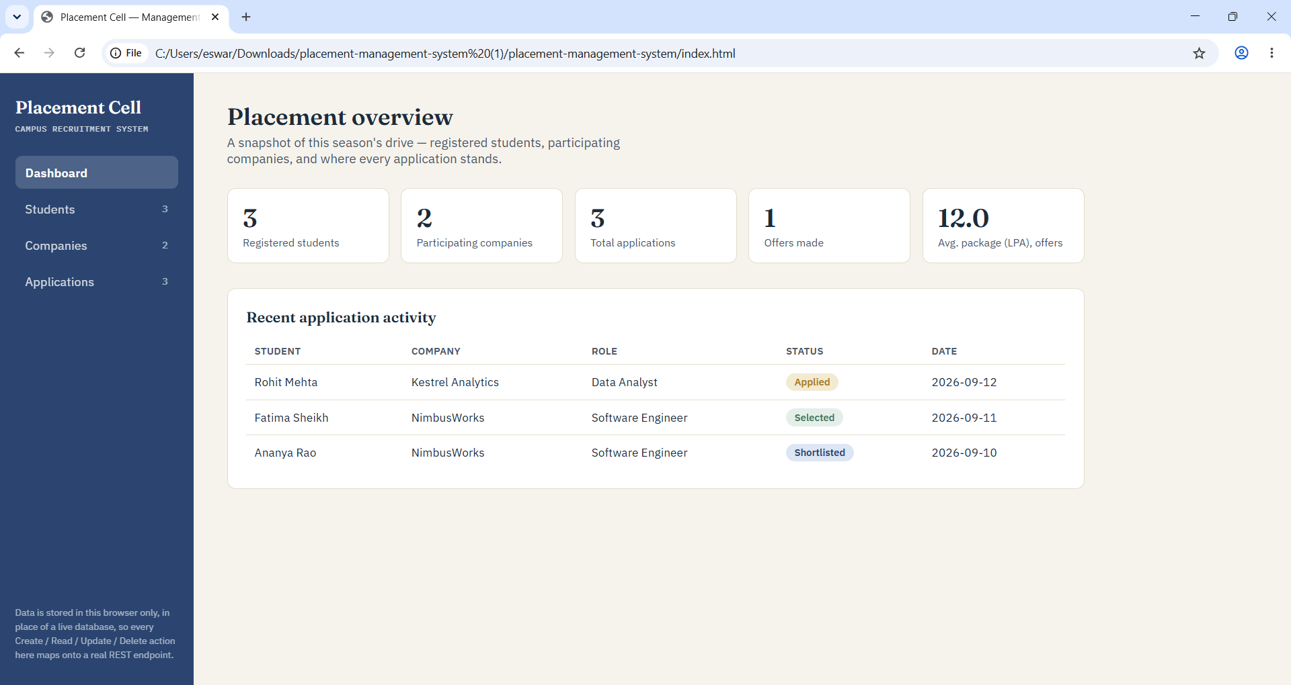
Figure 2: Dashboard showing live counts of students, companies, applications, offers made, and average package, alongside recent application activity.

8. CRUD Implementation Details
Operation | Implementation | Result
Create | Form submit → validate fields → API.<entity>.create(record) | New record appended and assigned an ID; table and dashboard counts refresh
Read | API.<entity>.getAll() → filtered by search box / status filter → rendered into table rows | Matching records displayed; empty state shown when no matches
Update | Edit button loads record into the form → submit → API.<entity>.update(id, patch) | Existing record merged with new values; table and dashboard refresh
Delete | Delete button → dependency check (Applications) → API.<entity>.delete(id) if unblocked | Record removed, or deletion blocked with a message if dependent Applications exist

9. Validation Rules Implemented
- Required fields cannot be left empty (name, roll number, email, company name, role, etc.).
- Email must follow a valid email format and be unique per student.
- Roll number must be unique per student.
- CGPA must fall between 0 and 10.
- Phone number must be exactly 10 digits.
- Package (LPA) must be a positive number.
- An application cannot be created twice for the same student–company pair.
- A student or company with existing applications cannot be deleted until those applications are removed first.
Each violation highlights the offending field and shows an inline error message rather than failing silently.

10. Testing Procedure and Results
Testing followed the SOP's manual test procedure (in place of Postman API tests, since there is no server endpoint yet):
Test Case | Steps | Result
Create — invalid data | Add student with duplicate roll number / invalid email | Pass — rejected, field highlighted
Create — valid data | Add a valid student and company | Pass — appears in table, dashboard count updates
Read — search | Search Students by name, roll number, department | Pass — table narrows to matches
Read — filter | Filter Applications by status (e.g. Selected) | Pass — only matching rows shown
Read — empty state | Search for a non-existent value | Pass — "no records" message shown
Update | Edit a student's CGPA / an application's status | Pass — row and dashboard stats recalculate
Delete — blocked | Delete a student/company with an existing application | Pass — deletion blocked with message
Delete — allowed | Delete the application, then the student/company | Pass — deletion succeeds
Persistence | Refresh the browser tab | Pass — data retained via localStorage
Responsiveness | Resize window to mobile width | Pass — sidebar collapses to top bar

11. Installation and Execution Steps
- Unzip the project folder and open it in Visual Studio Code (File → Open Folder…).
- (Optional) Install the Live Server extension by Ritwick Dey.
- Right-click index.html → "Open with Live Server", or simply double-click index.html to open it directly in a browser — no build step or server is required.
- Use the sidebar to navigate between Dashboard, Students, Companies, and Applications, and test each CRUD operation as described in Section 10.

12. Challenges and Solutions
Challenge | Solution
Preventing orphaned Applications when a Student/Company is deleted | Added a dependency check in the delete handler that blocks deletion while related Applications exist
Keeping the Dashboard's stats (offers made, average package) accurate after every edit | Recalculated all summary figures directly from the current data set on every render, instead of maintaining separate counters
Designing the data layer so it could later connect to a real backend | Wrote a single API object with getAll/create/update/delete methods per entity, matching REST semantics, so localStorage calls can be swapped for fetch() calls without touching UI code
Supporting both light and dark themes | Used CSS custom properties (variables) with a prefers-color-scheme media query and an optional data-theme override

13. Future Enhancements
- Replace the localStorage-backed API object with a real Django REST Framework or Spring Boot backend, connected to MySQL/PostgreSQL, exposing the REST endpoints described in the SOP (/api/students/, /api/companies/, /api/applications/).
- Add server-side validation and error handling to match the client-side rules.
- Add authentication so only authorised placement-cell staff can modify records.
- Add pagination and CSV export for large data sets.
- Write automated API tests (e.g. with Postman collections) once the backend is in place.

14. Repository
GitHub Repository: https://github.com/asmie11052008-lab/SOP_Mini-Web-Application-

15. Conclusion
The Placement Management System successfully implements all four CRUD operations for Students, Companies, and Applications, with validation, search/filtering, referential-integrity checks, and a responsive, theme-aware interface. The frontend and its REST-shaped data layer fulfil the SOP's frontend requirements in full and are structured to integrate directly with a Django or Spring Boot backend and a relational database as a future enhancement.

