Name: Asmita Suresh Shinde

PRN: 21510012

CNS LA2

List of experiments

7. Implementation of RSA Algorithm

8. Implement the Diffie-Hellman Key Exchange algorithm for a given problem

9. Calculate the message digest of a text using the SHA-1 algorithm

10. Implement the SIGNATURE SCHEME – Digital Signature Standard

11. Demonstration of SSL using Wireshark

**7. Implementation of RSA Algorithm**

**8. Implement the Diffie-Hellman Key Exchange algorithm for a given problem**

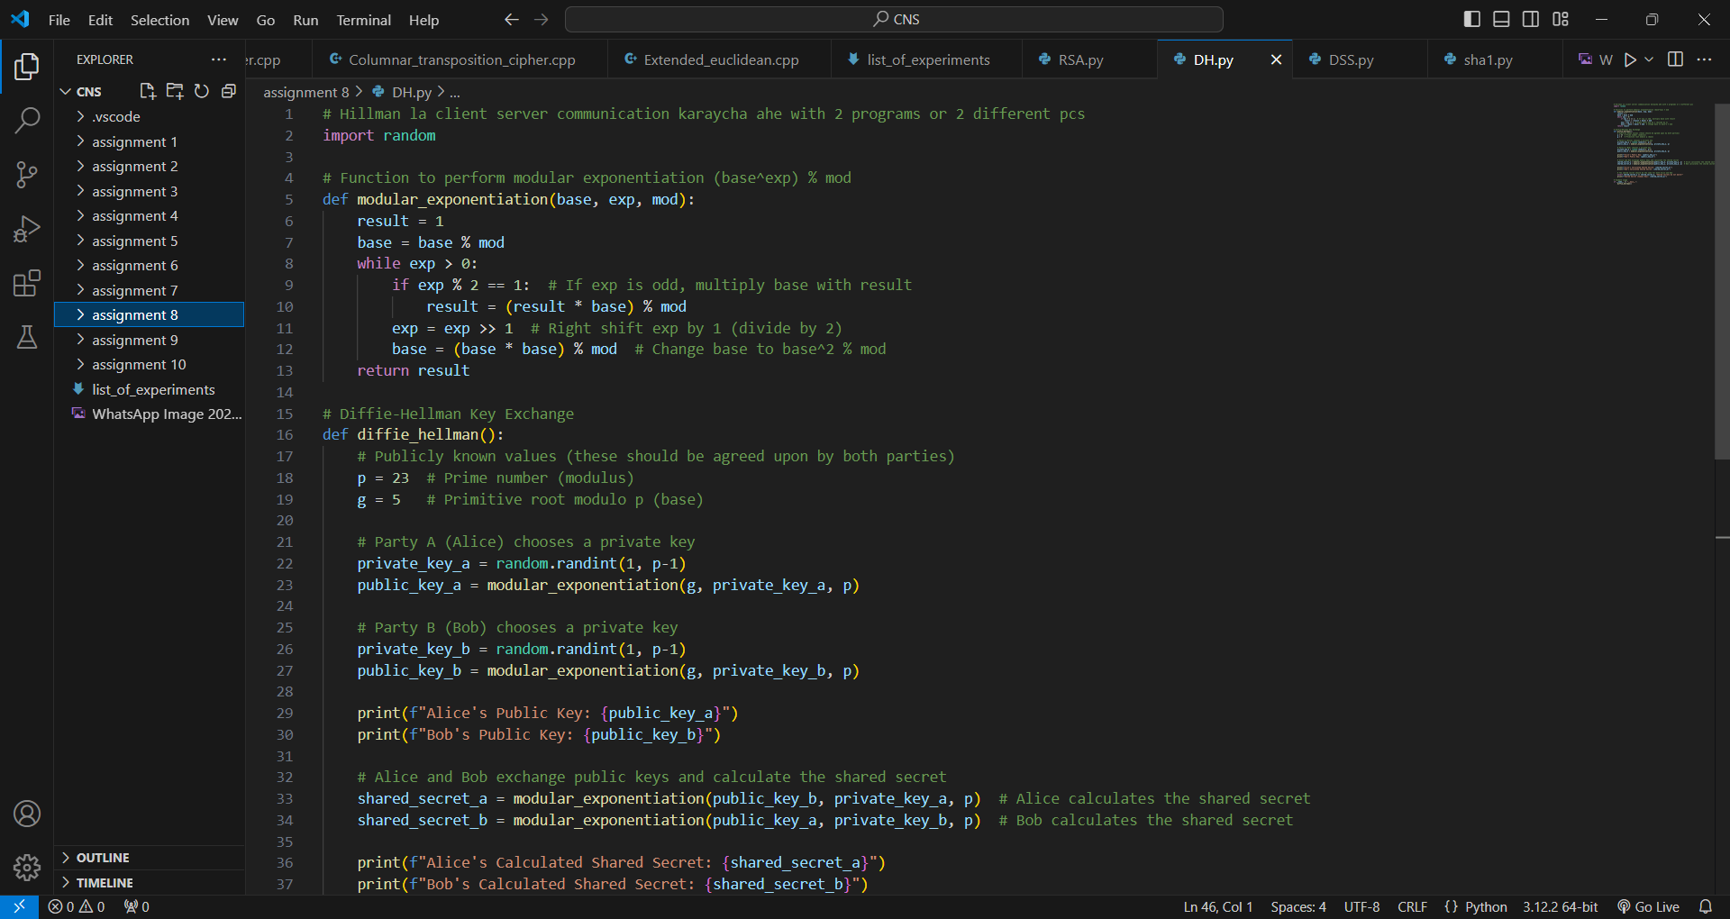

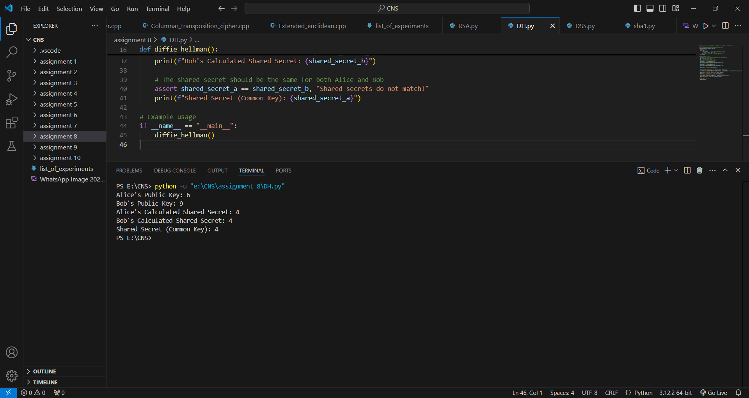

**9. Calculate the message digest of a text using the SHA-1 algorithm**

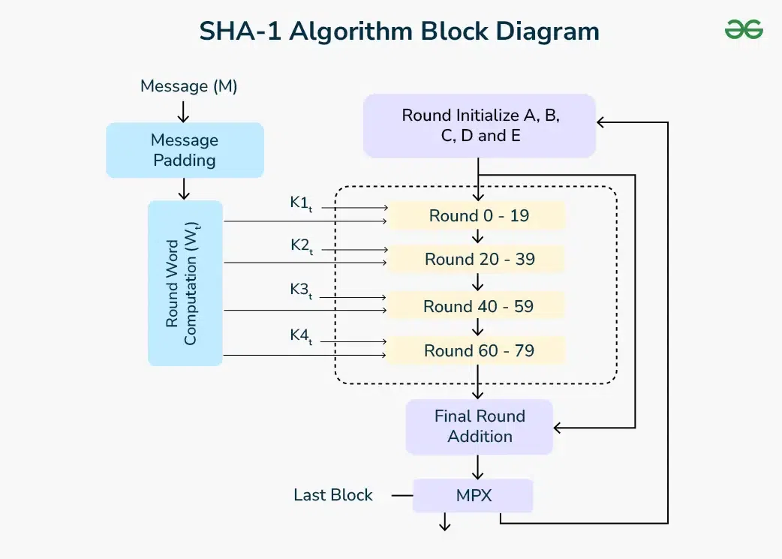

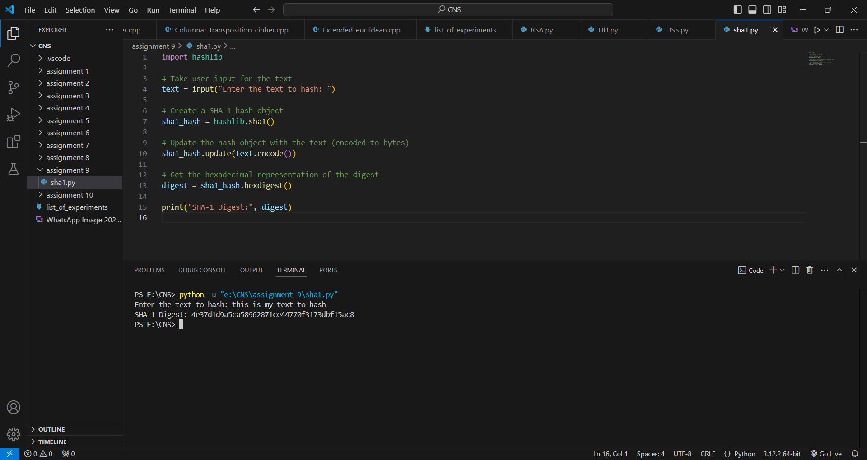

**10. Implement the SIGNATURE SCHEME – Digital Signature Standard**

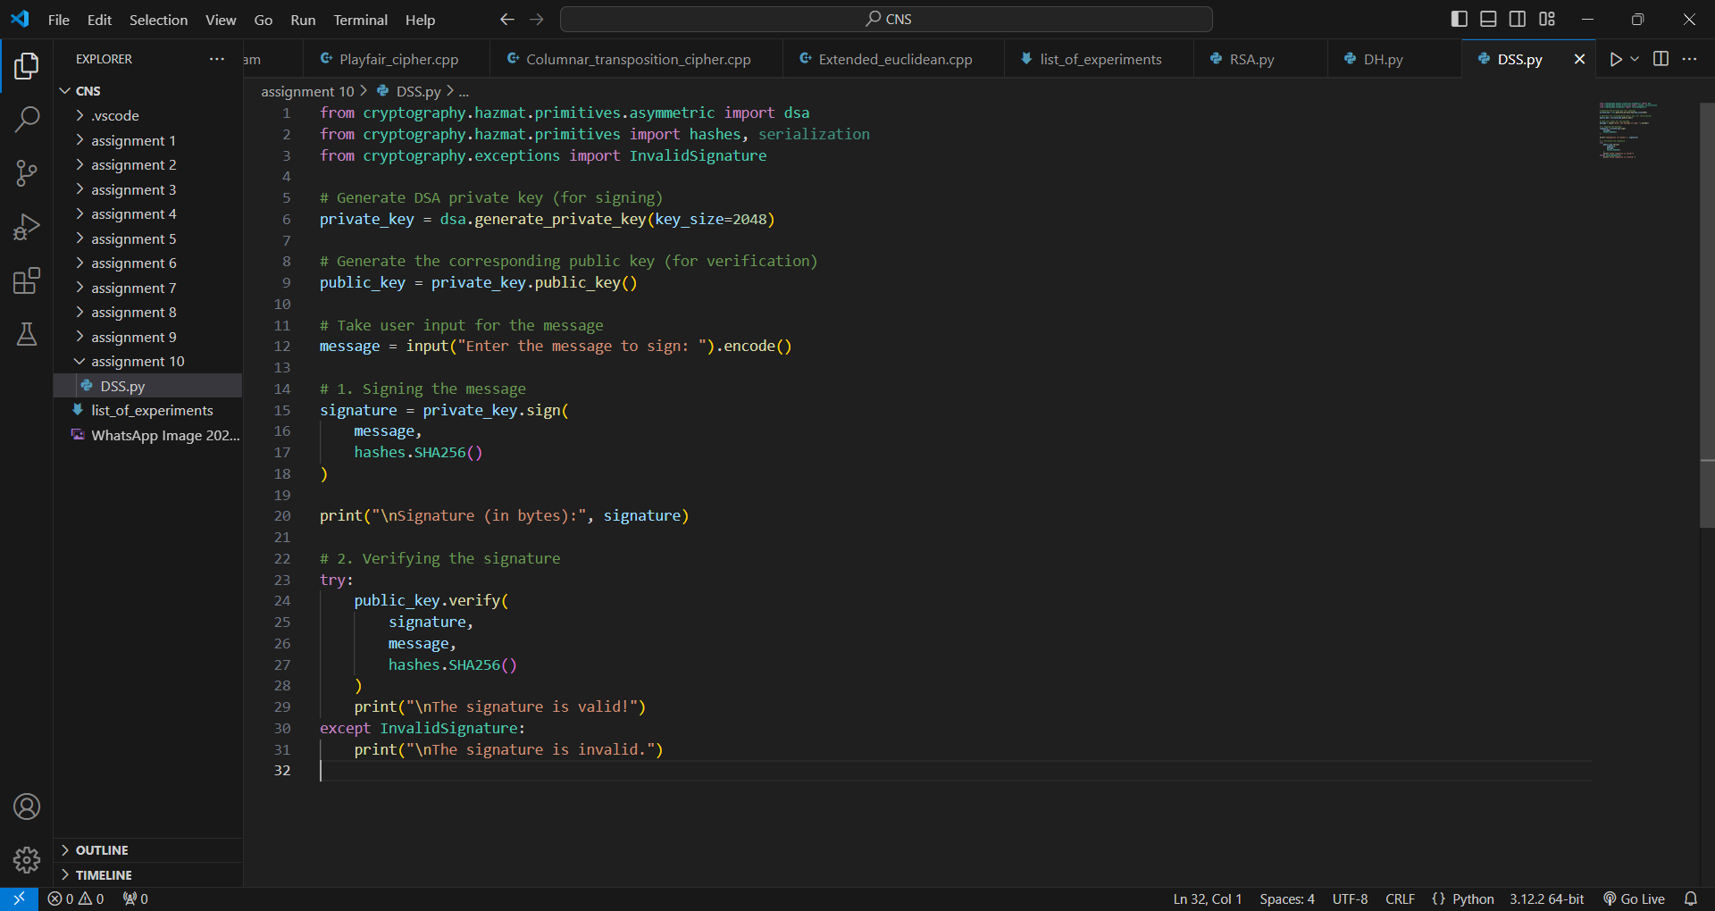

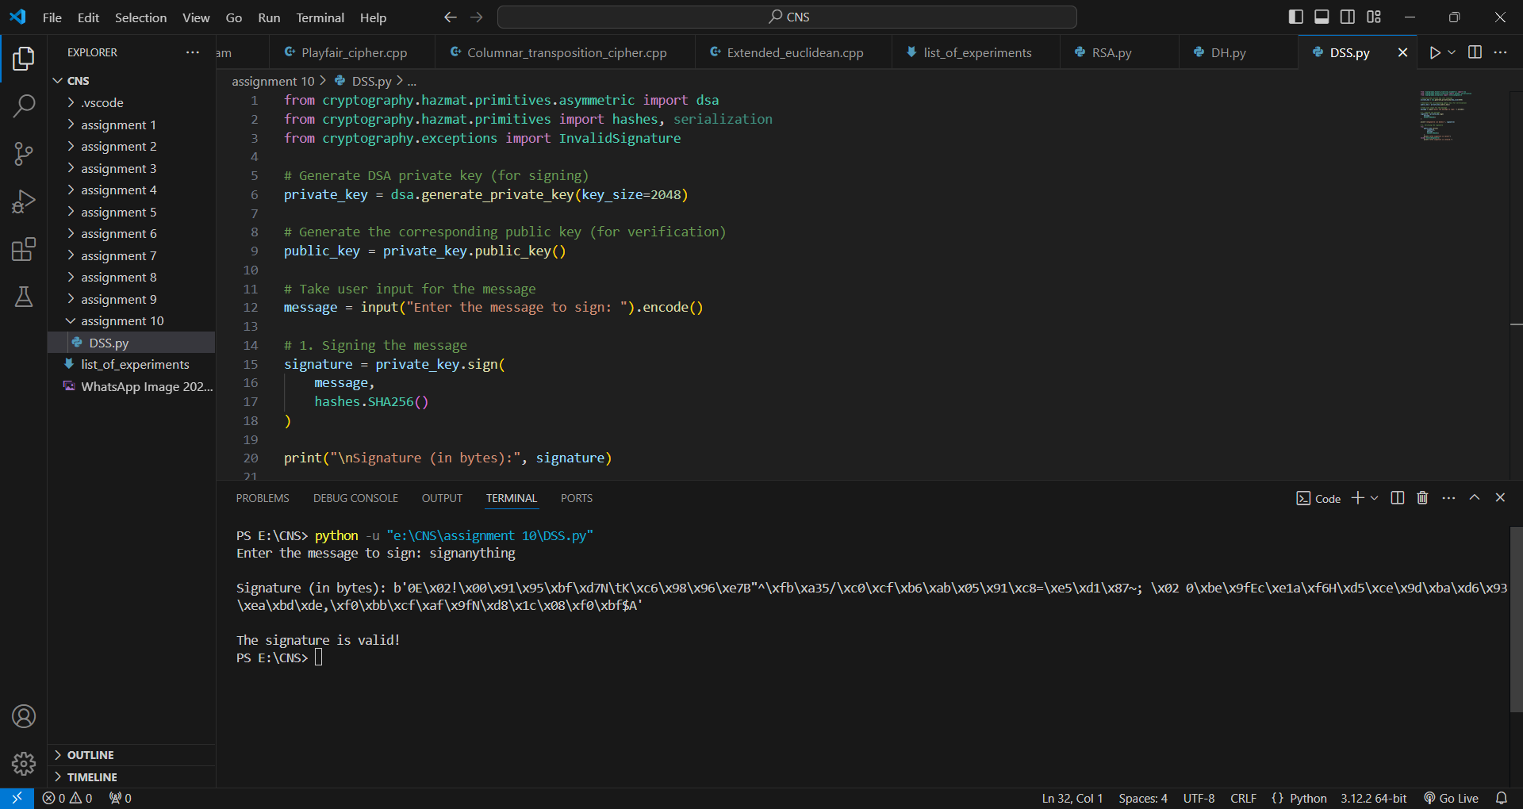

**11. Demonstration of SSL using Wireshark**

Step 1: Open a Trace

Step 2: Inspect the Trace

Step 3: The SSL Handshake

Hello Messages

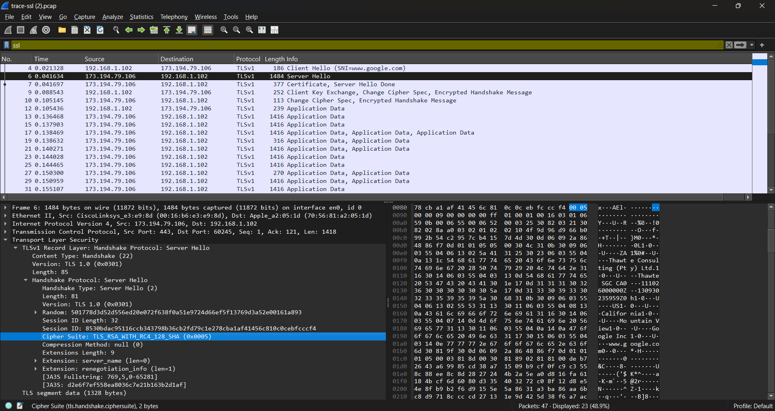

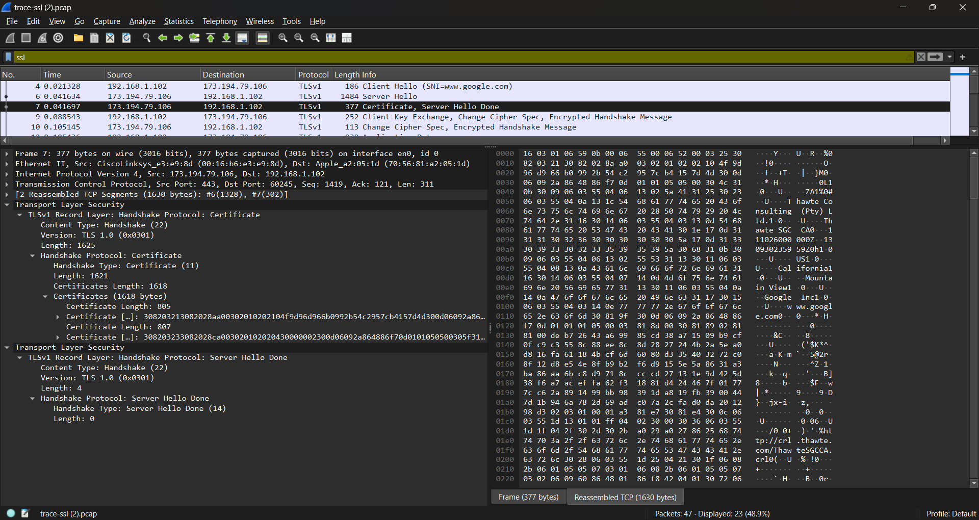

Certificate Messages

Alert Message

