Project Report on Campus Navigation System

Introduction
The name of our project is Campus Navigation System. The goal of this project is to create a straightforward application that functions similarly to Google Maps, which helps the user to navigate the entire campus. This program would enable the user to find their route from one building to another. This project helped us to understand how the use of graphs, HashMap, and priority queues can be utilized in practical applications. In addition, it taught us how to use JavaFX for the display of graphics and how to read information from files using File I/O.

Project Overview
The overall objective of the project revolves around ensuring that it becomes easier for people to navigate the campus. This project is an interactive route-finding application built using Java, JavaFX, and graph data structures.
Users can:
- View a map containing buildings (nodes) and roads (edges with weights).
- Click two nodes to choose a start and end location.
- The program computes the shortest path using Dijkstra’s algorithm.
- The UI visually highlights the path and displays the total distance.
This project demonstrates the practical use of:
- Graph algorithms
- Data structures such as HashMap, PriorityQueue, ArrayList
- GUI design using JavaFX

Project Goals
- Implement a weighted and undirected graph.
- Calculate the shortest path between two selected buildings.
- Visualize nodes and edges in JavaFX.
- Allow users to click nodes to autofill start/end fields.
- Display the final path and total distance on the interface

System Design and Architecture
Main Components
Module | Description
Graph.java | Stores adjacency list + nodes
Node.java | Custom node class storing id, coordinates and name
Edge.java | Store head and tail of an edge, and the edge itself
DataLoader.java | Load nodes and edges from edges.csv and nodes.csv files
Dijkstra.java | Algorithm to find the shortest path
MapCanvas.java | Draw the graph on a Pane
MainApp.java | Complete GUI of the app: Buttons, labels, node circles, and visual maps
edges.csv | csv file store head and tail of an edge, and its weight
nodes.csv | csv file store id, name and coordinate of a node

Data Structures Used
i)Graph Representation
An adjacency list is used to implement the graph:
HashMap<String, ArrayList<Edge>> This enables quick lookup, simple updates, and effective neighbor storage.
For Example:
Building C → (Building B, 100m), (Building D, 120m),
Building B → (Building A, 100m) is an example of a structure.
ii) Edge Structure
public class Edge {
private final String from;
private final String to;
private final double weight;
}
iii) PriorityQueue:
Used for Dijkstra’s algorithm:
PriorityQueue<NodeDistance> pq;
This guarantees that the node with the smallest tentative distance is processed first.
iv) HashMaps
Utilized for:
· distances: find each building's shortest path
· previous: rebuild the shortest path
· nodeCoordinates: store the x, y coordinates of every node on the map.
v)ArrayList: Used to store the edges that are attached to every building.
vi) File Input/Output: Our project uses two CSV files to store building information and path distances:
nodes.csv: this file stores each building’s ID, name, and its X/Y coordinates on the campus map.
id,name,x,y
paths.csv: This file stores the walking distances (in feet) between two connected buildings.
from, to, weight
The parser:
· Reads every line.
· Divides values
· Buildings are kept in a HashMap
· Generates graph edges
· Gives the algorithm the finished graph.
This system makes it easy to add new buildings and pathways
Algorithm Used
Dijkstra: This is used to find the shortest path between the defined starting and ending buildings.
Procedure:
- Start with the source node.
- Use PriorityQueue to always select the node with the lowest distance.
- Update the distances to adjacent nodes, iterating until reaching the destination.
- Use the predecessor mapping to trace the path.
The output generated is made up of:
- The ordered sequence of buildings forming the shortest path
- The total path length
- Estimate walking time

JavaFX Design Mechanism
i) Layout
- BorderPane is used to provide the basic structure.
- The center pane displays the campus map
- The top bar holds the text inputs and control buttons

ii)Node Visualization
Every structure on the map is represented by:
- A circle(radius 10-15px)
- A label showing the name of the building
- A mouse click event to auto-fill a corresponding field

iii) Edge Visualization
Edges are represented by Lines, and each line is labeled by distance.

iv) Event Handling
When user clicks a node:
- If cursor is in Start field → auto-fill start
- If cursor is in End field → auto-fill end
After completion of the selection and execution of "Find Path," JavaFX Pane displays the shortest route found.

Sample Output
Case buildings studied:
Shortest Path: Dempster Hall → Seabaugh Polytechnic Building → Group/Greek Housing → Facilities Management → Autism Center
Total distance: 4674.0 ft
Estimated walking time: 15.58 min
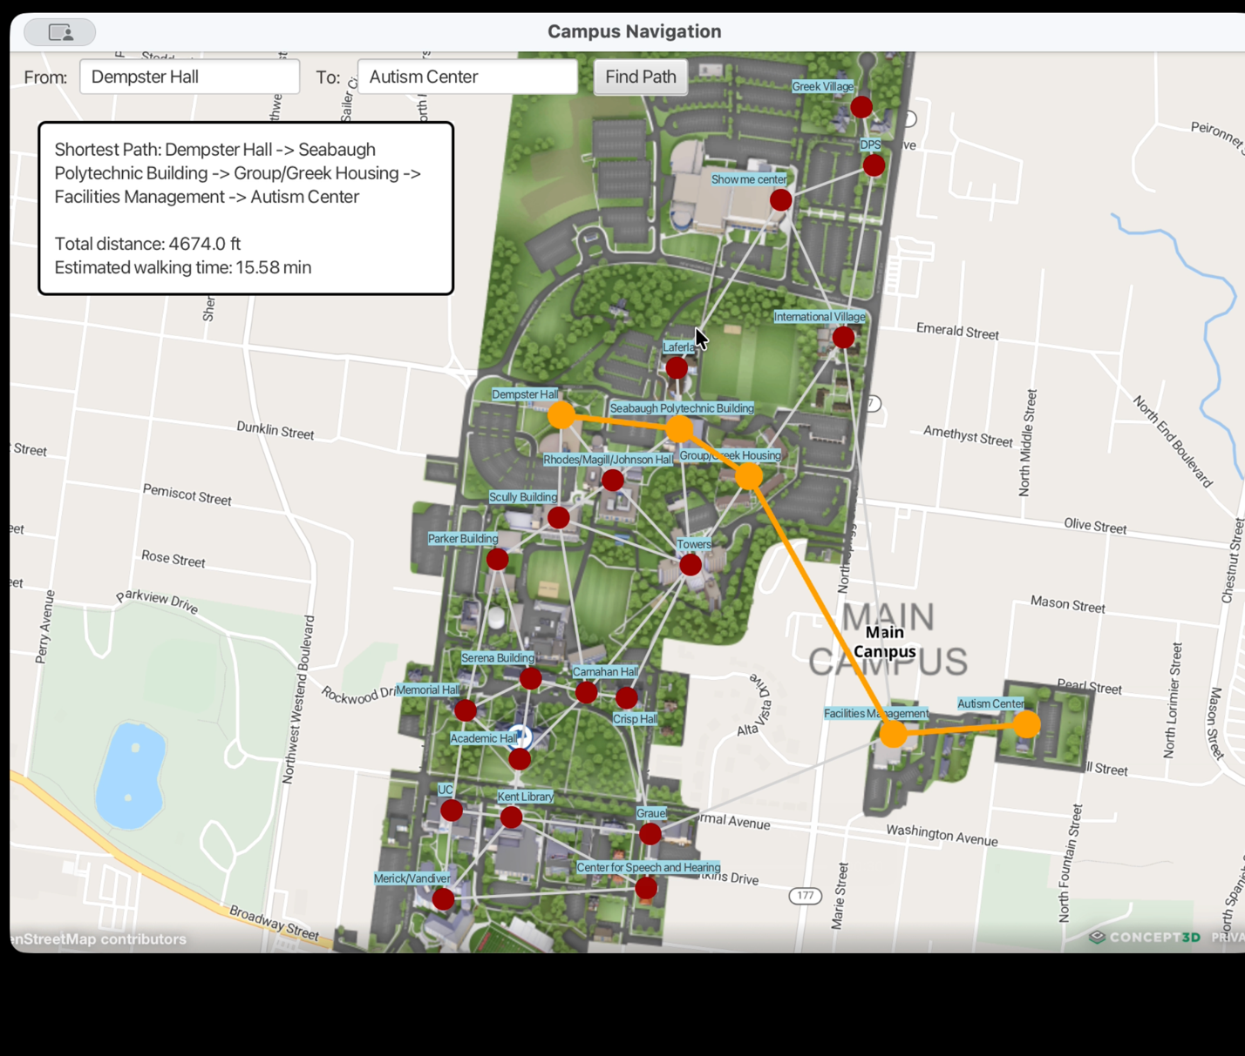
The route is marked by orange on the campus map.
How Graph and Data Structures Interact
i) User clicks two nodes: controller retrieves node names
ii) Controller calls: Dijkstra.shortestPath(graph, s_id, t_id)
iii) Dijkstra algorithm runs using:
- Adjacency list (HashMap)
- PriorityQueue
- HashMap for distances
- HashMap for reconstruction
iv)Controller retrieves the path: draws highlighted edges and nodes on JavaFX Pane
v)Label shows total distance of path.

How to run the Program
Requirements
- JDK 19
- JavaFX 21.
- IntelliJ IDEA, Eclipse, and Visual Studio Code
Procedural Steps
1. Open the project folder inside the IDE of choice.
2) Adding the JavaFX Library.
3) Configure VM Options:
--module-path /"path/to/javafx/lib" --add-modules javafx.controls,javafx.fxml,javafx.media --add-exports=javafx.base/com.sun.javafx=ALL-UNNAMED --add-exports=javafx.media/com.sun.media.jfxmedia.locator=ALL-UNNAMED
4) Run Main.java
5) Select the start and destination buildings.
6) Click "Find Path".
7) The shortest route is marked on the campus map.

Conclusion
This project has taught us the significance of data structures for practical use. This program, which uses graphs and Dijkstra’s algorithm, helped us learn the functionality of applications like GPS. JavaFX gave the opportunity to develop interactive user interface elements, and the parsing of files makes the system adaptable and simple to modify. Overall, this project proved to be an excellent learning experience for us, as it gave us the opportunity to use the theoretical concepts that we had learned and implement them into an effective graphical interface system.

