
Flight Price Prediction using Machine Learning
A Comparative Study of Five Regression Models on Indian Airfare Data
Name: Asmi Pandey
Roll No: 32
Reg No: 12418814
Section: K3P24MT
Course Code: INT234
Course Title: Predictive Analytics
Teacher Name: Dr. Tanima Thakur
Academic Task Number: 3
Academic Task Type: ASSIGNMENT 3

CERTIFICATE
This is to certify that the project report entitled "Flight Price Prediction using Machine Learning" submitted by Asmi Pandey (Reg. No. 12418814, Roll No. 32, Section K3P24MT) as Academic Task 3 (Assignment 3) of the course Predictive Analytics (Course Code INT234) at Lovely Professional University, Phagwara, Punjab, is a bonafide record of the work carried out by the student under my supervision and guidance during the academic session 2026–27.
To the best of my knowledge, the matter embodied in this report has not been submitted to any other university or institution for the award of any degree or diploma.

______________________ ______________________
Dr. Tanima Thakur Head of School
Course Instructor, INT234 School of Computer Science & Engg.
Date: 28 October 2026
Place: Phagwara, Punjab

DECLARATION
I, Asmi Pandey, student of Lovely Professional University, Phagwara, Punjab, hereby declare that the project report entitled "Flight Price Prediction using Machine Learning" is an original work carried out by me as Academic Task 3 (Assignment 3) of the course Predictive Analytics (INT234), under the guidance of Dr. Tanima Thakur.
I further declare that the dataset used in this project is publicly available and has been duly acknowledged, and that all other sources of information have been properly cited in the references. This work has not been submitted elsewhere for the award of any degree, diploma or certificate.

Signature: Asmi Pandey
Date: 28 October 2026 Asmi Pandey
Place: Phagwara, Punjab Reg. No.: 12418814
Roll No.: 32, Section: K3P24MT

ACKNOWLEDGEMENT
I would like to express my sincere gratitude to my course instructor for Predictive Analytics (INT234), Dr. Tanima Thakur, for the valuable guidance, constant encouragement and constructive suggestions provided throughout the course of this project. Their insights into predictive modelling and data analysis helped me shape this work in the right direction.
I am thankful to the School of Computer Science and Engineering and all the faculty members for providing the necessary facilities and a supportive academic environment at Lovely Professional University, Phagwara, Punjab.
I would also like to thank the creators of the Flight Price Prediction dataset on Kaggle for making the data publicly available, and the open-source communities behind Python, Pandas, NumPy, Matplotlib, Seaborn, Scikit-learn and XGBoost, whose tools made this analysis possible.
Finally, I am grateful to my family and friends for their continuous support and motivation during the completion of this project.

Signature: Asmi Pandey
Asmi Pandey
Reg. No.: 12418814
Date: 28 October 2026

ABSTRACT
Airline ticket prices in India change frequently and depend on many factors such as the airline, route, class of travel, number of stops, time of departure and, most importantly, how many days before the journey the ticket is booked. For a traveller, this makes it difficult to know whether a quoted fare is reasonable or whether waiting will make it cheaper or costlier. This project applies predictive analytics and supervised machine learning to estimate the price of a domestic flight ticket from its characteristics.
The study uses the publicly available Flight Price Prediction dataset from Kaggle, which contains 3,00,153 flight records scraped from the EaseMyTrip booking website for travel between six major Indian metro cities — Delhi, Mumbai, Bangalore, Kolkata, Hyderabad and Chennai — across six airlines. The data was cleaned by removing redundant columns, 2,213 duplicate rows and 2,226 duration outliers detected using the Inter-Quartile Range (IQR) method, leaving 2,95,714 records for modelling. A detailed Exploratory Data Analysis (EDA) was performed to study the effect of class, airline, booking window, stops, departure and arrival time, route and duration on ticket price.
Categorical variables were converted into numerical form using binary, ordinal and one-hot encoding, resulting in 29 input features. Five regression models were trained on 80% of the data and evaluated on the remaining 20%: Linear Regression, Ridge Regression, Decision Tree Regressor, Random Forest Regressor and XGBoost Regressor. Model performance was measured using the Coefficient of Determination (R²), Mean Squared Error (MSE), Root Mean Squared Error (RMSE) and Mean Absolute Error (MAE), and validated using 5-fold cross validation.
XGBoost achieved the best performance with an R² score of 0.9874 (98.74%), an RMSE of ₹2,557 and an MAE of ₹1,342, followed closely by Random Forest (R² = 0.9864) and Decision Tree (R² = 0.9811). The linear models reached an R² of 0.9096, showing that the relationship between the features and the fare is strongly non-linear. The analysis also found that business class fares are about eight times higher than economy fares and that tickets booked within the last two weeks before departure are significantly more expensive. Finally, the trained XGBoost model was exported and deployed on Netlify as an interactive web application (flight-priceprediction.netlify.app) that predicts fares in real time; the source code is available on GitHub (github.com/asmipandey3762/flight-price-prediction).
Keywords: Predictive Analytics, Flight Price Prediction, Regression, XGBoost, Random Forest, Exploratory Data Analysis, Machine Learning

TABLE OF CONTENTS
Title Page No.
Certificate ii
Declaration iii
Acknowledgement iv
Abstract v
List of Figures viii
List of Tables viii
List of Abbreviations ix
Chapter 1: Introduction 1
1.1 Background 1
1.2 Problem Statement 1
1.3 Objectives 1
1.4 Scope of the Project 2
1.5 Organisation of the Report 2
Chapter 2: Literature Review 3
2.1 Early Work on Airfare Prediction 3
2.2 Machine Learning Approaches 3
2.3 Gradient Boosting Methods 3
2.4 Research Gap and Contribution 4
Chapter 3: Dataset Description 5
3.1 Source of the Data 5
3.2 Attribute Information 5
3.3 Descriptive Statistics 6
3.4 Composition of the Data 6
Chapter 4: Methodology 7
4.1 Project Workflow 7
4.2 Tools and Technologies 7
4.3 Evaluation Metrics 8
4.4 Cross Validation 9
Chapter 5: Data Cleaning and Pre-processing 10
5.1 Removing Unnecessary Columns 10
5.2 Handling Missing Values 10
5.3 Removing Duplicate Records 10
5.4 Checking Categorical Values 10
5.5 Outlier Detection and Removal 10
5.6 Summary of Data Cleaning 11
Chapter 6: Exploratory Data Analysis 12
6.1 Distribution of Ticket Price 12
6.2 Economy vs Business Class 12
6.3 Airline-wise Analysis 13
6.4 Effect of Days Left before Departure 14
6.5 Effect of Number of Stops 15
6.6 Departure and Arrival Time 15
6.7 Route-wise Analysis 16
6.8 Duration vs Price 16
6.9 Airline Share and Effect of Stops by Airline 17
6.10 Key Insights from EDA 17
Chapter 7: Feature Engineering 18
7.1 Binary Encoding of Class 18
7.2 Ordinal Encoding of Stops 18
7.3 One-Hot Encoding of Nominal Attributes 18
7.4 Correlation with Price 19
7.5 Train-Test Split and Feature Scaling 19
Chapter 8: Model Building 20
8.1 Linear Regression 20
8.2 Ridge Regression 20
8.3 Decision Tree Regressor 20
8.4 Random Forest Regressor 21
8.5 XGBoost Regressor 21
8.6 Hyperparameters Used 22
Chapter 9: Results and Discussion 23
9.1 Model Comparison Table 23
9.2 Discussion of Results 23
9.3 Cross Validation Results 24
9.4 Actual vs Predicted Prices 24
9.5 Residual Analysis 25
9.6 Feature Importance 26
9.7 Sample Predictions 26
9.8 Detailed Error Analysis 27
Chapter 10: Web-based Demonstration 30
10.1 Model Export 30
10.2 Features of the Web Page 30
10.3 Deployment 31
10.4 Example Use Case 31
Chapter 11: Conclusion and Future Scope 32
11.1 Conclusion 32
11.2 Limitations 32
11.3 Future Scope 33
References 34
Appendix A: Source Code 35

LIST OF FIGURES
Figure 4.1 Workflow of the project 7
Figure 4.2 Train-test split and 5-fold cross validation scheme 9
Figure 5.1 Box plots of price, duration and days left 10
Figure 6.1 Distribution of flight ticket price 12
Figure 6.2 Share of tickets and price by class 12
Figure 6.3 Number of flights and price by airline and class 13
Figure 6.4 Economy ticket price vs days left before departure 14
Figure 6.5 Average price by number of stops 15
Figure 6.6 Economy price by departure and arrival time 15
Figure 6.7 Average economy price by source and destination city 16
Figure 6.8 Duration vs price (random sample of 10,000 flights) 16
Figure 6.9 Share of flights by airline and average economy price by airline and stops 17
Figure 7.1 Example of one-hot encoding for the airline attribute 18
Figure 7.2 Correlation of each encoded feature with price 19
Figure 8.1 Structure of a regression decision tree (illustrative) 21
Figure 8.2 Working of the Random Forest (bagging) regressor 21
Figure 8.3 Sequential boosting in XGBoost — each tree corrects the previous errors 22
Figure 9.1 R² score (accuracy) and RMSE of the five models 23
Figure 9.2 Actual vs predicted prices for all five models 24
Figure 9.3 Actual vs predicted prices — XGBoost 25
Figure 9.4 Distribution of residuals — XGBoost 25
Figure 9.5 Top 15 important features — XGBoost 26
Figure 9.6 Train, test and 5-fold cross-validation R² of the five models 27
Figure 9.7 MAE and R² of each model computed separately for Economy and Business class 27
Figure 9.8 Training and test RMSE of XGBoost as more trees are added 28
Figure 9.9 Residuals against predicted price — Linear Regression vs XGBoost 28
Figure 9.10 Business class price vs days left (left) and XGBoost MAE by booking window (right) 29
Figure 10.1 Architecture of the web-based demonstration 30
Figure 10.2 FareCast India web page — desktop view 30
Figure 10.3 (a) Mobile view of the web page, (b) prediction for a business class flight from Bangalore to Kolkata 31

LIST OF TABLES
Table 2.1 Summary of related work 4
Table 3.1 Description of dataset attributes 5
Table 3.2 Descriptive statistics of numerical attributes 6
Table 3.3 Record count by category 6
Table 4.1 Tools and libraries used 7
Table 5.1 Summary of data cleaning steps 11
Table 6.1 Average economy fare by airline 13
Table 6.2 Average economy fare by booking window 14
Table 7.1 Encoding applied to each attribute 18
Table 8.1 Hyperparameters of the five models 22
Table 9.1 Performance comparison of the five regression models 23
Table 9.2 5-fold cross validation R² scores (50,000-record sample) 24
Table 9.3 Sample predictions of the XGBoost model on test data 26
Table 10.1 Project links 31

LIST OF ABBREVIATIONS
Abbreviation | Full Form
AI | Artificial Intelligence
CSV | Comma Separated Values
CV | Cross Validation
DT | Decision Tree
EDA | Exploratory Data Analysis
IATA | International Air Transport Association
IQR | Inter-Quartile Range
JSON | JavaScript Object Notation
LR | Linear Regression
MAE | Mean Absolute Error
ML | Machine Learning
MSE | Mean Squared Error
OLS | Ordinary Least Squares
R² | Coefficient of Determination
RF | Random Forest
RMSE | Root Mean Squared Error
XGBoost | Extreme Gradient Boosting

CHAPTER 1

INTRODUCTION

1.1 Background
The Indian civil aviation sector is one of the fastest growing aviation markets in the world. With the rise of low-cost carriers, online travel agencies and a growing middle class, air travel has become a common mode of transport for business and personal trips. Unlike train or bus fares, which are mostly fixed, airline fares are decided using dynamic pricing (also called revenue management). Airlines continuously change prices based on demand, remaining seats, competition, season, time to departure and many other factors.
Because of dynamic pricing, two passengers on the same flight may pay very different amounts depending on when and how they booked. For customers this creates uncertainty, and for travel portals it creates an opportunity to provide fare forecasts and booking advice. Predictive analytics — the use of historical data, statistical techniques and machine learning to predict future or unknown outcomes — is well suited to this problem.
Machine learning regression models can learn the hidden patterns between flight characteristics and the final ticket price from a large set of past records. Once trained, such a model can estimate the fare of any new flight configuration within a fraction of a second.

1.2 Problem Statement
Given the details of a domestic flight in India — airline, source city, destination city, departure time, arrival time, number of stops, class of travel, duration of journey and the number of days left before departure — predict the ticket price (in Indian Rupees) as accurately as possible.
Since the target variable (price) is continuous, this is a supervised regression problem. The project also aims to identify which factors influence the fare the most and to compare the effectiveness of different regression algorithms on this task.

1.3 Objectives
The main objectives of the project are:
- To collect a large, publicly available and reliable dataset of Indian domestic flight fares.
- To clean and pre-process the data by handling redundant columns, duplicates and outliers.
- To perform Exploratory Data Analysis (EDA) and find meaningful patterns and insights about airfare.
- To engineer and encode features so that they can be used by machine learning models.
- To build and train five regression models: Linear Regression, Ridge Regression, Decision Tree, Random Forest and XGBoost.
- To evaluate and compare the models using R² score, MSE, RMSE and MAE, along with cross validation.
- To identify the best model and deploy it as an interactive web-based demonstration.

1.4 Scope of the Project
The project covers economy and business class flights operated by six airlines (Vistara, Air India, Indigo, GO FIRST, AirAsia and SpiceJet) between six metro cities, forming 30 city-pair routes. The data relates to journeys with a booking window of 1 to 49 days. Predictions made by the model are therefore valid for these routes, airlines and booking windows. The methodology, however, is general and can be extended to more cities, airlines and time periods when more data becomes available.

1.5 Organisation of the Report
The rest of this report is organised as follows. Chapter 2 reviews existing work on airfare prediction. Chapter 3 describes the dataset in detail. Chapter 4 explains the methodology, tools and evaluation metrics. Chapter 5 covers data cleaning, and Chapter 6 presents the exploratory data analysis. Chapter 7 describes feature engineering and encoding. Chapter 8 explains the five regression models used. Chapter 9 presents and compares the results. Chapter 10 describes the interactive web demonstration, and Chapter 11 concludes the report with limitations and future scope.
CHAPTER 2

LITERATURE REVIEW
Airfare prediction has been studied by researchers for nearly two decades, both to help customers decide when to buy tickets and to help airlines and agencies understand pricing behaviour. This chapter summarises some of the important approaches reported in the literature.

2.1 Early Work on Airfare Prediction
One of the earliest and most cited studies is by Etzioni et al. (2003), who built a system called Hamlet that observed fares over time and advised customers whether to "buy now" or "wait". Using a combination of rule learning, time-series methods and reinforcement learning, the system was able to save customers a substantial amount compared to buying immediately. This work showed that fare movements, although complex, contain learnable patterns.
Groves and Gini (2013) extended this idea by using partial least squares regression and feature selection on airline data to predict the optimal purchase time. They found that the number of days before departure and the day of the week were among the most useful predictors.

2.2 Machine Learning Approaches
With the availability of larger datasets, researchers started applying standard machine learning regressors. Tziridis et al. (2017) compared eight machine learning models — including Multilayer Perceptron, Random Forest, Regression Tree, Bagging Regression Tree and Support Vector Regression — for airfare prediction on European routes. Their results showed that ensemble tree-based methods such as Bagging Regression Trees achieved the highest accuracy, reaching close to 88%.
Rajankar and Sakharkar (2019) studied Indian flight fares using Linear Regression, Decision Tree, KNN and Random Forest, and reported that Random Forest performed best. Similar studies on the Indian market have repeatedly found that class of travel, airline, stops and days left before departure are the most important features.

2.3 Gradient Boosting Methods
Chen and Guestrin (2016) introduced XGBoost, a scalable and regularised implementation of gradient boosted decision trees. XGBoost has since become one of the most successful algorithms for structured (tabular) data and is widely used in industry and in data science competitions. Several recent airfare studies report that boosting methods such as XGBoost, LightGBM and CatBoost outperform both linear models and single decision trees.

2.4 Research Gap and Contribution
Many existing studies use small datasets of a few thousand records or focus on routes outside India. This project uses a large dataset of over three lakh Indian domestic flight records and performs a systematic, side-by-side comparison of five regression models using four error metrics and cross validation. In addition, the best model is deployed as a working web application, which is often missing from academic studies.
Table 2.1: Summary of related work
Study | Data / Region | Methods | Key Finding
Etzioni et al. (2003) | US domestic routes | Rule learning, time series, Q-learning | Fare patterns are learnable; "buy or wait" advice saves money
Groves & Gini (2013) | US airline data | Partial least squares regression | Days to departure is a strong predictor
Chen & Guestrin (2016) | General tabular data | XGBoost (gradient boosting) | Fast, regularised boosting; state of the art on tabular data
Tziridis et al. (2017) | European routes | 8 ML regressors | Ensemble trees performed best (~88%)
Rajankar & Sakharkar (2019) | Indian routes | LR, DT, KNN, RF | Random Forest performed best
This project (2026) | Indian metros, 3 lakh rows | LR, Ridge, DT, RF, XGBoost | XGBoost best with R² = 0.9874

CHAPTER 3

DATASET DESCRIPTION

3.1 Source of the Data
The dataset used in this project is the "Flight Price Prediction" dataset published on Kaggle by Shubham Bathwal (kaggle.com/datasets/shubhambathwal/flight-price-prediction). The data was collected by scraping the EaseMyTrip website, a popular Indian online travel portal, using the Octoparse web scraping tool. It contains information about flight booking options for travel between six major metro cities of India over a period of 50 days, from 11 February to 31 March 2022.
The dataset is freely and publicly available for research and educational purposes. The cleaned version of the file (Clean_Dataset.csv) was used, which contains 3,00,153 rows and 12 columns.

3.2 Attribute Information
The table below describes each attribute present in the dataset.
Table 3.1: Description of dataset attributes
Attribute | Type | Description
Unnamed: 0 | Integer | Row index (not a feature)
airline | Categorical (6) | Name of the airline: Vistara, Air India, Indigo, GO FIRST, AirAsia, SpiceJet
flight | Categorical (1,561) | Flight code, e.g. SG-8709
source_city | Categorical (6) | City from which the flight departs
departure_time | Categorical (6) | Time slot of departure: Early Morning, Morning, Afternoon, Evening, Night, Late Night
stops | Categorical (3) | Number of stops: zero, one, two_or_more
arrival_time | Categorical (6) | Time slot of arrival (same 6 slots)
destination_city | Categorical (6) | City where the flight lands
class | Categorical (2) | Seat class: Economy or Business
duration | Continuous | Total travel time in hours
days_left | Integer | Days between booking date and travel date (1–49)
price | Continuous | Target variable — ticket price in ₹

3.3 Descriptive Statistics
The numerical attributes of the raw dataset have the following summary statistics:
Table 3.2: Descriptive statistics of numerical attributes
Statistic | duration (hours) | days_left (days) | price (₹)
Count | 3,00,153 | 3,00,153 | 3,00,153
Mean | 12.22 | 26.00 | 20,889.66
Standard deviation | 7.19 | 13.56 | 22,697.77
Minimum | 0.83 | 1 | 1,105
25th percentile | 6.83 | 15 | 4,783
Median | 11.25 | 26 | 7,425
75th percentile | 16.17 | 38 | 42,521
Maximum | 49.83 | 49 | 1,23,071

The large difference between the mean (₹20,890) and the median (₹7,425) price indicates that the price distribution is highly skewed. This is due to the presence of business class tickets, which are far costlier than economy tickets.

3.4 Composition of the Data
Out of the 3,00,153 records, 68.85% are Economy and 31.15% are Business class tickets. Vistara (1,27,859 records) and Air India (80,892) together account for nearly 70% of the data, followed by Indigo (43,120), GO FIRST (23,173), AirAsia (16,098) and SpiceJet (9,011). Most flights have one stop (2,50,863 records), while 36,004 are non-stop and 13,286 have two or more stops. The source cities are well balanced, with Delhi (61,343) and Mumbai (60,896) having the most departures and Chennai (38,700) the fewest.
Table 3.3: Record count by category
Category | Values (number of records)
Class | Economy 2,06,666 · Business 93,487
Airline | Vistara 1,27,859 · Air India 80,892 · Indigo 43,120 · GO FIRST 23,173 · AirAsia 16,098 · SpiceJet 9,011
Stops | One 2,50,863 · Zero 36,004 · Two or more 13,286
Source city | Delhi 61,343 · Mumbai 60,896 · Bangalore 52,061 · Kolkata 46,347 · Hyderabad 40,806 · Chennai 38,700

CHAPTER 4

METHODOLOGY

4.1 Project Workflow
The project follows the standard predictive analytics life cycle. Each stage of the workflow is shown in Figure 4.1 and explained in the following chapters.
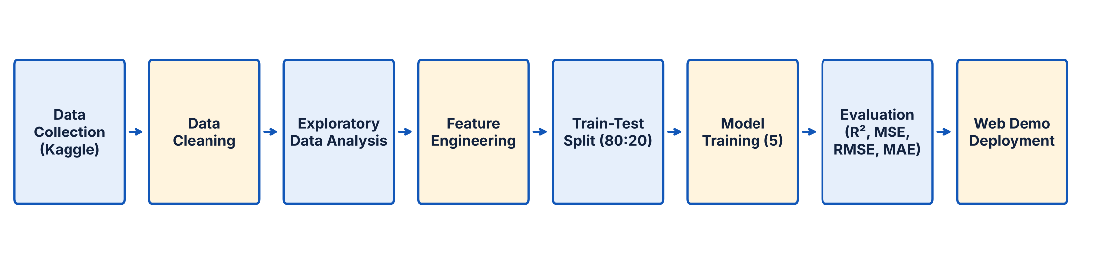
Figure 4.1: Workflow of the project
- Data Collection — the dataset was downloaded from Kaggle in CSV format.
- Data Cleaning — removal of unnecessary columns, duplicate rows and outliers; checking for missing and invalid values.
- Exploratory Data Analysis — univariate, bivariate and multivariate analysis using statistical summaries and visualisations.
- Feature Engineering — converting categorical attributes into numerical form using suitable encoding techniques.
- Train-Test Split — dividing the data into 80% training and 20% testing sets, followed by feature scaling.
- Model Training — training five regression models on the training set.
- Evaluation — comparing models on the test set using R², MSE, RMSE and MAE, and validating with 5-fold cross validation.
- Deployment — exporting the best model and building an interactive web page for real-time prediction.

4.2 Tools and Technologies
Table 4.1: Tools and libraries used
Tool / Library | Purpose
Python 3 | Programming language for the complete analysis
Jupyter Notebook | Interactive development and documentation of code with outputs
Pandas | Loading, cleaning and manipulating tabular data
NumPy | Numerical computations and array operations
Matplotlib & Seaborn | Data visualisation and plotting
Scikit-learn | Pre-processing, Linear/Ridge/Tree/Forest models, metrics and cross validation
XGBoost | Gradient boosted decision tree regressor
HTML, CSS, JavaScript | Interactive web demonstration of the trained model
Git & GitHub | Version control and hosting of code and demo

4.3 Evaluation Metrics
Since price prediction is a regression task, classification accuracy cannot be used. Instead, the following four standard regression metrics are used, where yᵢ is the actual price, ŷᵢ is the predicted price, ȳ is the mean of actual prices and n is the number of test samples.

4.3.1 Coefficient of Determination (R² Score)
R² measures the proportion of the variance in the target variable that is explained by the model. It ranges up to 1, where 1 means a perfect fit and 0 means the model is no better than always predicting the mean. In this report, the R² score is used as the accuracy of a regression model.
R² = 1 − [ Σ (yᵢ − ŷᵢ)² ] / [ Σ (yᵢ − ȳ)² ]

4.3.2 Mean Squared Error (MSE)
MSE is the average of the squared differences between actual and predicted values. Squaring gives higher weight to large errors, so MSE is sensitive to big mistakes. Its unit is the square of the target unit (₹²).
MSE = (1/n) Σ (yᵢ − ŷᵢ)²

4.3.3 Root Mean Squared Error (RMSE)
RMSE is the square root of MSE. It brings the error back to the same unit as the target (₹), making it easier to interpret.
RMSE = √MSE

4.3.4 Mean Absolute Error (MAE)
MAE is the average of the absolute differences between actual and predicted values. It tells us how many rupees the prediction is off by, on average, and is less sensitive to outliers than RMSE.
MAE = (1/n) Σ | yᵢ − ŷᵢ |
For R², a higher value is better, while for MSE, RMSE and MAE, a lower value is better.

4.4 Cross Validation
To make sure that the results are not due to one lucky train-test split, K-fold cross validation with K = 5 was used. The training data is divided into five equal parts; each time the model is trained on four parts and tested on the remaining one. The average R² over the five folds gives a more reliable estimate of model performance. Due to the size of the dataset, cross validation was performed on a random sample of 50,000 training records.
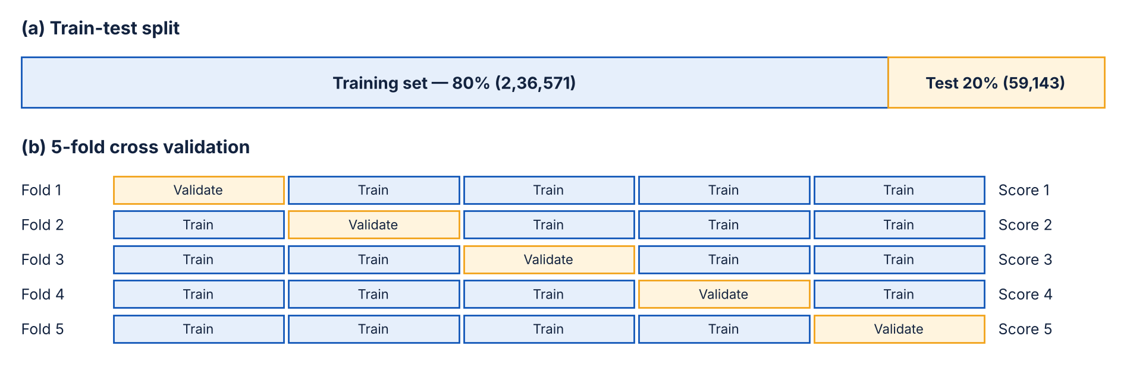
Figure 4.2: Train-test split and 5-fold cross validation scheme
CHAPTER 5

DATA CLEANING AND PRE-PROCESSING
Real-world data often contains irrelevant columns, missing values, duplicates and outliers that can reduce model performance. This chapter describes each cleaning step performed on the dataset.

5.1 Removing Unnecessary Columns
The column Unnamed: 0 is only a row index created while saving the file and carries no information about the flight. The column flight contains the flight code (for example SG-8709 or UK-995) and has 1,561 unique values. The airline information is already present in the airline column, and keeping such a high-cardinality identifier can make the model memorise individual flights instead of learning general patterns. Both columns were therefore dropped, leaving 10 columns.

5.2 Handling Missing Values
The dataset was checked for missing values in every column using the isnull() function. No missing values were found in any of the columns, so no imputation was needed.

5.3 Removing Duplicate Records
After dropping the index and flight code columns, some rows became exact copies of each other. A total of 2,213 duplicate rows were found and removed, because duplicates can bias the model and give an over-optimistic test score if the same record appears in both training and testing sets.

5.4 Checking Categorical Values
All the unique values of each categorical column were printed and checked for spelling mistakes, inconsistent case or invalid entries. All categories were found to be clean and consistent. It was also confirmed that no record has the same source and destination city.

5.5 Outlier Detection and Removal
Box plots were drawn for price, duration and days left to visually detect outliers (Figure 5.1).
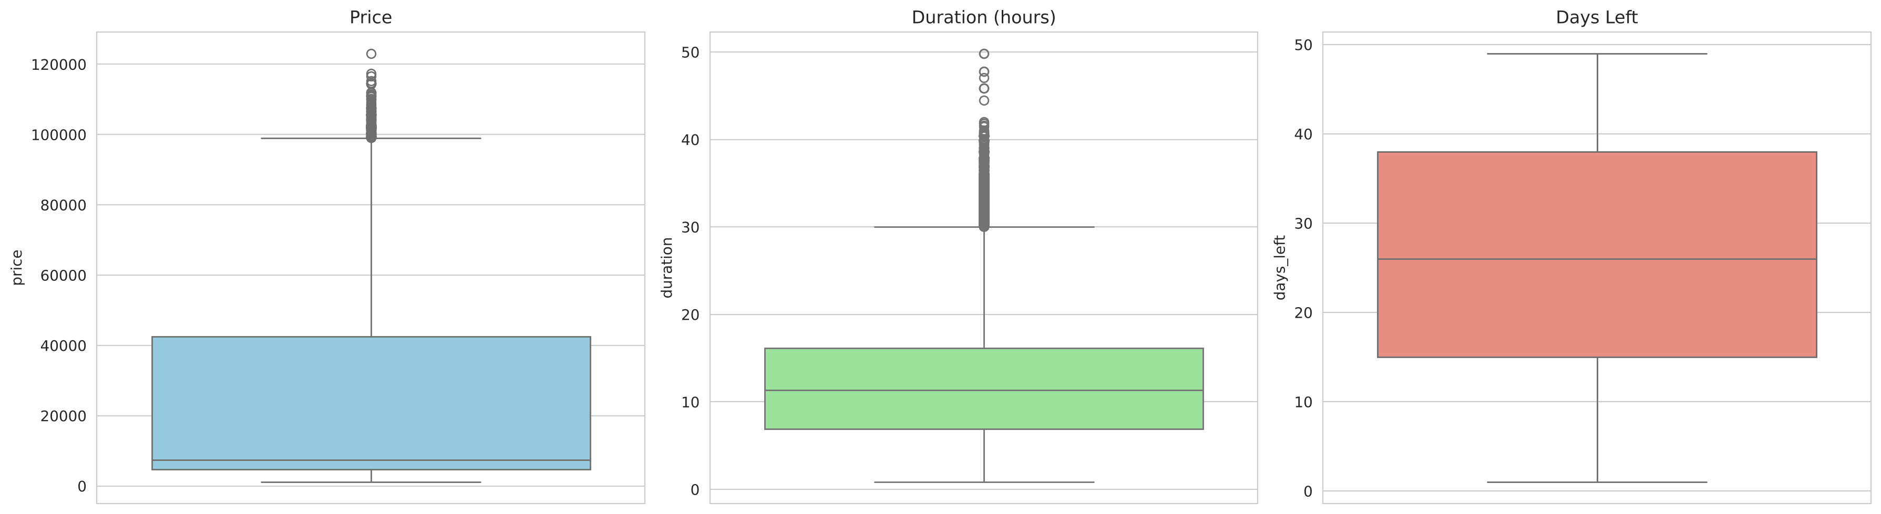
Figure 5.1: Box plots of price, duration and days left
The price column shows many points above the upper whisker. However, these high values belong to business class tickets and are genuine prices, not errors, so they were kept. The days left column has no outliers. The duration column has some extremely long journeys of more than 30 hours with multiple stops, which are rare and unusual. These were removed using the Inter-Quartile Range (IQR) method:
IQR = Q3 − Q1, Upper limit = Q3 + 1.5 × IQR
With Q1 = 6.83 hours and Q3 = 16.17 hours, the upper limit was found to be 30.05 hours. All 2,226 records with a duration greater than this limit were removed.

5.6 Summary of Data Cleaning
Table 5.1: Summary of data cleaning steps
Step | Action Taken | Rows Remaining
Original dataset | — | 3,00,153
Drop columns | Removed Unnamed: 0 and flight | 3,00,153
Missing values | None found | 3,00,153
Duplicates | Removed 2,213 duplicate rows | 2,97,940
Outliers (duration) | Removed 2,226 rows above 30.05 hours | 2,95,714

After cleaning, the final dataset contains 2,95,714 records and 10 columns, which was used for analysis and modelling.
CHAPTER 6

EXPLORATORY DATA ANALYSIS
Exploratory Data Analysis (EDA) helps in understanding the structure of the data, the distribution of variables and the relationships between the features and the target. The key analyses and their findings are presented in this chapter.

6.1 Distribution of Ticket Price
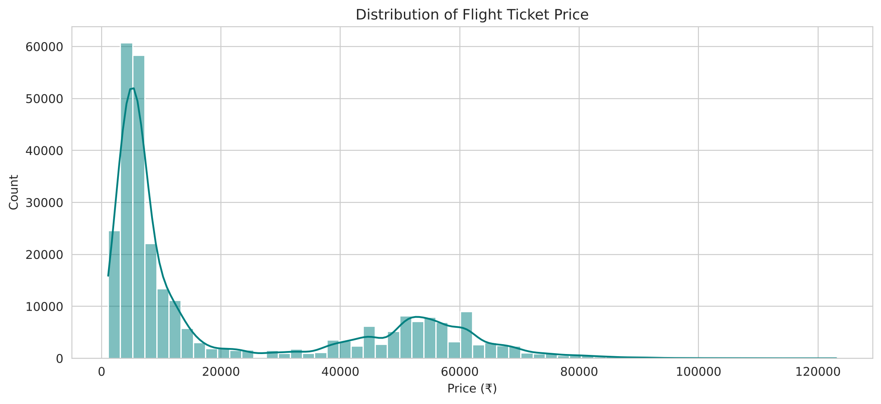
Figure 6.1: Distribution of flight ticket price
The price distribution is bimodal (it has two peaks). The first and larger peak lies between ₹2,000 and ₹15,000 and corresponds to economy class tickets, while the second peak between ₹40,000 and ₹70,000 corresponds to business class tickets. This shows that class is likely to be the single most important factor in deciding the price.

6.2 Economy vs Business Class
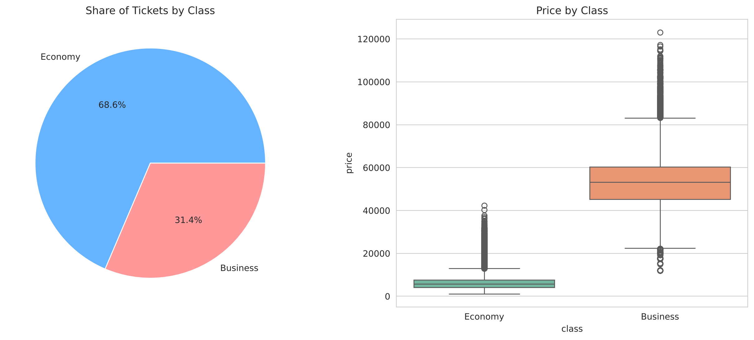
Figure 6.2: Share of tickets and price by class
About 69% of the tickets are economy and 31% are business class. The average economy fare is about ₹6,572 whereas the average business fare is about ₹52,540, which means business class tickets are roughly eight times costlier. The ranges also hardly overlap, confirming that class divides the data into two very different price groups.

6.3 Airline-wise Analysis
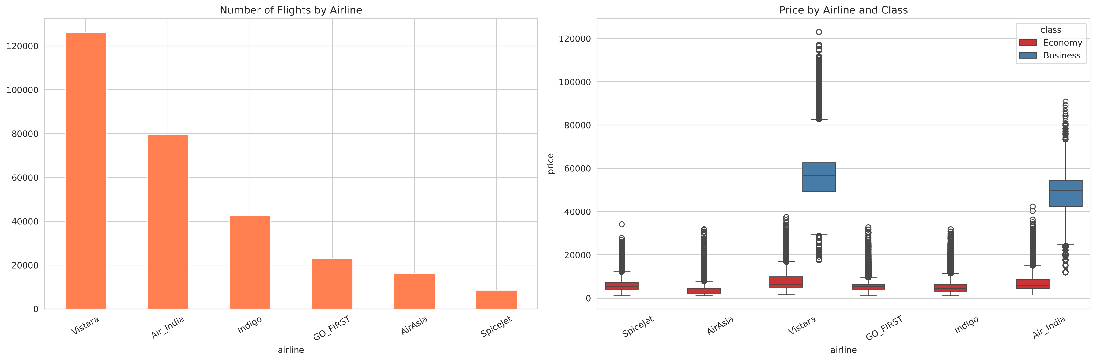
Figure 6.3: Number of flights and price by airline and class
Vistara and Air India operate the highest number of flights in the dataset and are the only airlines that offer business class. In economy class, AirAsia (₹4,091) and Indigo (₹5,324) are the cheapest on average, followed by GO FIRST and SpiceJet, while Vistara (₹7,807) and Air India (₹7,314) are the most expensive. Full-service carriers therefore charge more than low-cost carriers.
Table 6.1: Average economy fare by airline
Airline | Average Economy Fare (₹) | Type
AirAsia | 4,091 | Low-cost carrier
Indigo | 5,324 | Low-cost carrier
GO FIRST | 5,652 | Low-cost carrier
SpiceJet | 6,179 | Low-cost carrier
Air India | 7,314 | Full-service carrier
Vistara | 7,807 | Full-service carrier

6.4 Effect of Days Left before Departure
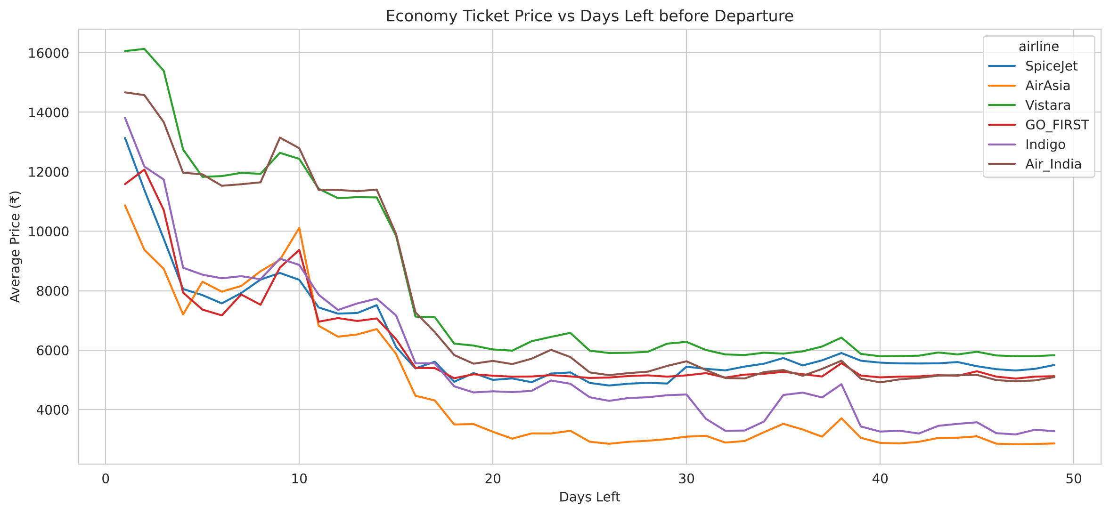
Figure 6.4: Economy ticket price vs days left before departure
This is one of the most important findings of the analysis. For all airlines, the fare stays fairly low and stable when the ticket is booked more than about 15–20 days in advance. As the departure date comes closer, prices rise steadily, and in the last 1–3 days they jump sharply. On average, economy tickets booked 1–3 days before travel cost about ₹13,808, compared to about ₹4,919 for tickets booked 31–49 days before — nearly 2.8 times more. This reflects the dynamic pricing strategy of airlines, which charge last-minute travellers (often business travellers) higher prices.
Table 6.2: Average economy fare by booking window
Days Left before Travel | Average Economy Fare (₹)
1–3 days | 13,808
4–7 days | 10,565
8–14 days | 10,048
15–30 days | 5,588
31–49 days | 4,919

6.5 Effect of Number of Stops
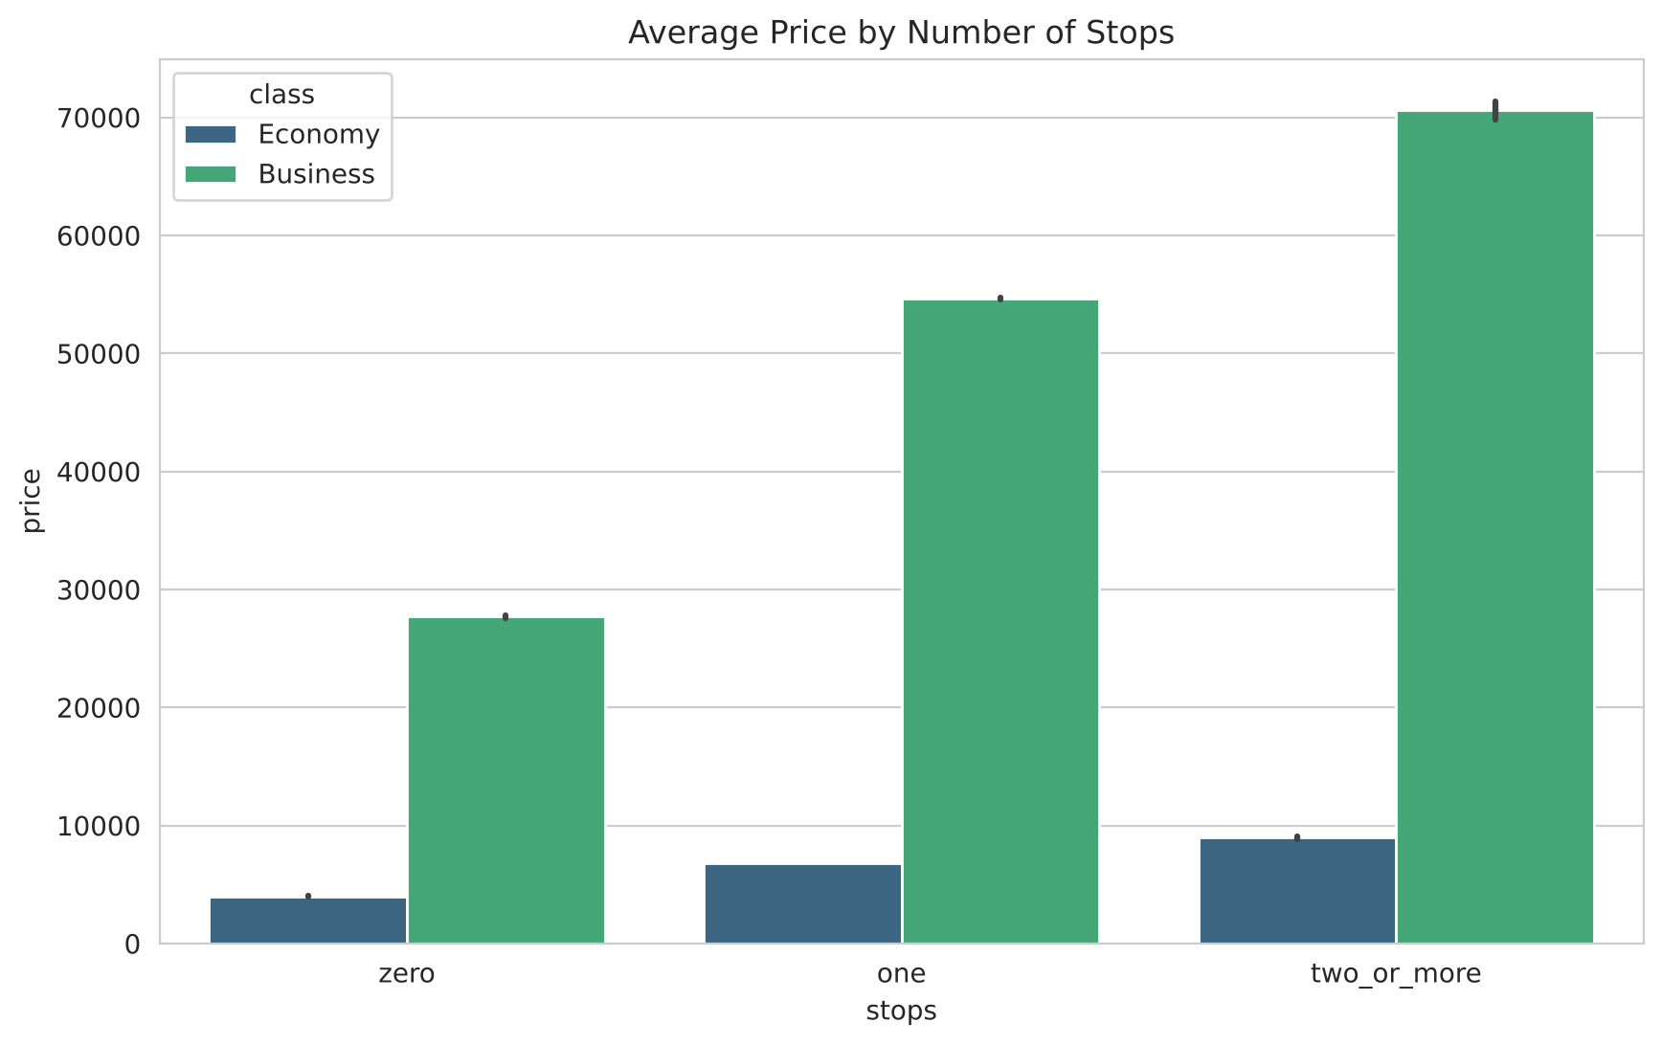
Figure 6.5: Average price by number of stops
Surprisingly, non-stop flights are the cheapest on average (about ₹4,013 in economy), while one-stop (₹6,813) and two-or-more-stop flights (₹9,142) are costlier. This is because non-stop routes are mostly served by low-cost carriers, while connecting itineraries are mostly sold by full-service airlines and combine the price of two flight segments.

6.6 Departure and Arrival Time
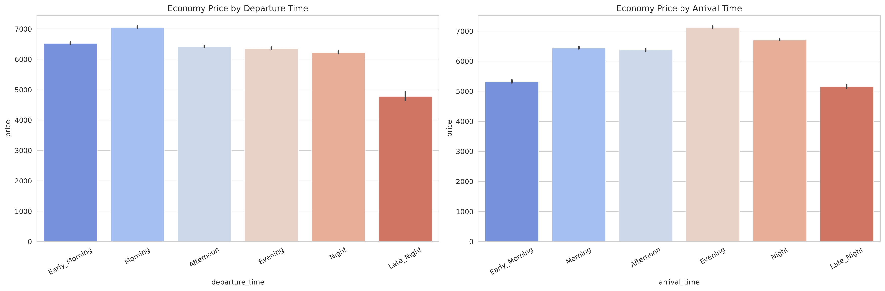
Figure 6.6: Economy price by departure and arrival time
Late night flights are clearly the cheapest, with an average economy fare of about ₹4,785, because they are less convenient for most passengers. Morning departures are the most expensive (about ₹7,119). The arrival time shows a similar pattern, with late night and early morning arrivals being cheaper.

6.7 Route-wise Analysis
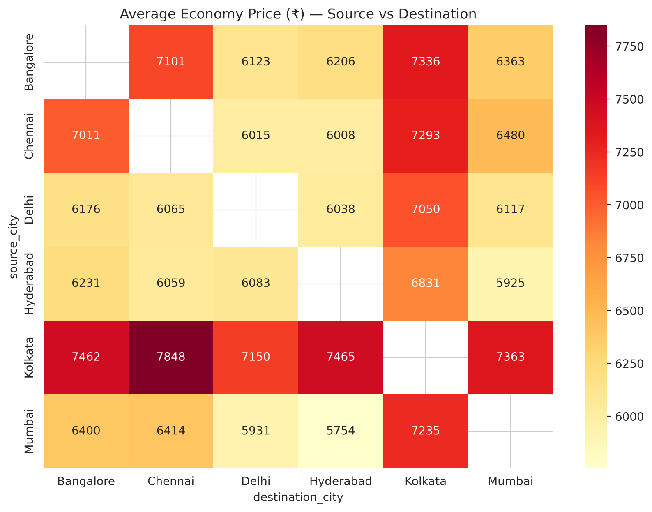
Figure 6.7: Average economy price by source and destination city
The heat map shows the average economy fare for each of the 30 routes. Routes starting from or ending at Delhi are generally the cheapest, likely due to high competition and frequency. Routes involving Chennai, Bangalore and Kolkata tend to be costlier. The fare between two cities is roughly similar in both directions.

6.8 Duration vs Price
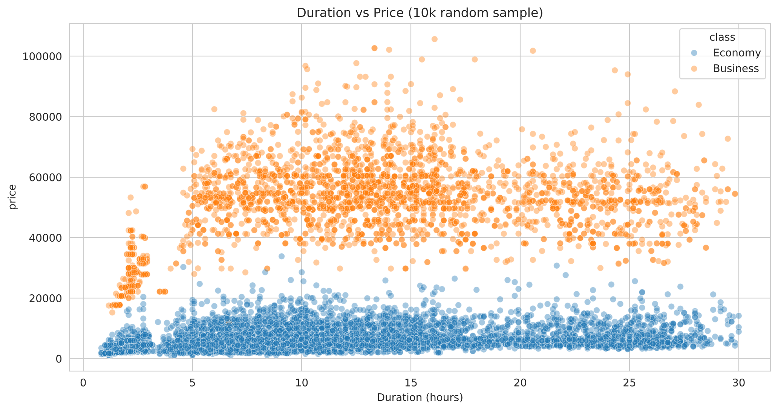
Figure 6.8: Duration vs price (random sample of 10,000 flights)
There is no simple straight-line relationship between duration and price. Within each class, prices vary widely for the same duration. Very short flights are mostly non-stop low-cost flights and are cheaper, while medium durations (connecting flights) show a wider spread. This non-linear behaviour suggests that tree-based models will perform better than linear models.

6.9 Airline Share and Effect of Stops by Airline
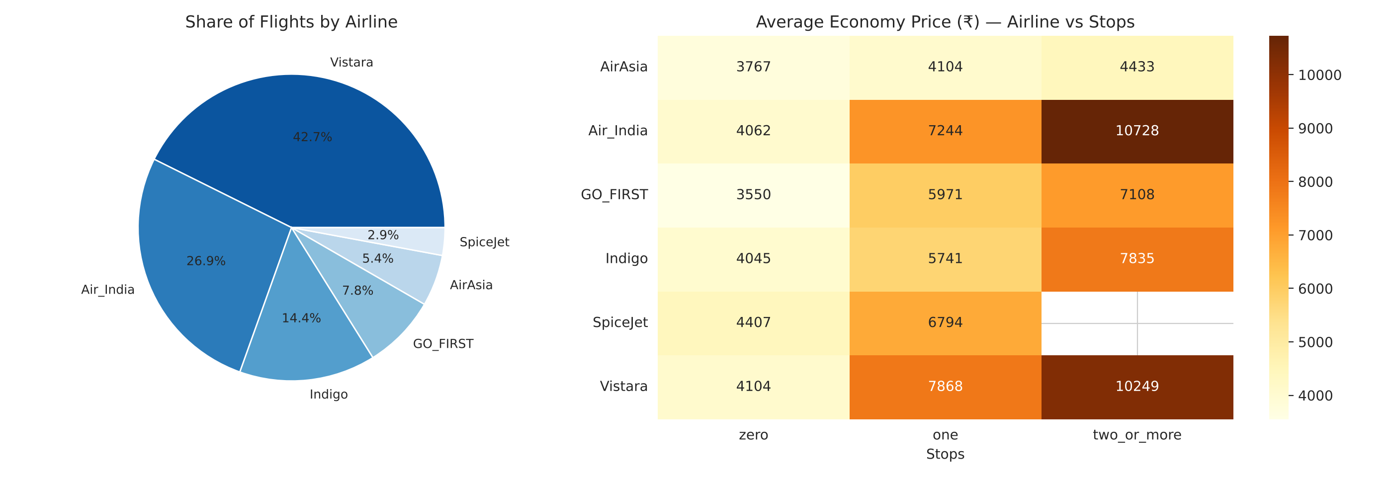
Figure 6.9: Share of flights by airline and average economy price by airline and stops
Vistara alone accounts for 42.7% of all flights and Air India for 26.9%, so the two full-service carriers dominate the dataset. The heat map shows that the extra cost of a stop depends strongly on the airline. For AirAsia, the average economy fare only rises from ₹3,767 (non-stop) to ₹4,433 (two or more stops), while for Air India it rises from ₹4,062 to ₹10,728 and for Vistara from ₹4,104 to ₹10,249. Non-stop fares are similar across all airlines (₹3,550–₹4,407), so most of the price difference between airlines comes from their connecting flights. SpiceJet does not operate any two-or-more-stop itineraries in the data.

6.10 Key Insights from EDA
- Class is the strongest factor — business fares are about 8 times economy fares.
- Booking early saves money — fares rise sharply in the last two weeks before departure.
- Low-cost carriers (AirAsia, Indigo) are cheaper than full-service carriers (Vistara, Air India).
- Non-stop and late night flights are generally the cheapest options.
- Route matters — Delhi routes are cheaper, while Chennai and Bangalore routes are costlier.
- Most relationships are non-linear, so advanced tree-based models are expected to perform best.
CHAPTER 7

FEATURE ENGINEERING
Machine learning models work with numbers, so all categorical attributes have to be converted into a numerical form. Different encoding techniques were chosen based on the nature of each attribute.

7.1 Binary Encoding of Class
The class attribute has only two values, so it was mapped directly to Economy = 0 and Business = 1.

7.2 Ordinal Encoding of Stops
The stops attribute has a natural order (zero < one < two or more). It was therefore encoded as zero = 0, one = 1 and two_or_more = 2, preserving this order.

7.3 One-Hot Encoding of Nominal Attributes
The attributes airline, source_city, destination_city, departure_time and arrival_time are nominal — their values have no natural order. Assigning numbers like 1, 2, 3 to them would wrongly suggest an order, so one-hot encoding was used. Each category becomes a separate binary column (0 or 1). To avoid the dummy variable trap (perfect multicollinearity) in linear models, the first category of each attribute was dropped using drop_first = True.
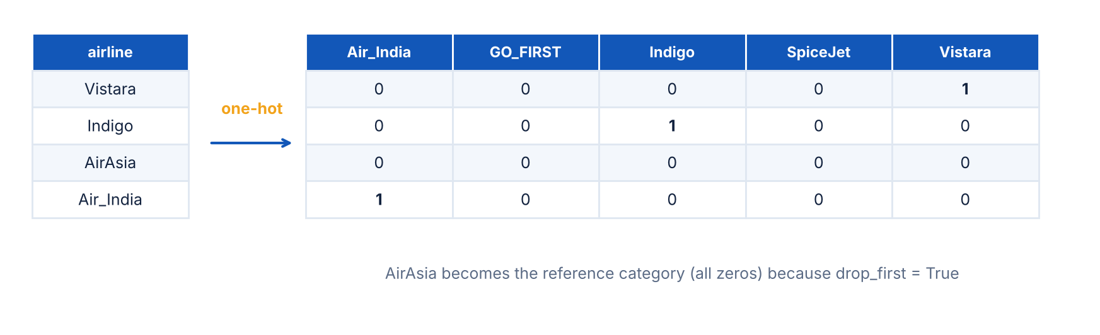
Figure 7.1: Example of one-hot encoding for the airline attribute
Table 7.1: Encoding applied to each attribute
Attribute | Encoding Technique | Resulting Columns
class | Binary (0 / 1) | 1
stops | Ordinal (0 / 1 / 2) | 1
airline | One-hot (drop first) | 5
source_city | One-hot (drop first) | 5
destination_city | One-hot (drop first) | 5
departure_time | One-hot (drop first) | 5
arrival_time | One-hot (drop first) | 5
duration | Kept as numeric | 1
days_left | Kept as numeric | 1
Total input features |  | 29

After encoding, the dataset had 30 columns — 29 input features and 1 target variable (price).

7.4 Correlation with Price
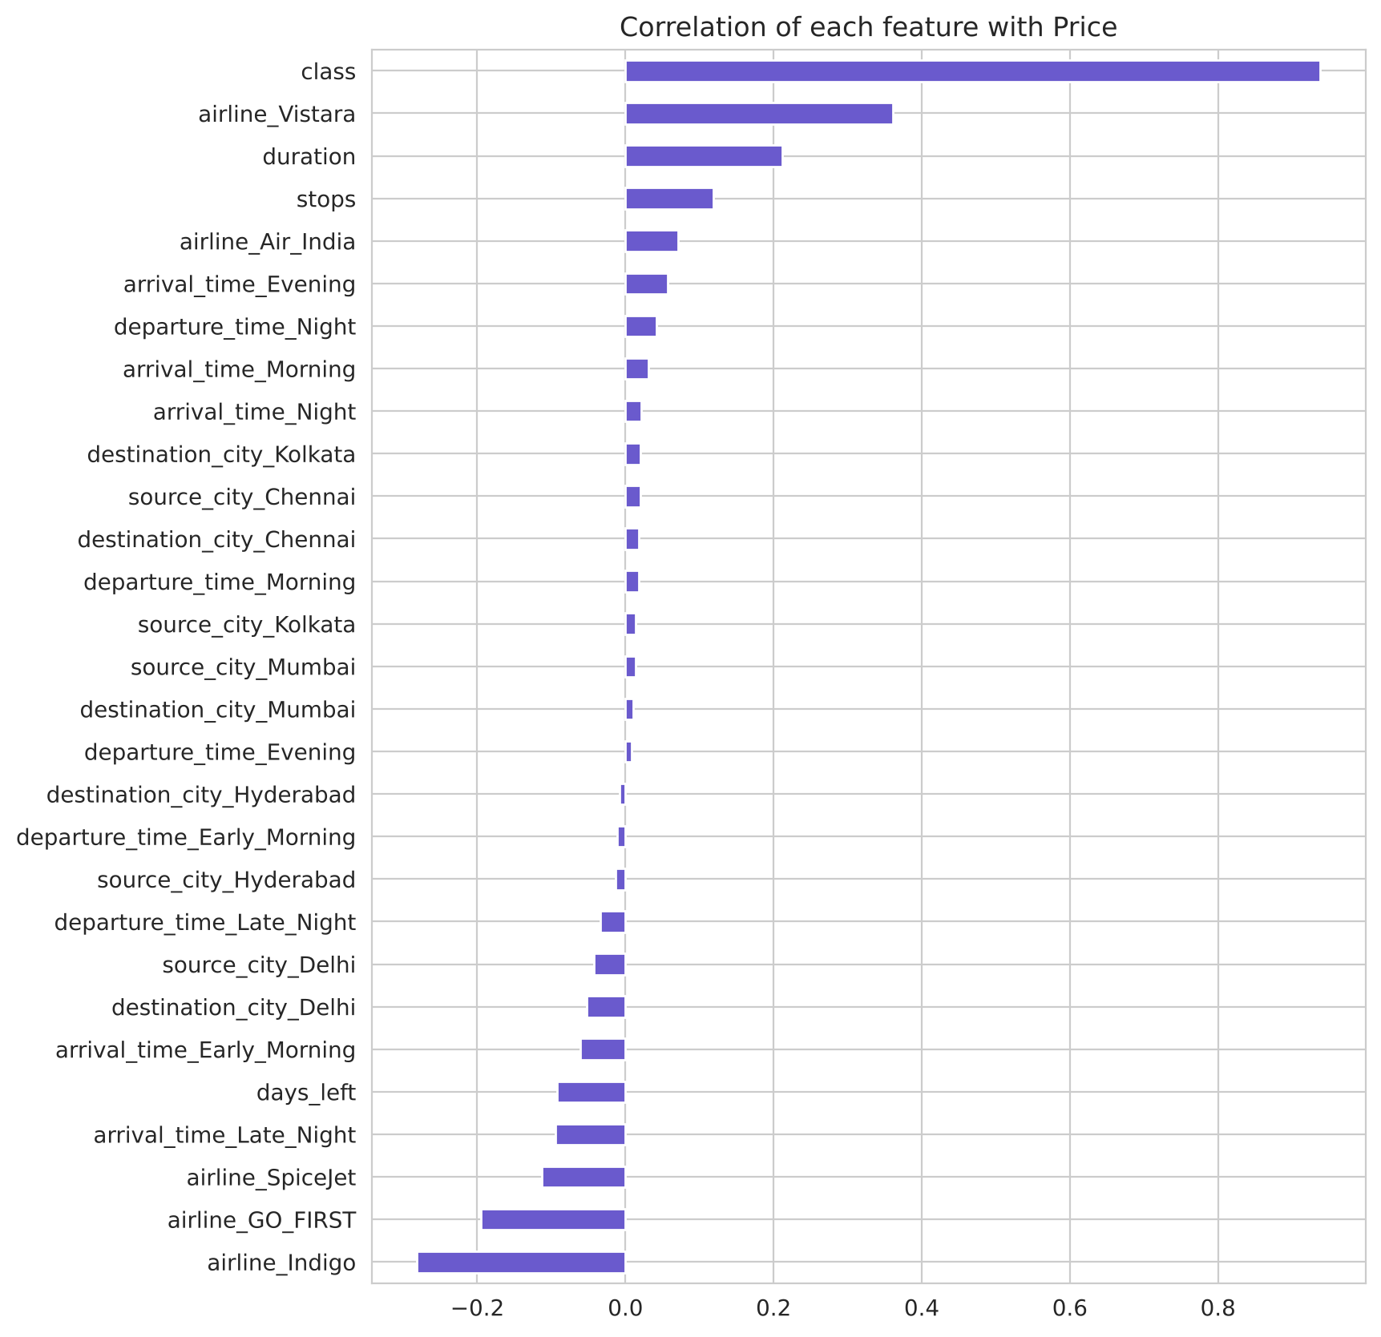
Figure 7.2: Correlation of each encoded feature with price
The correlation chart confirms the EDA findings. Class has an extremely high positive correlation (about 0.94) with price. Vistara and Air India have positive correlations, while AirAsia and Indigo are negatively correlated with price. Days left has a negative correlation, meaning that more days left leads to a lower price. Stops and duration show a moderate positive correlation.

7.5 Train-Test Split and Feature Scaling
The data was split into a training set of 80% (2,36,571 records) and a testing set of 20% (59,143 records) using train_test_split with random_state = 42 for reproducibility. The features were then standardised using StandardScaler, which transforms each feature to have zero mean and unit variance:
z = (x − μ) / σ
The scaler was fitted only on the training data and then applied to the test data, to avoid any information from the test set leaking into training. Scaling is important for Linear and Ridge Regression, while tree-based models are not affected by it.
CHAPTER 8

MODEL BUILDING
Five regression algorithms were selected so that the comparison covers simple linear models, a single tree model and two powerful ensemble models. This chapter explains how each algorithm works and the settings used.

8.1 Linear Regression
Linear Regression is the simplest regression technique. It assumes that the target is a linear combination of the input features and finds the coefficients that minimise the sum of squared errors (Ordinary Least Squares).
ŷ = β₀ + β₁x₁ + β₂x₂ + … + βₙxₙ
It is fast, easy to interpret and serves as a good baseline model. However, it cannot capture non-linear relationships or interactions between features unless they are explicitly created.

8.2 Ridge Regression
Ridge Regression is a regularised version of linear regression. It adds an L2 penalty on the size of the coefficients to the loss function, which reduces overfitting and handles multicollinearity among features.
Loss = Σ (yᵢ − ŷᵢ)² + α Σ βⱼ²
Here α controls the strength of regularisation. A value of α = 1.0 was used. Like linear regression, Ridge remains a linear model.

8.3 Decision Tree Regressor
A Decision Tree splits the data into smaller and smaller groups by asking a series of yes/no questions on the features (for example, "Is class = Business?" or "Is days_left < 15?"). At each node, the split that most reduces the variance (mean squared error) of the target is chosen. The prediction at a leaf is the average price of the training samples in that leaf.
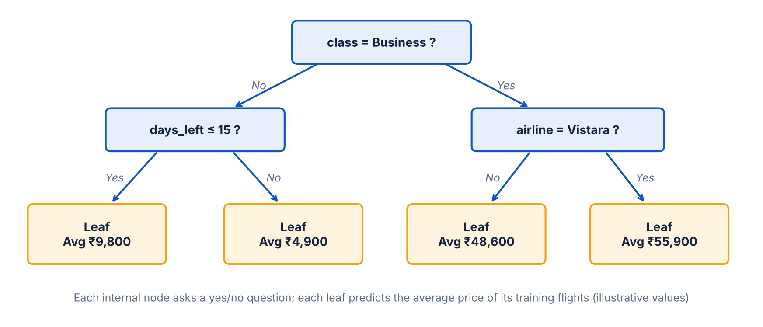
Figure 8.1: Structure of a regression decision tree (illustrative)
Decision trees can model non-linear relationships and interactions naturally and are easy to visualise. However, a single deep tree can easily overfit. To control this, the tree depth was limited to 20 and each leaf had to contain at least 5 samples.

8.4 Random Forest Regressor
Random Forest is an ensemble of many decision trees built using bagging (bootstrap aggregation). Each tree is trained on a random sample of the training data, and at each split only a random subset of features is considered. The final prediction is the average of all trees.
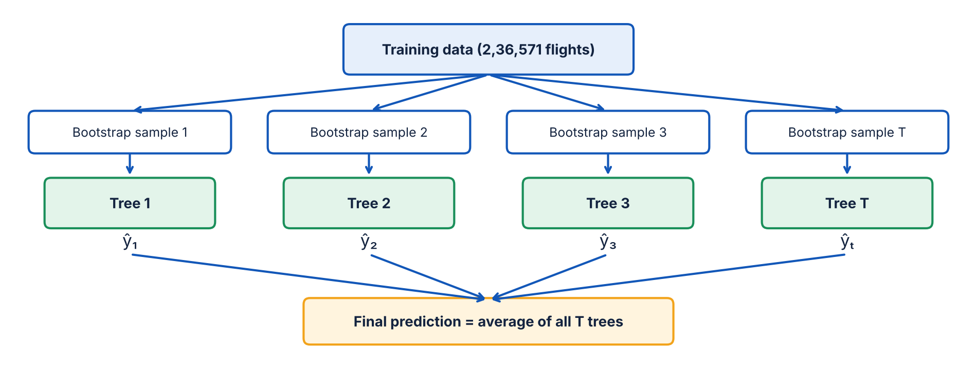
Figure 8.2: Working of the Random Forest (bagging) regressor
ŷ = (1/T) Σ ŷₜ , t = 1 … T
Averaging many different trees reduces variance and overfitting, giving much more stable and accurate predictions than a single tree. A forest of 60 trees with a maximum depth of 25 and a minimum of 2 samples per leaf was used.

8.5 XGBoost Regressor
XGBoost (Extreme Gradient Boosting) is also an ensemble of decision trees, but the trees are built sequentially using boosting. Each new tree is trained to correct the errors (residuals) made by the previous trees. The final prediction is the sum of the predictions of all trees, each scaled by a learning rate η.
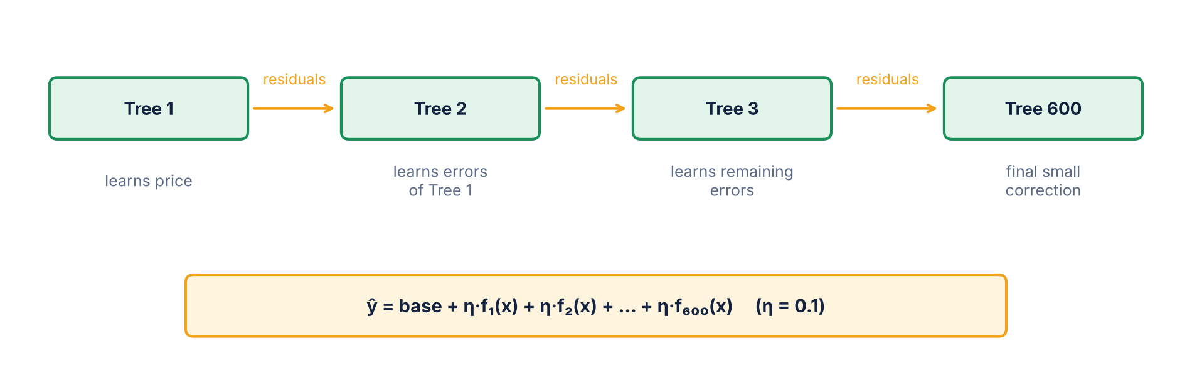
Figure 8.3: Sequential boosting in XGBoost — each tree corrects the previous errors
ŷ⁽ᵗ⁾ = ŷ⁽ᵗ⁻¹⁾ + η · fₜ(x)
XGBoost also includes regularisation terms in its objective function, handles large datasets efficiently and uses second-order gradient information for faster convergence. It is widely regarded as one of the best algorithms for tabular data. 600 trees with a learning rate of 0.1 and a maximum depth of 8 were used.

8.6 Hyperparameters Used
Table 8.1: Hyperparameters of the five models
Model | Library | Key Hyperparameters
Linear Regression | scikit-learn | Default (ordinary least squares)
Ridge Regression | scikit-learn | alpha = 1.0
Decision Tree | scikit-learn | max_depth = 20, min_samples_leaf = 5
Random Forest | scikit-learn | n_estimators = 60, max_depth = 25, min_samples_leaf = 2
XGBoost | xgboost | n_estimators = 600, learning_rate = 0.1, max_depth = 8

All models used random_state = 42 wherever applicable so that the results can be reproduced. Each model was trained on the scaled training data and then used to predict prices for the test data.
CHAPTER 9

RESULTS AND DISCUSSION

9.1 Model Comparison Table
The performance of all five models on the test set of 59,143 flights is shown in Table 9.1. The models are ranked by their test R² score.
Table 9.1: Performance comparison of the five regression models
Rank | Model | Train R² | Test R² (Accuracy) | MSE | RMSE (₹) | MAE (₹)
1 | XGBoost | 0.9909 | 0.9874 (98.74%) | 65,38,317 | 2,557 | 1,342
2 | Random Forest | 0.9941 | 0.9864 (98.64%) | 70,46,288 | 2,654 | 1,119
3 | Decision Tree | 0.9869 | 0.9811 (98.11%) | 97,88,739 | 3,129 | 1,419
4 | Linear Regression | 0.9102 | 0.9096 (90.96%) | 4,67,61,203 | 6,838 | 4,536
5 | Ridge Regression | 0.9102 | 0.9096 (90.96%) | 4,67,61,199 | 6,838 | 4,536

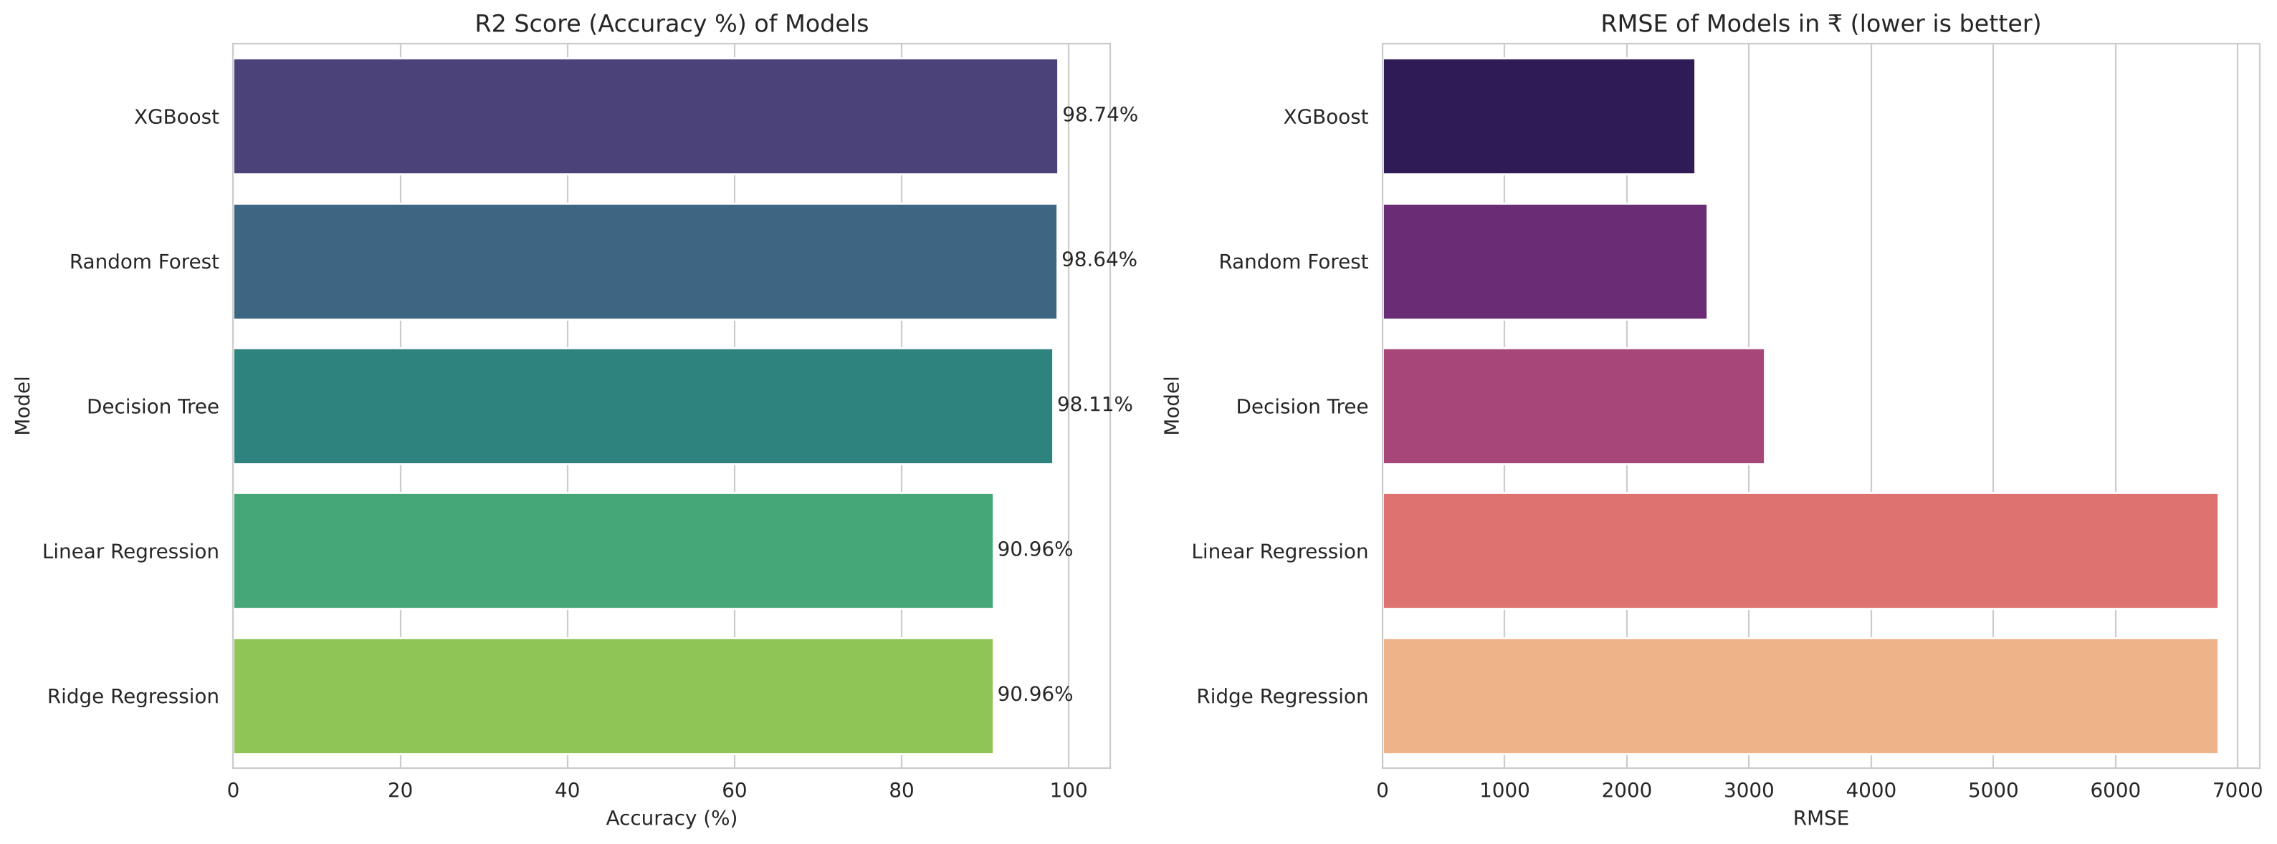
Figure 9.1: R² score (accuracy) and RMSE of the five models

9.2 Discussion of Results

9.2.1 Linear and Ridge Regression
Both linear models achieved an R² of 0.9096, meaning they explain about 91% of the variation in price. This is mainly because the class feature alone separates economy and business fares very well. However, their RMSE of ₹6,838 and MAE of ₹4,536 are very high compared to the average economy fare of about ₹6,500. Ridge Regression gave almost identical results to Linear Regression, because the dataset is large and the features are not heavily collinear, so regularisation has little effect. The train and test scores are almost equal, which means these models are underfitting — they are too simple to capture the non-linear effects of days left, duration and route.

9.2.2 Decision Tree
The Decision Tree improved the R² to 0.9811 and reduced the RMSE by more than half to ₹3,129. This shows the benefit of modelling non-linear relationships and interactions such as "business class on Vistara booked within 3 days".

9.2.3 Random Forest
Random Forest achieved an R² of 0.9864 and the lowest MAE of ₹1,119, meaning its typical error is the smallest. Its training R² (0.9941) is slightly higher than the test R², indicating mild overfitting, but the test performance is still excellent.

9.2.4 XGBoost
XGBoost gave the best overall performance, with the highest test R² of 0.9874 and the lowest MSE (65,38,317) and RMSE (₹2,557). The gap between its training and test R² is the smallest among the tree models (0.0035), showing good generalisation. Since RMSE penalises large errors more, XGBoost's lowest RMSE shows that it makes fewer large mistakes, especially on expensive business class tickets. It was therefore selected as the final model.

9.3 Cross Validation Results
Table 9.2: 5-fold cross validation R² scores (50,000-record sample)
Model | Mean CV R² | Standard Deviation
Linear Regression | 0.9098 | 0.0018
Ridge Regression | 0.9098 | 0.0018
Decision Tree | 0.9695 | 0.0012
Random Forest | 0.9785 | 0.0011
XGBoost | 0.9795 | 0.0009

The cross validation scores follow the same ranking as the test scores, with XGBoost again at the top. The standard deviations are very small (below 0.002), showing that the models perform consistently across different subsets of the data. The CV scores of the tree models are slightly lower than their test scores only because they were trained on a smaller sample of 50,000 records instead of the full training set.

9.4 Actual vs Predicted Prices
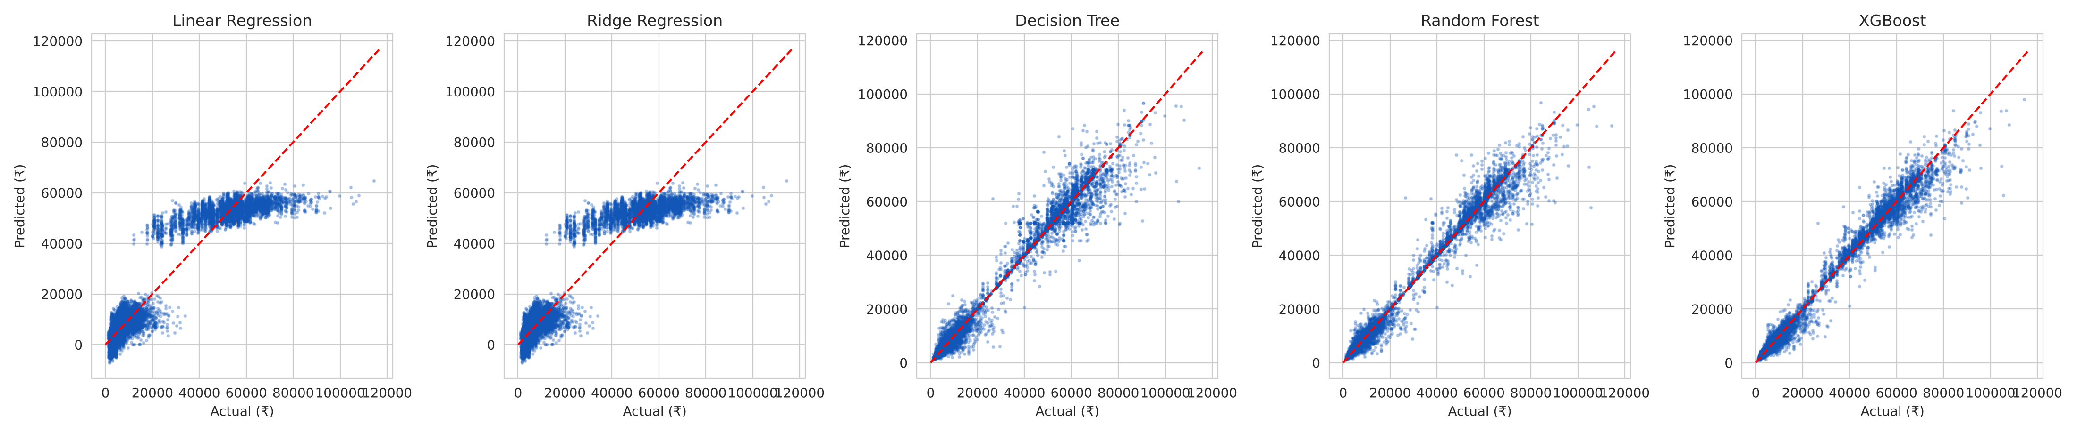
Figure 9.2: Actual vs predicted prices for all five models
In Figure 9.2, each point is a test flight and the red dashed line represents perfect prediction. For the linear models the points are widely scattered, and some predictions are even negative for cheap economy flights. The tree-based models have points tightly clustered around the line for both economy and business classes.
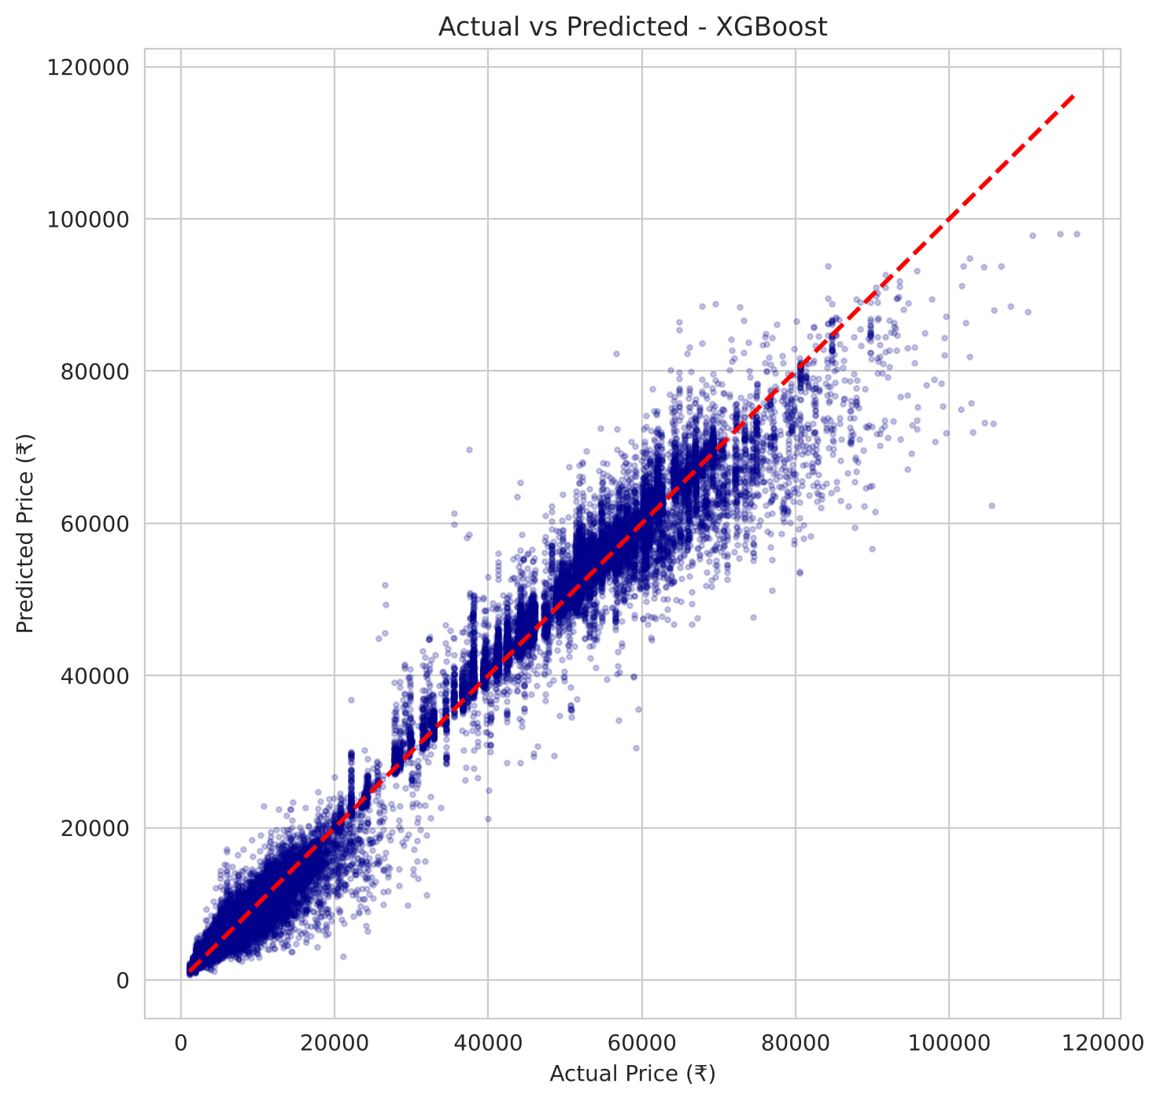
Figure 9.3: Actual vs predicted prices — XGBoost

9.5 Residual Analysis
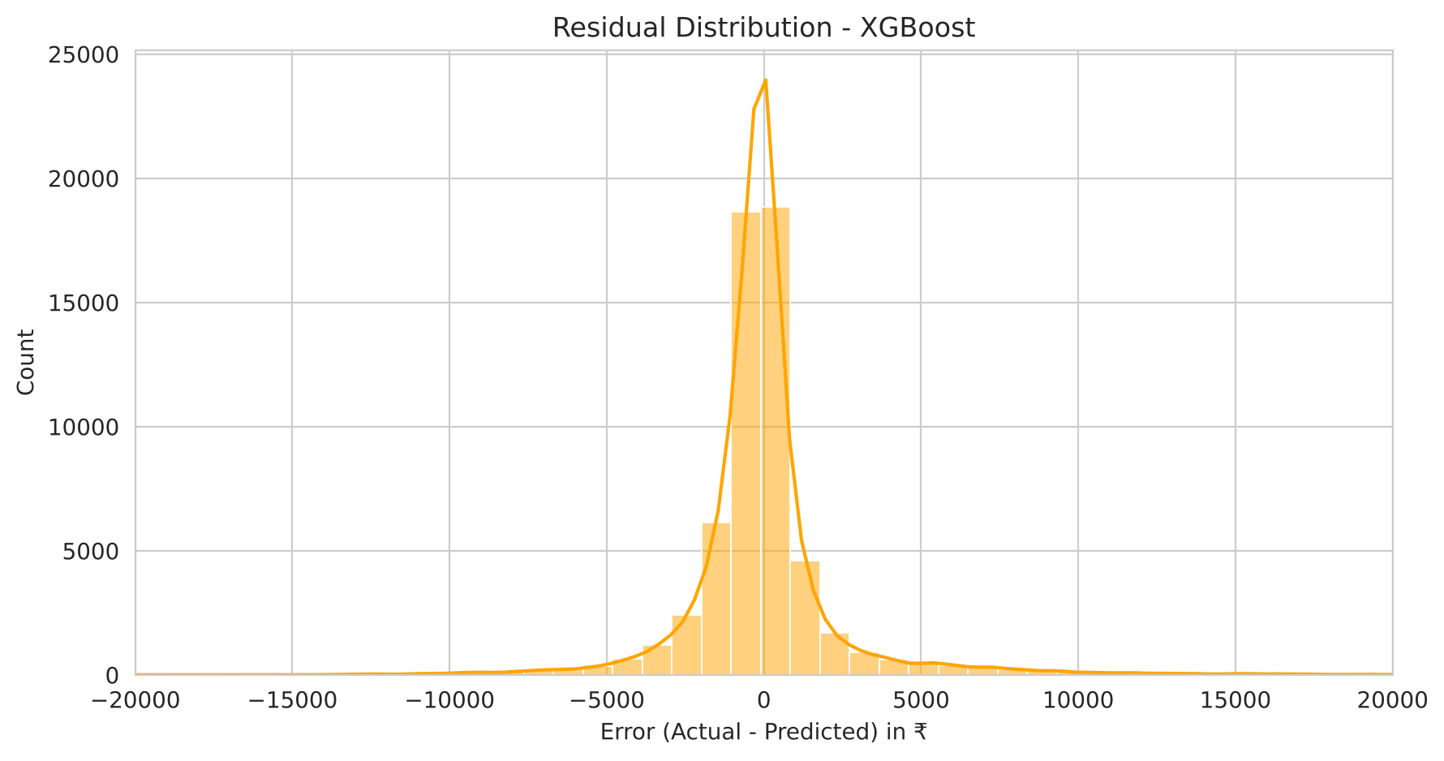
Figure 9.4: Distribution of residuals — XGBoost
The residuals (actual minus predicted price) of XGBoost are centred around zero and follow a roughly symmetric, bell-shaped distribution. Most errors lie within ±₹2,500. This indicates that the model has no systematic bias of over- or under-predicting prices.

9.6 Feature Importance
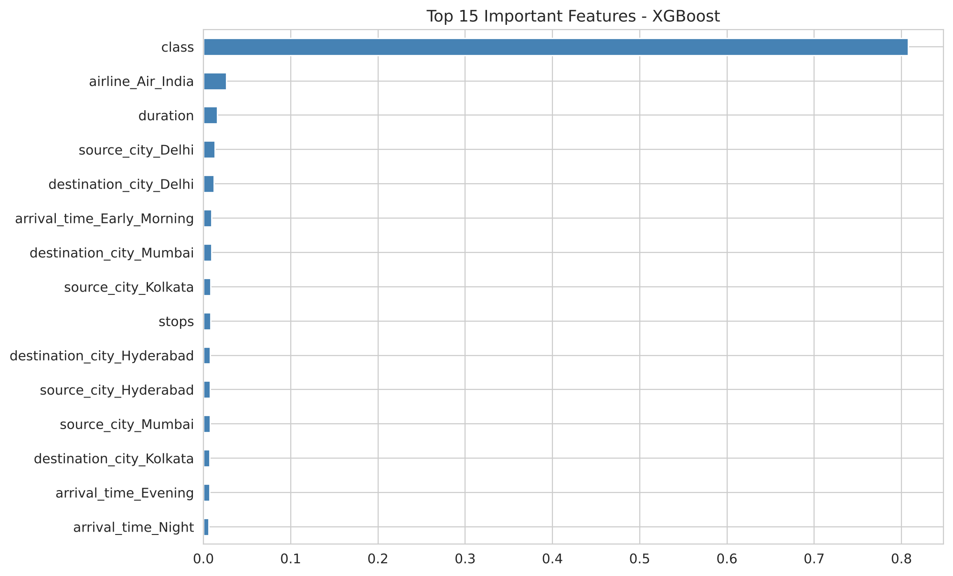
Figure 9.5: Top 15 important features — XGBoost
According to XGBoost, class is by far the most important feature, followed by airline (especially Vistara and Air India), the source and destination cities, days left, duration and stops. This matches the findings of the EDA and the correlation analysis.

9.7 Sample Predictions
Table 9.3: Sample predictions of the XGBoost model on test data
S. No. | Actual Price (₹) | Predicted Price (₹) | Difference (₹)
1 | 4,629 | 5,127 | −498
2 | 12,166 | 11,778 | 388
3 | 2,022 | 2,671 | −649
4 | 2,150 | 2,150 | 0
5 | 60,260 | 61,120 | −860
6 | 2,250 | 2,772 | −522
7 | 50,271 | 50,231 | 40
8 | 74,844 | 71,792 | 3,052

The predicted prices are very close to the actual prices for both cheap economy tickets and expensive business tickets, which confirms the high accuracy of the model.

9.8 Detailed Error Analysis

9.8.1 Train, Test and Cross-Validation Scores
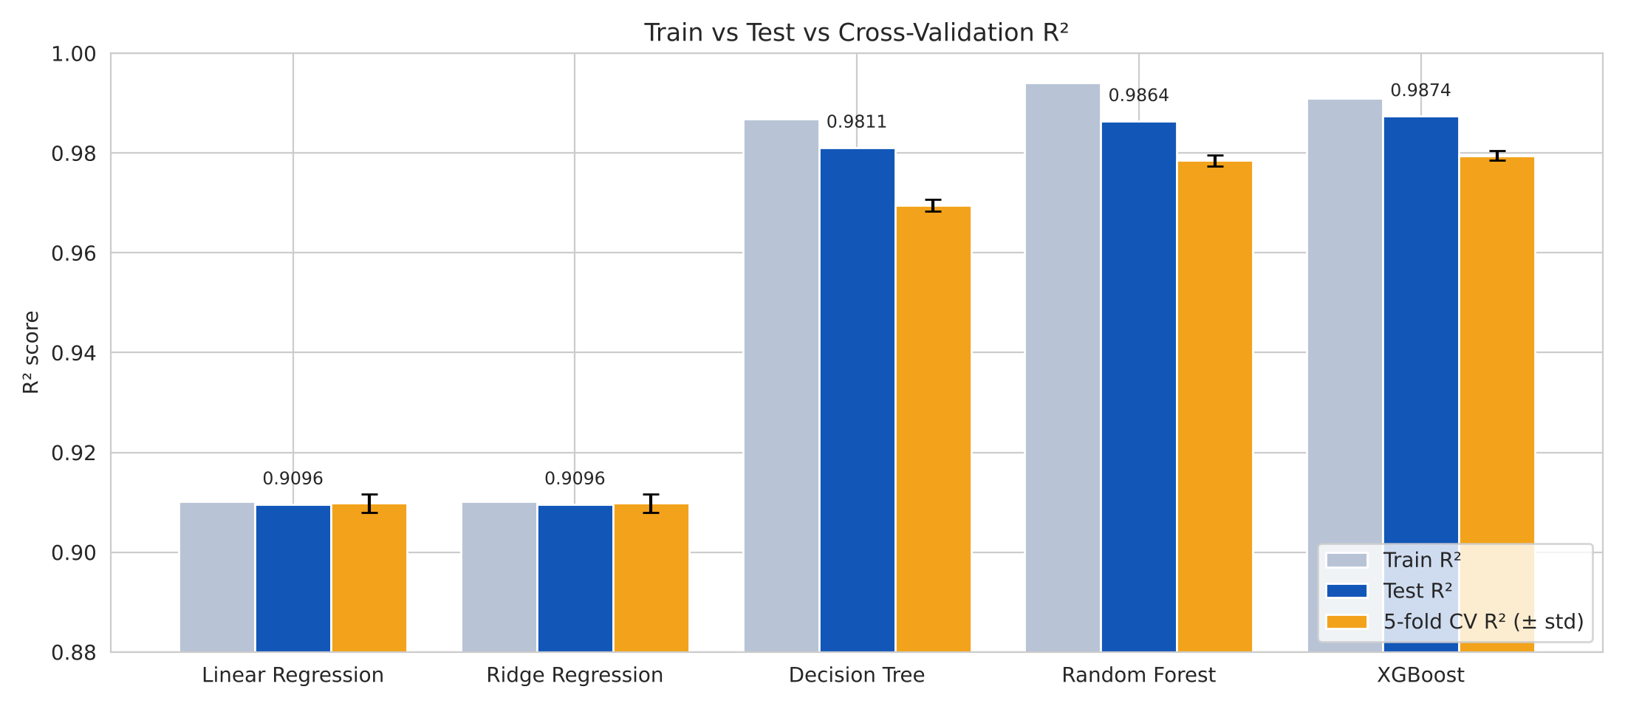
Figure 9.6: Train, test and 5-fold cross-validation R² of the five models
Figure 9.6 places the three R² measures side by side. For the linear models all three bars are almost equal (about 0.91), which confirms underfitting rather than overfitting. The Decision Tree shows the largest drop from training (0.9869) to cross validation (0.9695), indicating that a single tree overfits the most. XGBoost has the highest test and CV scores and the smallest error bar, which makes it the most reliable model.

9.8.2 Error by Class of Travel
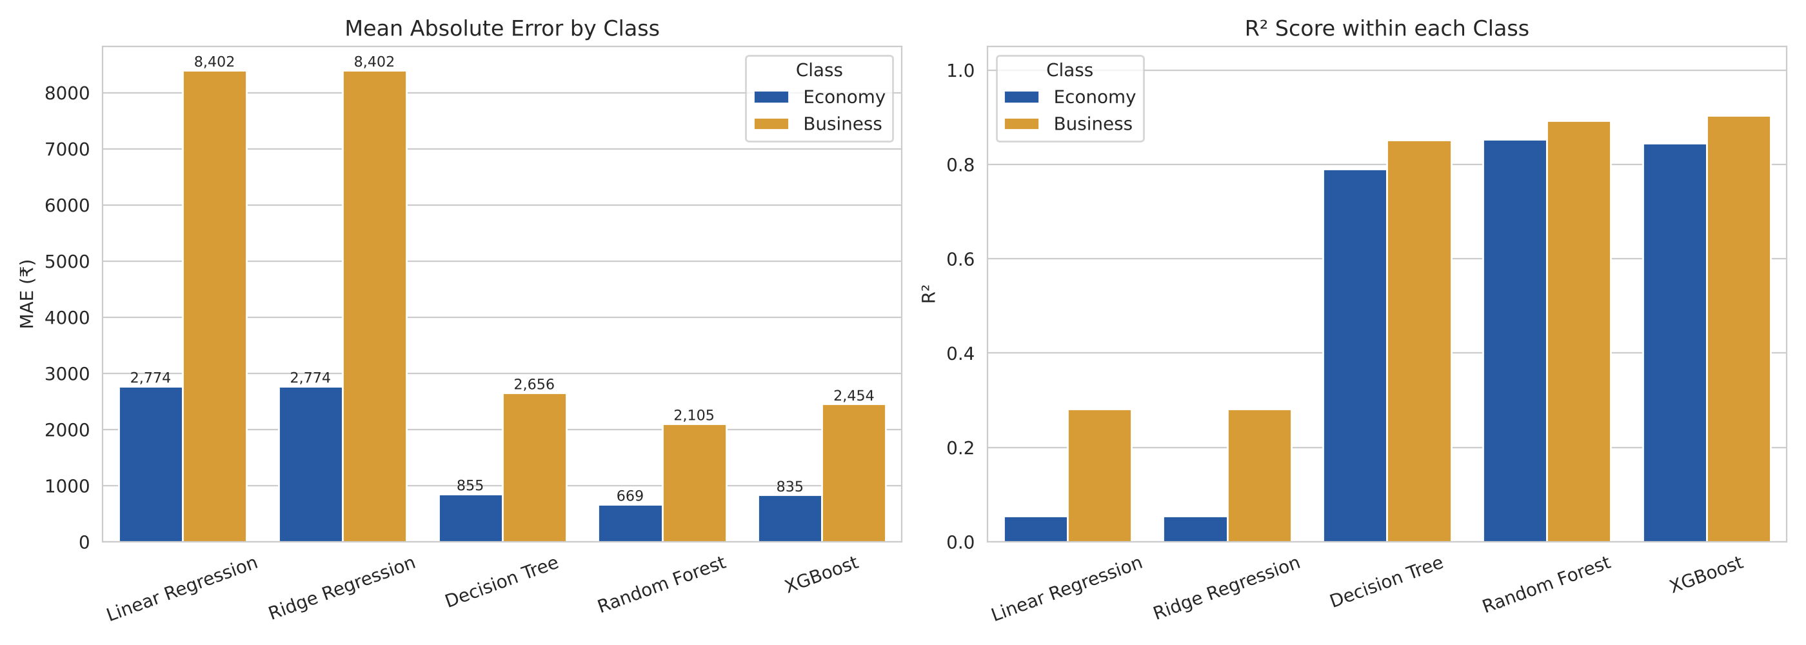
Figure 9.7: MAE and R² of each model computed separately for Economy and Business class
The overall R² of above 0.90 can hide weak performance inside each class, because the large gap between economy and business fares is easy to learn. When the R² is computed within each class separately, the linear models score only 0.05 for Economy and 0.28 for Business — they mainly separate the two classes and learn very little about the price inside a class. The tree-based models explain 79–85% of the variation within economy and 85–90% within business fares. Random Forest has the lowest MAE in both classes (₹669 economy, ₹2,105 business), while XGBoost has the best within-business R² (0.9037). Business class errors are larger in rupees for every model because business fares are about eight times higher.

9.8.3 XGBoost Learning Curve
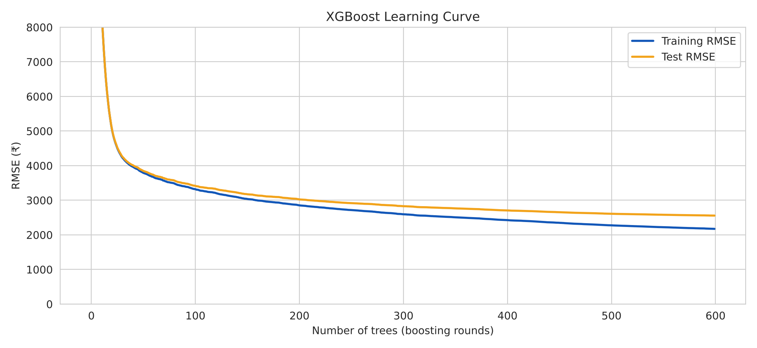
Figure 9.8: Training and test RMSE of XGBoost as more trees are added
The learning curve shows how the error of XGBoost falls as boosting rounds are added. The test RMSE drops very quickly in the first 50 trees (to about ₹3,865), reaches about ₹3,421 at 100 trees and ₹2,830 at 300 trees, and keeps improving slowly up to ₹2,557 at 600 trees. The training and test curves stay close together throughout, with a final gap of only about ₹380, so adding more trees has not caused harmful overfitting.

9.8.4 Residuals vs Predicted Values
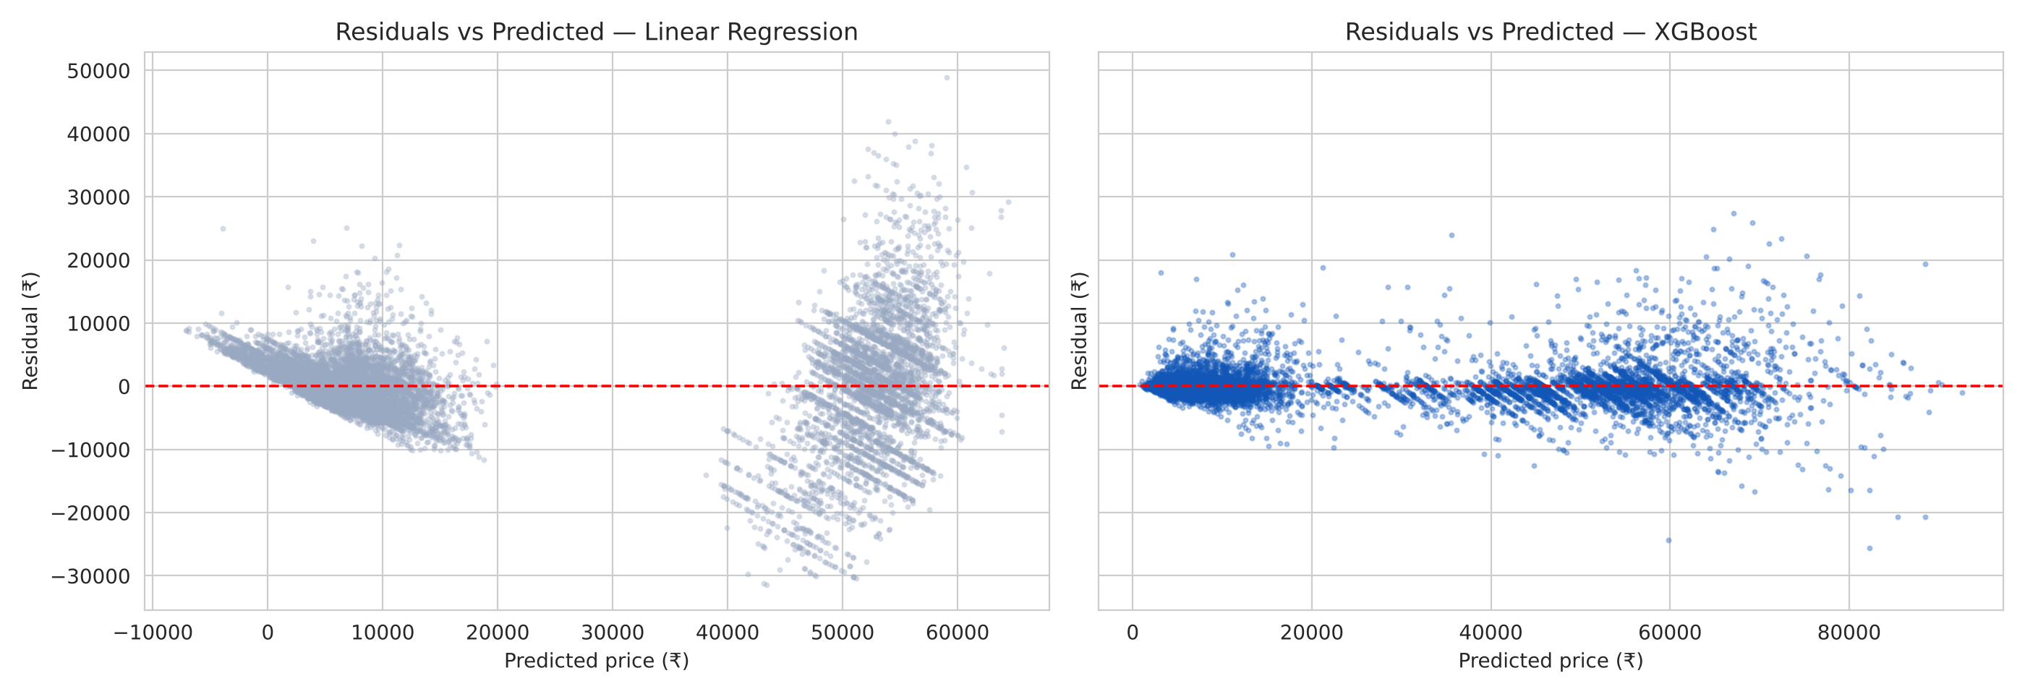
Figure 9.9: Residuals against predicted price — Linear Regression vs XGBoost
For Linear Regression the residuals form clear sloping bands and are spread up to ±₹30,000; the model even predicts negative prices for some cheap economy flights. This pattern shows that the model is missing important non-linear structure. For XGBoost the residuals are tightly centred around zero across the full price range, with no visible pattern, which is what a well-fitted regression model should look like.

9.8.5 Error by Booking Window
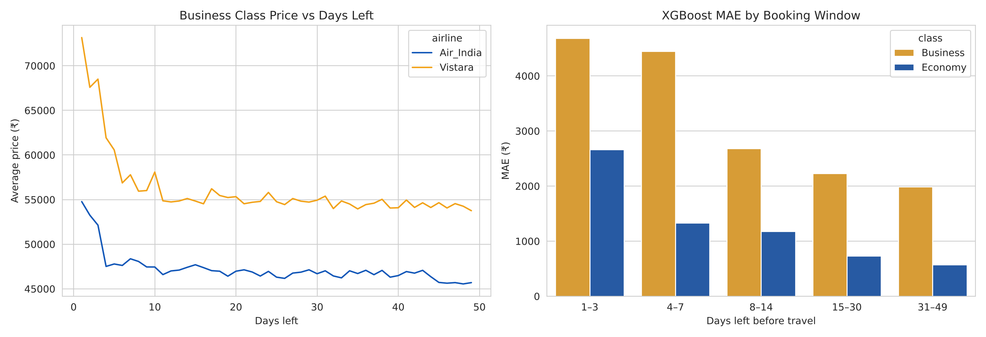
Figure 9.10: Business class price vs days left (left) and XGBoost MAE by booking window (right)
Business fares also rise sharply in the last few days before departure — Vistara business fares climb from about ₹54,000 to over ₹70,000 in the final week. These last-minute fares are the hardest to predict: the XGBoost MAE for business class is about ₹4,685 for 1–3 days before travel but only ₹1,991 for 31–49 days. For economy class the MAE falls from ₹2,662 to just ₹571. Prices close to departure are more volatile because airlines change them frequently based on the remaining seats, which are not available in the dataset.
CHAPTER 10

WEB-BASED DEMONSTRATION
To make the model useful and easy to demonstrate, an interactive web page named FareCast India was developed. It allows any user to enter flight details and instantly see the predicted ticket price.

10.1 Model Export
An XGBoost model with 300 trees (maximum depth 8) was trained on the same cleaned and encoded data; it achieved a test R² of 0.9845. Since tree models do not require feature scaling, this model was trained on unscaled features. All the trees — split features, thresholds and leaf values — were exported into a compact JSON file (model.json, about 1.9 MB). A small JavaScript function walks through every tree for the given input and adds up the leaf values, exactly reproducing the predictions of the Python model (maximum difference below ₹0.1). As a result, the prediction runs entirely in the browser without needing any server.
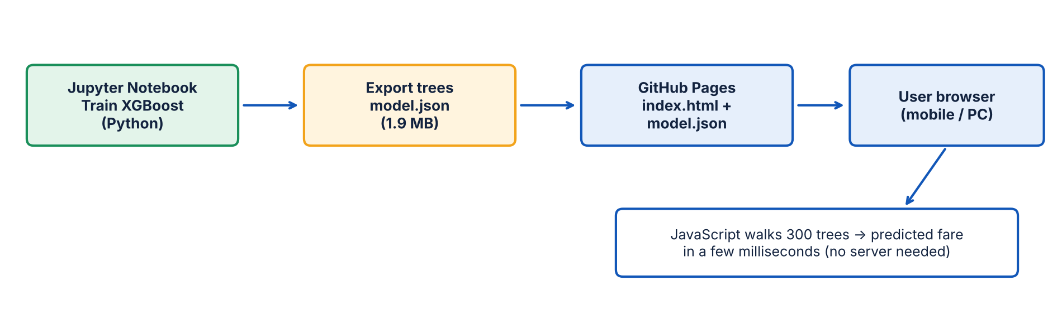
Figure 10.1: Architecture of the web-based demonstration

10.2 Features of the Web Page
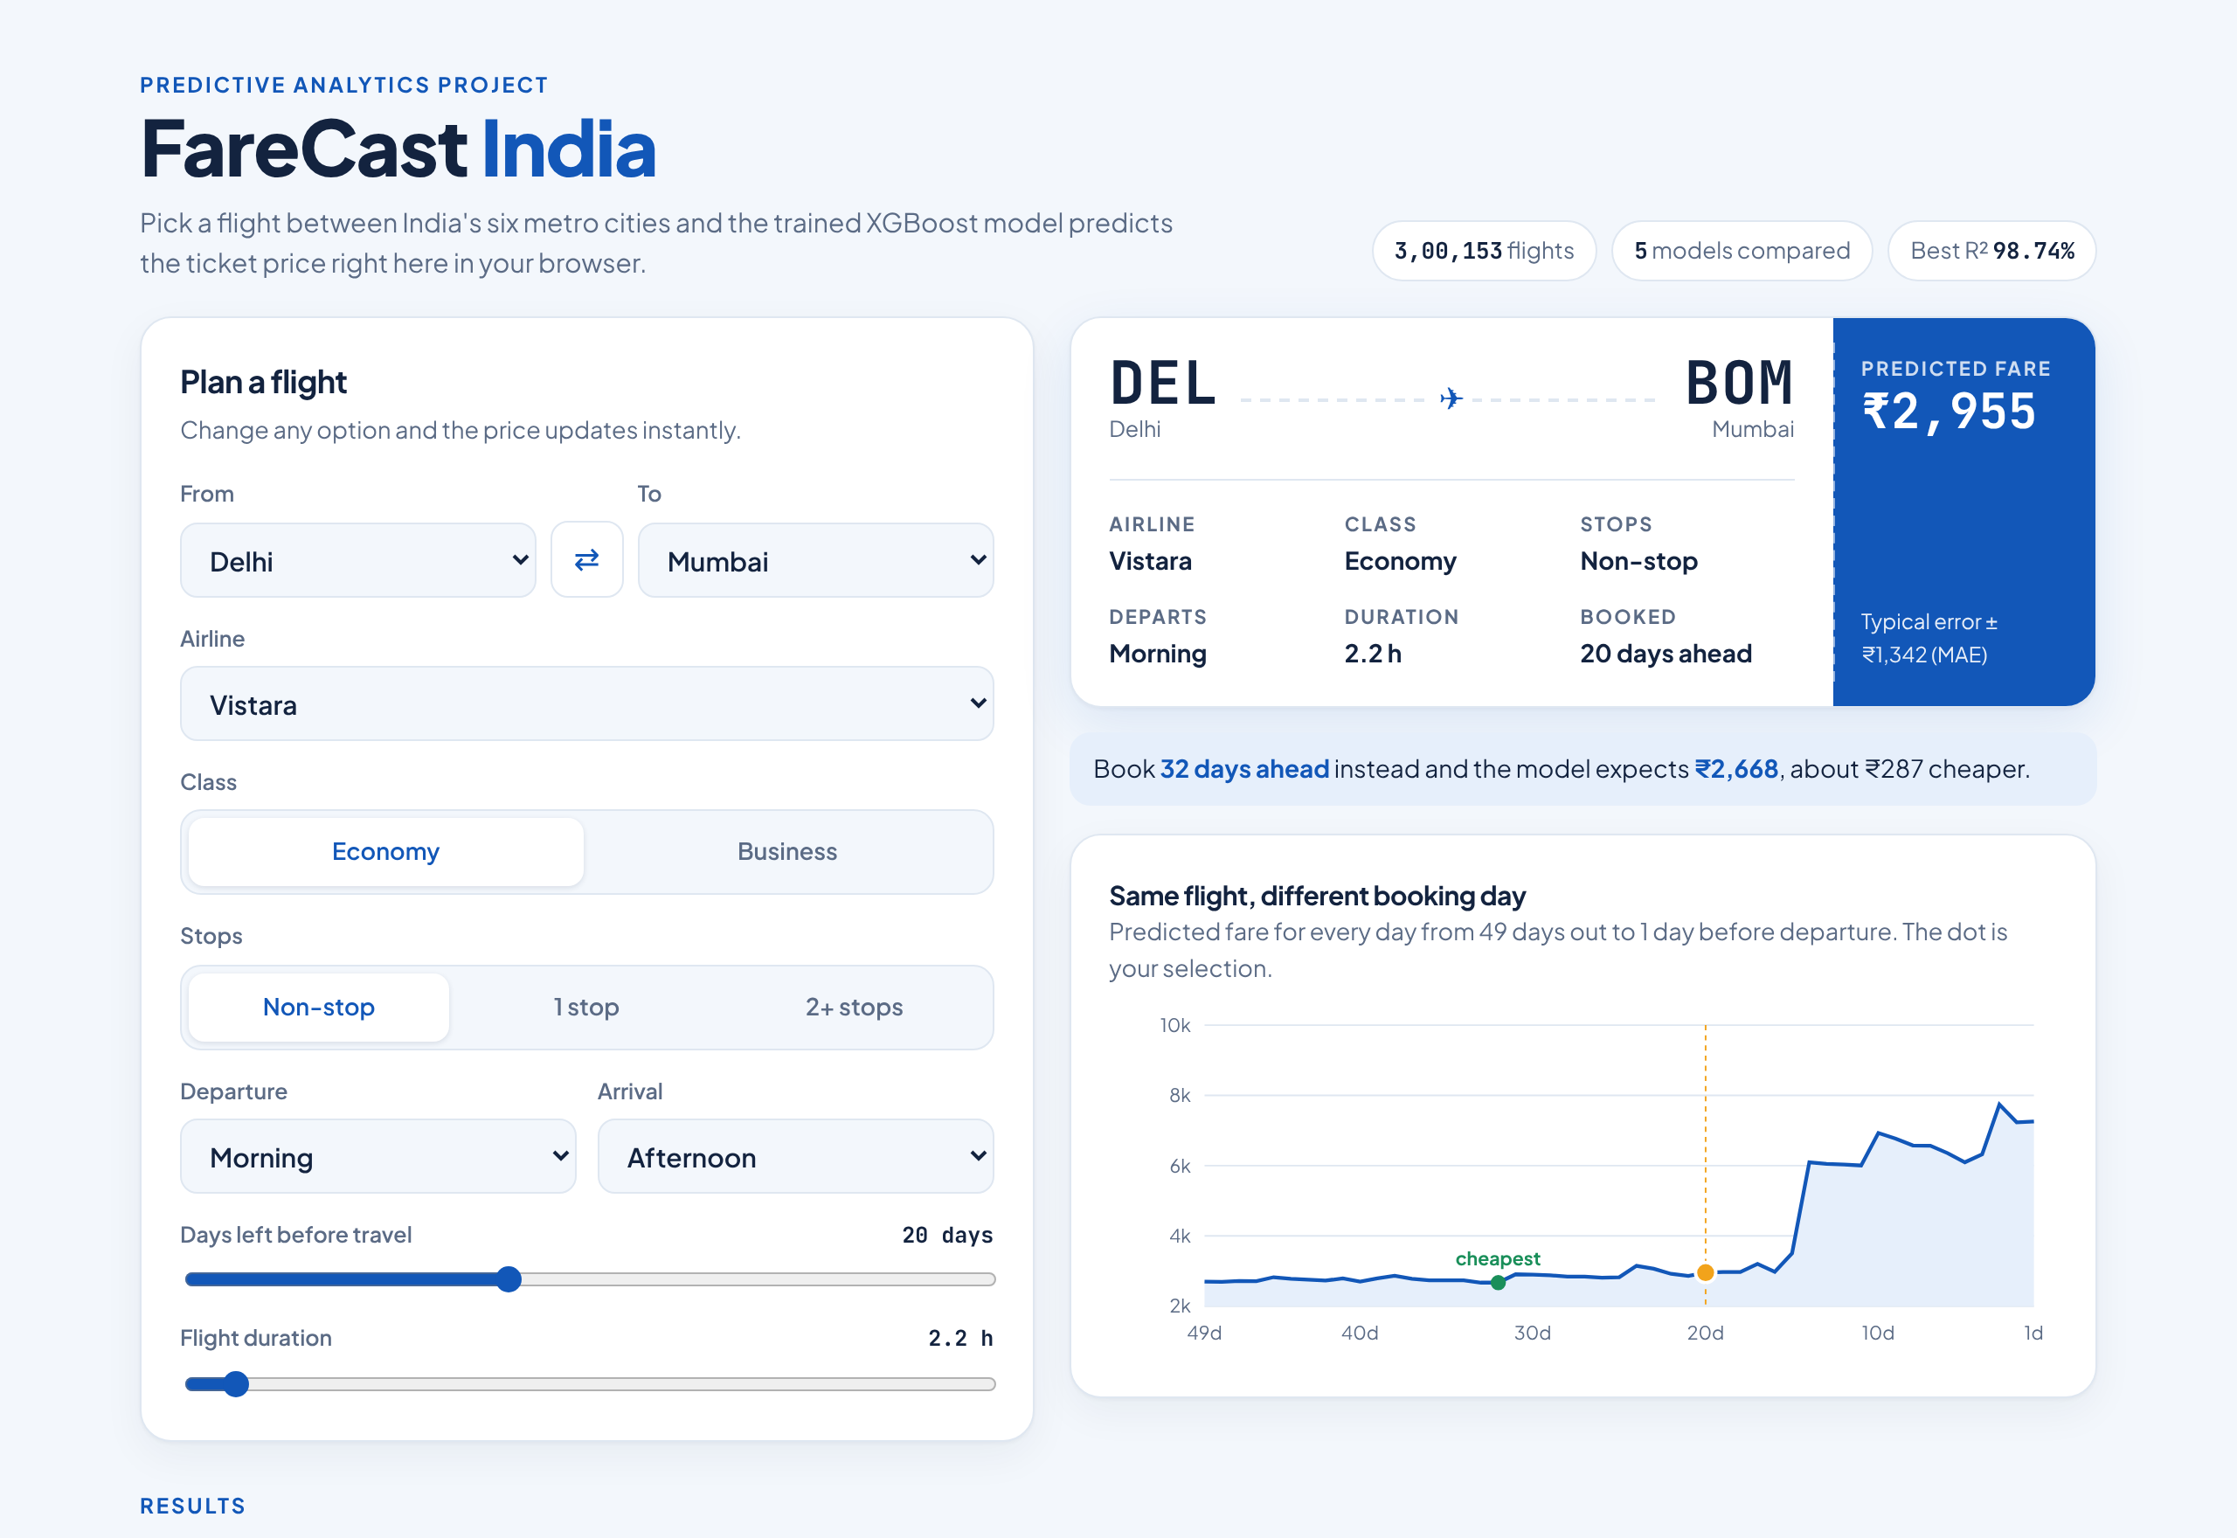
Figure 10.2: FareCast India web page — desktop view
- Flight planner form — select source and destination city, airline, class, stops, departure and arrival time, days left before travel and flight duration.
- Boarding-pass style result — shows the route with airport codes (DEL, BOM, BLR, CCU, HYD, MAA) and the predicted fare, updated instantly on every change.
- Booking-day chart — plots the predicted fare for the same flight for every booking day from 49 days to 1 day before departure and marks the cheapest day.
- Smart suggestion — tells the user how much they could save by booking on the cheapest day.
- Results and insights — the five-model comparison table and average-fare charts.
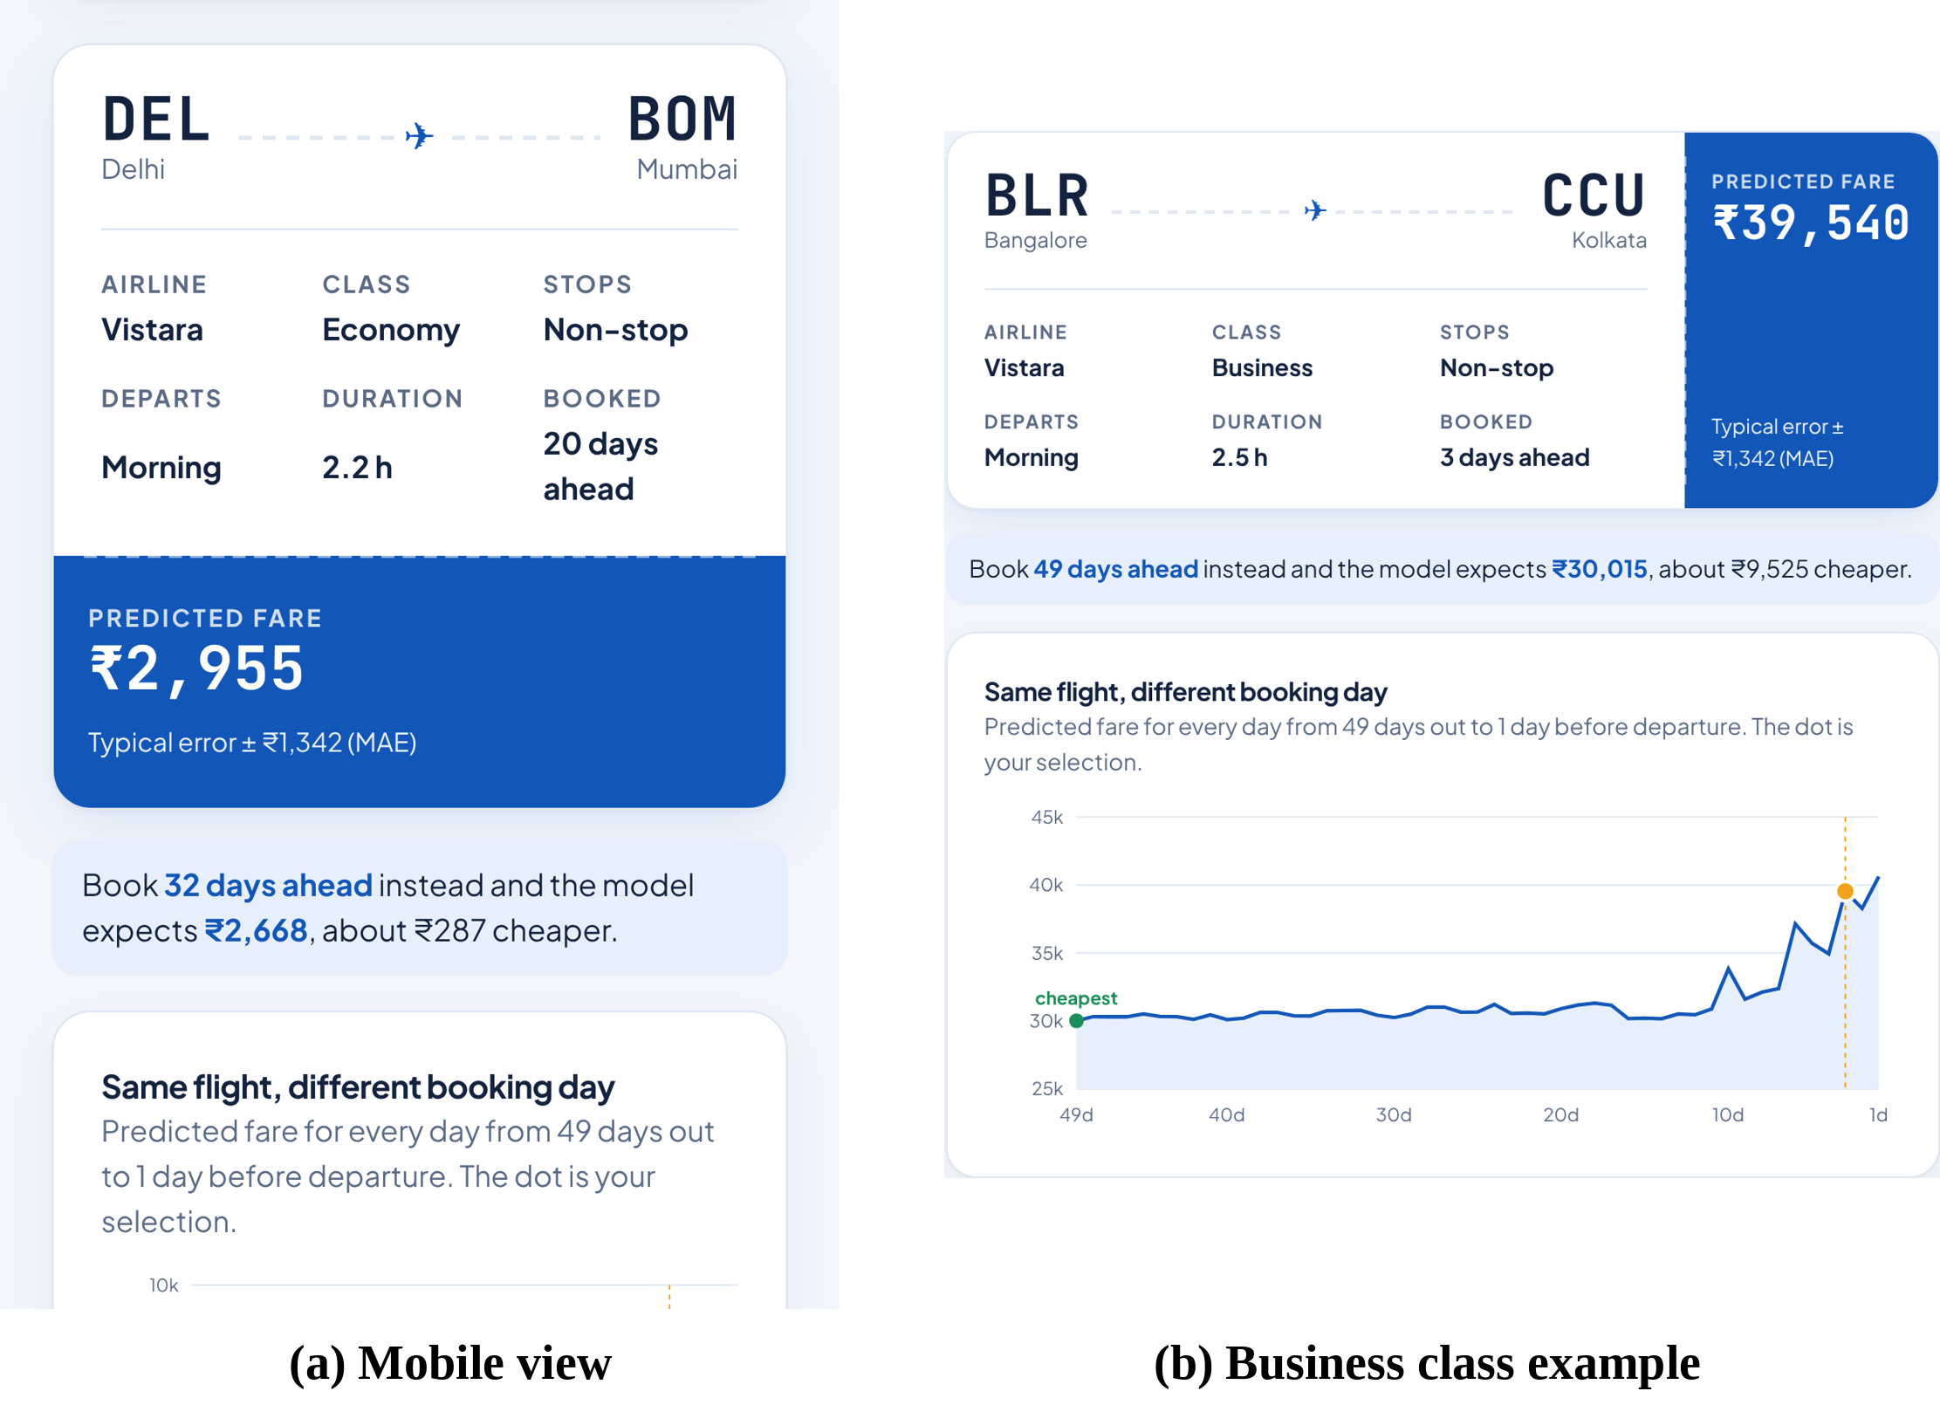
Figure 10.3: (a) Mobile view of the web page, (b) prediction for a business class flight from Bangalore to Kolkata

10.3 Deployment
The project is version-controlled on GitHub, and the web page (docs folder) is deployed on Netlify, which redeploys it automatically on every commit. The design is responsive and works on phones (Figure 10.3(a)).
Table 10.1: Project links
Resource | Link
Live web application (Netlify) | https://flight-priceprediction.netlify.app
Source code (GitHub) | https://github.com/asmipandey3762/flight-price-prediction
Project post (LinkedIn) | https://lnkd.in/p/gCmaf_9w
Dataset (Kaggle) | kaggle.com/datasets/shubhambathwal/flight-price-prediction

10.4 Example Use Case
For example, for an economy Vistara non-stop flight from Delhi to Mumbai departing in the morning, the model predicts a fare of about ₹7,259 when booked one day before travel, but only about ₹2,955 when booked 20 days before.
In Figure 10.3(b), a Vistara business class flight from Bangalore to Kolkata booked 3 days ahead is predicted at ₹39,540, versus about ₹30,015 if booked 49 days ahead — a saving of ₹9,525.
CHAPTER 11

CONCLUSION AND FUTURE SCOPE

11.1 Conclusion
In this project, a complete predictive analytics pipeline was developed to predict the price of domestic flight tickets in India. A large public dataset of 3,00,153 flight records from Kaggle was cleaned, analysed and used to train five regression models. The main conclusions are:
- After removing redundant columns, 2,213 duplicates and 2,226 outliers, a clean dataset of 2,95,714 records was obtained.
- EDA showed that class is the most important factor (business fares are ~8× economy fares), that fares rise sharply in the last two weeks before departure, and that low-cost carriers, non-stop flights and late-night flights are cheaper.
- Linear models achieved an R² of 0.9096 but had high errors, showing that the problem is non-linear.
- Tree-based models performed much better. XGBoost was the best model with an R² score of 0.9874 (98.74%), RMSE of ₹2,557 and MAE of ₹1,342, followed by Random Forest (98.64%) and Decision Tree (98.11%).
- 5-fold cross validation confirmed that the results are stable and reliable. Error analysis showed that tree models explain 79–90% of the price variation even within each class, while linear models explain very little, and that last-minute fares are the hardest to predict.
- The final model was deployed as an interactive web page on Netlify (flight-priceprediction.netlify.app) that predicts fares in real time and suggests the cheapest booking day. The complete source code is available at github.com/asmipandey3762/flight-price-prediction.
The project demonstrates that machine learning, especially gradient boosting, can predict airfares with very high accuracy and can provide useful guidance to travellers.

11.2 Limitations
- The dataset covers only six metro cities (30 routes) and six airlines, so the model cannot predict fares for other cities or airlines.
- The data was collected over a short period (February–March 2022) and does not capture seasonal effects such as festivals, holidays or summer vacations.
- Airline-specific factors such as remaining seats, fuel prices and promotional offers are not available in the dataset.
- Some airlines in the data (for example GO FIRST) have since stopped operations, and Vistara has merged with Air India, so the market has changed since the data was collected.

11.3 Future Scope
- Collect data for more cities, airlines and a longer time period, including festival and holiday seasons.
- Add new features such as day of the week, public holidays, fuel price and seat availability.
- Perform hyperparameter tuning using GridSearchCV or Bayesian optimisation to further improve accuracy.
- Try other advanced algorithms such as LightGBM, CatBoost and deep learning models.
- Build a live system that scrapes current fares daily and updates the model automatically.
- Extend the web application into a full fare-alert service that notifies users when prices are expected to drop.

REFERENCES
[1] Bathwal, S. (2022). Flight Price Prediction [Dataset]. Kaggle. https://www.kaggle.com/datasets/shubhambathwal/flight-price-prediction
[2] Chen, T., & Guestrin, C. (2016). XGBoost: A scalable tree boosting system. Proceedings of the 22nd ACM SIGKDD International Conference on Knowledge Discovery and Data Mining, 785–794.
[3] Etzioni, O., Tuchinda, R., Knoblock, C. A., & Yates, A. (2003). To buy or not to buy: Mining airfare data to minimize ticket purchase price. Proceedings of the 9th ACM SIGKDD International Conference on Knowledge Discovery and Data Mining, 119–128.
[4] Groves, W., & Gini, M. (2013). Optimal airline ticket purchasing using automated user-guided feature selection. Proceedings of the 23rd International Joint Conference on Artificial Intelligence (IJCAI), 150–156.
[5] Tziridis, K., Kalampokas, T., Papakostas, G. A., & Diamantaras, K. I. (2017). Airfare prices prediction using machine learning techniques. 25th European Signal Processing Conference (EUSIPCO), 1036–1039.
[6] Rajankar, S., & Sakharkar, N. (2019). A survey on flight pricing prediction using machine learning. International Journal of Engineering Research & Technology (IJERT), 8(6).
[7] Breiman, L. (2001). Random forests. Machine Learning, 45(1), 5–32.
[8] Hoerl, A. E., & Kennard, R. W. (1970). Ridge regression: Biased estimation for nonorthogonal problems. Technometrics, 12(1), 55–67.
[9] Pedregosa, F., et al. (2011). Scikit-learn: Machine learning in Python. Journal of Machine Learning Research, 12, 2825–2830.
[10] McKinney, W. (2010). Data structures for statistical computing in Python. Proceedings of the 9th Python in Science Conference, 56–61.
[11] Hunter, J. D. (2007). Matplotlib: A 2D graphics environment. Computing in Science & Engineering, 9(3), 90–95.
[12] Géron, A. (2022). Hands-On Machine Learning with Scikit-Learn, Keras, and TensorFlow (3rd ed.). O'Reilly Media.

APPENDIX A: SOURCE CODE
The complete code is available in the Jupyter Notebook Flight_Price_Prediction.ipynb in the project repository (github.com/asmipandey3762/flight-price-prediction). The key parts of the code are given below.

A.1 Importing Libraries and Loading Data
import numpy as np
import pandas as pd
import matplotlib.pyplot as plt
import seaborn as sns
from sklearn.model_selection import train_test_split, cross_val_score, KFold
from sklearn.preprocessing import StandardScaler
from sklearn.linear_model import LinearRegression, Ridge
from sklearn.tree import DecisionTreeRegressor
from sklearn.ensemble import RandomForestRegressor
from xgboost import XGBRegressor
from sklearn.metrics import r2_score, mean_squared_error, mean_absolute_error

df = pd.read_csv('Clean_Dataset.csv')
print("Shape of data:", df.shape)

A.2 Data Cleaning
df = df.drop(['Unnamed: 0', 'flight'], axis=1)
print(df.isnull().sum())
df = df.drop_duplicates()

Q1 = df['duration'].quantile(0.25)
Q3 = df['duration'].quantile(0.75)
IQR = Q3 - Q1
upper = Q3 + 1.5 * IQR
df = df[df['duration'] <= upper]
print("Final shape:", df.shape)

A.3 Feature Engineering
df['class'] = df['class'].map({'Economy': 0, 'Business': 1})
df['stops'] = df['stops'].map({'zero': 0, 'one': 1, 'two_or_more': 2})

df = pd.get_dummies(df, columns=['airline', 'source_city', 'destination_city',
'departure_time', 'arrival_time'],
drop_first=True, dtype=int)

X = df.drop('price', axis=1)
y = df['price']
X_train, X_test, y_train, y_test = train_test_split(X, y, test_size=0.2, random_state=42)

scaler = StandardScaler()
X_train_sc = scaler.fit_transform(X_train)
X_test_sc = scaler.transform(X_test)

A.4 Model Training and Evaluation
models = {
'Linear Regression': LinearRegression(),
'Ridge Regression': Ridge(alpha=1.0),
'Decision Tree': DecisionTreeRegressor(max_depth=20, min_samples_leaf=5, random_state=42),
'Random Forest': RandomForestRegressor(n_estimators=60, max_depth=25, min_samples_leaf=2,
random_state=42, n_jobs=-1),
'XGBoost': XGBRegressor(n_estimators=600, learning_rate=0.1, max_depth=8, random_state=42)
}

results = []
for name, model in models.items():
model.fit(X_train_sc, y_train)
y_pred = model.predict(X_test_sc)
r2 = r2_score(y_test, y_pred)
mse = mean_squared_error(y_test, y_pred)
rmse = np.sqrt(mse)
mae = mean_absolute_error(y_test, y_pred)
results.append([name, r2, mse, rmse, mae])

results_df = pd.DataFrame(results, columns=['Model', 'R2', 'MSE', 'RMSE', 'MAE'])
results_df.sort_values('R2', ascending=False)

A.5 Cross Validation
idx = np.random.RandomState(42).choice(len(X_train_sc), 50000, replace=False)
X_cv, y_cv = X_train_sc[idx], y_train.iloc[idx]
kf = KFold(n_splits=5, shuffle=True, random_state=42)
for name, model in models.items():
scores = cross_val_score(model, X_cv, y_cv, cv=kf, scoring='r2')
print(name, scores.mean().round(4), scores.std().round(4))

A.6 Browser Prediction Function (JavaScript)
function predict(s) {
const x = vec(s); // encode the selected options
let y = M.base; // base score of the model
for (const [F, T, L, R] of M.trees) {
let i = 0;
while (F[i] >= 0) i = x[F[i]] < T[i] ? L[i] : R[i]; // walk the tree
y += T[i]; // add the leaf value
}
return y;
}

