Name | Asmita Sinha
Roll no | 24204A0027
Batch | 2
Subject name | Python Programming & Data Structure
Teacher Name | Ms. Rasika Patil

Experiments | 5
Title | *Develop python program to perform following operations on Tuples:  a) Create  b) Access  c) Update  d) Delete elements from Tuples
Practical significance
Tuples in Python provide immutable data structures, ensuring data integrity and security. They are efficient for storing fixed collections and support multiple assignments for convenient data manipulation. Additionally, tuples can be used as dictionary keys, facilitating efficient data organization and lookup operations.
Relevant Theoretical Background
In Python, a tuple is an immutable collection of elements, meaning once created, its contents cannot be modified. Tuples are defined by enclosing elements within parentheses () and separating them with commas. They can contain elements of different data types, including integers, floats, strings, or even other tuples. Here's a detailed explanation with examples:

- Creating Tuples:
You can create a tuple by simply enclosing elements within parentheses. Tuples can have zero or more elements.
empty_tuple = () single_element_tuple = (5,)
multiple_elements_tuple = (1, 2, 3, 'a', 'b', 'c')
nested_tuple = ((1, 2), ('a', 'b'))

- Accessing Elements:
You can access elements of a tuple using indexing, similar to lists. Indexing starts from 0 for the first element and goes up to len(tuple) - 1 for the last element.
my_tuple = ('apple', 'banana', 'cherry', 'date') print(my_tuple[0]) # Output: 'apple' (Accessing first element)
print(my_tuple[-1]) # Output: 'date' (Accessing last element using negative indexing)

- Slicing Tuples:
You can also access a portion of a tuple using slicing, which creates a new tuple containing a subset of the original tuple.
my_tuple = ('apple', 'banana', 'cherry', 'date')
print(my_tuple[1:3]) # Output: ('banana', 'cherry') (Slice from index 1 to 2) print(my_tuple[:2]) # Output: ('apple', 'banana') (Slice from start to index 1) print(my_tuple[2:]) # Output: ('cherry', 'date') (Slice from index 2 to end)

- Immutable Nature:
Unlike lists, tuples are immutable, meaning their elements cannot be changed or modified after creation. Once a tuple is created, its contents remain fixed.
my_tuple = (1, 2, 3)
# Attempting to modify a tuple will result in an error
# my_tuple[0] = 10 # This will raise a TypeError: 'tuple' object does not support item assignment

- Tuple Packing and Unpacking:
Tuples support multiple assignments, allowing convenient packing and unpacking of data, which simplifies operations like function returns and concurrent processing.
# Tuple Packing my_tuple = 10, 20, 30 # Tuple Unpacking
x, y, z = my_tuple print(x) # Output: 10 print(y) # Output: 20 print(z) # Output: 30

- Tuples as Dictionary Keys:
Tuples are hashable and can be used as keys in dictionaries, unlike lists, which makes them suitable for dictionary keys when representing composite keys or immutable data.
my_dict = {('John', 25): 'Engineer', ('Alice', 30): 'Manager'} print(my_dict[('John', 25)]) # Output: 'Engineer' print(my_dict[('Alice', 30)]) # Output: 'Manager'
Tuples are versatile data structures in Python, useful for representing fixed collections of elements and ensuring data integrity in scenarios where immutability is required.

Programming Questions with Answer
1 | Library Inventory System – Tuple Based Programming Problem  Design and implement a Library Inventory System that uses a tuple data structure to store and manage information about book IDs (or book prices / accession numbers).  The system should provide the following functionalities:  - Allow the librarian to enter book data and store it in a tuple.  - Display all book records stored in the system.  - Calculate and display the total number of books and the average value (price or ID-based calculation).  - Identify and display the highest and lowest book values in the collection.  - Display a list of premium books whose value is greater than or equal to a given limit.  - Provide a search feature to check whether a particular book value exists in the tuple.  - Count how many times a specific book value appears in the tuple.  - Convert the tuple into a list to remove duplicate book records, then convert it back into a tuple.  - Display the tuple in reverse order.  - Find and display the position (index) of a particular book value in the tuple.  Use appropriate tuple operations and built-in functions to implement the above features, keeping in mind that tuples are immutable.
SCRIPT | def display_menu():  print("\n--- Library Inventory System ---")  print("1. Enter book values")  print("2. Display all book records")  print("3. Total number of books and average value")  print("4. Highest and lowest book value")  print("5. Display premium books")  print("6. Search for a book value")  print("7. Count occurrences of a book value")  print("8. Remove duplicate book records")  print("9. Display books in reverse order")  print("10. Find index of a book value")  print("0. Exit")  books = ()  while True:  display_menu()  choice = int(input("Enter your choice: "))  if choice == 1:  n = int(input("How many books do you want to enter? "))  temp_list = []  for i in range(n):  value = float(input(f"Enter value of book {i + 1}: "))  temp_list.append(value)  books = books + tuple(temp_list)  print("Books added successfully.")  elif choice == 2:  print("Book Records:", books)  elif choice == 3:  if books:  total_books = len(books)  average = sum(books) / total_books  print("Total number of books:", total_books)  print("Average book value:", average)  else:  print("No books available.")  elif choice == 4:  if books:  print("Highest book value:", max(books))  print("Lowest book value:", min(books))  else:  print("No books available.")  elif choice == 5:  limit = float(input("Enter premium book limit: "))  premium_books = tuple(b for b in books if b >= limit)  print("Premium Books:", premium_books)  elif choice == 6:  search_value = float(input("Enter book value to search: "))  if search_value in books:  print("Book value exists in the system.")  else:  print("Book value not found.")  elif choice == 7:  count_value = float(input("Enter book value to count: "))  print("Occurrences:", books.count(count_value))  elif choice == 8:  unique_books = tuple(set(books))  books = unique_books  print("Duplicates removed.")  print("Updated book records:", books)  elif choice == 9:  print("Books in reverse order:", books[::-1])  elif choice == 10:  index_value = float(input("Enter book value to find index: "))  if index_value in books:  print("Index position:", books.index(index_value))  else:  print("Book value not found.")  elif choice == 0:  print("Exiting Library Inventory System.")  break  else:  print("Invalid choice. Please try again.")
OP | 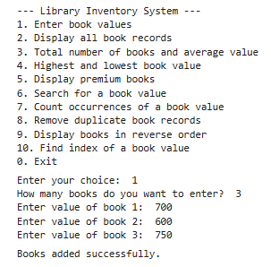  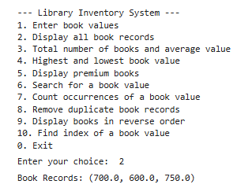  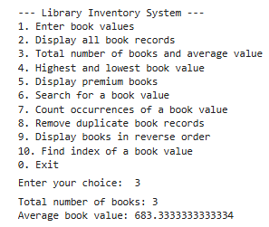  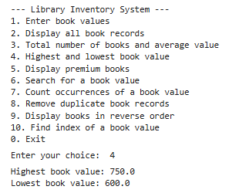  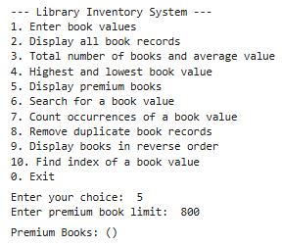  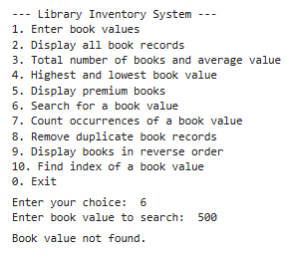  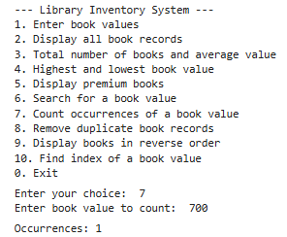\  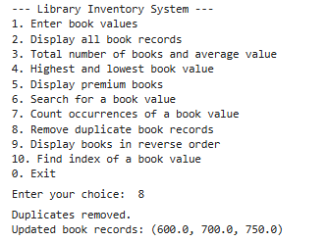  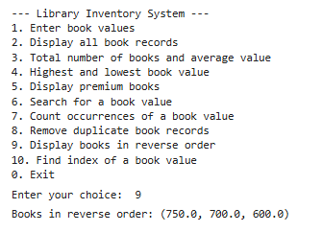  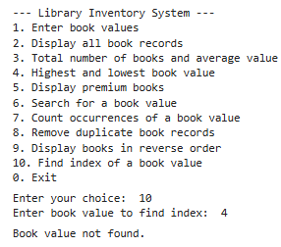  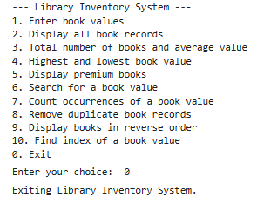
Debugging Questions with Corrected Answers
1 | Debug the following code  Wrong code:  t = (1, 2, 3)  t[0] = 10  print(t)
OP | Error: 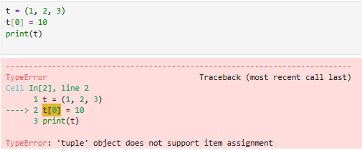  Correct code:  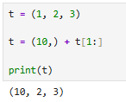
2 | Debug the following code  Wrong code:  t = (10 20 30)  print(t)
OP | Error:  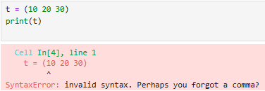  Correct code:  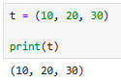
Conclusion | We learned to create and use tuples in a real life application secanrio.
Performance Indicators |  | Teachers Dated and Signature
Process Related  (15 M) | Product Related  (10 M) | Total (25 M)

