Name | Asmita Sinha
Roll no | 24204A0027
Batch | 2
Subject name | Python Programming & Data Structure
Teacher Name | Ms. Rasika Patil

Experiments | 6
Title | *Develop python program to perform following operations on Set:  a) Create  b) Access  c) Update  d) Delete elements from Set
Practical significance
Sets in Python provide an efficient way to store and manipulate unique elements, automatically eliminating duplicates. They support fast membership testing, making them ideal for tasks like filtering out repeated items and performing set operations like union, intersection, and difference. This makes sets particularly useful for handling collections of data where uniqueness and efficient lookups are crucial.
Relevant Theoretical Background
A set is an unordered collection of unique elements. This means that no element can appear more than once in a set. Sets are mutable, meaning you can add or remove elements from them after they are created. They are particularly useful for membership testing, removing duplicates from a sequence, and performing mathematical set operations like union, intersection, difference, and symmetric difference.
- Creating a Set
You can create a set by placing all the items (elements) inside curly braces {}, separated by commas, or by using the built-in set() function.
# Creating a set using curly braces
my_set = {1, 2, 3, 4, 5} print("Set:", my_set)
# Creating a set using the set() function my_set = set([1, 2, 3, 4, 5]) print("Set:", my_set)
# Creating an empty set
empty_set = set() print("Empty Set:", empty_set)
- Adding Elements to a Set
You can add elements to a set using the add() method or update() method. my_set = {1, 2, 3}
print("Original Set:", my_set) # Adding a single element
my_set.add(4)
print("Set after adding 4:", my_set)
# Adding multiple elements
my_set.update([5, 6])
print("Set after adding 5 and 6:", my_set)
- Removing Elements from a Set
You can remove elements using the remove() method, discard() method, or pop() method. The remove() method will raise a KeyError if the element is not found, while the discard() method will not.
my_set = {1, 2, 3, 4, 5} print("Original Set:", my_set)
# Removing an element
my_set.remove(4)
print("Set after removing 4:", my_set)
# Discarding an element
my_set.discard(3)
print("Set after discarding 3:", my_set)
# Removing an element using pop (removes an arbitrary element)
popped_element = my_set.pop() print("Popped Element:", popped_element) print("Set after popping an element:", my_set)
4. Set Operations
Sets support various mathematical operations.
Union: Combines elements from both sets (all unique elements). set1 = {1, 2, 3}
set2 = {3, 4, 5}
union_set = set1.union(set2) print("Union:", union_set)
Intersection: Returns elements that are common in both sets. set1 = {1, 2, 3}
set2 = {3, 4, 5}
intersection_set = set1.intersection(set2) print("Intersection:", intersection_set)
Difference: Returns elements that are in the first set but not in the second. set1 = {1, 2, 3}
set2 = {3, 4, 5}
difference_set = set1.difference(set2) print("Difference:", difference_set)
Symmetric Difference: Returns elements that are in either of the sets, but not in both. set1 = {1, 2, 3}
set2 = {3, 4, 5}
sym_diff_set = set1.symmetric_difference(set2) print("Symmetric Difference:", sym_diff_set)
Membership Testing : You can test if an element is a member of a set using the in keyword. my_set = {1, 2, 3}
print(1 in my_set) # Output: True print(4 in my_set) # Output: False
Sets are a powerful feature in Python that help in handling collections of unique elements and performing efficient membership tests and set operations.

Programming Questions with Answer
1 | Shopping Cart System – Set Based Programming Problem  Design and implement a Shopping Cart System using a set data structure to manage product IDs added to a cart.  The system should provide the following functionalities:  - Allow the user to add product IDs to the shopping cart using a set.  - Display all products currently present in the cart.  - Automatically ensure that duplicate product IDs are not allowed in the cart.  - Display the total number of unique products in the cart.  - Identify and display the highest and lowest product ID in the cart.  - Provide a search feature to check whether a specific product ID exists in the cart.  - Remove a product ID from the cart when an item is deleted.  - Display all premium products whose IDs are greater than or equal to a given value.  - Perform union and intersection operations between carts of two different users.  - Display the shopping cart items in sorted order.  Use appropriate set operations and functions to implement the above features.
SCRIPT | import sys  def main():  # DECLARE cartA <- EMPTY SET  cart_a = set()  # DECLARE cartB <- EMPTY SET  cart_b = set()  while True:  print("\n--- SHOPPING CART MENU ---")  print("1. Add Products to Cart A")  print("2. View Cart A Details (Items, Total, Max, Min)")  print("3. Search for Product in Cart A")  print("4. Remove Product from Cart A")  print("5. View Premium Products (Limit Filter)")  print("6. Add Products to Cart B")  print("7. Perform Set Operations (Union & Intersection)")  print("8. View Cart A in Sorted Order")  print("9. Exit")  choice = input("Enter your choice (1-9): ")  print("-" * 30)  # CHOICE 1: Add to Cart A  if choice == '1':  try:  n = int(input("Enter number of products to add to Cart A: "))  for i in range(n):  value = int(input(f"Enter Product ID {i+1}: "))  cart_a.add(value) # ADD value TO cartA  print("Products added successfully.")  except ValueError:  print("Invalid input! Please enter numbers only.")  # CHOICE 2: View Cart A Details  elif choice == '2':  if not cart_a:  print("Cart A is empty.")  else:  print("Products in Cart A:")  for item in cart_a:  print(item)  # SIZE, MAX, MIN  print(f"Total Unique Products in Cart A: {len(cart_a)}")  print(f"Highest Product ID: {max(cart_a)}")  print(f"Lowest Product ID: {min(cart_a)}")  # CHOICE 3: Search  elif choice == '3':  try:  search_value = int(input("Enter Product ID to search: "))  if search_value in cart_a:  print("Product found in cart")  else:  print("Product not found")  except ValueError:  print("Invalid input.")  # CHOICE 4: Remove  elif choice == '4':  try:  remove_value = int(input("Enter Product ID to remove: "))  if remove_value in cart_a:  cart_a.remove(remove_value)  print("Product removed")  else:  print("Product not found")  except ValueError:  print("Invalid input.")  # CHOICE 5: Filter Premium Products  elif choice == '5':  try:  limit = int(input("Enter premium product ID limit: "))  print("Premium Products:")  found = False  for item in cart_a:  if item >= limit:  print(item)  found = True  if not found:  print("No premium products found above that limit.")  except ValueError:  print("Invalid input.")  # CHOICE 6: Add to Cart B  elif choice == '6':  try:  n = int(input("Enter number of products for Cart B: "))  for i in range(n):  value = int(input(f"Enter Product ID {i+1}: "))  cart_b.add(value)  print("Products added to Cart B.")  except ValueError:  print("Invalid input.")  # CHOICE 7: Union and Intersection  elif choice == '7':  # unionCart <- cartA UNION cartB  union_cart = cart_a.union(cart_b) # Or cart_a | cart_b  # intersectionCart <- cartA INTERSECTION cartB  intersection_cart = cart_a.intersection(cart_b) # Or cart_a & cart_b  print(f"Union of Cart A and Cart B (All items): {union_cart}")  print(f"Intersection of Cart A and Cart B (Common items): {intersection_cart}")  # CHOICE 8: Sort  elif choice == '8':  if not cart_a:  print("Cart A is empty.")  else:  print("Cart A in Sorted Order:")  print(sorted(cart_a))  # CHOICE 9: Exit  elif choice == '9':  print("Exiting program.")  break  else:  print("Invalid choice. Please enter a number between 1 and 9.")  if __name__ == "__main__":  main()
OP | 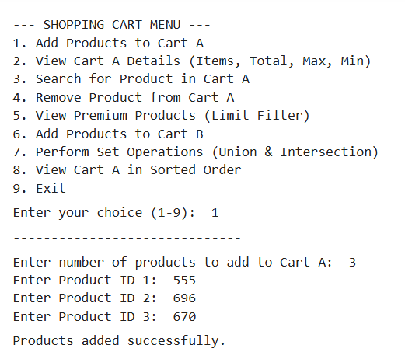  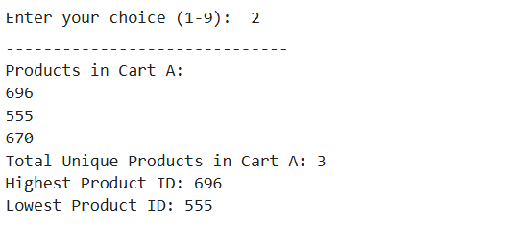  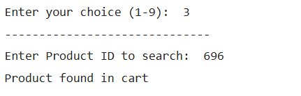  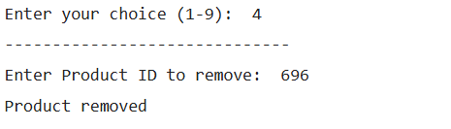  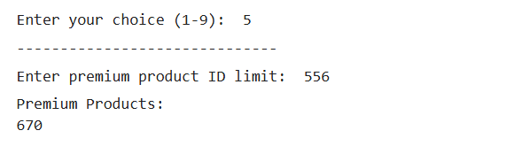  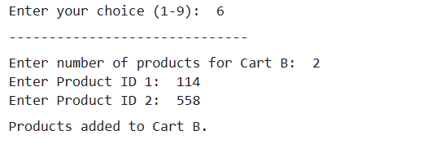  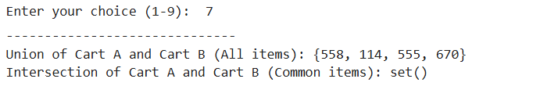  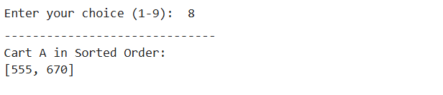  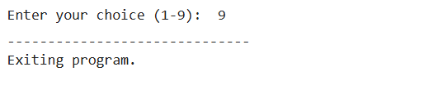
Debugging Questions with Corrected Answers
1 | Debug the following code  Wrong code:  s = {1, 2, 3}  print(s[0])
OP | Error:  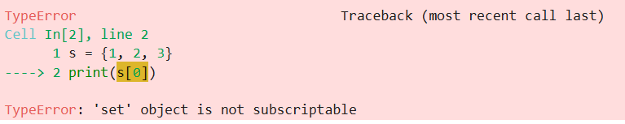  Correct code:  s = {1, 2, 3}  print(s)
2 | Debug the following code  Wrong code:  s = {10, 20, 30}  s.add(20)  print(s)
OP | Error: none,20 is duplicate and hence considered once  Correct code:  s = {10, 20, 30}  s.add(20)  print(s)
Conclusion | Hnce we learned to create and use set operators in a Python program
Performance Indicators |  | Teachers Dated and Signature
Process Related  (15 M) | Product Related  (10 M) | Total (25 M)

