Name | Asmita Sinha
Roll no | 24204A0027
Batch | 2
Subject name | Python Programming & Data Structure
Teacher Name | Ms. Rasika Patil

Experiments | 7
Title | *Develop python program to perform following operations on Dictionaries :  a) Create  b) Access  c) Update  d) Delete elements from Dictionaries
Practical significance
Python dictionaries allow us to associate a value to a unique key, and then to quickly access this value. Dictionaries are used to store data values in key:value pairs. A dictionary is a collection which is ordered, changeable and does not allow duplicates.
Relevant Theoretical Background
Python dictionary is a container of key-value pairs. It is mutable and can contain mixed types. A dictionary is an unordered collection. Python dictionaries are called associative arrays or hash tables in other languages. The keys in a dictionary must be immutable objects like strings or numbers. They must also be unique within a Dictionary.
- Creating the Dictionary
The most common method is to use curly braces {} separating the keys and values by colons. For example, the following example creates a dictionary with three items: The syntax to define the dictionary is given below:
dict = {"name": "John", "age": 30, "city": "New York"}
- Accessing Values in Dictionary:
To access dictionary elements, use square brackets along with the key to obtain its value. To extract values, use the following format:
dictionary[key] Example:
dict = {“name”: “John”, “age”: 30, “city”: “New York”} name = dict[“name”] # Get value assigned to the “name” key print(name)
Output:
John
- Updating Dictionary:
You can update a dictionary by adding a new entry or a key-value pair, modifying an existing entry, or deleting an existing entry.
Example 1:
dict = {"name": "John", "age": 30, "city": "New York"} print(dict) # Before modification
dict["age"] = 35
print(dict) # After modification
Output Before: {'name': 'John', 'age': 30, 'city': 'New York'}
Output After: {'name': 'John', 'age': 35, 'city': 'New York'}
Example 2:
dict = {"name": "John", "age": 30, "city": "New York"} dict["gender"] = "male" # Add new key-value pair print(dict)
Output:
{"name": "John", "age": 30, "city": "New York","gender":"male"}

d) Delete Dictionary Elements:
To remove individual dictionary elements or clear the entire contents of a dictionary or to delete entire dictionary in a single operation or to explicitly remove an entire dictionary, just use the del statement.
Example:
dict = {"name": "John", "age": 30, "city": "New York"} del dict['name']; # remove entry with key 'name'
Output:
{"age": 30, "city": "New York"} dict.clear(); # remove all entries in dict del dict ; # delete entire dictionary
i) Looping through Dictionary:
A dictionary can be iterated using the for loop. If you want to get both keys and the values in the output. You just have to add the keys and values as the argument of the print Statement in comma separation. After each iteration of the for loop, you will get both the keys its relevant values in the output.
Example
dict = {"name": "John", "age": 30, "city": "New York"} for key, value in dict.items():
print(key, ' - ', value)
Output:
name - John age - 30 city – New York

Programming Questions with Answer
1 | Bank Account System – Dictionary Based Programming Problem  Design and implement a Bank Account Management System using a dictionary data structure, where the account number is the key and the account balance is the value.  The system should provide the following functionalities:  - Allow the admin to create bank accounts by storing account numbers and balances in a dictionary.  - Display all account details stored in the system.  - Calculate and display the total and average balance of all accounts.  - Identify and display the highest and lowest account balances.  - Display accounts with high-value balances above a specified limit.  - Provide a search feature to check whether a particular account number exists.  - Update the account balance after deposit or withdrawal.  - Remove an account record when an account is closed.  - Display all account numbers and balances separately.  - Sort and display accounts based on account numbers.  Use appropriate dictionary methods and operations to implement the above features.
SCRIPT | # Bank Account Management System using Dictionary  accounts = {}  def create_account():  acc_no = int(input("Enter account number: "))  if acc_no in accounts:  print("Account already exists.")  else:  balance = float(input("Enter initial balance: "))  accounts[acc_no] = balance  print("Account created successfully.")  def display_accounts():  if not accounts:  print("No accounts available.")  else:  print("\nAccount Number : Balance")  for acc, bal in accounts.items():  print(acc, ":", bal)  def total_and_average_balance():  if not accounts:  print("No accounts available.")  else:  total = sum(accounts.values())  average = total / len(accounts)  print("Total Balance:", total)  print("Average Balance:", average)  def highest_and_lowest_balance():  if not accounts:  print("No accounts available.")  else:  max_acc = max(accounts, key=accounts.get)  min_acc = min(accounts, key=accounts.get)  print("Highest Balance:", accounts[max_acc], "in Account:", max_acc)  print("Lowest Balance:", accounts[min_acc], "in Account:", min_acc)  def high_value_accounts():  limit = float(input("Enter balance limit: "))  found = False  for acc, bal in accounts.items():  if bal > limit:  print(acc, ":", bal)  found = True  if not found:  print("No accounts above the given limit.")  def search_account():  acc_no = int(input("Enter account number to search: "))  if acc_no in accounts:  print("Account found. Balance:", accounts[acc_no])  else:  print("Account does not exist.")  def update_balance():  acc_no = int(input("Enter account number: "))  if acc_no in accounts:  amount = float(input("Enter amount (+deposit / -withdraw): "))  accounts[acc_no] += amount  print("Updated Balance:", accounts[acc_no])  else:  print("Account not found.")  def remove_account():  acc_no = int(input("Enter account number to remove: "))  if acc_no in accounts:  del accounts[acc_no]  print("Account removed successfully.")  else:  print("Account not found.")  def display_separately():  print("Account Numbers:", list(accounts.keys()))  print("Balances:", list(accounts.values()))  def sort_accounts():  if not accounts:  print("No accounts available.")  else:  print("\nAccounts sorted by account number:")  for acc in sorted(accounts):  print(acc, ":", accounts[acc])  # Menu-driven program  while True:  print("\n--- Bank Account Management System ---")  print("1. Create Account")  print("2. Display All Accounts")  print("3. Total and Average Balance")  print("4. Highest and Lowest Balance")  print("5. High-Value Accounts")  print("6. Search Account")  print("7. Update Balance (Deposit/Withdraw)")  print("8. Remove Account")  print("9. Display Account Numbers and Balances Separately")  print("10. Sort Accounts by Account Number")  print("11. Exit")  choice = int(input("Enter your choice: "))  if choice == 1:  create_account()  elif choice == 2:  display_accounts()  elif choice == 3:  total_and_average_balance()  elif choice == 4:  highest_and_lowest_balance()  elif choice == 5:  high_value_accounts()  elif choice == 6:  search_account()  elif choice == 7:  update_balance()  elif choice == 8:  remove_account()  elif choice == 9:  display_separately()  elif choice == 10:  sort_accounts()  elif choice == 11:  print("Exiting program...")  break  else:  print("Invalid choice. Please try again.")
OP | 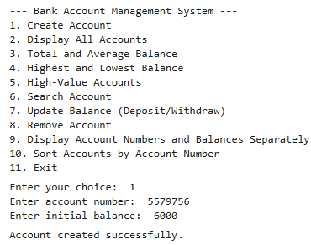  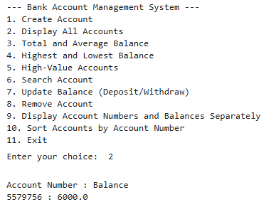  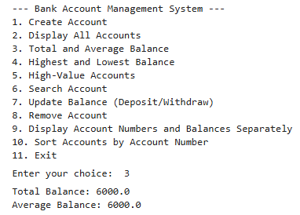\  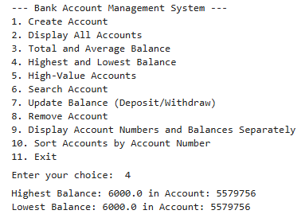  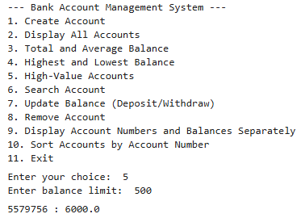  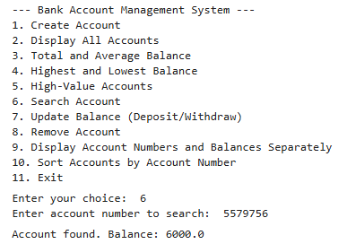  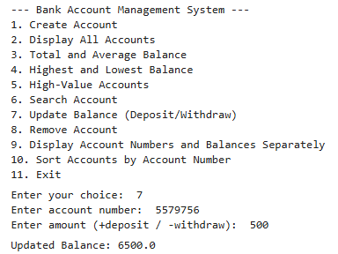  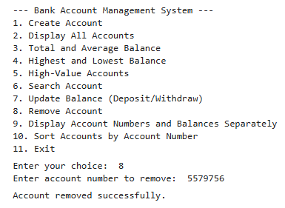  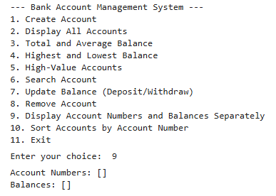  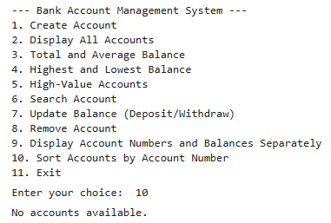  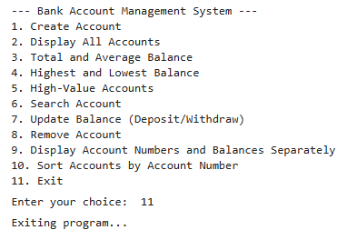
Debugging Questions with Corrected Answers
1 | Debug the following code  Wrong code:  d = {"a":1, "b":2}  print(d[a])
OP | Error:  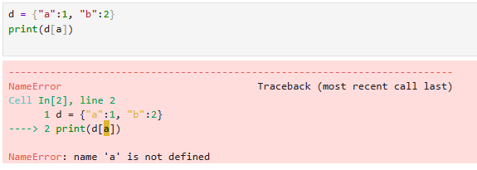  Correct code:  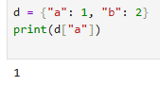
2 | Debug the following code  Wrong code:  d = {"name":"Amit"}  d.append("city")  print(d)
OP | Error:  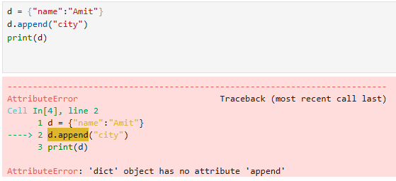  Correct code:  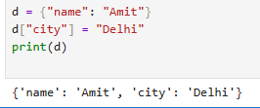
Conclusion | Python dictionaries provide an efficient way to store, access, update, and manage data using unique keys and associated values.
Performance Indicators |  | Teachers Dated and Signature
Process Related  (15 M) | Product Related  (10 M) | Total (25 M)

