**CLUSTER IP SERVICE**

* Create ClusterIP Based Service
* Easy way to create Service
* Cleanup
* create two pods named firstpod and secondpod with hello-app image. Let us create both the pods, by executing below commands.

1. kubectl create -f ~/kubernetes/service-first-pod.yml
2. kubectl create -f ~/kubernetes/service-second-pod.yml

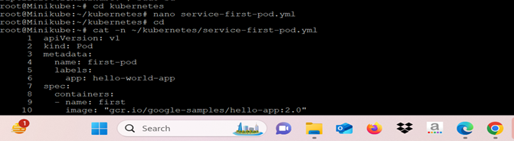

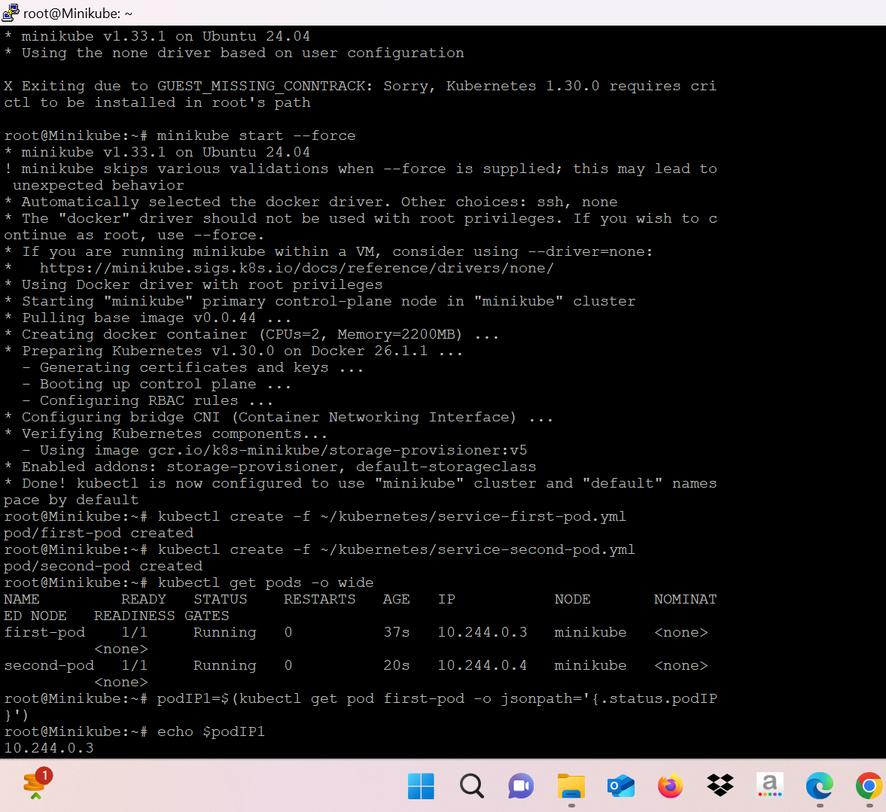

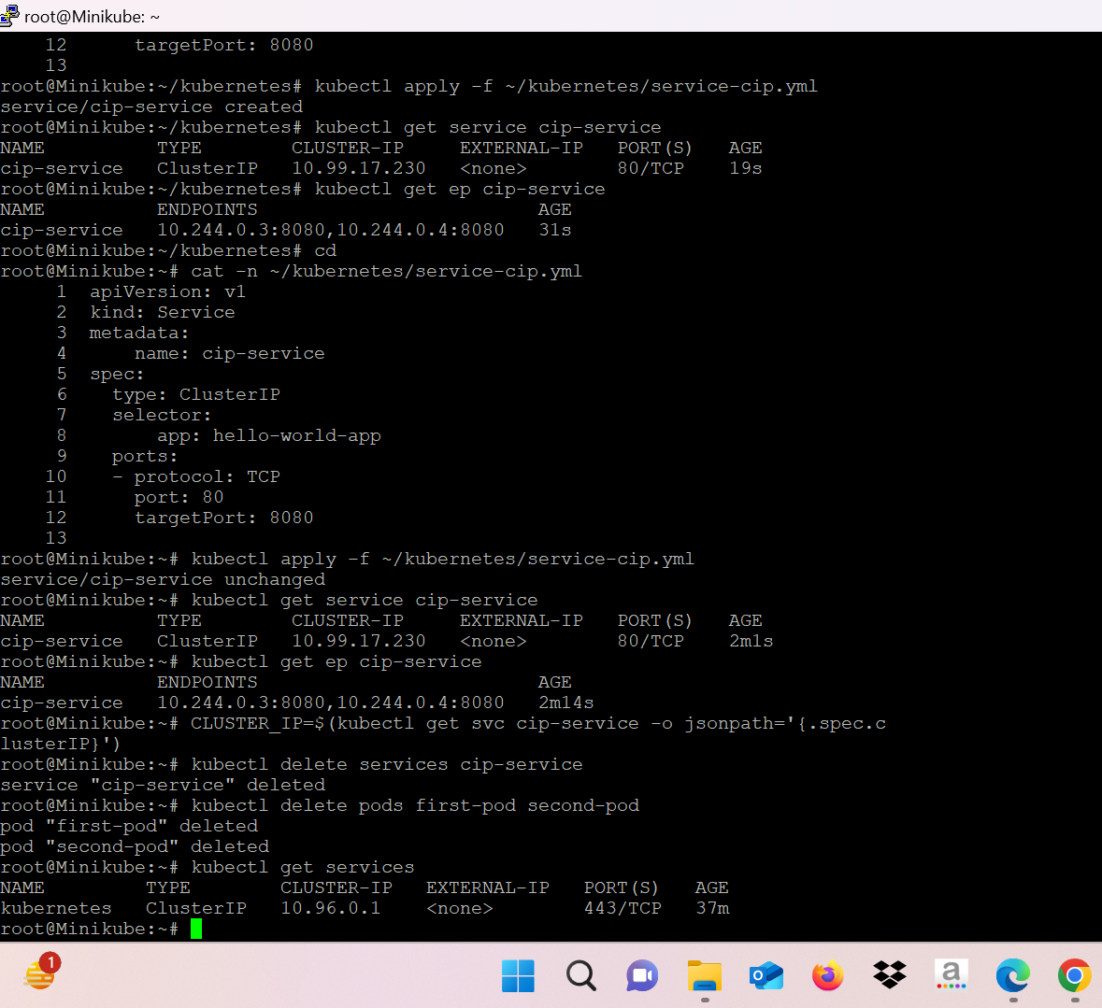

* view the yaml manifest file for service by executing the below command.
* create the Service of type ClusterIP by using the service-cip.yml file.
* list the service and capture the service ip by executing the below command.
* list the endpoints for the above created service
* Let’s access by using the Cluster-ip.
* cleanup the service by execute the below command.
* delete the pods by executing below command.



* create a service using imperative method type – ClusterIP.
* list the service that we just created.

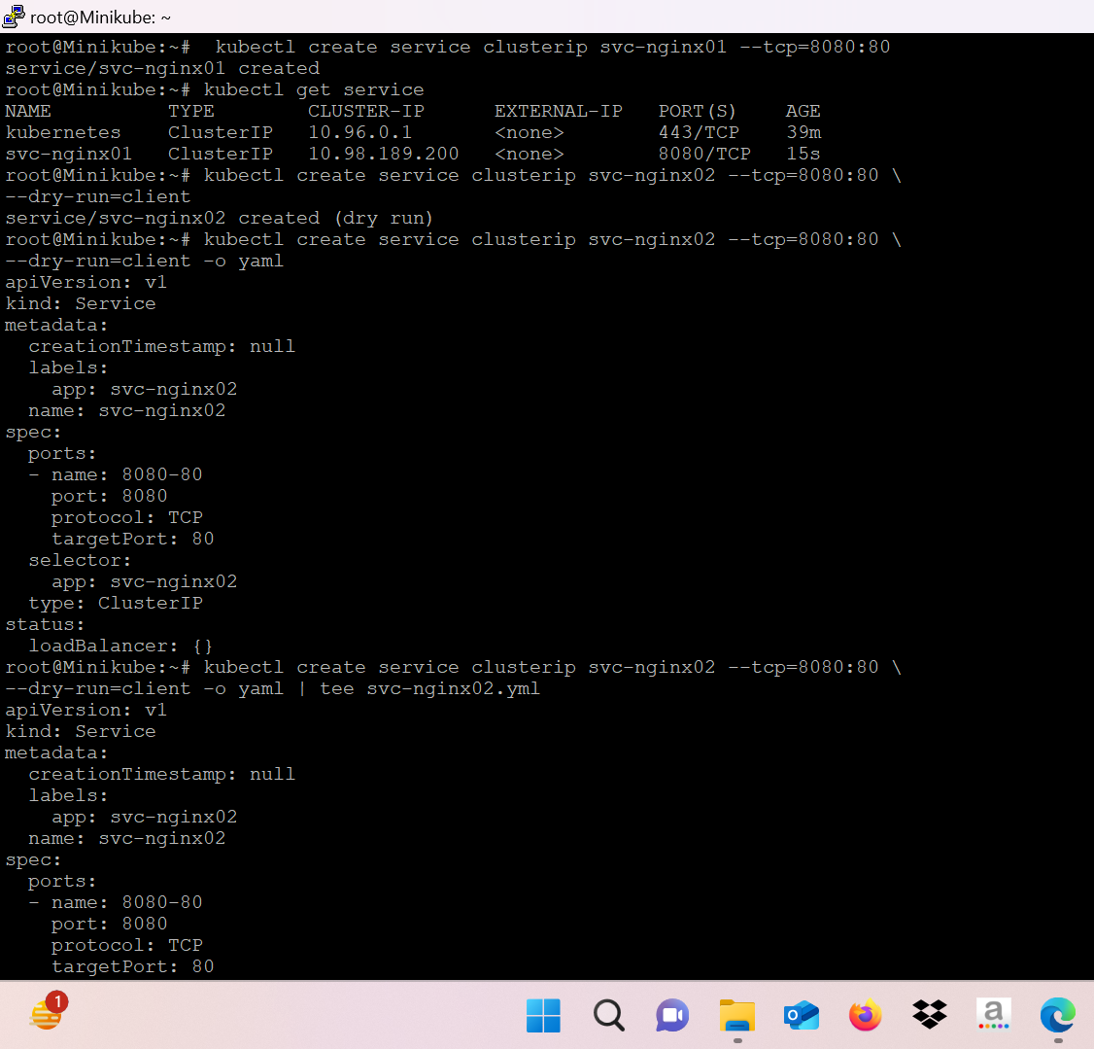

* Run an alternate method for creating a service (--dry-run to verify the command syntax).
* View the manifest in the yml format.

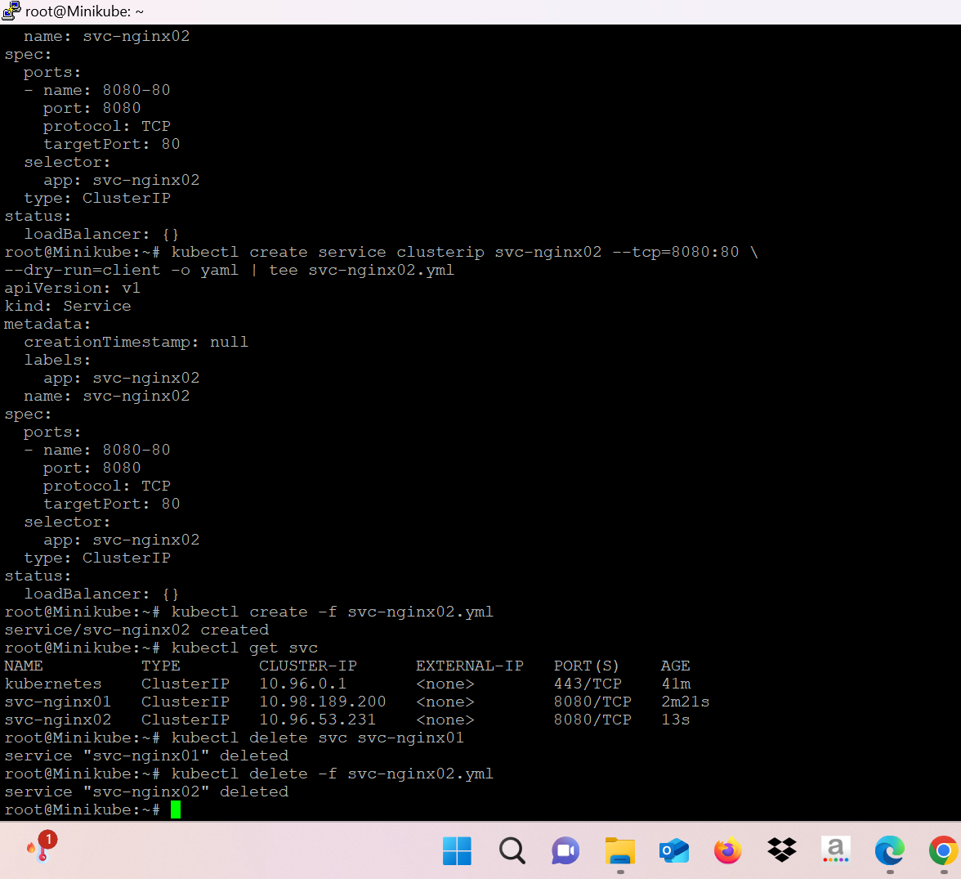

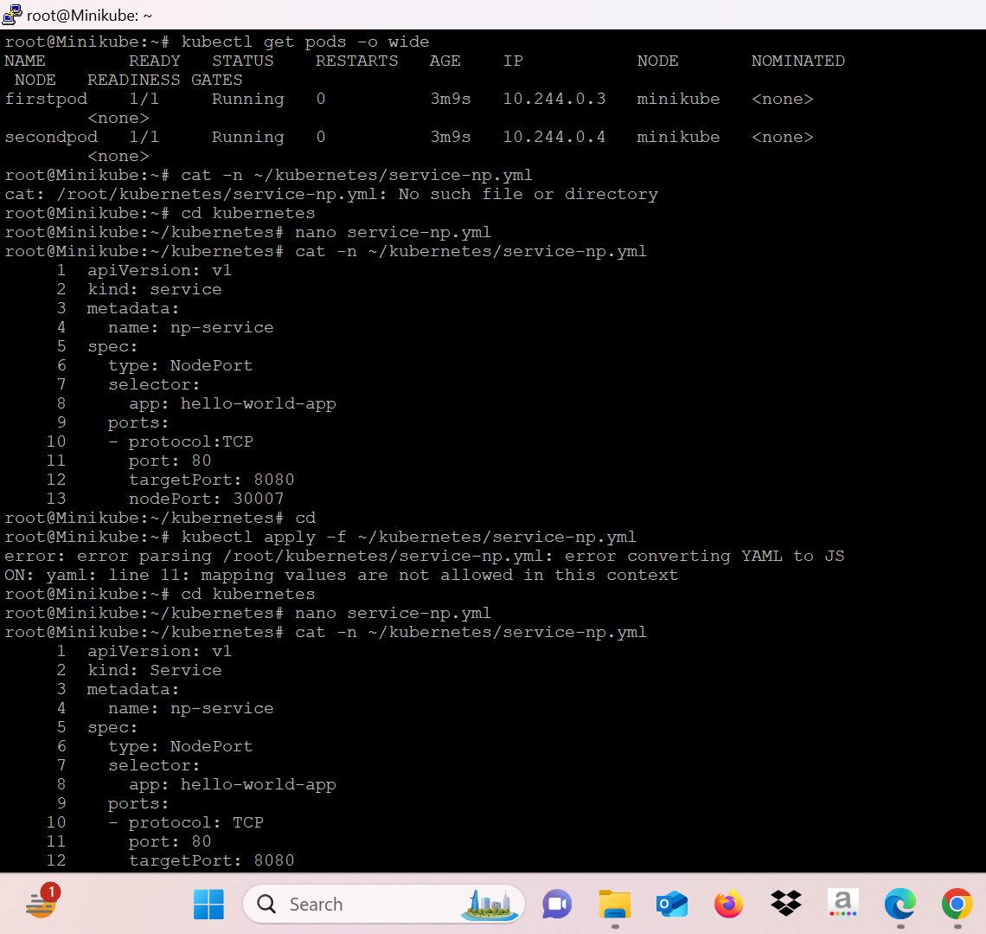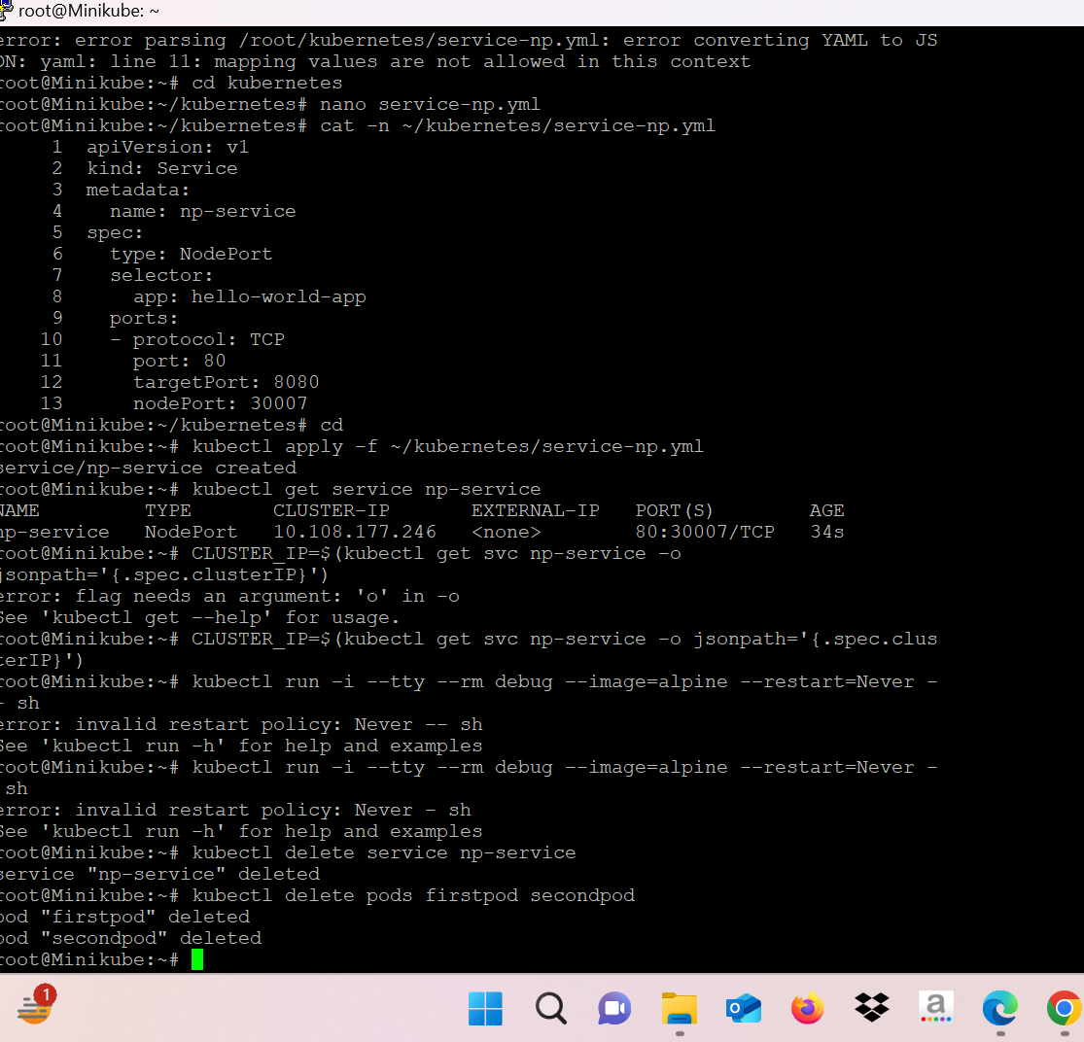

* Delete both the services using different methods.