**DOCKER INSTALLATION**

Here I created my Virtual machine-

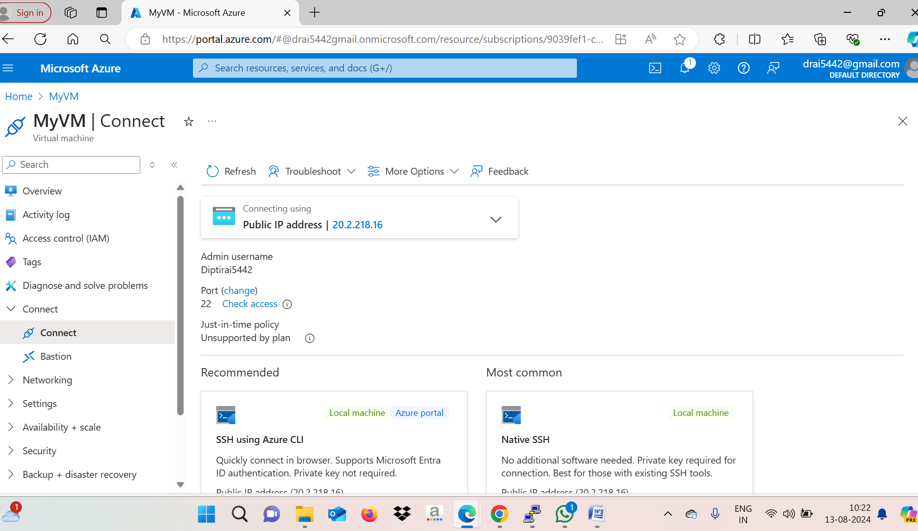

Follow these command line and Install Docker-

Follow this URL to install Docker -https://docs.docker.com/engine/install/ubuntu/

* sudo apt-get update
* sudo apt-get install ca-certificates curl
* sudo install -m 0755 -d /etc/apt/keyrings
* sudo curl -fsSL https://download.docker.com/linux/ubuntu/gpg -o /etc/apt/keyrings/docker.asc
* sudo chmod a+r /etc/apt/keyrings/docker.asc

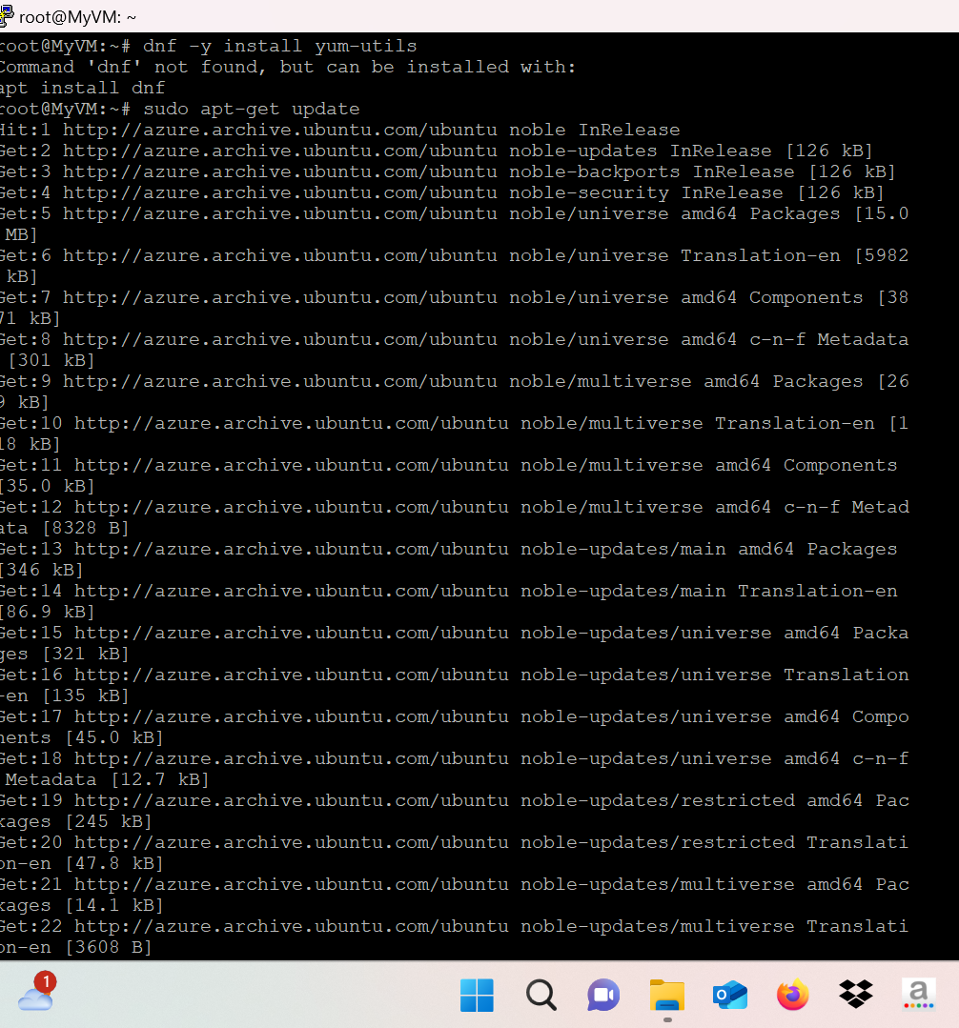

After installation check the status –

* Sudo systemctl status docker

