**INSTALLING MINIKUBE AND KUBERNETES RUNNING IN SINGLE VM**

Update all packages  by executing the following commands

        a. sudo apt update

        b.sudo apt upgrade -y

        c. sudo reboot

        d. Once the VM is rebooted s

Follow these command line and Install Docker-

Follow this URL to install Docker -https://docs.docker.com/engine/install/ubuntu/

* sudo apt-get update
* sudo apt-get install ca-certificates curl
* sudo install -m 0755 -d /etc/apt/keyrings
* sudo curl -fsSL https://download.docker.com/linux/ubuntu/gpg -o /etc/apt/keyrings/docker.asc
* sudo chmod a+r /etc/apt/keyrings/docker.asc
* sudo apt updateA screenshot of a computer screen

  Description automatically generated

After installation check the status – Sudo systemctl status docker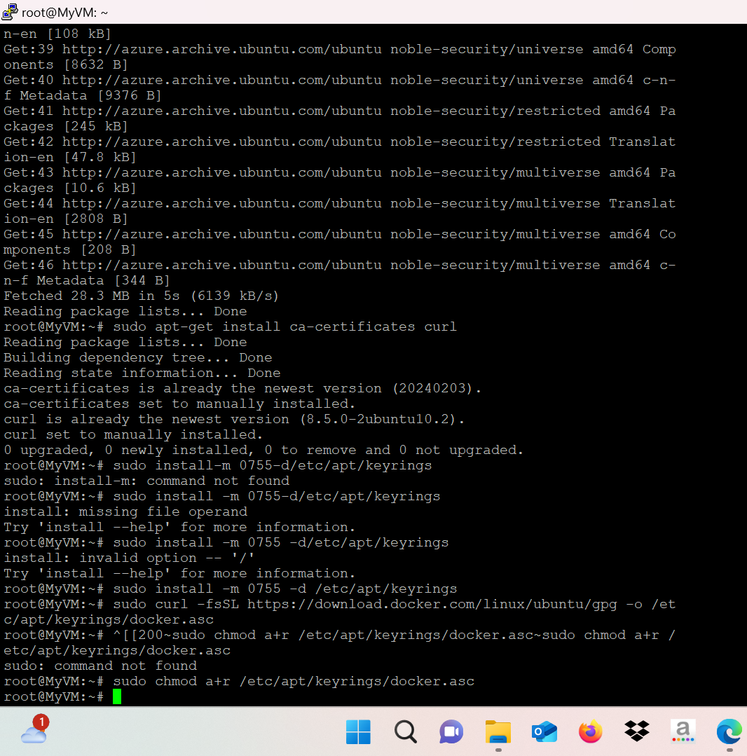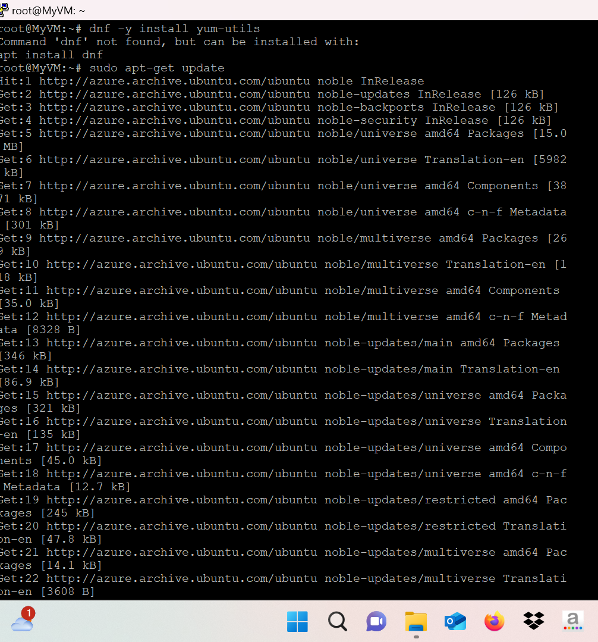

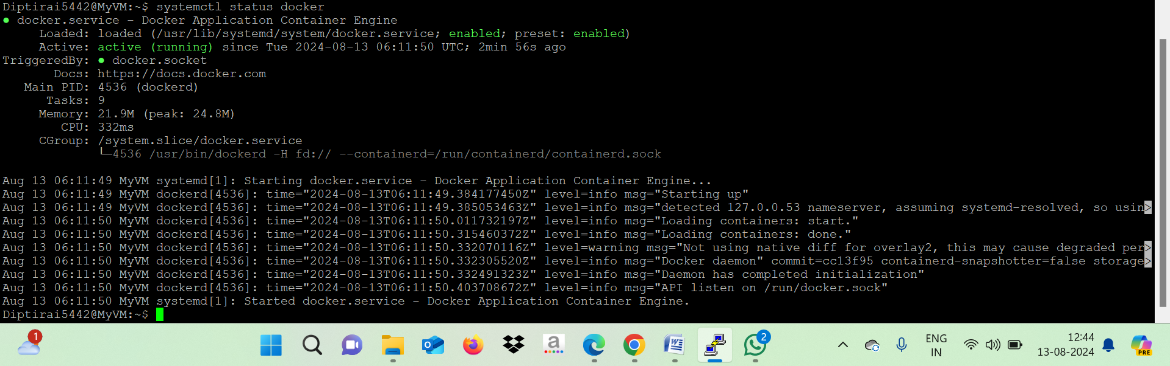

Download and Install / Enable Minikube Binary

* https://www.linuxbuzz.com/install-minikube-on-ubuntu/
* Continue from Step 3 in the above URL until Step 7
* Do not execute Step 8 in the above URL
* To see the status of minikube - minikube status
* To stop minikube - minikube stop
* To start minikube - minikube start –driver
* minikube start --driver-docker --force
* To delete minikube - minikube delete

