Title: Event Report of Club/Committee FF 984

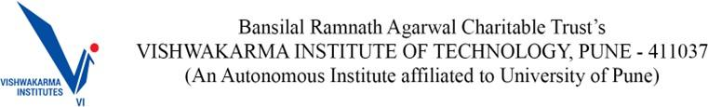

Event Report

Name of the Club:The Speaker’s Club
Name of the Event: Do we vote for the face or the flag?
Student Vertical : Others
Instalment of the said event (e.g.: Maiden/nth installment)
Date and time of event | 24/01/26 , 4:00 pm
Mode - Online Platform/ Venue: | 1002
Event span (hours/days) | 2 hrs
Footfall/Total attendance | 18
Name and contact of the key organiser(s) | Siddhesh Chavan (8459861918)
No. of people involved in the organizing committee | 3
No. of faculty participated
Objective of the event | To critically examine whether voter choices in Indian local elections are primarily influenced by individual candidates’ personalities, leadership image, and grassroots connect (the face) or by party ideology, symbols, and political loyalty (the flag), using recent local election outcomes to understand evolving voter behavior in Indian democracy.
Brief description of the said event (100 words or more) | Key Points from the Event:  - Face-centric voting can risk authoritarianism, as seen in personality-driven eras like Indira Gandhi’s, where institutions weaken and decision-making becomes concentrated around a single leader.  - In local elections, the individual candidate matters more because governance depends on daily follow-ups, accessibility, and practical problem-solving rather than ideology or national-level political narratives.  - Coalition politics has reduced voter trust, with opportunistic alliances such as Congress–Shiv Sena or Congress–BJP confusing mandates and weakening accountability at the grassroots level.  - Despite local needs, voters increasingly choose the flag, trusting party ideology, organizational strength, and access to funds over evaluating the actual performance of individual local representatives.  - Most citizens recognize party symbols but not their mayors or corporators, showing how symbol-based voting discourages awareness, scrutiny, and responsibility in local democratic governance.  - Voting for the flag feels safer because power, finance, and administrative control flow from higher levels, making party-backed candidates seem more capable of delivering development.  - Frequent party-switching exposes self-interest over ideology, weakening democratic ethics and raising doubts about whether leaders represent public welfare or merely personal political survival.  - Independent or weakly backed candidates can win, as rare examples show, but the system heavily favors parties, making capability secondary to winning probability.  - Democracy struggles when criminality, dynastic control, and proxy leadership persist, allowing power to be exercised indirectly while accountability and genuine representation decline.  - Ultimately, voting becomes a calculation between security and efficiency—between choosing a powerful system that may deliver resources and a capable individual who may lack institutional support.
Benefits to students and Faculty | Benefits to Students:  To improve public speaking confidence  Benefits to Faculty:
Key event outcomes | Sharing of idea/Thoughts on ongoing elections in India

Title: Event Report of Club/Committee FF 984

Milestones set by the event (if any)
Social media links for the respective team | https://www.instagram.com/speakers_club_vit/
Name and bio of chief guest/s in attendance along with social media links (if any)
Event Sponsors and their brief description (if any)

Program Outcomes Section

Program Outcomes Indirectly Attained (Please enter the rating in the second column) | Category (Rating) Not Applicable (0) Partially Agree(1) Agree (2)  Strongly Agree (3)
Engineering knowledge  Has your ability to apply engineering knowledge to find solutions to engineering problems improved? | 2
Problem analysis: Has your ability to identify, formulate, and analyse engineering problems improved? | 3
Design/development of solutions: Has your ability improved to design and develop solutions to solve real world problems? | 2
Conduct Investigations of Complex Problems:How effectively were you able to investigate complex engineering problems using research-based knowledge, including the design of experiments, modelling, analysis, and interpretation of data to draw valid conclusions? | 2
The Engineer and the world: Is it possible for you to better apply reasoning informed by the contextual knowledge to assess societal, health, safety, legal and cultural issues? | 2
Engineering Tool Usage: How effectively were you able to create, select, and apply appropriate modern engineering and IT tools, including modelling and prediction techniques, while recognizing their limitations, to solve complex engineering problems? | 1
Ethics: Is your professional ethics improved due to participation in the event/activities? | 3

Individual and team work: Has your ability to function effectively as an individual, and as a member or leader in diverse teams improved? | 2
Communication: Has your ability to communicate effectively (comprehend and write effective reports, design documentation, make effective presentations, and give and receive clear instructions) improved? | 2
Project management and finance: Are the project management skills and handling the finance for the event/activity improved? | 1
Life-long learning: Has your ability to engage in independent and life-long learning in the context of technological change improved? | 2

Photograph Section : geo-tagged photos

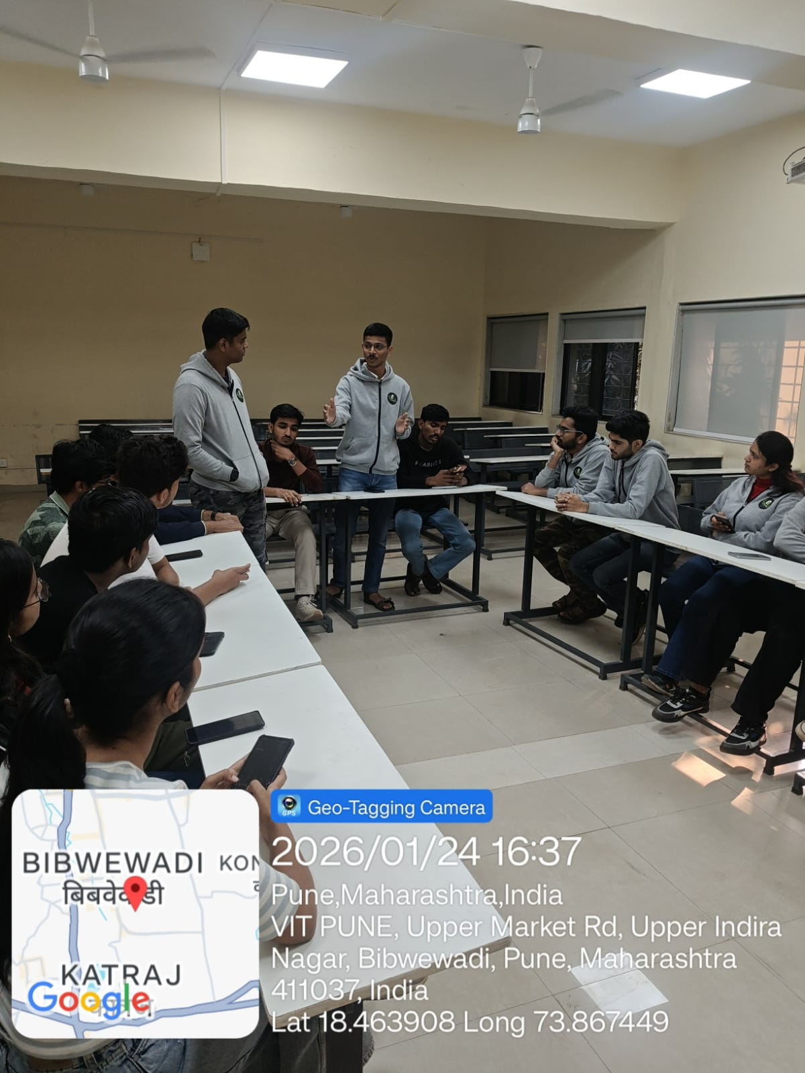

- Photograph Section : non geo-tagged photos

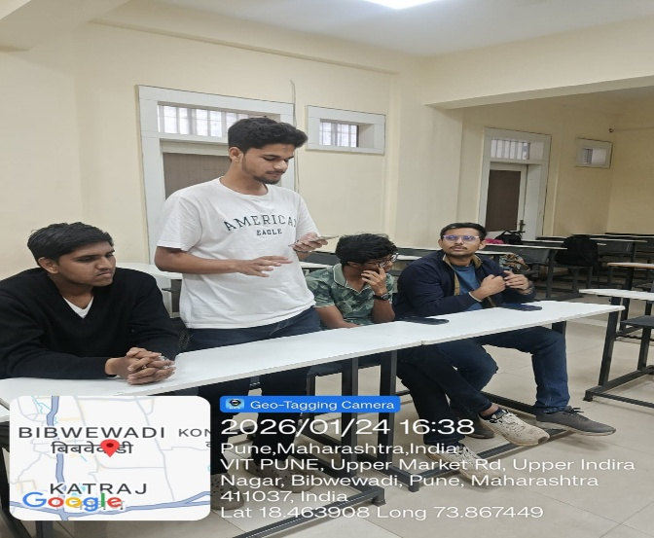

Additional details that are expected to be covered -
