Title: Event Report of Club/Committee FF 984
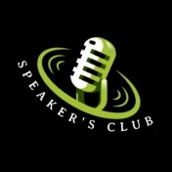
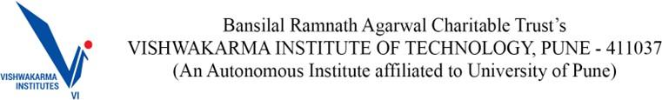

Event Report

Name of the Club:The Speaker’s Club
Name of the Event: Word War: The Battle of Languages
Student Vertical : Others
Instalment of the said event (e.g.: Maiden/nth installment)
Date and time of event | 5th September 2025 5 PM
Mode - Online Platform/ Venue: | Online
Event span (hours/days) | 2 hrs
Footfall/Total attendance | 24
Name and contact of the key organiser(s) | Siddhesh Chavan (8459861918)
No. of people involved in the organizing committee | 10
No. of faculty participated
Objective of the event | To improve public speaking confidence
Brief description of the said event (100 words or more) | In this event, we will discuss various issues related to language in India. The discussion will cover the historical background of language conflicts in the country, why these issues are emerging strongly today, and possible ways to resolve or mitigate them. We will also focus on the debate between regional languages and the idea of a national language. Through this discussion, participants will gain insights into multiple perspectives on India’s language issues.
Benefits to students and Faculty | Benefits to Students:  To improve public speaking confidence  Benefits to Faculty:
Key event outcomes | Sharing of idea/Thoughts on ongoing language issue in India

Title: Event Report of Club/Committee FF 984

Milestones set by the event (if any)
Social media links for the respective team | https://www.instagram.com/speakers_club_vit/
Name and bio of chief guest/s in attendance along with social media links (if any)
Event Sponsors and their brief description (if any)

Program Outcomes Section

Program Outcomes Indirectly Attained (Please enter the rating in the second column) | Category (Rating) Not Applicable (0) Partially Agree(1) Agree (2)  Strongly Agree (3)
Engineering knowledge  Has your ability to apply engineering knowledge to find solutions to engineering problems improved? | 2
Problem analysis: Has your ability to identify, formulate, and analyse engineering problems improved? | 3
Design/development of solutions: Has your ability improved to design and develop solutions to solve real world problems? | 2
Conduct Investigations of Complex Problems:How effectively were you able to investigate complex engineering problems using research-based knowledge, including the design of experiments, modelling, analysis, and interpretation of data to draw valid conclusions? | 2
The Engineer and the world: Is it possible for you to better apply reasoning informed by the contextual knowledge to assess societal, health, safety, legal and cultural issues? | 2
Engineering Tool Usage: How effectively were you able to create, select, and apply appropriate modern engineering and IT tools, including modelling and prediction techniques, while recognizing their limitations, to solve complex engineering problems? | 1
Ethics: Is your professional ethics improved due to participation in the event/activities? | 3

Individual and team work: Has your ability to function effectively as an individual, and as a member or leader in diverse teams improved? | 2
Communication: Has your ability to communicate effectively (comprehend and write effective reports, design documentation, make effective presentations, and give and receive clear instructions) improved? | 2
Project management and finance: Are the project management skills and handling the finance for the event/activity improved? | 1
Life-long learning: Has your ability to engage in independent and life-long learning in the context of technological change improved? | 2

Photograph Section : geo-tagged photos

- Photograph Section : non geo-tagged photos
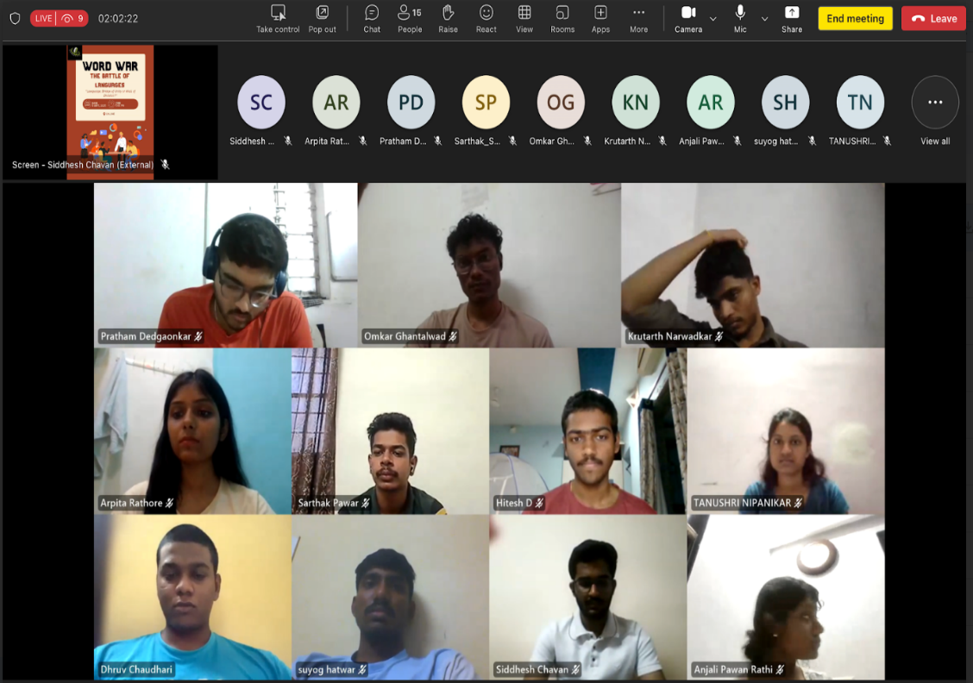

Additional details that are expected to be covered -

