Agile Methodology
Name: Asmita Patil
Branch: CESE
Div: B3
Roll No: 59
PRN: 12411211

Assignment- 6
Implement Jira, a project management tool that helps teams plan, track, and manage work for Software Application.

1. Aim
To implement and demonstrate Jira as a project management tool for a software application, using it to plan, organize, track, and monitor software development work through work items, backlog management, boards, sprints, reports, and project dashboards.

2. Objectives
- Create and configure a Jira project/space for a software application.
- Create and manage work items such as Epics, Stories, Tasks, and Bugs.
- Organize work using a product backlog and Scrum/Kanban board.
- Create sprints and assign work items to appropriate sprints.
- Track work using statuses such as To Do, In Progress, In Review, and Done.
- Monitor project progress using Jira's summary and reporting features.
- Demonstrate the implementation using screenshots as proof of work.

3. Software / Tools Used

Tool | Purpose | Evidence
Jira | Project and work-item management | Project Summary screenshot
Jira Backlog | Manage and prioritize backlog items | Backlog screenshot
Jira Board | Track task status visually | Board screenshot
Jira Reports | Analyze project and sprint progress | Reports screenshot

4. Project Implemented
A Jira space named “fitwel gaskets” was configured for managing the development of a software system. The project can be used to track requirements, development tasks, bugs, testing activities, and sprint progress.
Example project workflow:
Backlog → To Do → In Progress → In Review → Testing → Done

5. Jira Project Summary –
The following screenshot provides evidence that the Jira project/space was created and contains the required project management interface. The Summary page displays the project name, navigation tabs, work-item statistics, status overview, and reporting/automation areas.
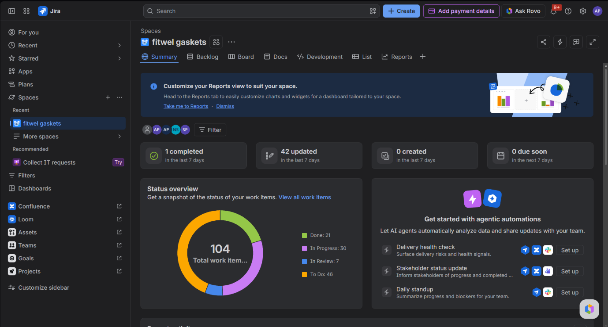
Figure 1: Jira Summary page for the “fitwel gaskets” project.

6. Work Item / Issue Management
Jira work items were used to represent individual units of software development work. Each item can contain a title, description, priority, assignee, status, labels, sprint, and other project information.

Issue Type | Example | Purpose | Status
Epic | Inventory Management | Large feature/module | In Progress
Story | Add New Product | User requirement | To Do
Task | Create Inventory API | Development activity | In Progress
Bug | Incorrect stock count | Defect tracking | In Review
Screenshot to add: capture the Jira Create/Edit Work Item screen or the List view showing the created issues. Replace the placeholder below with the screenshot.

7. Backlog and Sprint Management
The backlog is used to maintain pending work and prioritize tasks before adding them to a sprint. Work items can be grouped into sprints with defined start and end dates.
Create a product backlog.
Prioritize stories and tasks.
Create at least 5 sprints for demonstration.
Assign backlog items to the appropriate sprint.
Start and complete sprints to show project progression.

Suggested sprint structure:
Sprint | Main Focus | Example Work
Sprint 1 | Foundation planning | Requirements, project setup, database design
Sprint 2 | Authentication and RRBAC | Authentication, product module, APIs
Sprint 3 | Product and Inventory development | Stock tracking, outsourcing, product flow
Sprint 4 | Production and Outsourcing | Testing, bug fixes, validation
Sprint 5 | Testing and finalization | Reports, UI polishing, deployment
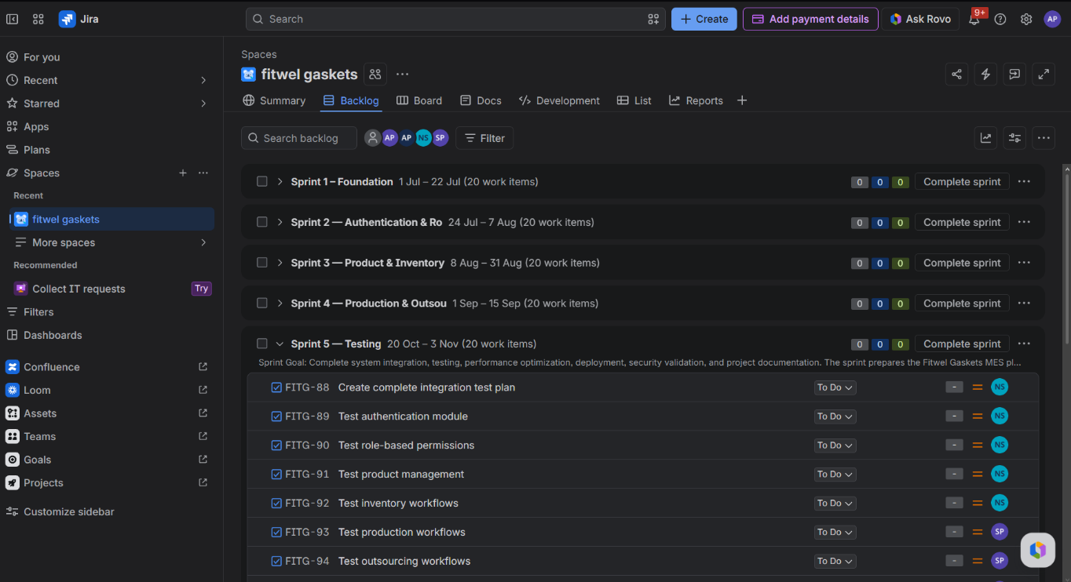

8. Scrum / Kanban Board
The Jira Board provides a visual representation of the project workflow. Work items are moved between columns as their development status changes.
To Do
In Progress
In Review
Testing

Done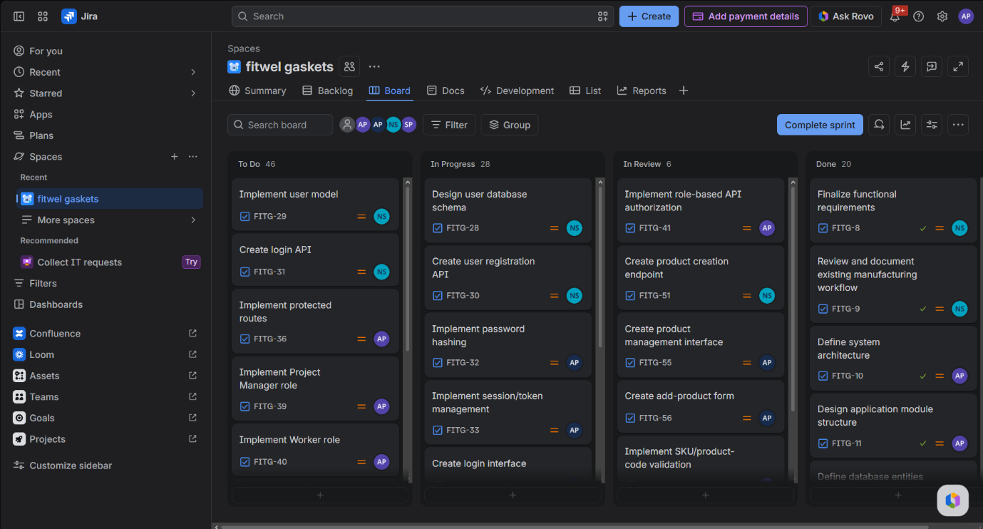

9. Reports and Project Monitoring
Jira reports are used to evaluate project progress and identify the current state of work. Useful reports include sprint progress, issue distribution, workload, and burndown/velocity information where available.
Status distribution
Sprint progress
Completed versus pending issues
Priority distribution
Developer/team workload
Sprint burndown or velocity
Screenshot to add: Jira Reports page showing at least one project/sprint report.

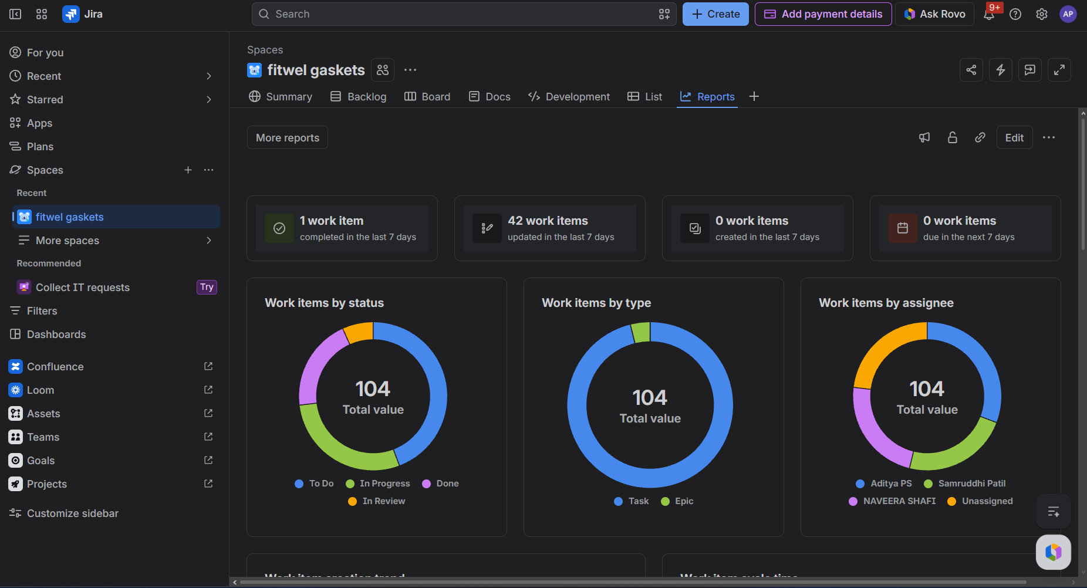

10. Result
Jira was successfully implemented/configured as a project management environment for the software application. The project provides a structured mechanism for creating work items, organizing backlog activities, managing sprints, tracking development status, and monitoring overall project progress through summaries and reports.

11. Conclusion
The assignment demonstrates how Jira can be used to apply Agile project management practices to software development. By dividing the project into manageable work items and sprints, the team can clearly track responsibilities, progress, defects, and pending work. The Summary, Backlog, Board, and Reports views provide a centralized platform for project monitoring and decision-making.

