Agile Methodology
Name: Asmita Patil
Branch: CESE
Div: B3
Roll No: 59
PRN: 12411211

Assignment- 7
Perform Testing activities within an agile project using Jira

1. Aim
To Perform Testing activities within an agile project using Jira.

2. Testing Approach in Agile
In an Agile project, testing is performed continuously alongside development rather than being left entirely until the end of the project. Test activities are associated with user stories, development tasks, and bugs in Jira. For the Fitwel Gaskets project, testing can cover modules such as authentication, product management, inventory workflows, outsourcing, AI-based gasket counting, dashboards, APIs, and database operations.
Create test scenarios for each completed feature.
Execute functional and integration test cases.
Record failed tests as Jira bugs/issues.
Assign defects to the responsible developer.
Move issues through To Do → In Progress → In Review/Testing → Done.
Retest fixed defects before marking them as completed.

3. Jira Sprint Testing Evidence
The following screenshot shows Sprint 5 – Testing in the Fitwel Gaskets Jira backlog. The sprint contains 20 work items and includes testing activities such as authentication testing, role-based permission testing, product management testing, inventory workflow testing, AI counting workflow testing, API integration testing, frontend testing, and database testing.

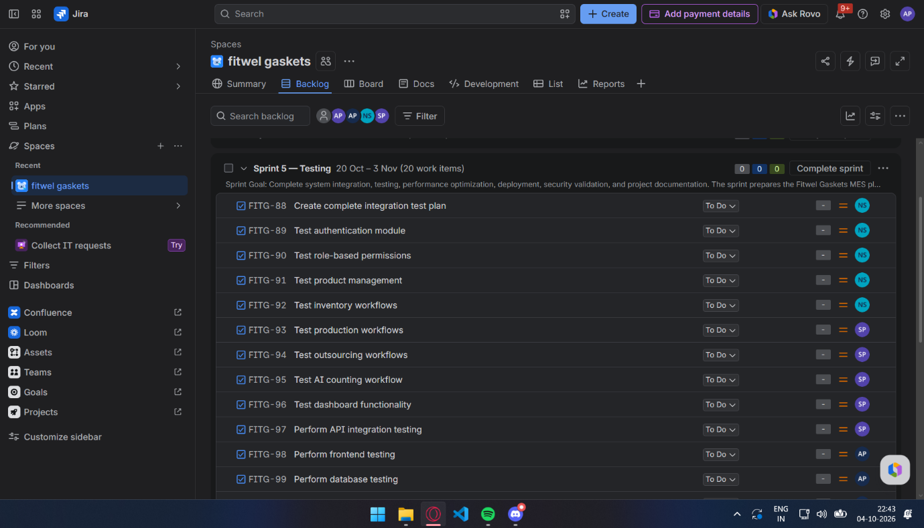
Figure 1: Jira Sprint 5 – Testing showing test-related work items.

4. Sample Test Cases

TC ID | Module | Test Scenario | Expected Result | Status
TC-01 | Authentication | Login with valid credentials | User is logged in successfully | Pass
TC-02 | Authentication | Login with invalid password | Error message is displayed | Pass
TC-03 | Roles | Worker opens admin function | Access is denied | Pass
TC-04 | Product | Add a new gasket product | Product is added to inventory | Pass
TC-05 | Inventory | Update product quantity | Updated quantity is stored | Pass
TC-06 | Inventory | View daily production count | Correct daily count is displayed | Pass
TC-07 | Outsourcing | Record outsourced batch | Outsourcing record is saved | Pass
TC-08 | AI Counting | Upload gasket image | System returns gasket count | Pending
TC-09 | API | Send valid inventory API request | Expected response is returned | Pass
TC-10 | Database | Retrieve product record | Correct record is returned | Pass

5. Sample Defect / Bug Tracking
When a test case fails, the tester creates a Jira bug and records the observed behavior, expected behavior, severity, priority, and evidence. After the developer fixes the issue, the tester retests it and closes the defect if the expected result is achieved.

Bug ID | Defect | Severity | Assigned To | Status
BUG-01 | Incorrect inventory quantity after update | High | Developer | Fixed / Retest
BUG-02 | Unauthorized user can access restricted page | Critical | Developer | Open
BUG-03 | Dashboard count does not refresh | Medium | Developer | In Progress

6. Result
A Jira-based Agile testing workflow was prepared for the Fitwel Gaskets software project. The Sprint 5 backlog provides evidence of dedicated testing work items, while the sample test cases and defect records demonstrate how functional testing, access-control testing, integration testing, database testing, and defect retesting can be tracked within Jira.

7. Conclusion
Jira provides an effective platform for integrating testing into Agile software development. Test activities can be directly associated with sprint work, defects can be assigned and tracked, and the status of testing can be monitored by the entire team. This approach improves visibility, accountability, and early identification of software defects.

