|  |  |  |
| --- | --- | --- |
| Functional and non-functional determination | Requirements | MoSCoW prioritization |
| F(R1) | Registration for customer | M |
| F(R2) | Login for admin | M |
| F(R3) | Login for customer | M |
| F(R4) | Add to stock | M |
| F(R5) | Update stock | M |
| F(R6) | Delete stock | M |
| F(R7) | View bookings | M |
| F(R8) | View members | M |
| F(R9) | Search for bikes | M |
| F(R10) | View new launches bikes | M |
| F(R11) | View upcoming models | S |
| F(R12) | View popular models | S |
| F(R13) | View according to brands | C |
| F(R14) | Show price of bikes | M |
| NF(R15) | User friendly interface | M |
| F(R16) | Generate bills | S |
| F(R17) | Update profile of customer | M |
| NF(R18) | Website security | M |
| NF(R19) | Reliable | M |
| F(R20) | Supplier’s information | M |
| F(R21) | Second hand bikes | C |
| F(R22) | Bike’s style | C |
| F(R23) | Feedback from clients | M |
| F(R24) | Book bike | M |

# Use case diagram

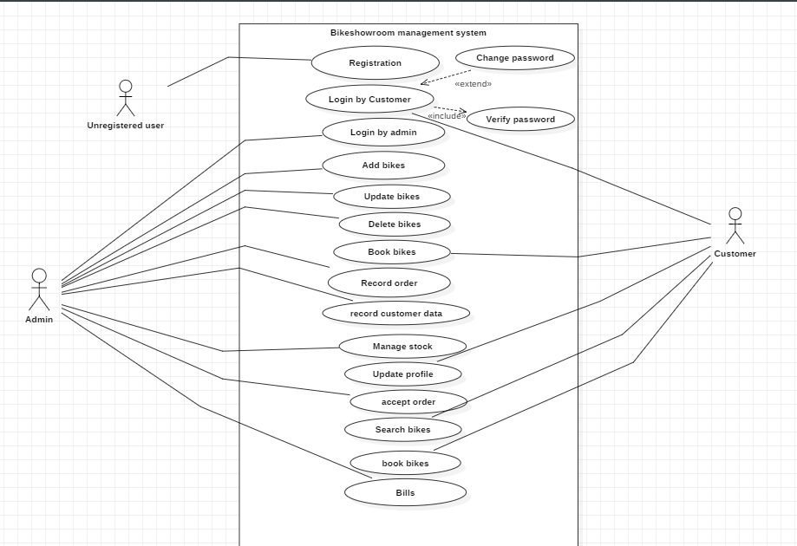

# Class Diagram

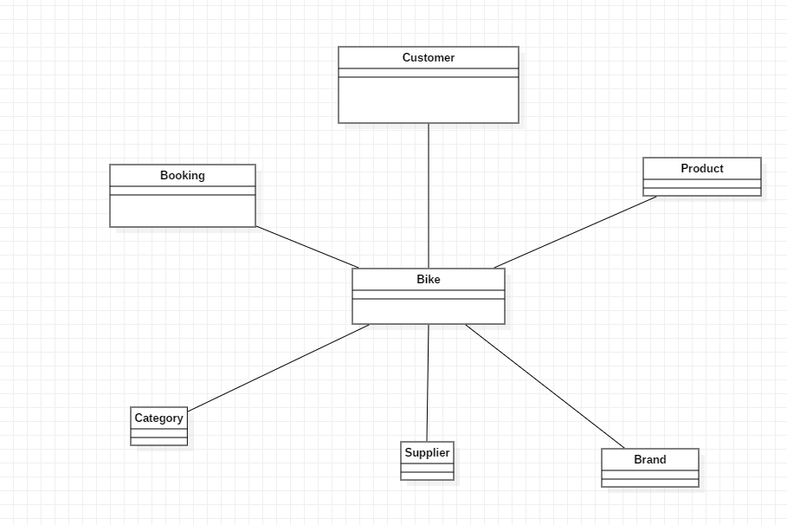

# ER diagram

