## **Acknowledgement:**

Throughout the project of computing project (CP) it was my great experience of my entire life. It was my honour to present the shots online liquor shopping an ecommerce site as a part of my level 5 diploma in computing (L5DC). This web-based application was built for the project of CP.

Building up this time of project help me build up more. This, project help me to gain more knowledge about several thing like Laravel framework, php testing etc.

# **Chapter 1: Introduction**

Online Bike showroom is a web-based shopping system. The project objective is to deliver the online shopping website.

Online shopping is the way where customers can buy goods directly from a seller in real-time. It is a form of electronic commerce. The system attempts to provide the facility of online shopping to the customers of a real shop which help buying products through Internet. From this customer could order product and it will be delivering to them as cash on delivery.

## **Section 1.1: Overview:**

Online showroom reduces time to customers to go to showroom and select the bike as they want. Thought, this project lacks payment system, but the customers could select their desired bikes and book it.

## **Section 1.2 - Problem Statement:**

As online shopping has become a trend nowadays the regular stores are losing their customers to online brands. Customers have effortless shopping experience and saving time through shopping online. For competing with those online sites, if shops are providing an online portal where their customers can store through internet and get the products at their doors it will increase the number of customers

**Section 1.3 - Features**:

* **Manage Products:**

1. Insert Product Details
2. View Product Details
3. Edit Product Details
4. Delete Product Details

* **Manage Users:**

1. Registration of User
2. View User Profile
3. Edit User details

* **Manage Orders:**

1. View Orders
2. Delete Orders

## **Section 1.4-Aims:**

* To develop website for online shopping of Bike showroom
* To add new arrivals bike
* To design admin and for general user system
* To manage general users

## **Section 1.5 - Objectives:**

* Designing a website to fulfill the aims of project.
* Develop sophisticated user-friendly interface, intuitive navigation
* Testing of a system under different circumstances
* Detail documentation of system working mechanisms
* Provide user manual for creating interactive relation between system and users.

# **Chapter 2- Analysis:**

## **Introduction:**

Analysis is detail inspection of data and facts to understand effect and cause relationships for providing basis to solve problem and decide. In the first phase of analysis the requirements are gathered. For the analysis phase various diagrams are drawn such as Use Cases, Rich pictures to visualize requirements. The steps of analysis are described in various sections down below which deals with problem faced by user in current system and requirement of the project. Data analysis is important to verify our results would be valid, reproducible and unquestionable.

## **Section 2.1- Analysis Methodology:**

Soft System Methodology is used for online Bike showroom as it is people-oriented project. Online showroom is dedicated to the customer where the need of customer is to be fulfilled. The methodology is used for solving problem and in management of change. The steps require for SSM are listed below:(anonymous, 2018)

**CATWOE** is used to create rigors and comprehensive root definition. It is a simple checklist used to stimulate thinking about problem and solutions. It is used to identify business achievement, problem areas and solutions.(anonymous, 2013-2015)

The six elements of CATWOE are listed below:

* **Clients:** Clients or Customer are the stakeholder who benefit or suffer during the change of system. In the first step of analysis customers are identified and understand how change in system affects them. The authorized person who signs in will be client of the system.
* **Actors:** Actors are people who are directly involved in system change. The impact of new system for them must be clarified. The stakeholder’s responsibilities are listed out. The admin of the system will be known as actor of the system.
* **Transformation:** It refers to what will happen to the data and what processes will be affected by the development of system. CATWOE analysis requires the list of inputs and the nature of change inputs undergo to give outputs. It deals with input and outputs the client’s gets during the access of the system which result robustness, accuracy, efficiency, reliability of the system. In the current scenario, customer visit liquor shop and view product then buy the liquor which is difficult for both customer and client to deal at the time and give response. By the development of new system both the customer and client could get benefit without facing problem.
* **World View:**  It refers to wider impact of transformed system. There might be positive and negative impact on the change of system on overall business matter. There might be different perspective of person regarding to solution to a problem as a world view. The problem of existing system is analyzed from various levels of stakeholders. For this system admin user would add product details and customers can view the product to order which would be delivery on cash. They can surf variety of brands, types of liquor with certain offers and prices.
* **Owners:**  They are person who owns the organization and has power to take decision for changing project and future works. In the system admin is the owner.
* **Environmental Constraints:**  It deals with political, legal, demographical, technological, social, economic environmental factors limitations and constraints. These environmental factors are kept in mind during the system development for successful project.

### Conceptual model:

The descriptive model of a system based on qualitative assumptions about its elements, their interrelationships and system boundaries. It is used to explain how the system should function and what activities are important to take place of processes. In this model 3E (Efficiency, Efficacy and Effectiveness) are measured to improve system performance.(Anon., 2018)

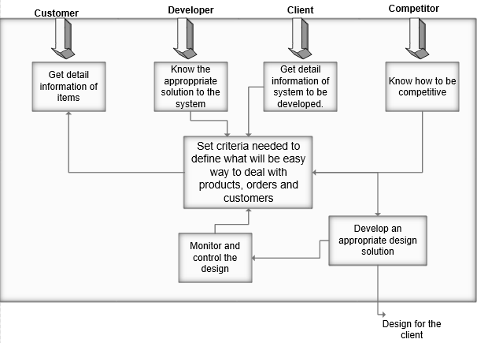

Figure 2: Conceptual model

## **Advantage of SSM:**

* Involvement and participation of user during development
* Open discussion of problems needs and solution
* Helps to deal with various environmental factors
* Joint problem-solving technique
* Various perceptions

## **Disadvantage of SSM:**

* Difficult to manage
* Does not fit for complex organization
* Lack of technical perspectives
* Difficult to get on agreements between users

## **Section 2.2: Feasibility Study:**

A feasibility study describes about viability of an idea within an emphasis on finding potential problems. This study will address where and how business will be operating. Market, Technical and Financial feasibility could be known by this study.

For this project some of the steps for feasibility study had been taken within the interaction of stakeholder which is described below:

### Interview:

The most common method to get information of an individual is interview. For the collection of data various type of interview such as structured, semi-structured and un-structured interview. It is conducted by different means as face-to-face, telephone, emails.

For the detection of problem live interview had been done with client and his customers. In this session, we had discussed about problem face from current system and what they want from new system. A certain customer where telephoned because of busy schedule we had tried to interact with daily customers and other customer to be get feed backs.

**Result:**  After this session, we get to know that there were both positive and negative about new system implementation from the customer. The problem faced by our client is also identified. For him it was difficult to interact with many people at a same time and get the product they want with in a bragging of prices. In customer point of view the new system will help them to get the product as per their wish with in all description they do not have to rush for offers too.

### Questionnaires’’:

It is another way to get information with the list of question asked to certain group of people to know their perspectives. Different sort of question is asked to people that may include the multiple choice, yes or no question to extract their view with short points.

Following list of question is asked to respondents:

1. Do you remember customers order in same time?
2. How long will you remember product details?
3. How many customers visit shop?
4. Did you get the product you want from store?
5. Do you prefer online shopping?

## **Section 2.3: Use Case Diagram:**

It is one of behavioural diagram that describe interaction of actor within a system. It describes about the user of the system and their roles.

The reason to sketch use case diagram are listed below:

* To identify how actor, interact system without worrying about functional requirement
* To visualize functional requirements which will be translate into choice of design and priorities for development.
* To identify external and internal factor which may influence system?

**Symbols and Notation of Use Case Diagram:**

1. **System:** It is a rectangular box which contains use case.
2. **Use Case:** It is a round shape which describe role of user.
3. **Actors:**  It is a stick man which is user of system.
4. **Relationships:**  It is a simple line that shows relation between actor and use cases. There are two type of relationship i.e. include and extend.

The **use case diagram** of system is shown below:

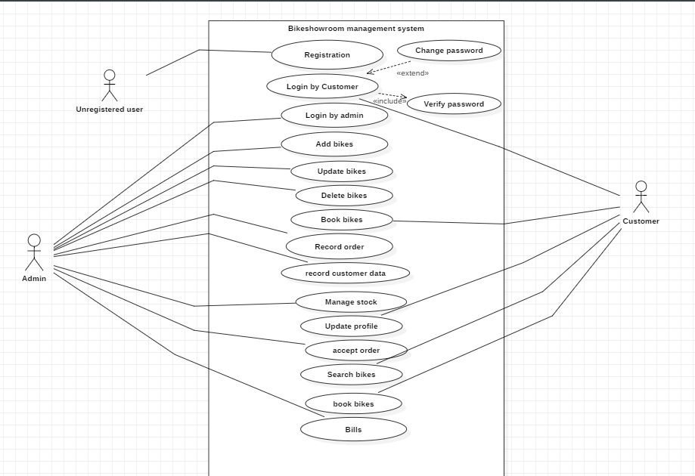

**Explanation:**

For the given diagram, there are two types of user to access the system i.e. admin user and authenticated user. Different type of privileges is given to both users i.e. admin and authenticate user.

1. General user opens the registration form and fills out the requirement.
2. User click on register button
3. System validate the given information from the user
4. System will throw message user is registered
5. Admin user can directly proceed to login within the verification
6. User can access the system by providing username and password
7. System will authenticate the username, password and user type
8. If login is successful, then dashboard of each type of user will be presented
9. If login is unsuccessful then error message will be thrown by the system
10. After login user can view their profile
11. User can edit their personal information in the profile
12. System will inform user when profile is edited
13. User can logout from the system

### Explanation:

For the given diagram, authenticate user privileges are shown. The less privilege to the system is given to this user where they can access some features. They can perform following activities after login to the system:

* **Search Product:**  They can surf to the product which has many varieties. In the system there are products like liquor, beverages, glasses and many more.
* **View Product Details:** Product detail can be viewed within their details like quantity, brands, volume, price, types are shown.
* **Order Product:** User can order the product after it is viewed.
* **Add Item to Cart:** Products are added to the cart which they want.
* **View Shopping Cart:** The products added to the cart can be viewed with in a calculation.
* **Remove Order Item:** When the product is shown in a cart they can remove the ordered item if they want.
* **View Offers:** There are variety of offers in the occasion within a special discount of price and free of other products.

## **Section 2.4: System Requirement System (SRS):**

SRS is a functional and non-functional requirement where a functional requirement refers to what a system do and non-functional requirement refers to how a system does.

## 2.4.1: Functional Requirement:

|  |  |
| --- | --- |
| Title | Prioritization |
| Registration | Must have |
| Login | Must have |
| Add new Product | Must have |
| Search Product | Should have |
| View Product | Should have |
| Edit Product | Should have |
| Delete Product | Should have |
| Order Product | Could have |
| View Order | Could have |
| View User | Should have |
| Delete User | Should have |
| Send Notification | Should have |
| Add product to cart | Should have |
| View cart | Should have |
| Remove Product from Cart | Could have |
| View Profile | Should have |
| Edit Profile | Could have |

## Non-Functional Requirement:

* The non-functional requirements are listed below:
* **Security:**  The security of the data plays important role for the development of system. The secure system can be gain by authentication during login, strong password and day-to-day backups. If the personal information of the user is used in illegal way such as hacking and data misuse, then it may arise huge problem.
* **Performance:** It deals with robustness of system. The execution of the functionality must be faster in use. The performance of the system is determined when various users will access same functionality at same point of time. The fault-tolerance of the system is also measured.
* **Usability:** The ease of use of system for user is Usability. Whenever user access the system there must proper understand, co-ordination and learning between user and system.
* **Availability:** The system must be made available whenever user wants to access from wherever.
* **Reliability:** System should provide extract output for the input given by the user when a task is being performed. For the protection of system from failure error must be identified and correction of strategy.

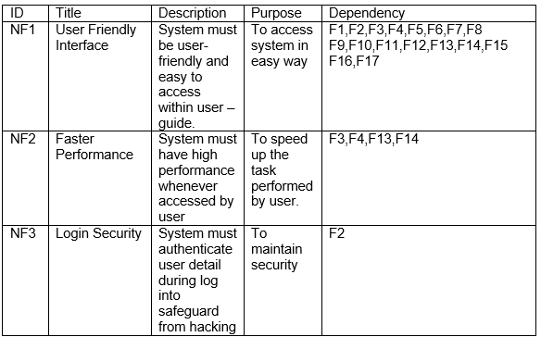

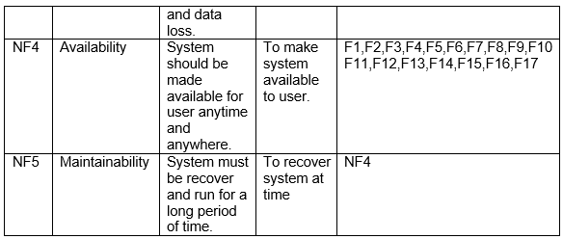

## **Section 2.5: Architecture**

It is overall structure of system which is responsible to handle functionality and quality requirement. For system architecture, functional and non-functional requirements are identify to the developers.

### 2.5.1: System Architecture:

For the development of website, MVC architecture is followed that comes up with Model, View and Controller.(anonymous, 05 May 2008)

* **Model:** It is collection of data
* **View:** The graphical representation of system
* **Controller:** The main brain between model and view.

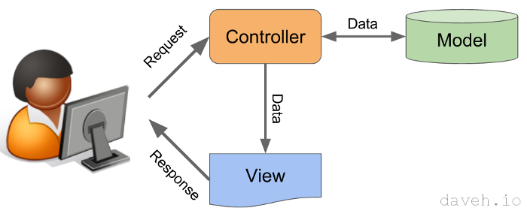

Figure 8: system Architecture

### 2.6.2: Initial Class Diagram:

The blueprint of the system is known as the class diagram. The class of the initial diagram is the main classes and should be included in the main class. The initial class diagram is drawn during the analysis period.

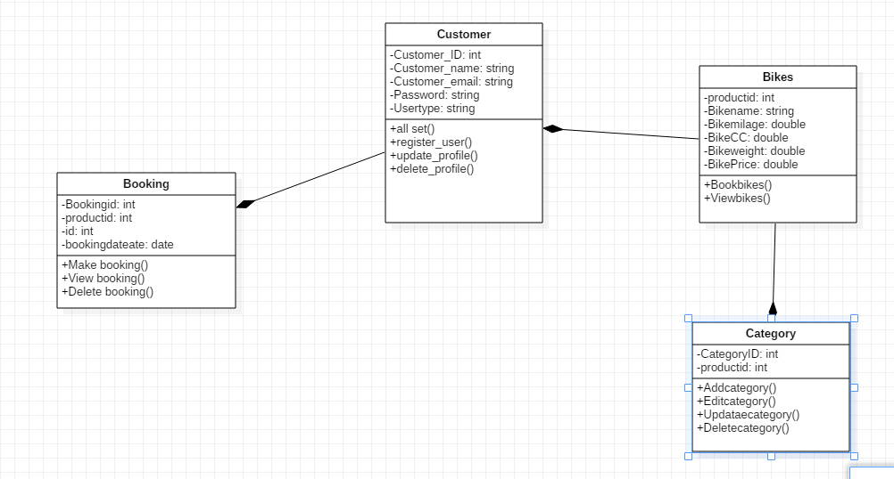

# **Chapter 3: Design**

## **Introduction:**

The solution of the creation of new system is system design. This phase of development deals with the detail implementation of the feasible system. It is based on specific customers need. It consists of three phases of development which are structural design, behavioural design and database design.

## **Section 3.1: Structural Design:**

It is the architectural map for a system that emphasizes the structure of the objects, class, attributes, operations and relationships.

### **Class Diagram:**

Class Diagram shows a static view of a system. Class diagram consist of collection of class, relationships, interface, constraints and collaborations. It is a diagram which can mapped directly with object-oriented languages.(anonymous, 2018)

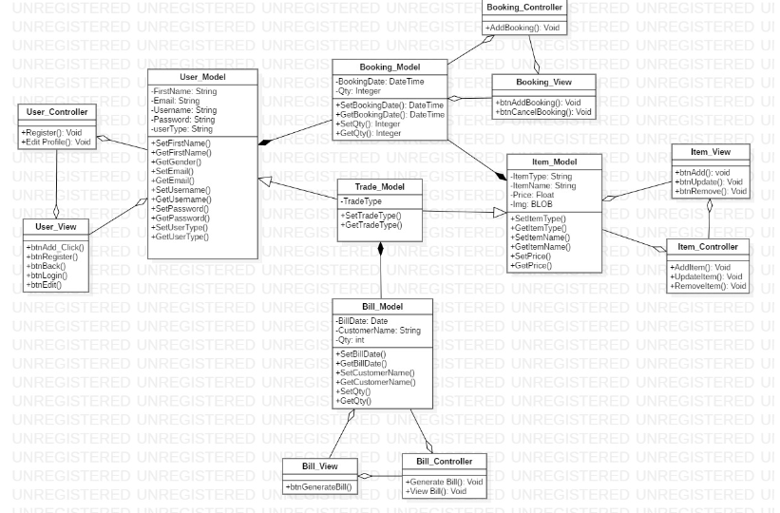

The above class diagram consists of various relationships such as composition, dependency, association. Each model consists of controller which is dependent to own classes. Product is related to product type and user model within a composition relationship in the absence of one another could not work. User model has a multiple association relationship as a one user can get much notification at a time. User and Order has a composition relationship since order is dependent to user. Sale and Cart is dependent to order class within a composition relationship.

## **Section 3.2: Behavioral Design:**

It is a behavior of a system which changes over a time. It shows the interaction of the object to produce particular system behavior in a use case, sequence and activity diagram.

### **Activity Diagram:**

It is a visual representation of series of actions of a system. It explain about how activity coordination to provide features at different levels of abstraction.(anonymous, 2018)

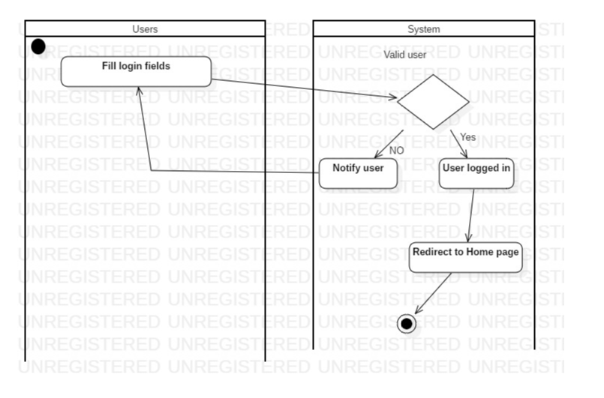

the above diagram, the actions during the login and registration activity are shown. User can visit login or registration page as they require. If the user is already registered, they can visit login otherwise registration page is available for non-registered user.

For the login process, the username and password must be made available. If the username and password is null then the login page is reloaded and if user enter invalid credentials then error message will be loaded in login page. Otherwise user can easily login to the system within an authentication process.

For the registration process, user must provide the registration detail in the form within a proper validation of data. If the data is valid then user will be register successfully otherwise error message will be displayed in the registration page. After registration user can login to the system and if login error will displayed then the login page will be displayed.

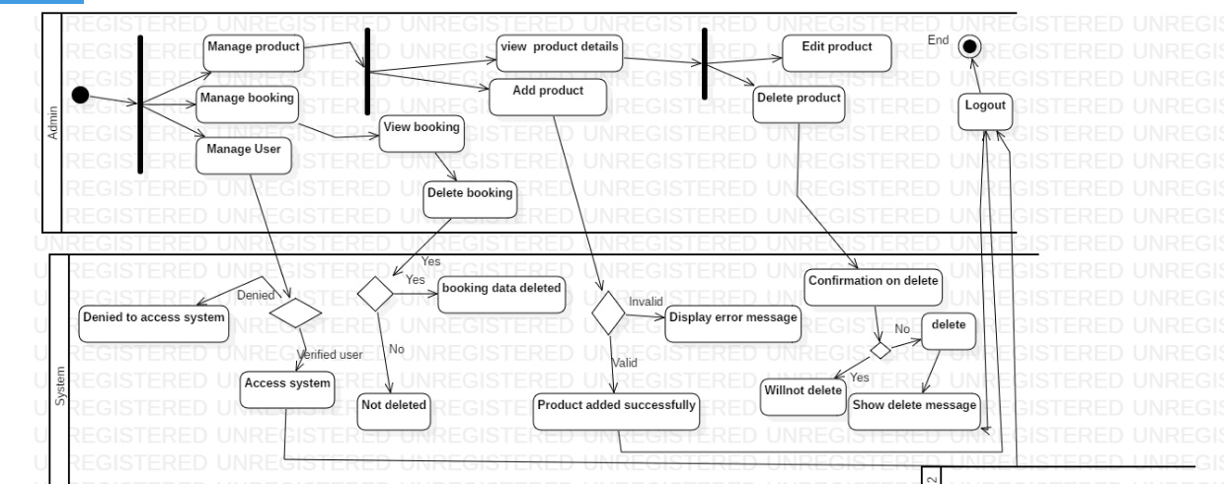

Figure 12: Admin User

In the above diagram, the actions of admin are shown. As an admin user, they can perform action as managing product, order, user and sending notifications. Login is requiring performing such actions.

Admin user can **manage product** as adding product details, view product detail, edit and delete product details. When adding product detail, the valid data must be filled up otherwise error message will be displayed. For modifying product details, the view of product detail is viewed, and user can edit and delete product as they require. If valid data is entering while editing product details, then success message will be displayed otherwise the error message will be reloaded in the system. Whenever user want to delete product details the conformation message is displayed and if they click on yes then data will be deleted and if no is clicked then data will not be deleted.

Admin user can **manage user** as blocking user to access the system. If the admin user deleted the user from the system, then they cannot access the system and if they are not blocked then they can access to system.

## **Section 3.3: Database Design:**

It is a logical view of the data which shows the relationship between tables and exchange of data in a system.

### **Entity Relationship Diagram:**

It is related to data structure diagram which shows relationship between entities and elements of entities. It maps out the flow of information for a system.(anonymous, 2018)

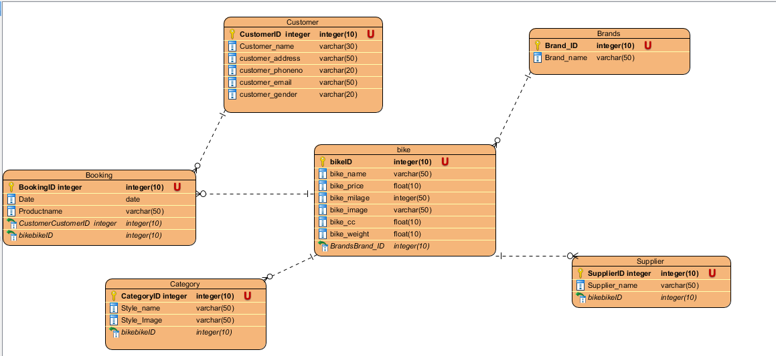

ER diagram

Justification

* To visualize database design ideas, we have a chance to identify the mistakes and design flaws, and to make correction before executing the changes in database.
* By visualizing a database schema with an ERD, we have a full picture of the entire database schema. You can easily locate entities, view their attributes and to identify the relationships they have with others.

Advantage

* It is very simple if we know relationship between entities and attributes.
* It is better visual representation.
* It is an effective communication tool for database designer.

Disadvantage

* It has limited constraints and specification.
* Information can be hidden in ER model.
* It is difficult to show data manipulation in ER model.

# Meta Data

|  |  |  |  |  |  |
| --- | --- | --- | --- | --- | --- |
| User table | | | | | |
| Column Name | Type | Length | Key | Null | Description |
| Customer ID | Int | 10 | PK | No | Unique identification of customer |
| Customer Name | Varchar | 30 |  | No | Customer’s Name |
| Customer’s address | Varchar | 50 |  | No | Customer’s address |
| Customer’s email | Varchar | 50 |  | No | Customer’s email |
| Customer’s phone | Varchar | 20 |  | No | Customer’s phone |
| Customer’s gender | Varchar | 20 |  | No | Customer’s gender |

|  |  |  |  |  |  |
| --- | --- | --- | --- | --- | --- |
| Product table | | | | | |
| Column Name | Type | Length | Key | Null | Description |
| Bike ID | Int | 10 | PK | No | Unique identification of Bike |
| Bike Name | Varchar | 30 |  | No | Bike Name |
| Bike price | Float | 10 |  | No | Bike price |
| Bike CC | Float | 10 |  | No | Bike CC |
| Bike mileage | Float | 10 |  | No | Bike mileage |
| Bike weight | Float | 10 |  | No | Bike weight |
| Bike Image | Varchar | 20 |  | No | Bike’s Image |

|  |  |  |  |  |  |
| --- | --- | --- | --- | --- | --- |
| Booking table | | | | | |
| Column Name | Type | Length | Key | Null | Description |
| Booking ID | Int | 10 | PK | No | Unique identification of Booking |
| Date | Date |  |  | No | Booking Date |
| Product name | Varchar | 30 |  | No | Product Name |
| Customer ID | Int | 10 | FK | No | Customer’s ID |
| Bike ID | Int | 10 | FK | No | Bike ID |
| Bike Image | Varchar | 50 |  | No | Bike Image |

|  |  |  |  |  |  |
| --- | --- | --- | --- | --- | --- |
| Category table | | | | | |
| Column Name | Type | Length | Key | Null | Description |
| Category ID | Int | 10 | PK | No | Unique identification of Category |
| Style Name | Varchar | 50 |  | No | Bike Style name |
| Bike ID | Int | 10 | FK | No | Bike ID |

|  |  |  |  |  |  |
| --- | --- | --- | --- | --- | --- |
| Brand table | | | | | |
| Column Name | Type | Length | Key | Null | Description |
| Brand ID | Int | 10 | PK | No | Brand ID |
| Brand Name | Varchar | 50 |  | No | Bike Brand name |

|  |  |  |  |  |  |
| --- | --- | --- | --- | --- | --- |
| Supplier table | | | | | |
| Column Name | Type | Length | Key | Null | Description |
| Supplier ID | Int | 10 | PK | No | Supplier ID |
| Supplier Name | Varchar | 50 |  | No | Bike Supplier name |
| Brand ID | Int | 10 | FK | No | Brand ID |

# **Chapter 4: Implementation**

## **Introduction:**

Implementation is a technique to convert design into real time working environment which is coded within a use of various programming language. The process is carried out when a design model meets client's expectations.

### **Section 4.1: Choice of Language:**

A website is coded in PHP language. PHP is open source scripting language usually used for a web development which is embedded into HTML. This language was developed within a combination of various programs such a CGI (Common Gate Interface) for interaction of interface and database. Further more concepts and login were added and various versions were developed. Thus, PHP is flexible and easier to access.

### **Section 4.2: Development Environment;**

### **Frameworks:**

A project is developed in Laravel Framework which is open-source web designed framework. It follows up MVC pattern and Symphony. There are inbuilt set of features as routing, validation, authentication, testing and many more.

### **Standard Libraries:**

A package of small program codes which help developer to design system within a small effort is a library. For current system development, CSS and JS are included to support UI.

**JQuery:** A special library highlighted for java script which simplify HTML documentation traversing, event handling, animation and interaction with Ajax.

**Semantic Unit:** It is collection of CSS and JS that will be used in system design.

## **Section 4.3: Development Platform:**

The website is developed and designed in Windows.

## **Section 4.4: IDE:**

IDE refers to Integrated Development Environment. It is tools to platform for efficient coding within integration of different feature.

Phpstrom is a perfect IDE for developing website .The general features of Phpstorm is language feature support, code completion, code quality analysis, debugging, testing and many more. It is an IDE which support the given framework (Laravel).

## **Section 4.5: Deployment strategy:**

It is a way to deliver actual project from development phase to client workstation. It consists of various steps which are listed below:

* Release: When a system passes by development process, it is ready to release in real environment.
* Activation and Installation: Activation is method to execute software components. Installation is process to use system in computer.
* Deactivate: It is reverse process to activation.
* Adapt: It is modification of system which had been installed.
* Update: The process to replace older version into new one is update.(anonymous, 2018)

## **Section 4.6: System Migration:**

System Migration is specialized method of moving processed from one computer environment to another. It varies within situation. During migration there will be physical or logical dependencies which must be checked and fulfilled at initial stage.

Some of physical and logical dependencies of system are listed below:

* Server: It is a device of high configuration which can handle a large user at a time.
* Apache Server: Serve which runs in PHP scripts.
* My Sql: It is database server.
* Composer: It is dependency manager of PHP.

And all the required coding screenshot and image Is in Appendix.

# Chapter 5: Testing

## Introduction**:**

Testing is investigation and evaluation software quality. The main aim of software testing is to measure software core requirement. Each function in the core system is tested by different user interaction and expected outputs were gained. Testing is done for the further precautions so that in future user would face problem while accessing it.

There are various types of testing as unit testing, black box testing, white box testing, acceptance testing and many more. Each of testing consist of own features and have different goals.

Black box testing and white box testing are performed within test case and test plans.

Test case: It is a set of actions performed in software which is well documented.

**Advantage of Test Case:**

* It can be referred anytime in a team for understanding of functionalities
* Time Consuming
* Improve Software Quality

**Test Script:** It is line by line description of action which is performing as a test.

**White box testing**

White box is known as the clear or glass box testing. The testing I done internally with several programming skills and coding in the test package. The white box testing gives the prompt test results as it is done through the coding. This, testing is done within the unit level. The white box testing is also known as unit, integration and system level testing. White box testing for the shots online liquor store are as follows:

|  |  |
| --- | --- |
| Test Case | White Box (1) |
| 1. Purpose of test case |  |
| 1. Test Data |  |
| 1. Class name | Register test |
| 1. Function name | testRegister |
| 1. Expected result | Display registration form |
| 1. Actual result | registration form display successful |
| 1. outcome | Yes |

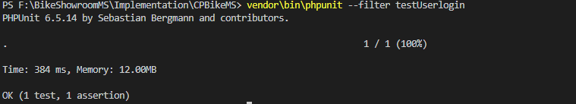

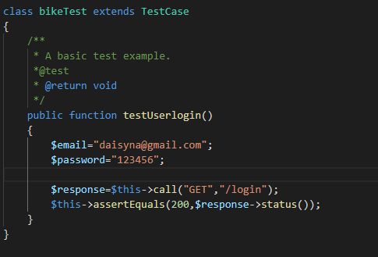

## **Chapter 6: Other Project Issues:**

## **Section 6.1: Risk Management**

Risk Management is the process of identifying, assessing and controlling threats to an organization’s capital and earnings. For the successful project risk management is important because achieving a project’s goals depends on planning, preparation, results and evaluation that contribute to achieving strategic goals.(anonymous, 2018)

In the risk matrix, likelihood is the pre-defined thought that affects system objectives and consequences defines the result of some activities. Impact of the risk is directly proportional to likelihood and consequences.

|  |  |
| --- | --- |
| **Consequence** | **Value** |
| Very Low | 1 |
| Low | 2 |
| Medium | 3 |
| High | 4 |
| Very High | 5 |

|  |  |
| --- | --- |
| **Likelihood** | **Value** |
| Low | 1 |
| Medium | 2 |
| High | 3 |

Table 7: Risk Likelihood and Consequence Values

|  |  |  |  |  |
| --- | --- | --- | --- | --- |
| **Risk** | **Likelihood** | **Consequence** | **Impact** | **Action** |
| Server failure | 1 | 5 | 5 | Monitor server regularly. |
| Database Failure | 1 | 4 | 4 | Back-up of data in database. |
| Power fluctuation | 1 | 2 | 2 | Reduction of amplitude voltage. |
| Server overload | 2 | 5 | 10 | Maintenance on monthly basic, cleaning the servers and databases. |
| Employee theft | 2 | 5 | 10 | Marinating trustful environment with employee. Employee dissatisfaction leads to employee theft. |
| Lack of resources | 2 | 2 | 4 | Budget increment and make sure of available resources. |
| Lack of user knowledge | 3 | 2 | 6 | Users awareness should be provided about using the system. |

## **Section: 6.2: configuration Management:**

**Configuration management** (**CM**) is a system engineering process for establishing and maintaining consistency of a product's performance, functional, and physical attributes with its requirements, design, and operational information throughout its life.

