**Check the home server**

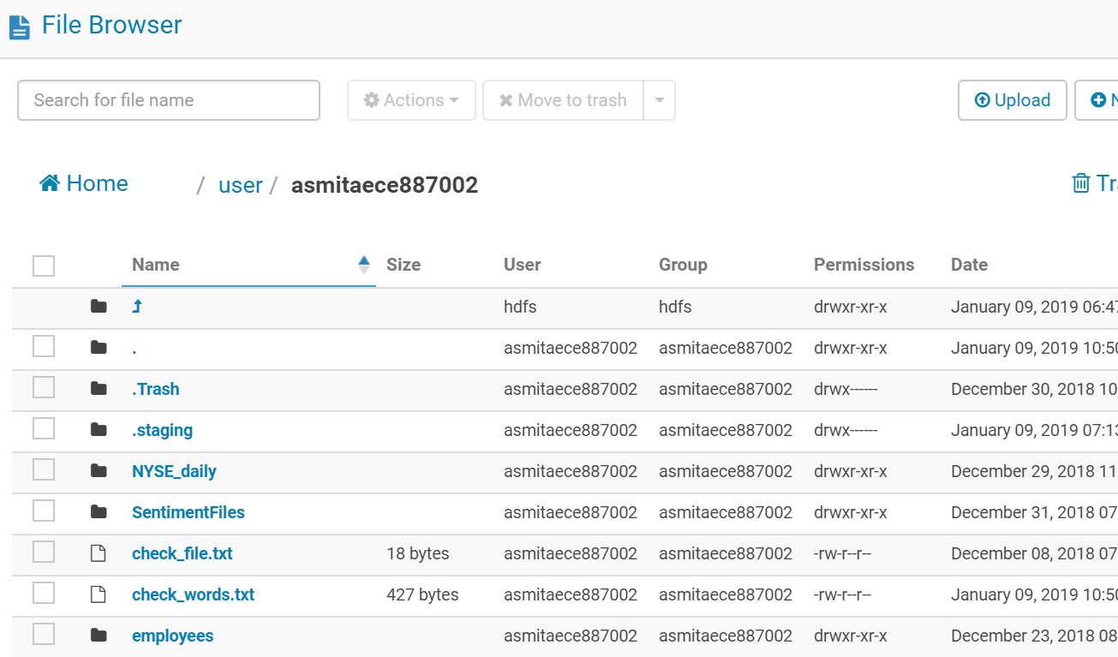

Now , we need to find out the frequency of words in the file **check_file.txt.**

**Approach 1 :**

**Using Unix pipeline commands to check the word count**

🡪Replace space with a newline

🡪Order lines with a sort command

🡪 Then find frequencies using uniq

🡪 Scans from top to bottom

🡪 prints the count when line value changes

The command for the same is :

cat check_words.txt| sed -E 's/[\t ]+/\n/g'| sort -S 1g | uniq -c



