Project: |  | University Bazaar System (UBS)
Team No.: |  | Team 5
Class: |  | CSE 3310; Fall 2016
Module: |  | System Requirements Analysis (SRA)
Deliverable: |  | SRA Document
Version: |  | [1.1] | Date: | [12/05/2016]

Contributors:
Suman Shrestha
Shrey Aryal
Asmita Shrestha
Sosal Pokhrel

Revision History
Version number | Date | Originator | Reason for change | High level description of changes
1.0 | 11/03/2016 | Suman Shrestha  Shrey Aryal  Asmita Shrestha  Sosal Pokhrel | Initial draft
1.1 | 12/04/2016 | Suman Shrestha  Shrey Aryal  Asmita Shrestha  Sosal Pokhrel | Final draft | All the functionalities are implemented with exception handling.

TABLE OF CONTENTS
1. Introduction and Project Overview 4
2. Objectives 5
2.1 BUSINESS Objectives 5
2.2 SYSTEM Objectives 7
3. Project Context Diagram 8
4. Systems Requirements 9
4.1 “Home Screen” Requirements 9
4.2 “Login and Registration” Requirements 10
4.3 “Form Club” Requirements 13
4.4 “Communication” Requirements 14
4.5 “Trade” Requirements 16
4.6 “Payment” Requirements 21
4.7 “Member Information” Requirements 23
4.8 “Search” Requirements 24
5. Software Processes and Infrastructure 25
5.1 Hardware and Infrastructure 25
5.2 System Class Diagram 25
5.3 Login and Registration UML 26
5.4 Form Club UML 27
5.5 Communication UML 28
5.6 Trade UML 29
5.7 Payment UML 30
5.8 Member Information UML 31
5.9 Search UML 32
5.10 Conceptual Data Model - Database 33
5.11 Screen Shots 34
5.12 Test Plan 35
6. Assumptions and Constraints 36
6.1 ASSUMPTIONS 36
6.2 CONSTRAINTS 36
6.3 Out of Scope material 36
7. Delivery and Schedule 37
8. Stakeholder Approval Form 39
Appendix: 40

1. Introduction and Project Overview

Group 5 has been employed to design and develop an android application to help University students exchange information, form clubs, and buy/sell/trade goods. This android-based application should allow members to form specific organizations/clubs and send messages to all or a subgroup of members. In addition to that, this application should provide the platform for students to exchange information about any appropriate topic such as: job posting, company hiring, class information, sub-leasing apartments, sharing rides, and other activities around the University. The application will be operational starting the first week of December, 2016.

2. Objectives

2.1 BUSINESS Objectives
The following is a list of business objectives:
Objective 1: Member Registration: All members must provide the following information prior to using the system:
- First Name, Middle Name {Optional}, last Name
- Student/Faculty/Staff ID
- Home and mailing addresses
- E-mail address
- Phone Number

Objective 2: Login functionality: All members must login to the system with a user/password that was established during Member registration stage.
Objective 3: “Form Club” functionality must be supported that allows the user to form specific organizations/clubs and send invitation to selected members. Additionally, user should provide the following information:
- Club Name
- Club Description
- Email of the Members

Objective 4: “Communication” functionality must be supported such that it allows the user to send messages to selected members or subgroup of members and create event by providing the event details. Additionally, user should provide the following information:
- Email of the members
- Event name
- Event description
- Event cover photo

Objective 5: “Trade” functionality: The system should allow the user to buy/sell/lend/exchange items.
- Buy
- Sale Price
- Item Quantity
- Shipping Address
- Payment method
- Sell
- Item description
- Sale price
- Item availability
- Bank deposit information
- Lend
- Item description
- Duration
- Lend price
- Item availability
- Exchange
- Item description
- Offer exchange item

Objective 6: “Payment” functionality should allow the user to make a payment for any transactions performed through the system. The following information should be provided:
- Card type (visa/discover/master card)
- Card number
- Expiration date
- CVV
- Billing address
- Name on the card

Objective 7: “Member Information” functionality should allow the user to view and edit their profile.
Objective 8: “Search” functionality should allow the user to search relevant information on the desired keyword throughout the system. The user may enter the following:
- Items for trade
- Clubs/organizations
- Members
- Events

Objective 9: “Advertisement” functionality displays the advertisement to the user as banner on the bottom of the screen. These advertisements might be changed and updated by the system admin.

2.2 SYSTEM Objectives
The following is a list of system objectives:

Objective 1: System will be an Android application
Objective 2: Search functionality will utilize Google’s search
Objective 3: SQL-Lite will be used to save limited amount of data
Objective 4: Square payments API will be used for processing payments
Objective 5: User interface will be intuitive.

3. Project Context Diagram

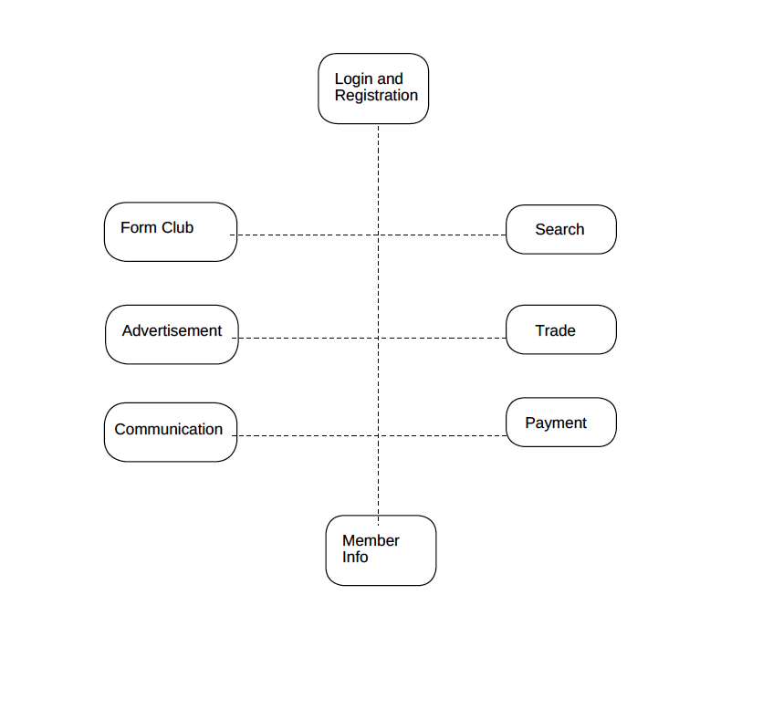

4. Systems Requirements

The following sections detail the system requirements we devised to ensure the application we develop meets the specifications detailed out in the project description. The requirements are grouped by subsystem. The categories include home screen, login and registration, search, buy/sell/lend/exchange, form club, and advertisement.

4.1 “Home Screen” Requirements

Requirement Title: | Home Screen
Sequence No: | 001
Short description: | Display welcome screen of the UBS
Description: | The system shall have the background image that represents the university. Additionally, the system shall have two buttons; one for ‘login’ and the other for ‘register’.
Pre-Conditions: | The user should have the application installed on the android supporting device.
Post Conditions: | Successful click will direct the user to the login screen or the register screen.
Other attributes: | There must be a title labelled “UBS” on top of the welcome screen.

4.2 “Login and Registration” Requirements

Requirement Title: | Login and Registration
Sequence No: | 001
Short description: | Register new users
Description: | Register new users by collecting the following information:  - Name  - Email  - Phone no.  - Address  - User id  - Create password  Create a screen with two edit boxes (UserId and Password) and two buttons, one for submit and the other for cancel.
Pre-Conditions: | No duplicates allowed
Post Conditions: | Notify user that the registration is complete via email.
Other attributes: | System should check for the errors in the input data from the user and check if all the required input fields are completed.  Save information permanently in the system.

Requirement Title: | Login and Registration
Sequence No: | 002
Short description: | Logging in existing users
Description: | The system shall have two edit boxes where the user will input their username and password. The text boxes should be individually labeled as “Username” and “Password”. Each input area will allow users to input maximum 25 characters in length.
Pre-Conditions: | User must be already registered
Post Conditions: | Users can input password as many time as they want
Other attributes: | There must be button labeled “Sign In” that will attempt to allow the user to access the system when clicked.

Requirement Title: | Login and Registration
Sequence No: | 003
Short description: | Password retrieval functionality
Description: | The system shall provide the functionality such that there will be a button labelled “Forgot Password” on the login screen that will send temporary password to the users email id.  Input: Enter valid email address associated with a registered user.  Output: Email sent to user with temporary password and can change the password afterward.
Pre-Conditions: | The provided email address must be linked to a registered user in order to generate the email.
Post Conditions: | When successful, email will be sent with temporary password.
Other attributes: | The user should use the temporary password for login and can change the password afterward.

4.3 “Form Club” Requirements
Requirement Title: | Form Club
Sequence No: | 001
Short description: | Allows user to create new group
Description: | The system shall allow users to create a new club/organization and invite other user to be the member of the group.  Then, the system shall register the group in database.
Pre-Conditions: | There should not be any club/organization formed under the same name.
Post Conditions: | The creator of the group shall then send invitation to selected members to join the club.
Other attributes: | The admin reserves the right to remove a particular member in case of any inappropriate language or behavior.

4.4 “Communication” Requirements

Requirement Title: | Communication
Sequence No: | 001
Short description: | Send private message functionality
Description: | The system shall allow the users to send messages to other users individually or in group via email. The email will be spent to user in their any email id but the user should use their Gmail id. This is the best means of communication between two users and support emoji’s.
Pre-Conditions: | The user should input the email to send the message.  The recipient must be registered in the system with the email address and username provided by the sender.
Post Conditions: | The system shall display “message sent” in the communication screen.  The recipient shall be able to view the message in their respective email.
Other attributes: | The recipient shall have to option to reply the sender.

Requirement Title: | Communication
Sequence No: | 002
Short description: | Create event functionality
Description: | The system shall allow the user to create an event like job fair, company hiring, conferences, sharing rides, tutoring, subleasing apartment, and more.  The user shall be able to upload the cover image for the event.
Pre-Conditions: | The event being created should be scheduled for a later date than current date.
Post Conditions: | The system shall add the event created to the database.  All the members of the system will have access to view these events in their homepage.
Other attributes: | System admin shall monitor the events being created and reserves the right to take action against the fake or inappropriate event.

4.5 “Trade” Requirements
Requirement Title: | Trade
Sequence No: | 001
Short description: | “Buy” functionality
Description: | - The system shall display all the available items for sale to the users.  - The system shall allow the users to buy the items posted for sale by other users.  - The buyer shall select the item and provide the number of quantity intended to make purchase.  - Then, the system shall ask for the shipping address to the buyer.  - Finally, the system shall direct the buyer to make the payment.
Pre-Conditions: | User must be logged in.  Inputs must be valid and all inputs must be filled in.  The number of quantity selected for an item should be less than or equal to the available quantity for sale.
Post Conditions: | Re-direct the user to the payment screen once all the required data has been acquired.
Other attributes: | The system shall allow the user to forwarded to the payment screen.

Requirement Title: | Trade
Sequence No: | 002
Short description: | “Sell” functionality
Description: | The system shall allow the registered users to sell their items providing the item description, item price, item quantity and images.  Additionally, the system shall provide an option to the user to select if they want to sell the item, exchange the item, lend the item or any combination of these three.  Inputs:  - item description  - item quantity  - item price  - images  - trade options (sell/exchange/lend)  - if Lend, base price for item (price/month)  - Banking account information  Outputs:  - User will be able to see the items in the buy, exchange, and borrow lists.
Pre-Conditions: | User must be logged in.  All the input fields relating to the item should be filled.
Post Conditions: | The item posted for sale will be added to the corresponding database depending on the selected category of sale.  The system shall allow the user to list for sell/exchange/borrow before the item has been bought.
Other attributes: | The system shall ask the banking information to the user, so that the system can deposit the amount to the seller’s bank account once the transaction has been occurred.

Requirement Title: | Trade
Sequence No: | 003
Short description: | “Exchange” Functionality on buyer’s side
Description: | The system shall display all the items are available in the database for exchange.  The system then shall allow the user to exchange offer with the exchange item.  Inputs:  - Item description  - Item images  - Item Quantity  Outputs:  - User will be able to see the listed product in the exchange page.
Pre-Conditions: | User must be logged in.  All the input fields must be completed.  The item should be available for exchange.
Post Conditions: | The system shall allow the user to see the listed offer page by all the sellers.
Other attributes: | The user shall provide the counter exchange offer.

Requirement Title: | Trade
Sequence No: | 004
Short description: | “Exchange” Functionality on seller’s side
Description: | The seller will be able to view exchange offer from other buyer.  The system shall provide the option to accept or reject the offer.  If the exchange offer is accepted by the seller, notify the buyer and provide the contact information to decide the place to meet for the exchange.  If the exchange offer is rejected, notify the buyer.
Pre-Conditions: | User must be logged in.  The item should be available for exchange.
Post Conditions: | Once, the offer has been accepted, remove the item from the exchange database.  The buyer shall be notified with response to the offer from the seller.
Other attributes: | N/A

Requirement Title: | Trade
Sequence No: | 005
Short description: | “Borrow the item” functionality
Description: | The system shall display all the items that are available to borrow with the item description, item price/month and images.  Inputs:  - Item quantity  - Time frame  - Shipping address of the borrower
Pre-Conditions: | User must be logged in.  The item must be available to borrow.  Required input field must be completed.
Post Conditions: | The system shall direct the user to the payment screen once the borrow details has been reviewed and submitted by the user.
Other attributes: | The system shall calculate the borrow price depending on the borrow time frame and the base price/month.

4.6 “Payment” Requirements

Requirement Title: | Payment
Sequence No: | 001
Short description: | “Card payment” functionality for buyers
Description: | The system shall allow the user to make the payment for the transaction by asking the following inputs from the user:  - Card type (visa/discover/MasterCard)  - Card number  - Expiration date  - CVV  - Billing address  - Name on card  The system shall process the payment and notify the user with the status (i.e. payment accepted or not).
Pre-Conditions: | User must be logged in.  All the required input fields must be completed.  The shopping cart should not be empty.
Post Conditions: | The system shall notify the user with the purchase details.  The system shall also notify the seller that the transaction has been completed.  The item sold shall be removed from the system.
Other attributes: | The system shall allow the user to re-enter the payment information if the payment is unsuccessful.

Requirement Title: | Payment
Sequence No: | 002
Short description: | Deposit to the seller’s bank account
Description: | The system shall process the payment received from the buyer to deposit the amount in the seller’s bank account.  The system shall notify the user when the deposit transaction is processed.
Pre-Conditions: | The seller’s bank information must be stored in the database.
Post Conditions: | N/A
Other attributes: | N/A

4.7 “Member Information” Requirements
Requirement Title: | Member Information
Sequence No: | 001
Short description: | Display member information
Description: | The system shall allow the user to view their profile by clicking “profile” button.  Additionally, the system shall provide the functionality to edit the information in their profile.  The system shall then display the member information with the changes made.
Pre-Conditions: | User must be logged in.
Post Conditions: | The system shall save the changes to the database.
Other attributes: | N/A

4.8 “Search” Requirements
Requirement Title: | Search
Sequence No: | 001
Short description: | The system allows the user to search for the members.
Description: | The system will take the input from the user in the input test field that will displayed on every page of the application once the user successfully logs into the system.
Pre-Conditions: | The user must be logged in to be able to use the search feature.
Post Conditions: | Displays the member information input by the user.
Other attributes: | There should be a label ‘search’ in the input text filed or a symbol denoting search function on the side of the input text field.

l

5. Software Processes and Infrastructure

5.1 Hardware and Infrastructure
Android studio would be used as the IDE and android OS version 6.0 Marshmallow would be used as the emulator to test the application.

5.2 System Class Diagram

UML – Class Diagram - system
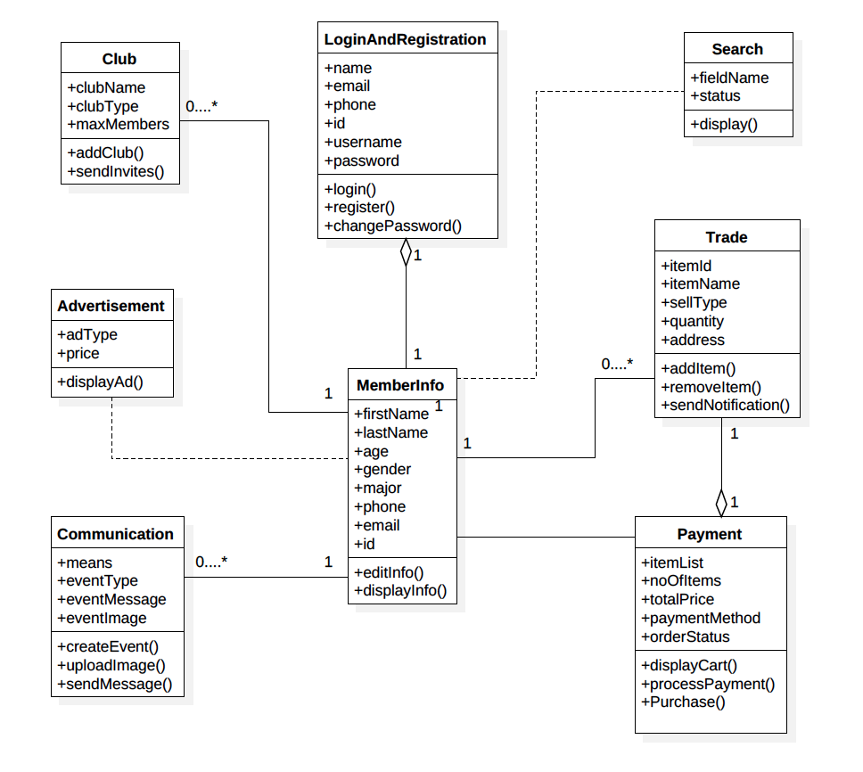

5.3 Login and Registration UML

UML – State Transition Diagram – Login & Registration

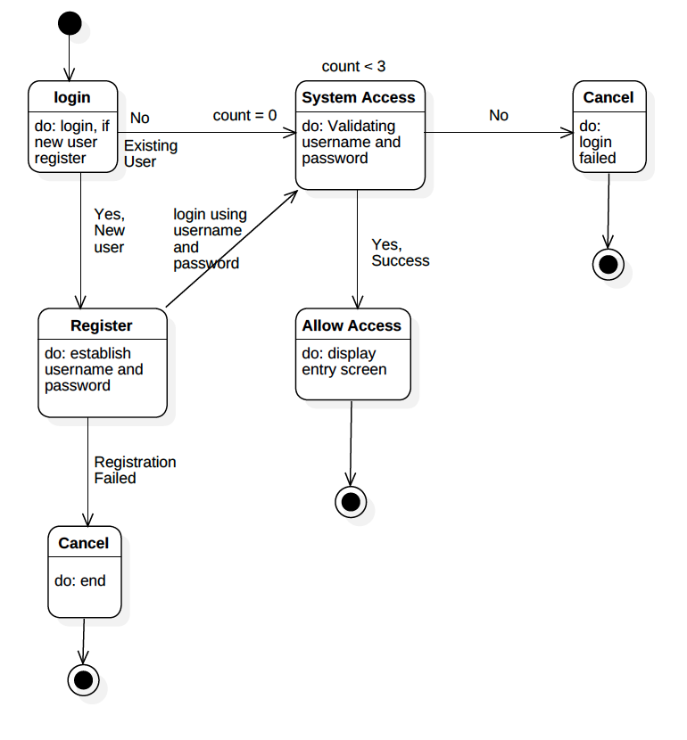

5.4 Form Club UML

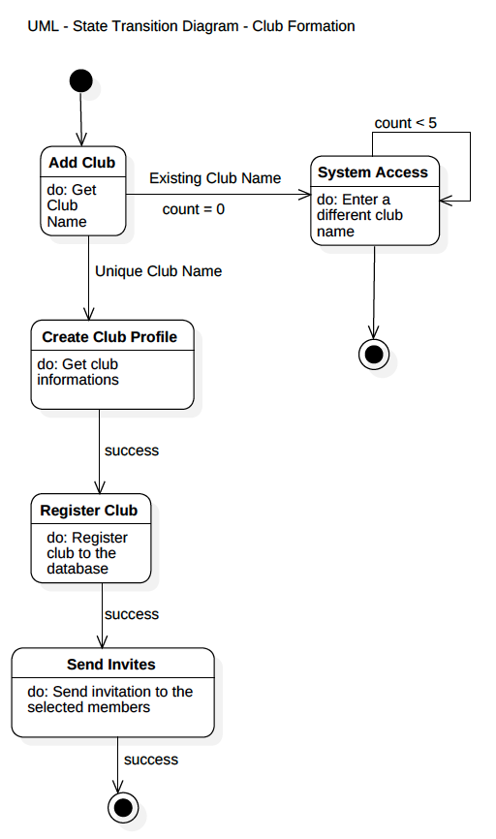

5.5 Communication UML

UML – State Transition Diagram - Communication
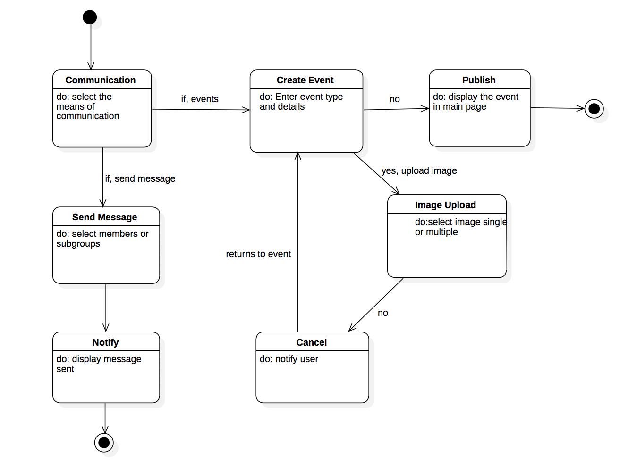

5.6 Trade UML

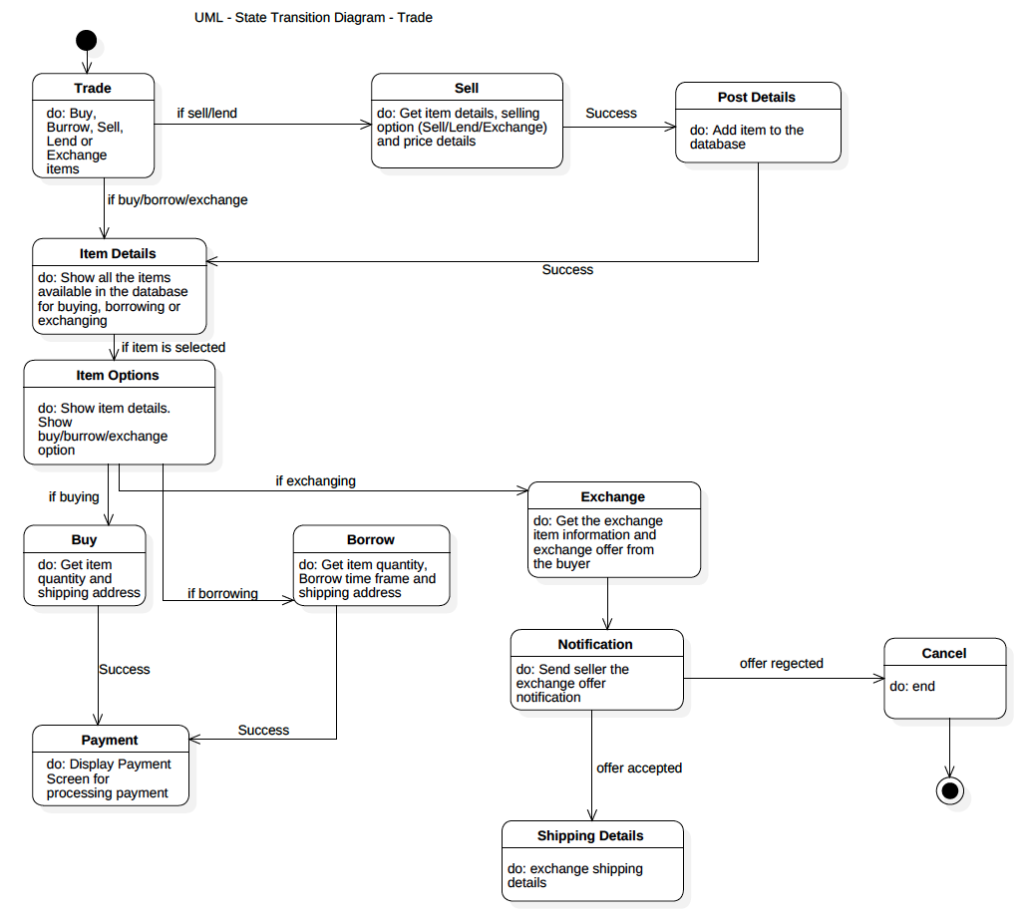

5.7 Payment UML

UML - Sequence Diagram - Payment
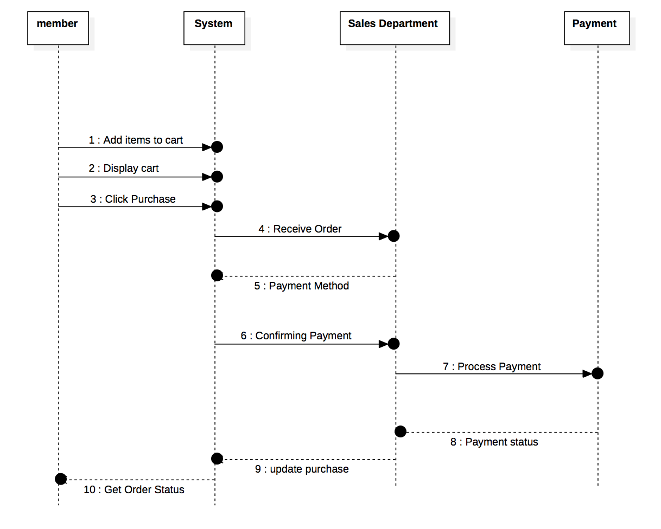

5.8 Member Information UML

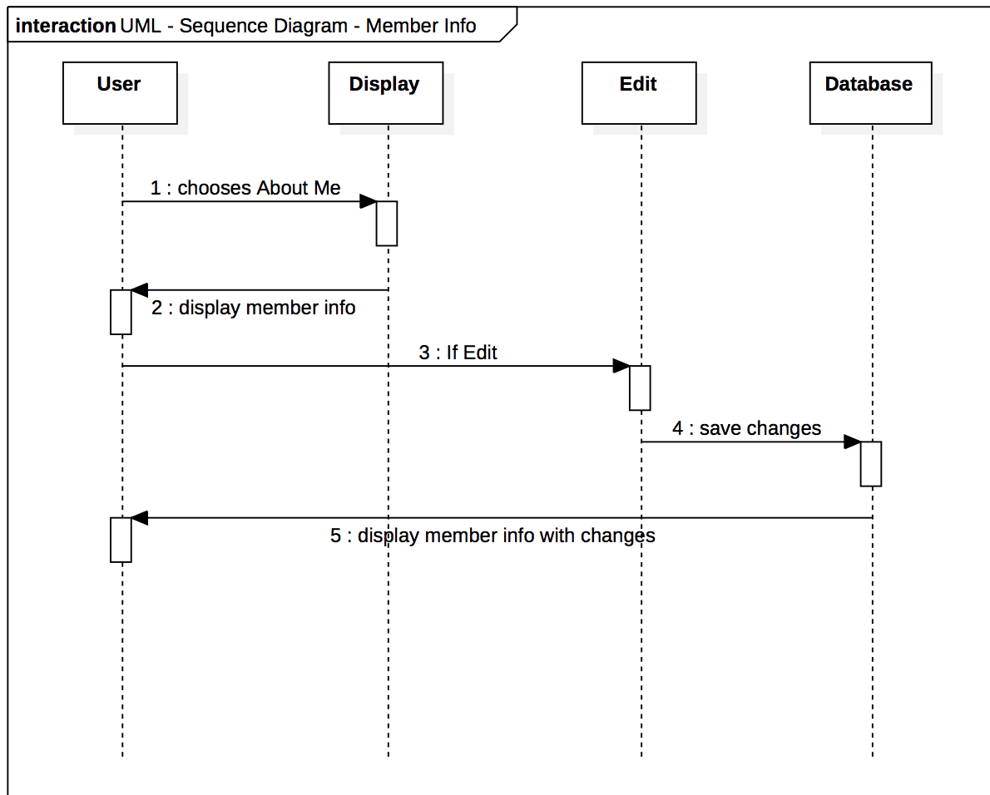

5.9 Search UML
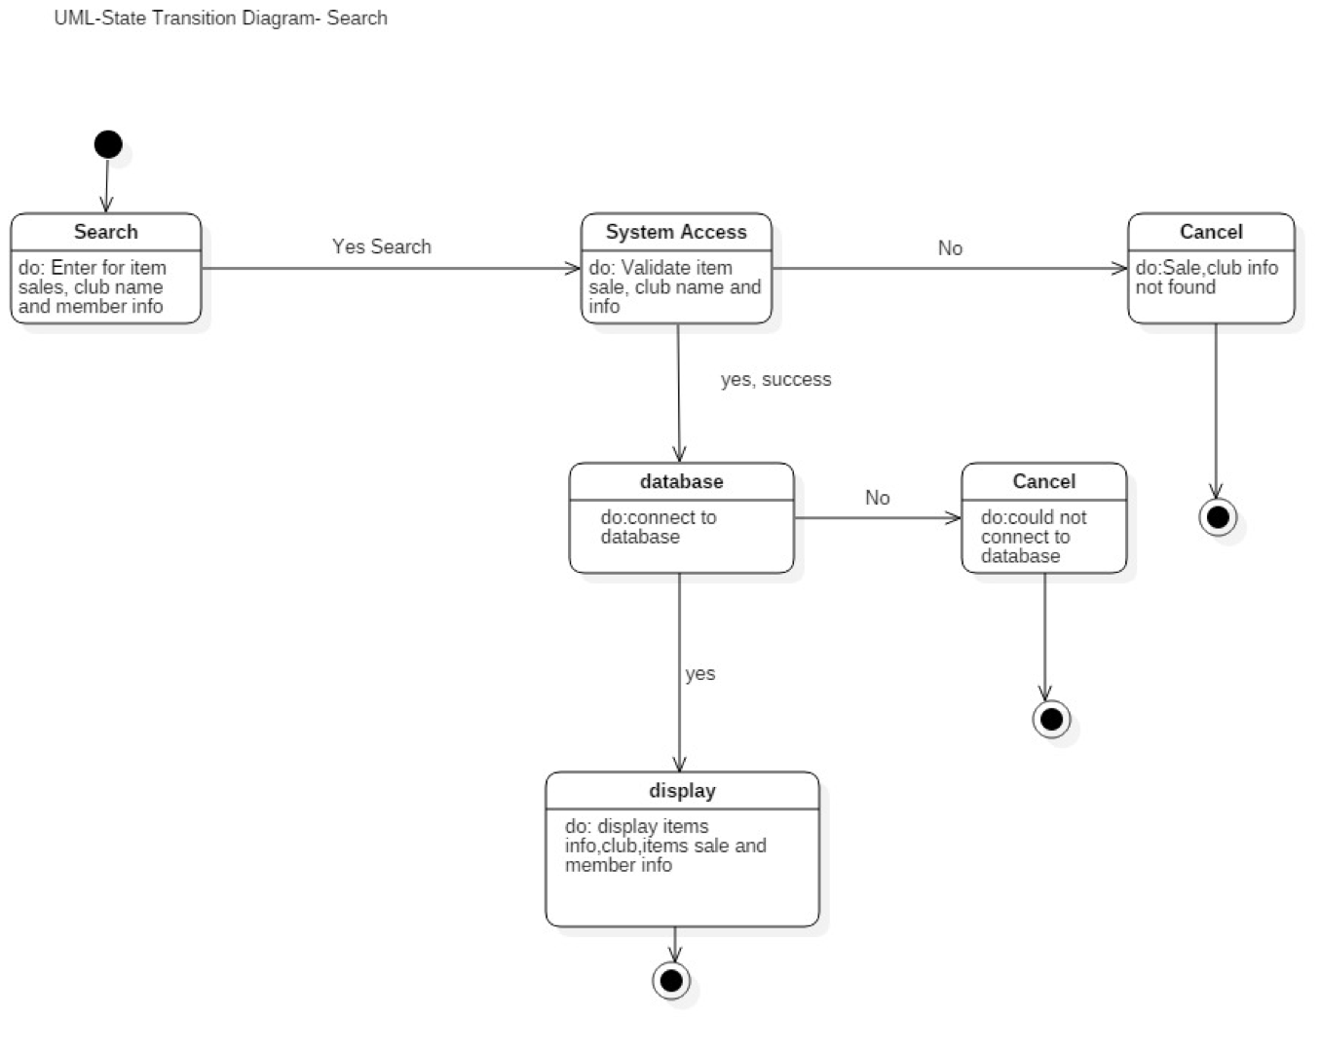

5.10 Conceptual Data Model - Database
We will use Firebase as the relational database management system. Firebase queries will be written. More information will be available as we develop the back end.

5.11 Screen Shots

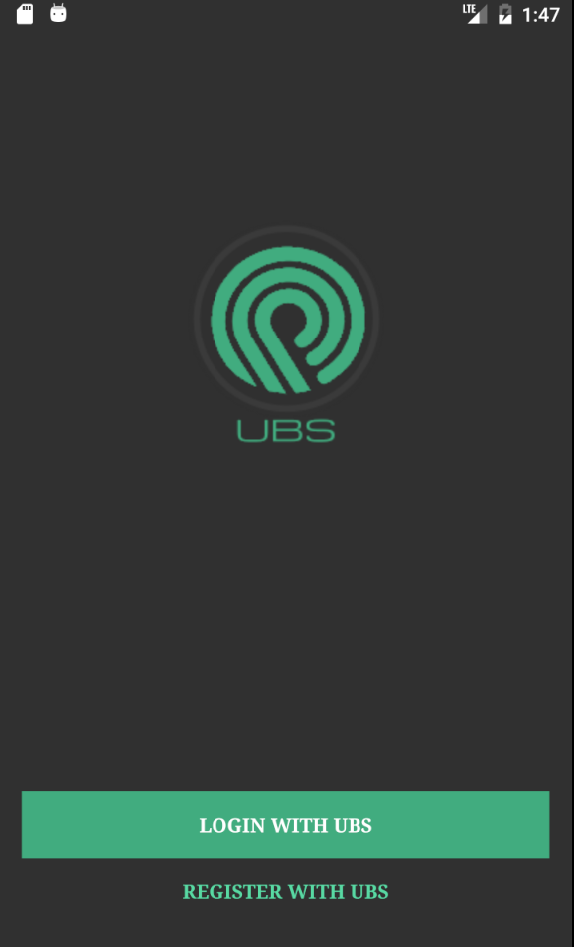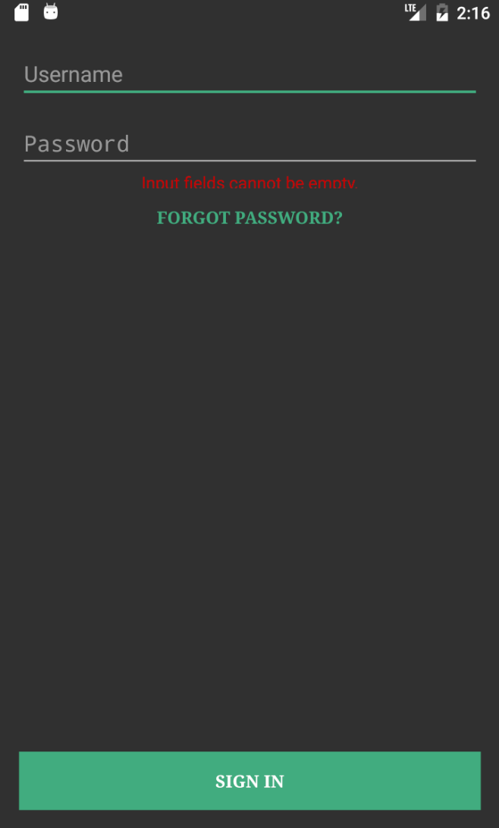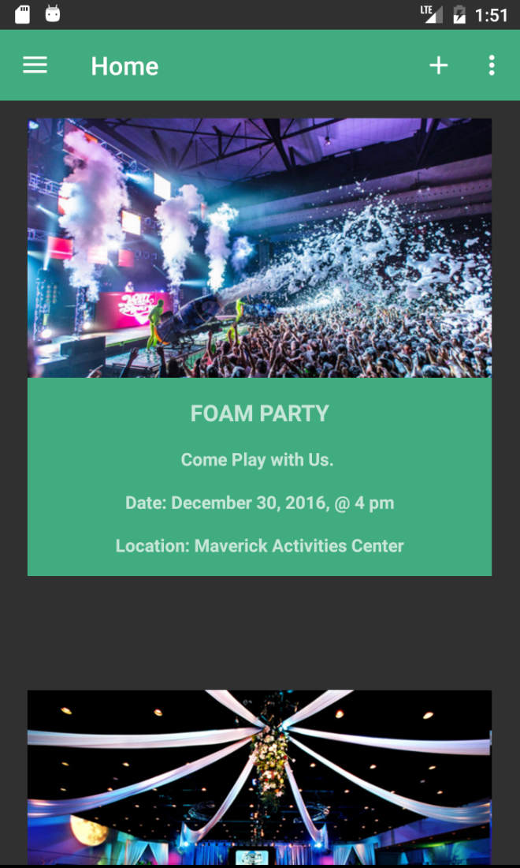

5.12 Test Plan
The test plan was provided at the later stages of this development.
The updated test plan will be attached with other submissions in the project binder.

6. Assumptions and Constraints

6.1 ASSUMPTIONS
The following is a list of assumptions:
- Ignore collecting money from external advertisement and general accounting
- Ignore compliance issues
- Assume all users are active students
- Ignore any TAX issues
- Ignore any vacation and social and health insurance costs
- Ignore Post project maintenance issues

6.2 CONSTRAINTS
The following is a list of constraints:
- Team lacks android experience
- Schedule very aggressive
- Team lacks database management and programming (Firebase) skills

6.3 Out of Scope material
The following is a list of “out of scope” material:
- Post Project maintenance is not covered
- Payment is processed by the third party

7. Delivery and Schedule

{List all tasks/milestones from start of the project to the end with specific dates for both Anticipated Start & End Dates
Task/Milestone Description | Anticipated Start Date | Anticipated End Date | Status | Comments
Prepare Requirements and UML diagram | 9/14/2016 | 9/29/2016 | Completed | Deliverable will be UML document.  Increment 1 Deliverable
SRA document (Includes project objectives, Requirements and UML diagrams) | 10/3/2016 | 11/3/2016 | Completed | Deliverable will be the SRA document. All stakeholders agree on the content of the SRA by signing in section 8.  Increment 2 Deliverable
Home screen design and implementation | 10/23/2016 | 11/30/2016 | Completed
Login and registration design and implementation | 10/23/2016 | 11/30/2016 | Completed
Form Club Design Implementation | 10/23/2016 | 11/30/2016 | Completed
Communication design and implementation | 10/23/2016 | 11/30/2016 | Completed
Trade Design and Implementation | 10/23/2016 | 11/30/2016 | Completed
Payment Design and Implementation | 10/23/2016 | 11/30/2016 | Completed
Member Information Design and Implementation | 10/23/2016 | 11/30/2016 | Completed
Search Design and Implementation | 10/23/2016 | 11/30/2016 | Completed
Test case design | 11/05/2016 | 11/22/2016 | Completed | Increment 3 Deliverable
External Documentation (i.e. User Manual) | 11/25/2016 | 12/6/2016 | Completed | Will be provided with all the increment deliverables in the project binder
Project presentation | 11/29/2016 | 12/8/2016 | Completed | Project presentation and demonstration done in class
Final Milestone: project delivery |  | 12/8/2016 | Completed | Increment 4 Deliverable

8. Stakeholder Approval Form

Stakeholder Name | Stakeholder Role | Stakeholder Comments | Stakeholder Approval Signature and Date
Bahram Khalili | Development Mgr
Akshit Singhal | Project Assistant
Suman Shrestha | Developer
Shrey Aryal | Developer
Asmita Shrestha | Developer
Sosal Pokhrel | Developer

Appendix:

None

