** WhatsViz: Instructions**

🔹 **Step 1: Pick Your Chat**

Open WhatsApp and navigate to the conversation you want to analyze.

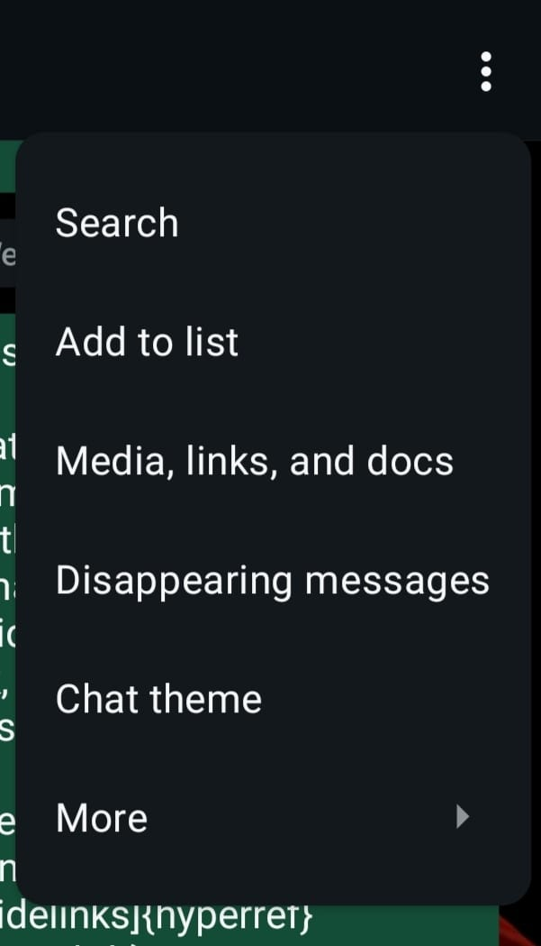

🔹 **Step 2: Export the Chat**

Tap the options menu (⋮), select **More**, and hit **Export Chat**.

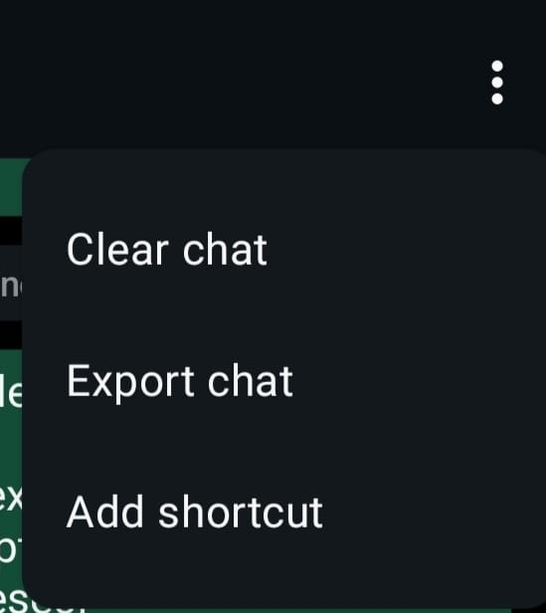

🔹 **Step 3: Choose "Without Media"**

To keep it clean and focused, export the chat **without media** files.

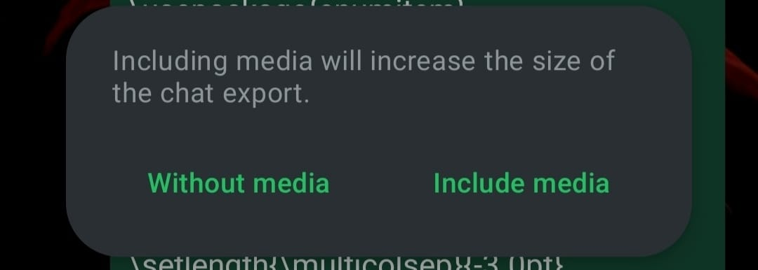

🔹 **Step 4: Upload & Discover**

Simply upload the exported chat file and let the insights roll in! 🚀

