Agent is working in BeROCK when Tested it with Nova Lite Model

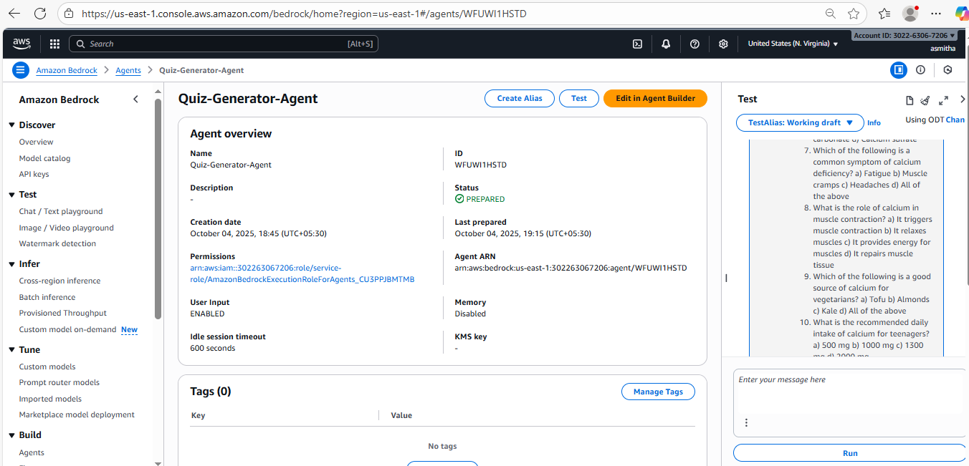

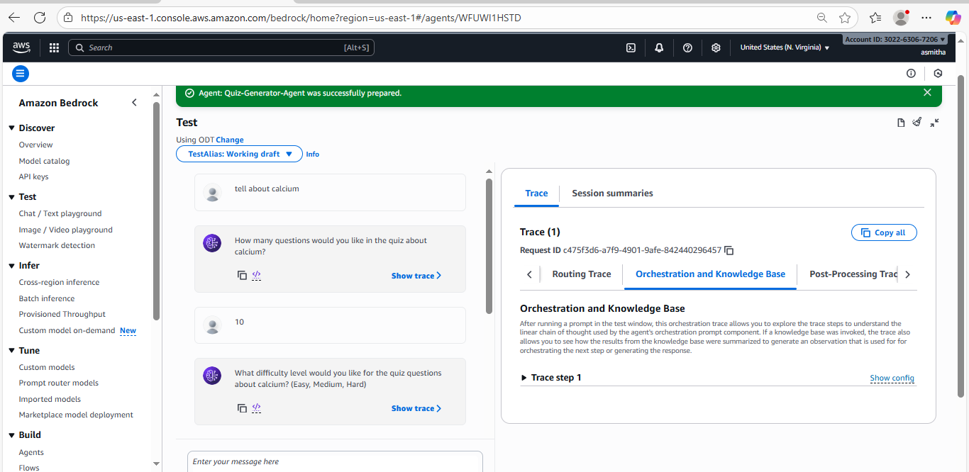

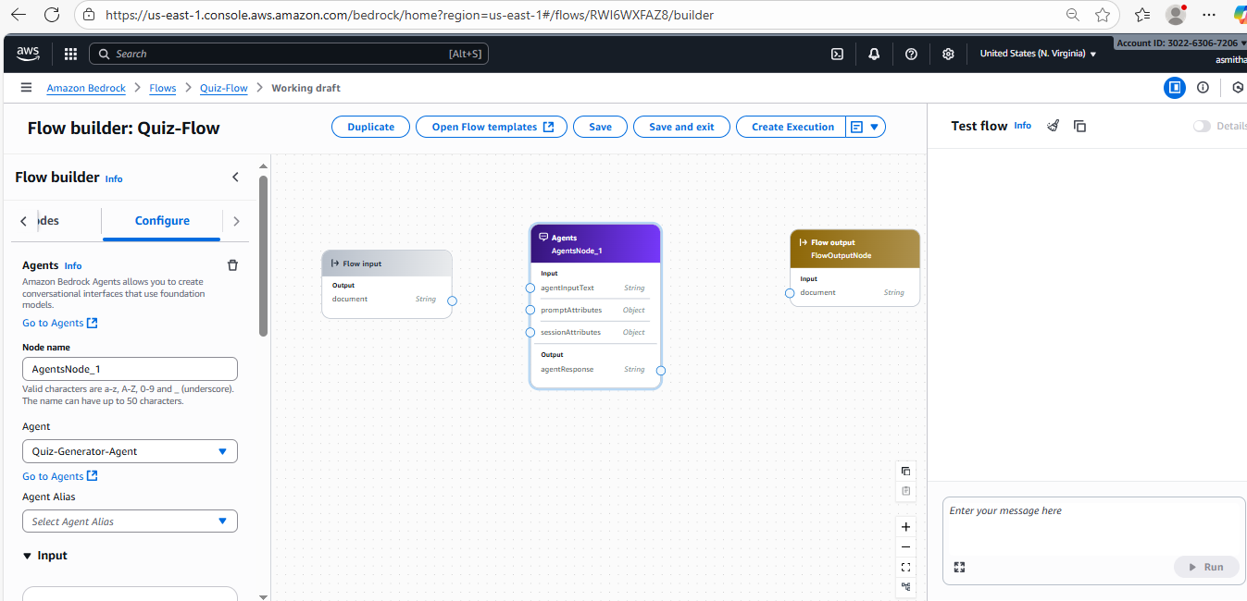

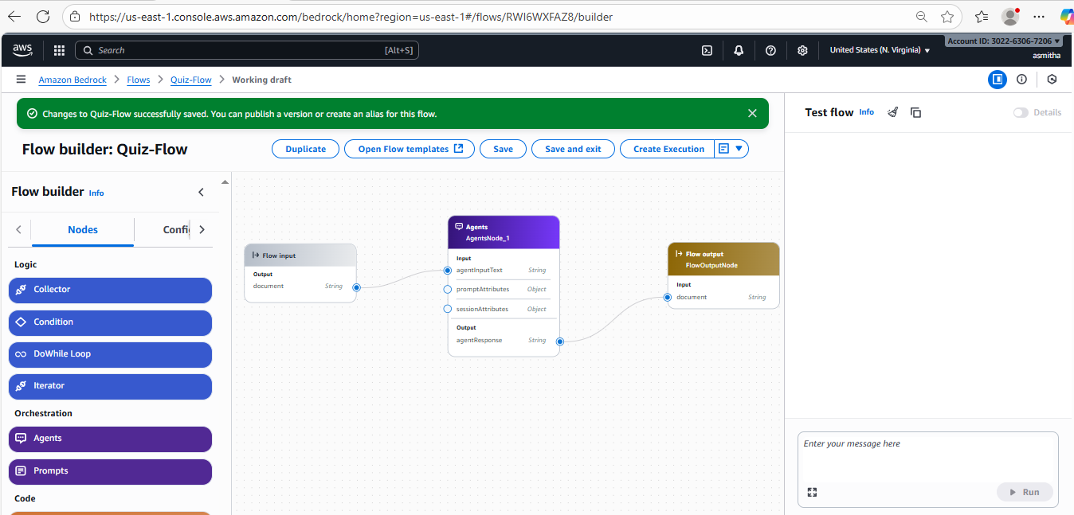

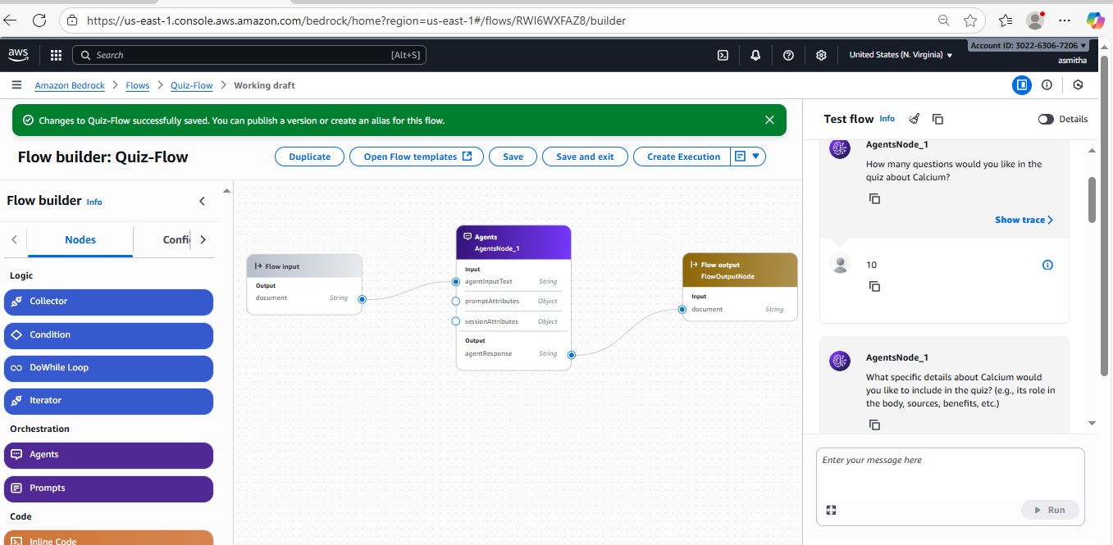

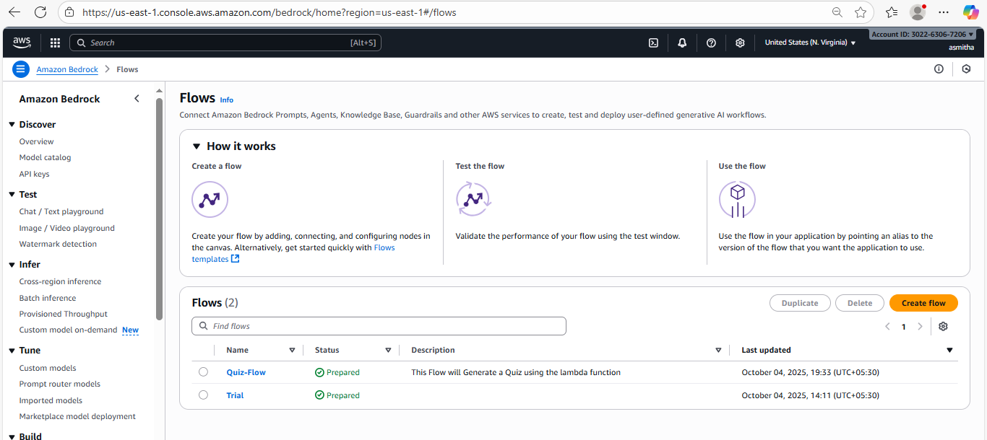

Here is a quiz on the role of Calcium:

1. What is the primary role of calcium in the body?

a) Building bones and teeth

b) Regulating muscle contractions

c) Both a and b

d) None of the above

2. Which of the following is a primary source of calcium?

a) Meat

b) Fruits

c) Dairy products

d) Vegetables

3. How does calcium help in blood clotting?

a) By activating clotting factors

b) By forming a clot

c) By stopping bleeding

d) By none of the above

4. What is the recommended daily intake of calcium for adults?

a) 1000 mg

b) 1200 mg

c) 1500 mg

d) 2000 mg

5. Which of the following is a sign of calcium deficiency?

a) Brittle nails

b) Muscle cramps

c) Fatigue

d) All of the above

6. What is the role of calcium in nerve function?

a) Transmitting nerve impulses

b) Regulating nerve activity

c) Both a and b

d) None of the above

7. How does calcium help in maintaining a healthy weight?

a) By reducing appetite

b) By increasing metabolism

c) Both a and b

d) None of the above

8. What is the role of calcium in bone health?

a) Building and maintaining bones

b) Preventing osteoporosis

c) Both a and b

d) None of the above

9. Which of the following is a risk factor for calcium deficiency?

a) Age

b) Gender

c) Diet

d) All of the above

10. What is the role of calcium in muscle function?

a) Contracting and relaxing muscles

b) Regulating muscle activity

c) Both a and b

d) None of the above

Answers: 1) c, 2) c, 3) a, 4) a, 5) d, 6) c, 7) c, 8) c, 9) d, 10) c

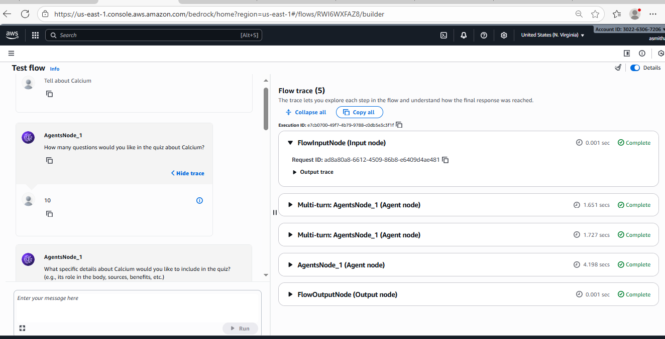

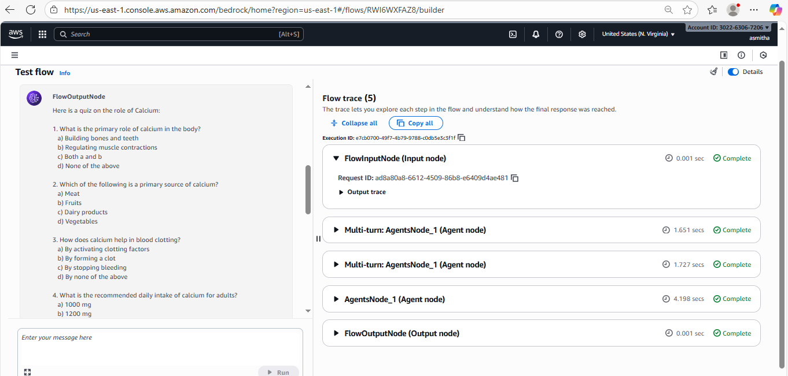

To import BedROCK Flows in Github we need to use AWS CLI

• Go to the **AWS Console** → Top navigation bar → Click the **CloudShell icon (terminal prompt)**.

• This opens a terminal in your browser with AWS CLI pre-installed and credentials already configured.

• Run commands directly, e.g.:

aws bedrock-agent get-flow --flow-identifier RWI6WXFAZ8 --region us-east-1

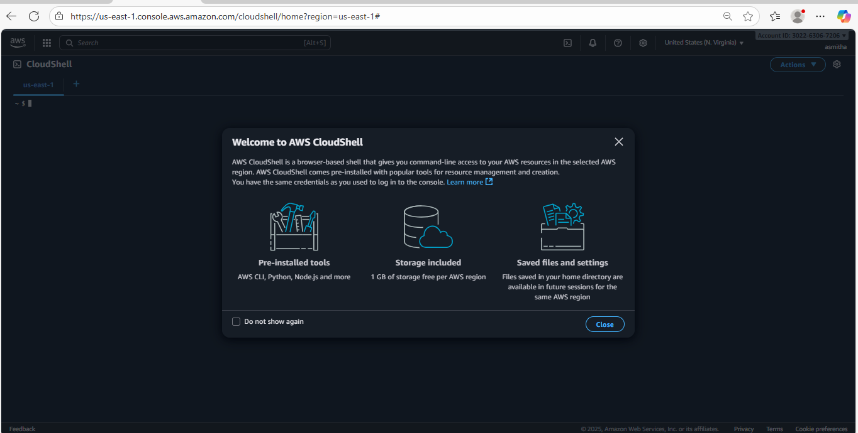

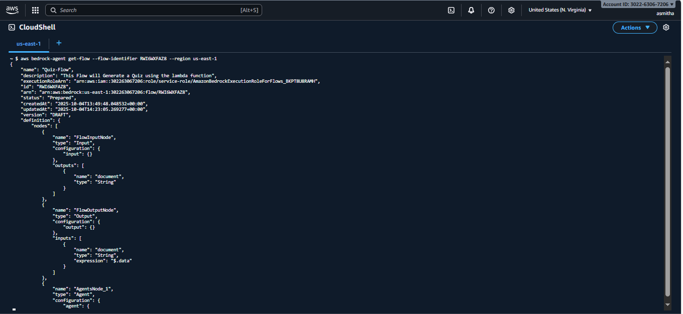

{

"name": "Quiz-Flow",

{

"name": "Quiz-Flow",

"description": "This Flow will Generate a Quiz using the lambda function",

"executionRoleArn": "arn:aws:iam::302263067206:role/service-role/AmazonBedrockExecutionRoleForFlows_BKPT8U8RAMH",

"id": "RWI6WXFAZ8",

"arn": "arn:aws:bedrock:us-east-1:302263067206:flow/RWI6WXFAZ8",

"status": "Prepared",

"createdAt": "2025-10-04T13:49:48.048532+00:00",

"updatedAt": "2025-10-04T14:23:05.269277+00:00",

"version": "DRAFT",

"definition": {

"nodes": [

{

"name": "FlowInputNode",

"type": "Input",

"configuration": {

"input": {}

},

"outputs": [

{

"name": "document",

"type": "String"

}

]

},

{

"name": "FlowOutputNode",

"type": "Output",

"configuration": {

"output": {}

},

"inputs": [

{

"name": "document",

"type": "String",

"expression": "$.data"

}

]

},

{

"name": "AgentsNode_1",

"type": "Agent",

"configuration": {

"agent": {

"agentAliasArn": "arn:aws:bedrock:us-east-1:302263067206:agent-alias/WFUWI1HSTD/M8IQPJLQE0"

}

},

"inputs": [

{

"name": "agentInputText",

"type": "String",

"expression": "$.data"

},

{

"name": "promptAttributes",

"type": "Object",

"expression": "$.data"

},

{

"name": "sessionAttributes",

"type": "Object",

"expression": "$.data"

}

],

"outputs": [

{

"name": "agentResponse",

"type": "String"

}

]

}

],

"connections": [

{

"type": "Data",

"name": "FlowInputNodeFlowInputNode0ToAgentsNode_1AgentsNode0",

"source": "FlowInputNode",

"target": "AgentsNode_1",

"configuration": {

"data": {

"sourceOutput": "document",

"targetInput": "agentInputText"

}

}

},

{

"type": "Data",

"name": "AgentsNode_1AgentsNode0ToFlowOutputNodeFlowOutputNode0",

"source": "AgentsNode_1",

"target": "FlowOutputNode",

"configuration": {

"data": {

"sourceOutput": "agentResponse",

"targetInput": "document"

}

}

}

]

},

"validations": []

}

(END)

