Simulation Assignment - Step-by-Step Procedure
23ECE336 VLSI Testing and Testability | Project 10: BCD Adder | Tools: Verilog (Icarus), ATALANTA, Cadence Modus
This guide follows your support document. It has three parts, one for each algorithm in the assignment. Every step gives the command or code, the file it uses and the output you should get. All results and graphs below come from real runs.
CO | Algorithm | Tool | Main output
CO2 | Fault list reduction | Cadence Modus (+ Verilog flow) | Collapsed fault list, graph g1
CO3 | Test pattern generation | ATALANTA (+ Verilog flow) | Patterns, coverage, graphs g2, g3, g5
CO4 | Fault simulation | Cadence Modus (+ Verilog flow) | Coverage vs patterns, graphs g4, g6, g7
Modus is a licensed tool on your lab machine, so its commands are given as scripts to run there. The Verilog and ATALANTA parts were run and give the numbers and graphs shown here.

Step 0: Folder and tools
BCD_project/
rtl/ bcd_adder.v bcd_adder.bench
verilog_sim/ bcd_adder_tb.v fault_force.vh gen.py run_verilog.sh results.txt
modus/ step1_fault_list_reduction.cmd step3_fault_simulation.cmd
atalanta/ build_atalanta.sh run_atalanta.sh runs/ (outputs)
plots/ make_plots.py g1 ... g7 graphs
run_all.sh runs everything except Modus

Install once (Ubuntu): sudo apt install iverilog g++ git python3-matplotlib. Then, to repeat everything: ./run_all.sh

Step 1: Design the BCD adder (Verilog)
Two 4-bit adders plus correction logic. It is written with gate primitives so that every wire can be faulted. File: rtl/bcd_adder.v
// Gate-level BCD adder: 4-bit binary adder + correction (+6) logic
module bcd_adder(input a0,a1,a2,a3,b0,b1,b2,b3,cin, output s0,s1,s2,s3,cout);
wire f0_x, f0_s, f0_a1, f0_a2, f0_c, f1_x, f1_s, f1_a1, f1_a2, f1_c, f2_x, f2_s, f2_a1, f2_a2, f2_c, f3_x, f3_s, f3_a1, f3_a2, f3_c, t1, t2, cor, h1_s, h1_c, f5_x, f5_s, f5_a1, f5_a2, f5_c, h3_s, h3_c;
xor g0(f0_x, a0, b0);
xor g1(f0_s, f0_x, cin);
and g2(f0_a1, a0, b0);
and g3(f0_a2, f0_x, cin);
or g4(f0_c, f0_a1, f0_a2);
xor g5(f1_x, a1, b1);
xor g6(f1_s, f1_x, f0_c);
and g7(f1_a1, a1, b1);
and g8(f1_a2, f1_x, f0_c);
or g9(f1_c, f1_a1, f1_a2);
xor g10(f2_x, a2, b2);
xor g11(f2_s, f2_x, f1_c);
and g12(f2_a1, a2, b2);
and g13(f2_a2, f2_x, f1_c);
or g14(f2_c, f2_a1, f2_a2);
xor g15(f3_x, a3, b3);
xor g16(f3_s, f3_x, f2_c);
and g17(f3_a1, a3, b3);
and g18(f3_a2, f3_x, f2_c);
or g19(f3_c, f3_a1, f3_a2);
and g20(t1, f3_s, f2_s);
and g21(t2, f3_s, f1_s);
or g22(cor, f3_c, t1, t2);
xor g23(h1_s, f1_s, cor);
and g24(h1_c, f1_s, cor);
xor g25(f5_x, f2_s, cor);
xor g26(f5_s, f5_x, h1_c);
and g27(f5_a1, f2_s, cor);
and g28(f5_a2, f5_x, h1_c);
or g29(f5_c, f5_a1, f5_a2);
xor g30(h3_s, f3_s, f5_c);
and g31(h3_c, f3_s, f5_c);
assign s0 = f0_s;
assign s1 = h1_s;
assign s2 = f5_s;
assign s3 = h3_s;
assign cout = cor;
endmodule

Quick test: run ./verilog_sim/run_verilog.sh. The first lines of the output must say: [0] Functional check: 200 patterns, 0 errors -> PASS.

Step 2: Fault list reduction (CO2)

2A. In Cadence Modus
File: modus/step1_fault_list_reduction.cmd. Start the tool, then type the commands one by one.
csh
source /home/installs/cshrc
modus

build_model -designsource bcd_adder.v
build_testmode -testmode FULLSCAN
verify_test_structures -testmode FULLSCAN
build_faultmodel
create_logic_tests -testmode FULLSCAN -experiment FULL -effort high
report_fault_statistics -testmode FULLSCAN -experiment FULL
report_faults -testmode FULLSCAN -experiment FULL \
-faultstatus "untested aborted redundant" -logfile faults_hard.log
create_logic_tests -testmode FULLSCAN -experiment reduced_faults \
-append no -maxpatterns 5
report_fault_statistics -testmode FULLSCAN -experiment reduced_faults
create_logic_tests -testmode FULLSCAN -experiment 70percent -maxcoverage 70.0
report_fault_statistics -testmode FULLSCAN -experiment 70percent

- build_model reads bcd_adder.v and makes the gate database (tbdata/modeldata).
- build_testmode and verify_test_structures set up the test mode and check design rules. The adder has no flip-flops, so no scan chain is built.
- build_faultmodel makes the stuck-at fault list and collapses equivalent faults. This is the fault list reduction. Note the numbers of total and active faults.
- create_logic_tests ... -experiment FULL gives the baseline. report_faults lists the hard (untested, aborted, redundant) faults in faults_hard.log.
- The reduced_faults run (-maxpatterns 5) and the 70percent run (-maxcoverage 70.0) show how few patterns are needed. Compare all three with report_fault_statistics.
Take screenshots of the build_faultmodel output and the three report_fault_statistics outputs for your report.

2B. Verilog flow (already run)
The testbench (verilog_sim/bcd_adder_tb.v) injects every stuck-at fault with force/release and removes (a) faults no valid BCD input can detect and (b) equivalent faults that give identical outputs on all 200 patterns. Command: ./verilog_sim/run_verilog.sh
Item | Faults
Full list (41 sites x 2) | 82
Undetectable removed | 2
Equivalent removed | 13
Collapsed list | 67 (18 % smaller)
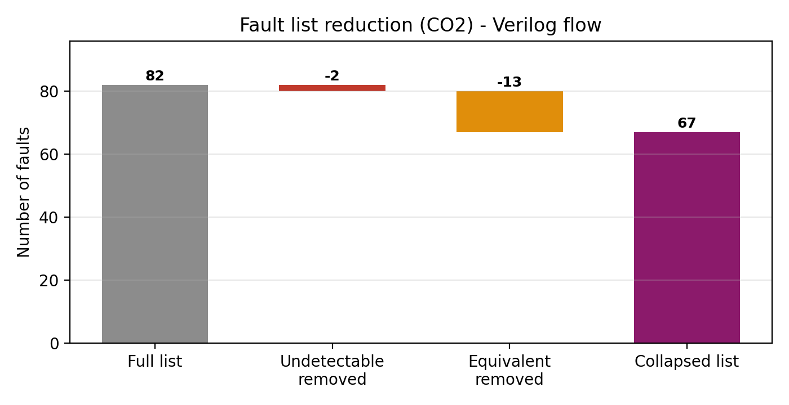
Graph g1: fault list reduction
The 2 undetectable faults are on h3_c, the last carry. It is not connected to any output.

Step 3: Test pattern generation with ATALANTA (CO3)
As your support document says, ATALANTA gives the fault coverage and the number of detectable faults. It also writes the patterns it used.

3A. Make the .bench netlist
ATALANTA reads the ISCAS .bench format, not Verilog. File: rtl/bcd_adder.bench (31 gates). Each Verilog gate becomes one line. The unused carry h3_c is removed, because ATALANTA stops with the error "floating output h3_c detected".
# bcd_adder
# BCD adder gate-level netlist: 9 inputs, 5 outputs, 31 gates (unused carry h3_c removed)
INPUT(a0)
INPUT(a1)
INPUT(a2)
INPUT(a3)
INPUT(b0)
INPUT(b1)
INPUT(b2)
INPUT(b3)
INPUT(cin)
OUTPUT(f0_s)
OUTPUT(h1_s)
OUTPUT(f5_s)
OUTPUT(h3_s)
OUTPUT(cor)

f0_x = XOR(a0, b0)
f0_s = XOR(f0_x, cin)
f0_a1 = AND(a0, b0)
f0_a2 = AND(f0_x, cin)
f0_c = OR(f0_a1, f0_a2)
f1_x = XOR(a1, b1)
f1_s = XOR(f1_x, f0_c)
f1_a1 = AND(a1, b1)
f1_a2 = AND(f1_x, f0_c)
f1_c = OR(f1_a1, f1_a2)
f2_x = XOR(a2, b2)
f2_s = XOR(f2_x, f1_c)
f2_a1 = AND(a2, b2)
f2_a2 = AND(f2_x, f1_c)
f2_c = OR(f2_a1, f2_a2)
f3_x = XOR(a3, b3)
f3_s = XOR(f3_x, f2_c)
f3_a1 = AND(a3, b3)
f3_a2 = AND(f3_x, f2_c)
f3_c = OR(f3_a1, f3_a2)
t1 = AND(f3_s, f2_s)
t2 = AND(f3_s, f1_s)
cor = OR(f3_c, t1, t2)
h1_s = XOR(f1_s, cor)
h1_c = AND(f1_s, cor)
f5_x = XOR(f2_s, cor)
f5_s = XOR(f5_x, h1_c)
f5_a1 = AND(f2_s, cor)
f5_a2 = AND(f5_x, h1_c)
f5_c = OR(f5_a1, f5_a2)
h3_s = XOR(f3_s, f5_c)

3B. Build and run ATALANTA
cd atalanta
./build_atalanta.sh # downloads and builds ATALANTA
./run_atalanta.sh Atalanta/atalanta # runs 4 settings, saves to runs/
# or, one run by hand:
Atalanta/atalanta -s 1 -l base.log -t base.test ../rtl/bcd_adder.bench

Options used: -s 1 fixes the random seed, -l writes a log with the faults caught by each pattern, -t names the pattern file, -N switches compaction off, -r 0 switches the random-pattern phase off.

3C. Read the output
Number of primary inputs : 9
Number of primary outputs : 5
Number of gates : 31
Level of the circuit : 14
Test pattern generation Mode : RPT + DTPG + TC
Backtrack limit : 10
Test pattern compaction Mode : REVERSE + SHUFFLE
Number of shuffles : 4
Number of test patterns before compaction : 18
Number of test patterns after compaction : 14
Fault coverage : 99.291 %
Number of collapsed faults : 141
Number of identified redundant faults : 1
Number of aborted faults : 0

ATALANTA result | Value
Collapsed faults | 141
Patterns before / after compaction | 18 / 14
Detected faults | 140
Redundant faults | 1 (f5_x->f5_a2 /1)
Fault coverage | 99.291 %
Files in atalanta/runs/: base.test (patterns with expected outputs), base.log (faults detected by each pattern), base_summary.txt, plus the -N and -r 0 runs.
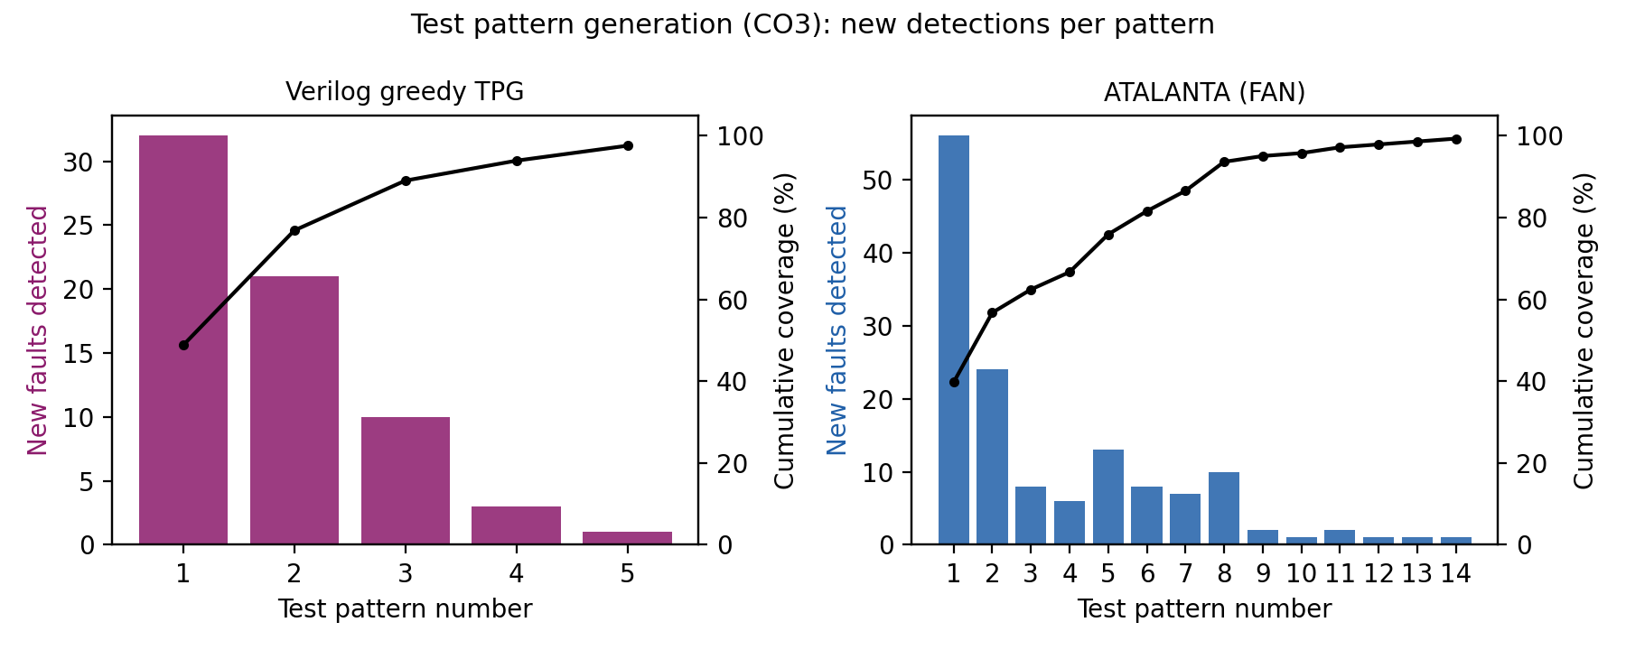
Graph g2: new faults detected by each pattern
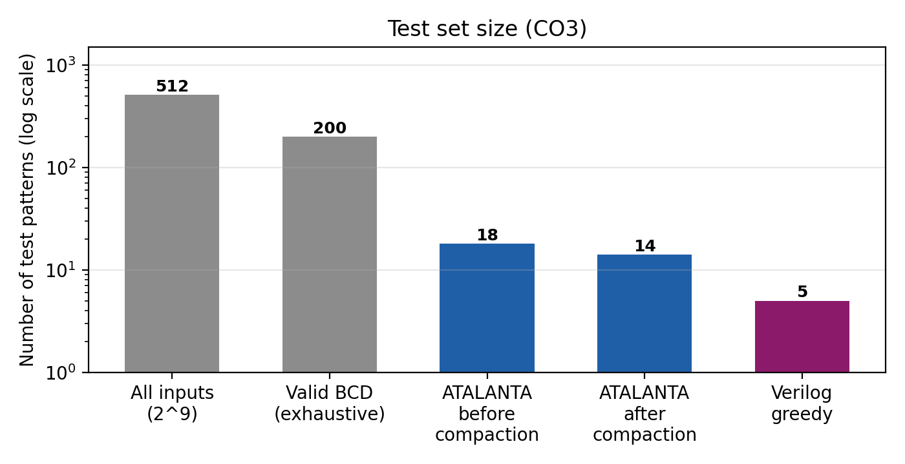
Graph g3: size of each test set
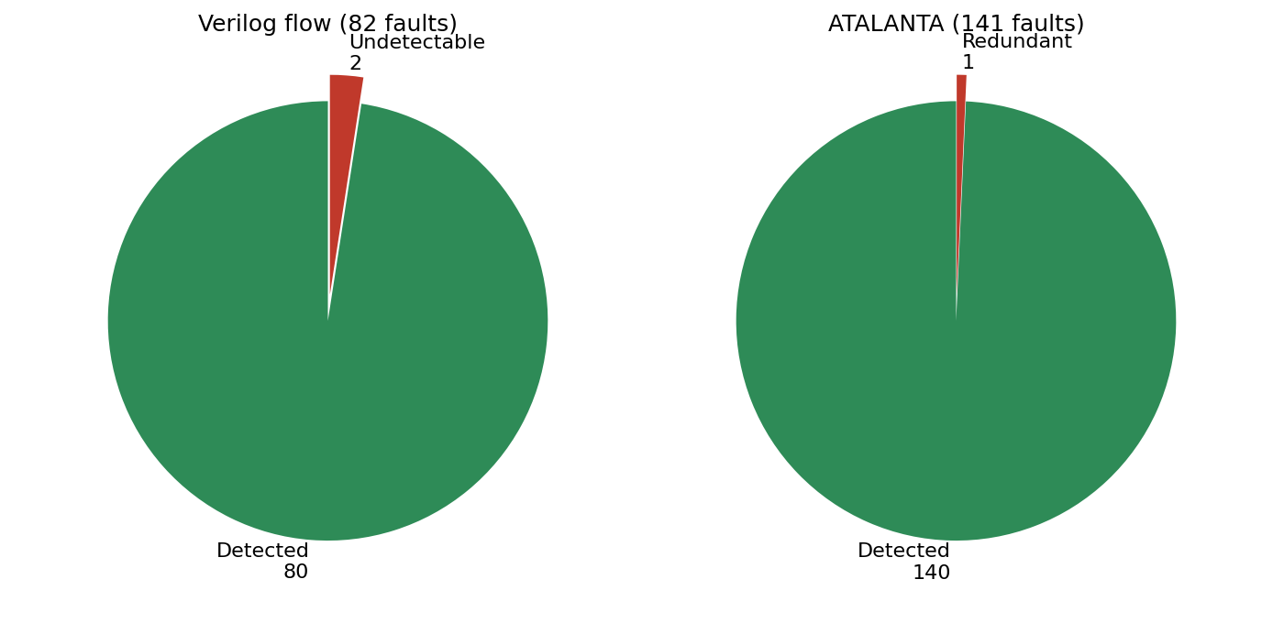
Graph g5: detected and undetectable faults

3D. Verilog greedy TPG (already run)
The testbench picks, at each step, the valid BCD pattern that detects the most remaining faults. Five patterns cover everything detectable: (A,B,Cin) = (2,7,1), (9,8,0), (5,7,0), (0,8,0), (6,9,1).
Why the numbers differ: ATALANTA also models fan-out branch faults (141 faults, not 82) and uses all 512 input combinations, including digits above 9. The Verilog flow uses only valid BCD inputs.

Step 4: Fault simulation (CO4)

4A. In Cadence Modus
File: modus/step3_fault_simulation.cmd. Start Modus the same way as before.
create_logic_tests -testmode FULLSCAN -experiment FULL -effort high
write_vectors -testmode FULLSCAN -inexperiment FULL -language verilog
write_vectors -testmode FULLSCAN -inexperiment FULL -language stil
report_fault_statistics -testmode FULLSCAN -experiment FULL
create_logic_tests -testmode FULLSCAN -experiment C70 -maxcoverage 70.0
report_fault_statistics -testmode FULLSCAN -experiment C70
create_logic_tests -testmode FULLSCAN -experiment HS -maxpatterns 1
report_fault_statistics -testmode FULLSCAN -experiment HS
create_logic_tests -testmode FULLSCAN -experiment GP -maxpatterns 3
report_fault_statistics -testmode FULLSCAN -experiment GP
create_logic_tests -testmode FULLSCAN -experiment MP -maxpatterns 5
report_fault_statistics -testmode FULLSCAN -experiment MP

- write_vectors -language verilog gives testresults/verilog/ (testbench with patterns). -language stil gives the tester file.
- report_fault_statistics shows the final coverage of each experiment (FULL, C70, HS, GP, MP).
- HS (1 pattern) is fast but shallow, GP (3) is balanced, MP (5) is exhaustive. Efficiency = coverage % / elapsed time in seconds, read from the logs in testresults/logs/.

4B. Verilog fault simulation (already run)
Serial fault simulation with fault dropping: for each undetected fault, inject it, apply the pattern, compare with the fault-free output. Result after each pattern:
After pattern | Detected (of 82) | Coverage
T1 | 40 | 48.8 %
T2 | 63 | 76.8 %
T3 | 73 | 89.0 %
T4 | 77 | 93.9 %
T5 | 80 | 97.6 %
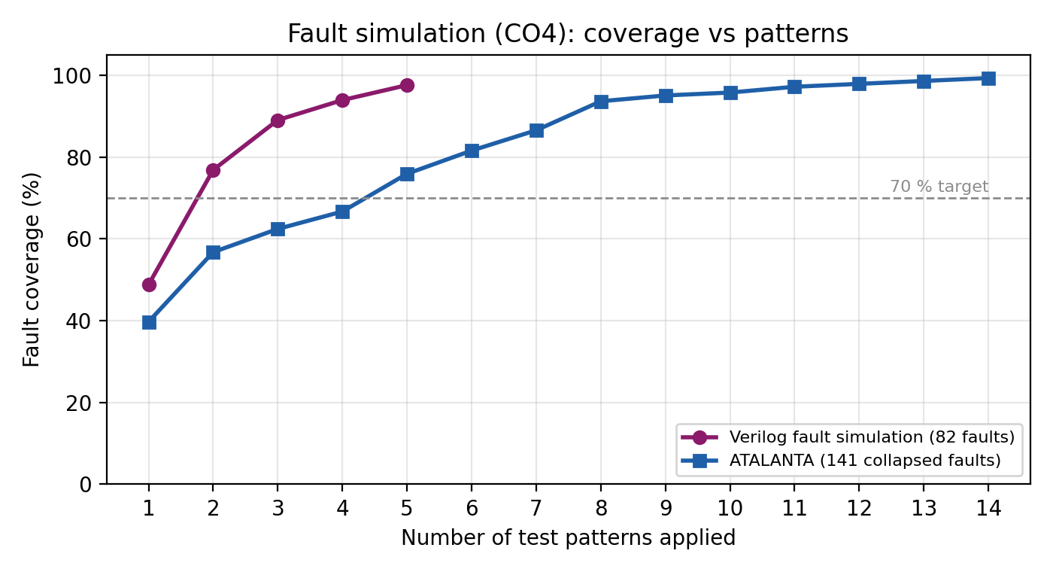
Graph g4: fault coverage against number of patterns
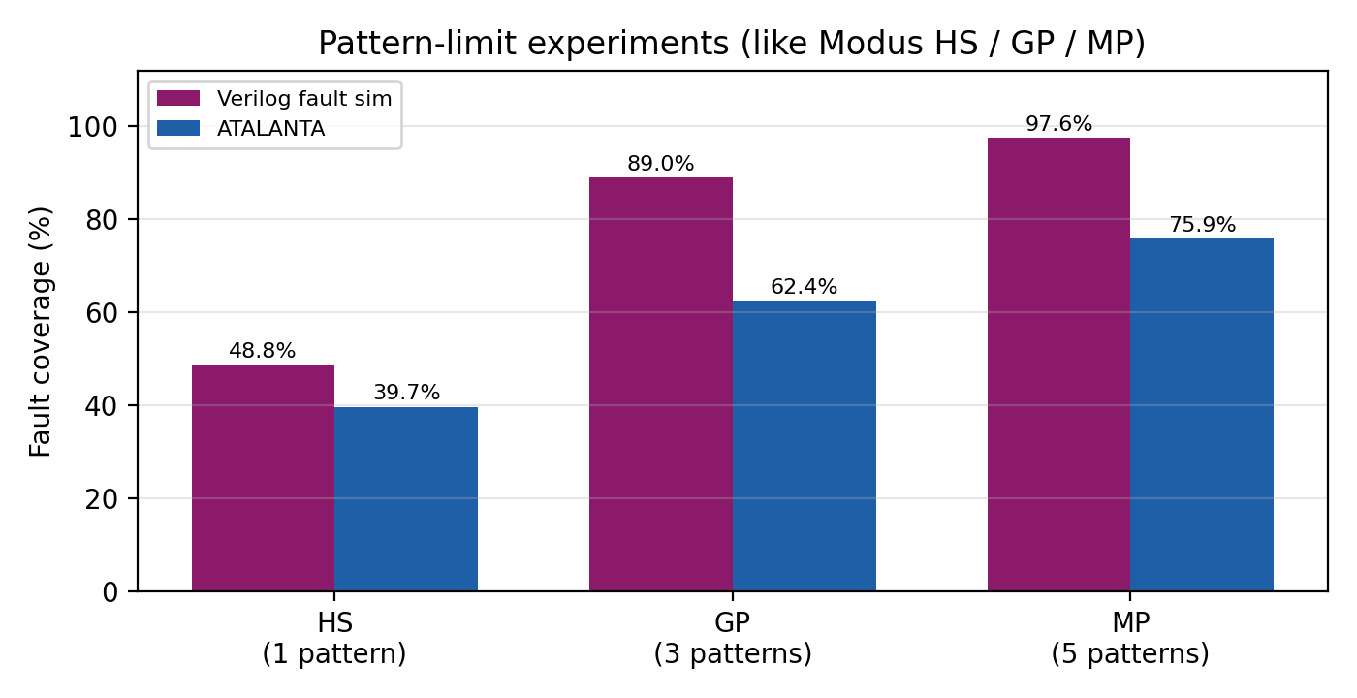
Graph g6: coverage with 1, 3 and 5 patterns (like HS, GP, MP)
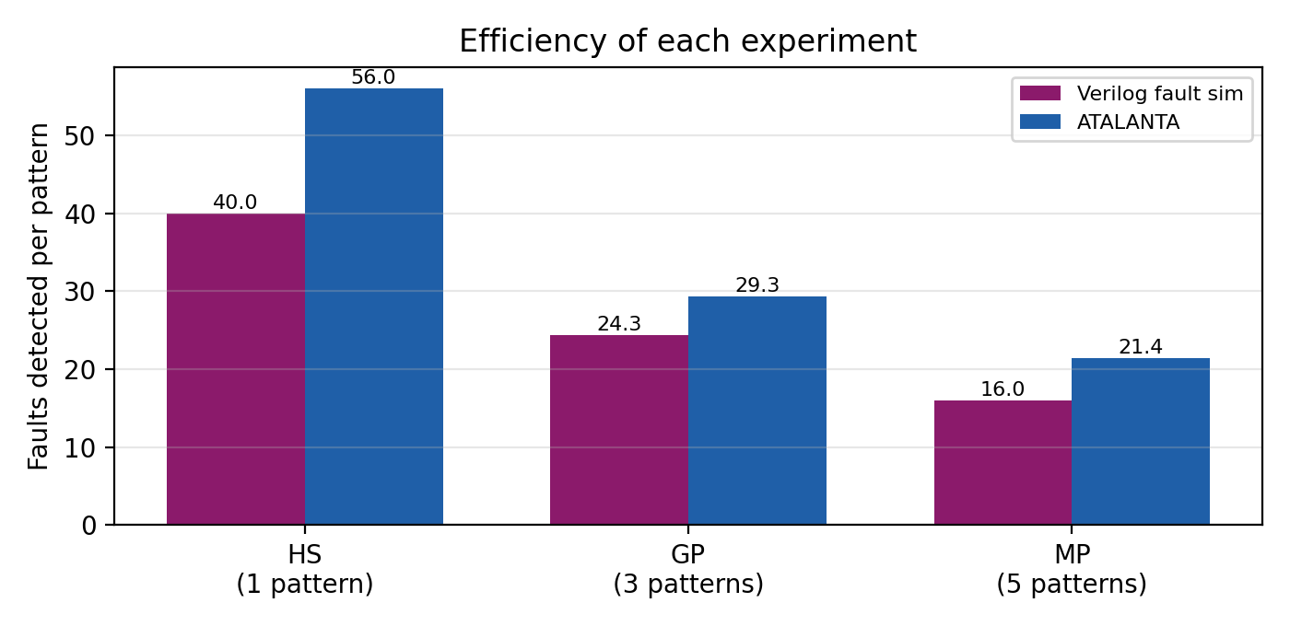
Graph g7: faults detected per pattern
Both curves rise fast at first and then flatten, so the last patterns only catch a few hard faults. The 70 % line is crossed after pattern 2 in the Verilog flow and after pattern 5 in ATALANTA.

Step 5: Analysis points for the report and viva
- Fault list reduction cut 82 faults to 67 (Verilog) and ATALANTA works on 141 collapsed faults. Equivalent faults need only one test.
- Test length: 5 patterns (Verilog greedy) or 14 (ATALANTA) give almost full coverage, against 200 or 512 exhaustive patterns.
- Coverage is 97.5 % (Verilog) and 99.29 % (ATALANTA). The missing faults are redundant: they sit on logic that cannot change any output. Removing that logic gives 100 % coverage.
- ATALANTA's random-pattern phase plus FAN catches most faults with the first few patterns. Compaction removed 4 of 18 patterns without losing coverage.
- Limits: single stuck-at faults only. Bridging and delay faults are not covered.

Step 6: Run it all again
cd BCD_project
./run_all.sh

This runs the Verilog flow, builds and runs ATALANTA, and redraws all graphs in plots/. Only the Modus steps must be done on the lab machine.

