EXPLORATORY TESTING REPORT
BookNest Online Bookstore, Web Application (QA practice build 1.0-RC1)
Week 2 Deliverable: Exploratory Testing Execution and Reporting
Document Control
Document title | BookNest Exploratory Testing Report: Charters, Session Reports and Bug Reports
Version / status | 1.0 / Final for review
Prepared by | Asmita T , Junior Quality Assurance Analyst
Reviewer | [QA Lead name]
Date | 2.10.2026
Related document | BookNest Test Plan and Test Cases v1.0 (Week 1)
Summary of results | 5 sessions, 38 scenarios explored, 13 defects (1 Critical, 4 High, 7 Medium, 1 Low) and 5 observations

Contents
1. Executive Summary
2. Application Under Test and Environment
3. Exploratory Testing Approach
4. Test Charters
5. Session Reports
6. Scenarios Explored
7. Observations and Questions
8. Bug Summary
9. Detailed Bug Reports (BUG-01 to BUG-13)
10. Analysis, Risk and Recommendations
Appendix A. Severity and Priority Definitions
Appendix B. Session Note Template
Appendix C. How to Reproduce These Tests
Appendix D. References

1. Executive Summary
This report documents exploratory testing of BookNest, the online bookstore described in the Week 1 test plan. The aim was to find problems that the scripted test cases in that plan are unlikely to catch, by exploring the application with curiosity, unusual input and unexpected sequences of actions.
Five time-boxed sessions were run, each guided by a written charter covering search, cart and pricing, checkout and orders, accounts and authentication, and usability and accessibility. In total, 38 scenarios were explored. They produced 13 defects: one Critical, four High, seven Medium and one Low, plus five observations that need a product decision.

1.1 Key findings
- Payment risk. Double-clicking "Pay Now" creates two orders (BUG-04, Critical). This is the most serious defect because it can charge a customer twice.
- Security. Search text is reflected into the page without encoding and can run script (BUG-02, High). Login messages also reveal which emails are registered (BUG-08).
- Money and pricing. Negative or oversized quantities (BUG-01), a promo code that stacks without limit (BUG-11) and a tax rounding mismatch (BUG-05) all affect order values.
- Accessibility and mobile. The "Add to cart" controls cannot be reached with the keyboard (BUG-10), and the cart and header break on a 360 px phone screen (BUG-13, BUG-09).

1.2 Release recommendation
Against the exit criteria of the test plan (no open Critical or High defects), the build is not ready for release. BUG-04, BUG-02, BUG-01, BUG-11 and BUG-10 should be fixed and retested first. Section 10 gives the full list of recommendations, including new scripted regression cases to add to the Week 1 suite.
Severity | Count | Defect IDs
Critical | 1 | BUG-04
High | 4 | BUG-01, BUG-02, BUG-10, BUG-11
Medium | 7 | BUG-03, BUG-05, BUG-06, BUG-07, BUG-08, BUG-12, BUG-13
Low | 1 | BUG-09
Total | 13

2. Application Under Test and Environment
The task asks for exploratory testing of a simulated, hypothetical web application. The application under test is therefore a simulated build of the BookNest bookstore, created for this exercise as a single-page web application. It contains deliberately seeded defects, which this report treats exactly as if they had been found in a real release candidate. The same scope as the Week 1 plan applies: accounts, catalogue search, cart, checkout and orders.
Item | Details
Application / build | BookNest QA practice build 1.0-RC1 (single HTML page, runs in the browser; the file is described in Appendix C)
Modules explored | Search and catalogue, cart and promo code, checkout and orders, registration and login, header and navigation
Browser and platform | Chromium (current version) on Linux; desktop window 1100 x 620 px and phone viewport 360 x 740 px
Test accounts | alex@example.com / BookNest#2026 (seeded); additional accounts were created during testing
Test data | 12 seeded books; test card 4242 4242 4242 4242 (sandbox-style value, no real payment); promo code SAVE10
Tools used | Browser developer tools, a browser automation script to drive the sessions and capture screenshots, and a notes template (Appendix B)
Evidence method | Screenshots with the relevant area outlined in red, measured values (for example page widths) and captured dialog text. Each defect lists exact steps so it can be repeated.
Limitations | The build runs entirely in the browser, so server-side behaviour (database errors, real payment gateway, email delivery) could not be assessed. Performance and load testing are outside this exercise.

3. Exploratory Testing Approach

3.1 What exploratory testing is
Exploratory testing is simultaneous learning, test design and test execution. The tester does not follow a fixed script; instead each result guides the next idea. It is an experience-based technique recognised by ISTQB and is especially good at finding unexpected problems, usability issues and defects that arise from unusual combinations of actions. It complements the scripted cases of the Week 1 plan, which check known requirements.

3.2 Session-based test management
To keep the exploration focused and the results accountable, the work followed session-based test management (James and Jonathan Bach). Each session has the following structure:
- Charter. A one-sentence mission that states what to explore, with what, and what kind of problem to look for.
- Time-box. An uninterrupted session of a fixed length (60 minutes planned for each charter).
- Notes. Observations are written while testing, tagged as TEST (what was tried), BUG, QUESTION or IDEA.
- Evidence. Defects are reproduced a second time, minimised to the shortest steps, and documented with a screenshot immediately.
- Debrief. At the end of each session the results are reviewed and follow-up charters are proposed.

3.3 Heuristics, tours and oracles
Technique | Idea | How it was used
SFDIPOT (Structure, Function, Data, Interfaces, Platform, Operations, Time) | Checklist of product dimensions to explore (Bolton and Bach). | Charters were split by function and data; platform was covered by the phone viewport; time by double-clicks and refreshes.
Money tour | Follow the features that earn or lose money (Whittaker). | Cart, promo code, tax and checkout were explored in C2 and C3.
Back-alley and antisocial tours | Use rarely visited paths and deliberately hostile input. | Direct address to checkout with an empty cart; HTML in the search box; negative quantities.
Boundary and data variation | Try values at and beyond the limits; vary case, spaces and length. | Quantity 10, 11, 0, -2; emails in upper case or with a trailing space; 200-character search; 104-character name.
Interruptions | Break the normal sequence (refresh, repeat, rush). | Refresh with items in the cart; double-click Pay Now; apply a promo code repeatedly.
Keyboard and responsive tours | Use the product without a mouse or on a small screen. | Tab order through the home page; 360 px cart and header.
Oracles (HICCUPPS) | Ways to recognise a problem: History, Image, Comparable products, Claims, User expectations, Product, Purpose, Statutes. | Claims: requirements REQ-01 to REQ-12 and the Week 1 test cases. User expectations: totals add up. Statutes: WCAG 2.1 and security guidance.

3.4 Defect handling
Each defect has an ID, a title that states the problem, a module, the charter that found it, severity and priority (definitions in Appendix A), numbered steps, expected and actual results, evidence, the impact and a suggested fix. Severity describes the damage the defect can do; priority describes how soon it should be fixed.

4. Test Charters
Five charters were defined from the risk list of the Week 1 test plan. Each charter follows the pattern: Explore (area) with (resources or data) to discover (information or risk).
ID | Charter (mission) | Areas and data | Risk targeted | Time-box
C1 | Explore the search box with unusual, hostile and extreme input to discover mishandled text, wrong matches and display problems. | Search by title, author, ISBN; mixed case; spaces; symbols; 200 characters; HTML and script text. | R3 injection | 60 min
C2 | Explore cart quantity, promo code and totals with extreme and repeated actions to discover calculation and state errors. | Quantities 0, 10, 11, -2; promo codes FREE and SAVE10; page refresh; totals check by hand. | R4 cart and price | 60 min
C3 | Explore checkout and order creation with rushed, repeated and incomplete actions to discover duplicate, invalid or lost orders. | Empty fields; valid test card; double-click; empty cart; order list. | R1 payment | 60 min
C4 | Explore registration and login with near-duplicate data, wrong credentials and very long values to discover data integrity, security and layout problems. | Duplicate emails (case, space); weak passwords; unknown email vs wrong password; 104-character name. | R2 authentication | 60 min
C5 | Explore the main shopping path with keyboard only and a 360 px phone viewport to discover accessibility and responsive design problems. | Tab key through home page; cart at 360 px; header at 360 px. | R5 and R6 mobile and accessibility | 60 min

Out of scope for all charters: load testing, real payment gateway behaviour, email delivery and the admin area.

5. Session Reports

Session C1: Search and catalogue
Field | Details
Charter | Explore the search box with unusual, hostile and extreme input to discover mishandled text, wrong matches and display problems.
Time-box | 60 minutes (planned)
Environment | Chromium, desktop 1100 x 620 and phone 360 x 740; build 1.0-RC1
Test notes | Start from the home page, check the catalogue, then move from normal searches to unusual input. Searches by title, partial title, full title and ISBN worked, including upper-case title text. Author searches behaved differently: "Martin" found two books but "martin", "MARTIN" and "fowler" found none (BUG-03). Special characters, a SQL-style string and a 200-character string produced no errors, but because the build has no server, database-level injection could not be assessed. HTML typed into the search box was then tried and was found to be interpreted by the page, first as bold text, then as a heading and finally as an image tag that ran script (BUG-02). The empty-result screen showed two almost identical lines and gave no advice, and whitespace only was treated as a real query (OBS-1, OBS-2).
Defects found | BUG-02, BUG-03
Observations | OBS-1, OBS-2
Debrief / next steps | Follow-up: test whether the search address can be shared as a link that triggers BUG-02 for another user.

Session C2: Cart and pricing
Field | Details
Charter | Explore cart quantity, promo code and totals with extreme and repeated actions to discover calculation and state errors.
Time-box | 60 minutes (planned)
Environment | Chromium, desktop 1100 x 620 and phone 360 x 740; build 1.0-RC1
Test notes | Added the same book three times and checked the arithmetic by hand, which revealed a one-cent difference between the lines and the total (BUG-05). The "+" button stopped at 10, but typing 11 in the quantity box was accepted, and -2 produced negative totals and a negative badge count (BUG-01). Typing 0 removed the item silently (OBS-3); the number field blocked letters natively. Promo code FREE was rejected correctly, but SAVE10, entered in lower case, could be applied again and again, stacking 10% each time (BUG-11). Finally, after logging in and adding two books, a page refresh emptied the cart although the user remained logged in (BUG-07).
Defects found | BUG-01, BUG-05, BUG-07, BUG-11
Observations | OBS-3
Debrief / next steps | Follow-up: check the promo code with a very high number of applications, and carts with many different books.

Session C3: Checkout and orders
Field | Details
Charter | Explore checkout and order creation with rushed, repeated and incomplete actions to discover duplicate, invalid or lost orders.
Time-box | 60 minutes (planned)
Environment | Chromium, desktop 1100 x 620 and phone 360 x 740; build 1.0-RC1
Test notes | Opened checkout with an item and pressed Pay Now with empty fields; the validation message was shown correctly. With valid data, a quick double-click on Pay Now produced two orders for one purchase (BUG-04). The checkout page itself showed only a total and no item list (OBS-4). After the cart was emptied, the checkout page could still be opened directly and an order for $0.00 and 0 items was placed (BUG-12). The order list shows every order as "Confirmed" with no detail link (OBS-5).
Defects found | BUG-04, BUG-12
Observations | OBS-4, OBS-5
Debrief / next steps | Follow-up: try using the browser Back button during payment and a slow network, which this build cannot simulate.

Session C4: Accounts and authentication
Field | Details
Charter | Explore registration and login with near-duplicate data, wrong credentials and very long values to discover data integrity, security and layout problems.
Time-box | 60 minutes (planned)
Environment | Chromium, desktop 1100 x 620 and phone 360 x 740; build 1.0-RC1
Test notes | Compared the messages for an unknown email and a wrong password and found that they differ and so reveal which emails exist (BUG-08). Registration correctly rejected an exact duplicate email, a malformed email and two weak passwords. The same email in upper case, or with a trailing space, was accepted as a new account (BUG-06). A 104-character display name made the header 1056 px wide on a 360 px screen, pushing the Log out link off the screen (BUG-09); on a desktop window there was no overflow.
Defects found | BUG-06, BUG-08, BUG-09
Observations | None
Debrief / next steps | Follow-up: password reset and profile editing were not part of this build and need to be explored when delivered.

Session C5: Usability, accessibility and mobile
Field | Details
Charter | Explore the main shopping path with keyboard only and a 360 px phone viewport to discover accessibility and responsive design problems.
Time-box | 60 minutes (planned)
Environment | Chromium, desktop 1100 x 620 and phone 360 x 740; build 1.0-RC1
Test notes | Navigated the home page using only the Tab key. Focus moved through the header controls and then left the page without ever stopping on any of the 12 "Add to cart" controls (BUG-10). At 360 px the cart table was 576 px wide, hiding the Line total and Remove columns (BUG-13). The catalogue itself showed all 12 books correctly and the header links worked.
Defects found | BUG-10, BUG-13
Observations | None
Debrief / next steps | Follow-up: screen reader pass and colour contrast check with axe DevTools; zoom to 200%.

6. Scenarios Explored
The table lists every scenario tried, including those that passed. Passed scenarios show where the application behaved correctly, which is also part of the coverage.
# | Ses. | Scenario / action | Observed result | Status
1 | C1 | Home page catalogue | 12 books displayed | Pass
2 | C1 | Search "clean" | 1 result | Pass
3 | C1 | Search "CLEAN" (upper case title text) | 1 result | Pass
4 | C1 | Search full title "Clean Code" | 1 result | Pass
5 | C1 | Search by ISBN 9780132350884 | 1 result | Pass
6 | C1 | Search "Martin" (author, capital M) | 2 results: Clean Code, Refactoring | Pass
7 | C1 | Search "martin", "MARTIN", "fowler" | 0 results each | BUG-03
8 | C1 | Search "zzzz" (no match) | "0 result(s) found" plus a second "0 result(s)" line, no advice | OBS-1
9 | C1 | Search with spaces only | 0 results (treated as a real query) | OBS-2
10 | C1 | Search "%", "' OR '1'='1" and 200 characters | 0 results, no error shown (client-side build) | Pass
11 | C1 | Search <b>bold test</b> | Text rendered in bold | BUG-02
12 | C1 | Search <h1 ...>INJECTED HEADING</h1> | Heading element shown in the page | BUG-02
13 | C1 | Search <img src=x onerror=alert(document.domain)> | Alert dialog "localhost" displayed | BUG-02
14 | C2 | Add "Clean Code" three times | Quantity 3, badge "Cart (3)" | Pass
15 | C2 | Check subtotal, tax and total by hand | $59.97 + $4.79 shown, total $64.77 | BUG-05
16 | C2 | Press "+" 12 times | Quantity stops at 10 | Pass
17 | C2 | Type 11 in the quantity box | Accepted; badge "Cart (11)", total $237.48 | BUG-01
18 | C2 | Type -2 in the quantity box | Accepted; total -$43.18, badge "Cart (-2)" | BUG-01
19 | C2 | Type 0 in the quantity box | Item removed, "Your cart is empty" | OBS-3
20 | C2 | Type letters in the quantity box | Blocked by the number field | Pass
21 | C2 | Apply promo code FREE | "Invalid promo code" | Pass
22 | C2 | Apply promo code save10 three times | 30% discount, total $45.34 | BUG-11
23 | C2 | Logged in, add 2 books, refresh the page | Cart (0), still logged in | BUG-07
24 | C3 | Pay Now with empty fields | "Please fill in all fields." | Pass
25 | C3 | Pay Now double-click with valid data | Two orders #1001 and #1002 | BUG-04
26 | C3 | Checkout with empty cart, then Pay Now | Order #1003, 0 items, $0.00 | BUG-12
27 | C3 | Review checkout page content | Only a total, no item list | OBS-4
28 | C3 | Review the order list | All orders "Confirmed"; no link to order details | OBS-5
29 | C4 | Login with unknown email | "No account found with this email address." | BUG-08
30 | C4 | Login with wrong password | "Incorrect password." (different message) | BUG-08
31 | C4 | Register existing email exactly | Rejected: already registered | Pass
32 | C4 | Register invalid email "alex@" | Rejected: enter a valid email | Pass
33 | C4 | Register passwords "Ab1" and "Passwordonly" | Both rejected with the rule message | Pass
34 | C4 | Register ALEX@EXAMPLE.COM | Account created | BUG-06
35 | C4 | Register "alex@example.com " (trailing space) | Account created | BUG-06
36 | C4 | 104-character name at 360 px; same at 1100 px | Header 1056 px wide at 360 px; no overflow at 1100 px | BUG-09
37 | C5 | Tab through the home page (22 presses) | No "Add to cart" control is ever focused | BUG-10
38 | C5 | Cart at 360 px width | Table 576 px wide, columns cut off | BUG-13

Totals: 38 scenarios. Passed: 15. Defect found: 18 scenarios (13 distinct defects). Observation raised: 5.

7. Observations and Questions
Observations are behaviours that may not be defects, or where the requirement is unclear. Each needs a decision from the Product Owner.
ID | Observation | Question / suggestion
OBS-1 | The empty search result shows "0 result(s) found" and a second line "0 result(s)", with no advice. | Show one friendly message with tips (check spelling, try a shorter word) and popular books.
OBS-2 | A search made of spaces only returns 0 results. | Trim the query and treat it as empty, so the full catalogue is shown.
OBS-3 | Setting a quantity to 0 removes the item at once without confirmation. | REQ-05 does not say whether 0 should remove or be refused. Confirm the intended behaviour (see test plan section 4.2).
OBS-4 | The checkout page shows only the order total, with no item list, tax or delivery details. | Add an order summary so customers can review before paying.
OBS-5 | Every order is shown as "Confirmed" and cannot be opened for details. | Confirm the status list and whether order detail pages are in scope for 1.0 (REQ-07).

8. Bug Summary
ID | Title | Module | Ses. | Severity | Priority | Status
BUG-01 | Cart quantity field accepts negative and out-of-limit values | Cart | C2 | High | P1 | New
BUG-02 | Search text is inserted into the page without encoding (reflected HTML and script injection) | Search | C1 | High | P1 | New
BUG-03 | Author search is case-sensitive | Search | C1 | Medium | P2 | New
BUG-04 | Double-clicking "Pay Now" creates duplicate orders | Checkout | C3 | Critical | P1 | New
BUG-05 | Tax is truncated but the total is rounded, so displayed amounts do not add up | Cart | C2 | Medium | P2 | New
BUG-06 | Duplicate accounts can be created with a different letter case or a trailing space in the email | Accounts | C4 | Medium | P2 | New
BUG-07 | Cart is emptied when a logged-in user refreshes the page | Cart | C2 | Medium | P2 | New
BUG-08 | Login error messages reveal whether an email address is registered | Accounts | C4 | Medium | P2 | New
BUG-09 | Very long display name pushes the header off-screen on a phone | Accounts | C4 | Low | P3 | New
BUG-10 | "Add to cart" controls cannot be reached or used with the keyboard | Accessibility | C5 | High | P2 | New
BUG-11 | Promo code SAVE10 can be applied repeatedly and the discounts stack | Cart | C2 | High | P1 | New
BUG-12 | An order can be placed with an empty cart ($0.00 order) | Checkout | C3 | Medium | P2 | New
BUG-13 | Cart table is wider than a phone screen; Line total and Remove are cut off | Cart | C5 | Medium | P2 | New

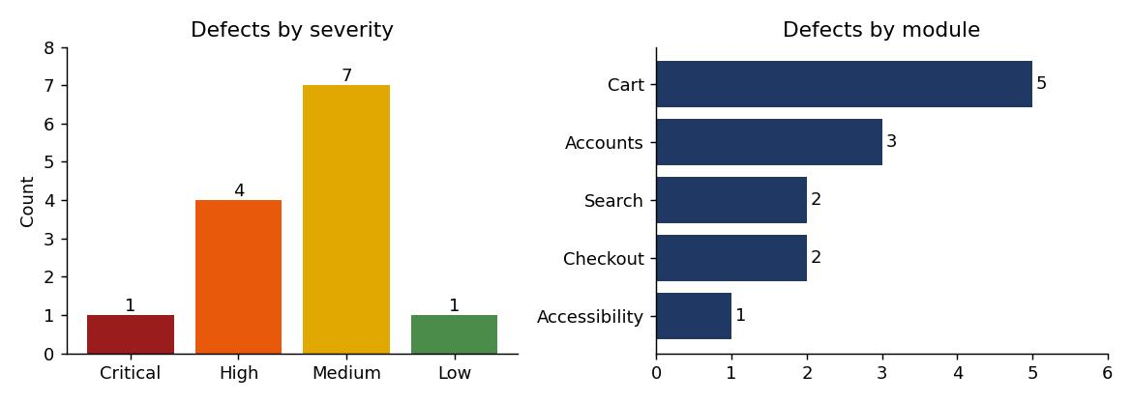
Figure 1: Defects by severity and by module

9. Detailed Bug Reports
Each report is written so that a developer can reproduce the problem without further questions. Evidence figures follow each report; red outlines mark the relevant area.
BUG-01: Cart quantity field accepts negative and out-of-limit values
Bug ID | BUG-01 | Module | Cart
Severity | High | Priority | P1
Found in | Session C2 | Status | New
Type | Functional / input validation
Environment | BookNest QA practice build 1.0-RC1, Chromium on Linux, desktop viewport 1100 x 620
Preconditions | Cart contains one copy of "Clean Code" ($19.99).
Test data | Quantity values 11 and -2
Steps to reproduce | 1. Open the home page and click "Add to cart" on "Clean Code".  2. Click the Cart link in the header.  3. Replace the quantity 1 with 11 and press Tab. Note the line total, totals and the cart badge.  4. Replace the quantity with -2 and press Tab. Note the totals and the badge again.
Expected result | Quantity is limited to 1 to 10 (REQ-05). Values outside the range are rejected with a message and the previous quantity is kept.
Actual result | 11 is accepted: line total $219.89, total $237.48, badge "Cart (11)". -2 is accepted: line total -$39.98, tax -$3.20, total -$43.18, badge "Cart (-2)". The "+" button correctly stops at 10, so the limit is enforced only on the buttons, not on the typed value.
Reproducibility | Always
Impact | Customers, or anyone editing requests, can bypass the purchase limit and create negative totals. If checkout accepted such a cart the shop could owe the buyer money.
Suggested fix | Validate quantity as an integer from 1 to 10 in the browser and again on the server; add min and max attributes; recalculate totals on the server.
Related items | REQ-05; TC-F-09 (covers 11 but not negative numbers); risk R4
Evidence | 2 figures follow this report (red outline marks the relevant area).
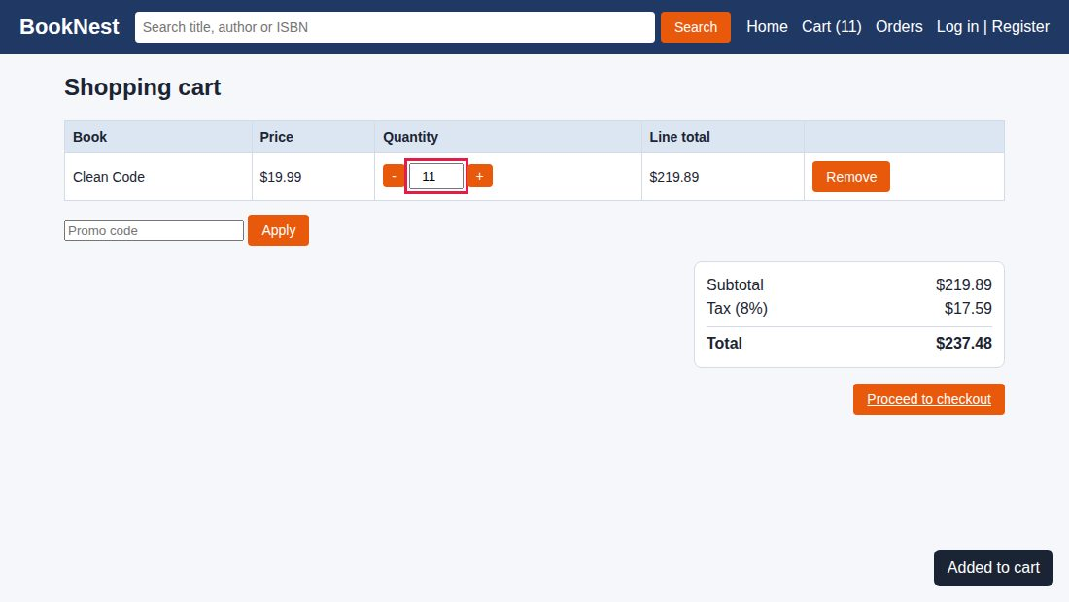
Figure 2: BUG-01: Quantity 11 accepted (limit is 10); badge shows 11
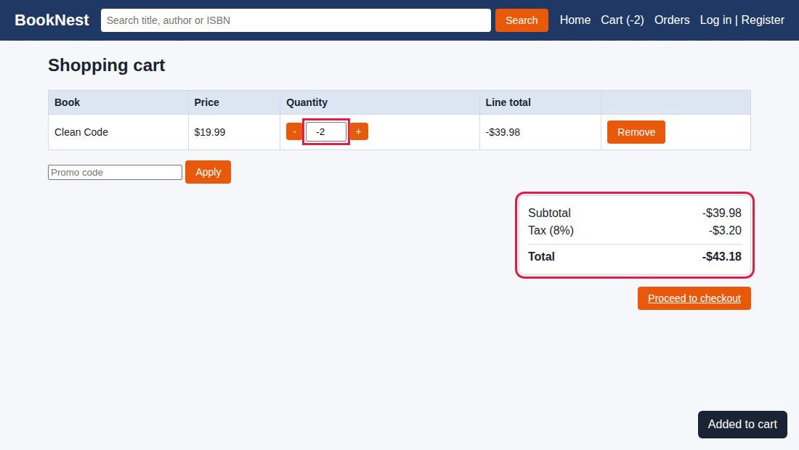
Figure 3: BUG-01: Quantity -2 accepted; subtotal, tax and total are negative

BUG-02: Search text is inserted into the page without encoding (reflected HTML and script injection)
Bug ID | BUG-02 | Module | Search
Severity | High | Priority | P1
Found in | Session C1 | Status | New
Type | Security (OWASP A03 Injection / XSS)
Environment | BookNest QA practice build 1.0-RC1, Chromium on Linux, desktop viewport 1100 x 620
Preconditions | None. The search query is also carried in the page address, so a crafted link can trigger the issue.
Test data | <b>bold test</b> | <h1 style="color:#c00">INJECTED HEADING</h1> | <img src=x onerror=alert(document.domain)>
Steps to reproduce | 1. Open the home page.  2. Type <b>bold test</b> in the search box and click Search. Look at the "Results for" heading.  3. Search for <h1 style="color:#c00">INJECTED HEADING</h1>.  4. Search for <img src=x onerror=alert(document.domain)> and watch for a dialog box.
Expected result | The text is shown exactly as typed (HTML-encoded). No markup is interpreted and no script runs.
Actual result | Step 2: the text is rendered in bold, so markup is interpreted. Step 3: a large red heading appears inside the page. Step 4: JavaScript executes and an alert dialog with the text "localhost" is displayed.
Reproducibility | Always
Impact | An attacker can send a victim a search link that runs script in their browser. This can steal session data, show fake login or payment forms, or redirect to a malicious site.
Suggested fix | Encode output (use textContent or an HTML-escape function); add a Content-Security-Policy header; add this input to the security regression suite.
Related items | REQ-11; TC-S-02; risk R3
Evidence | 2 figures follow this report (red outline marks the relevant area).
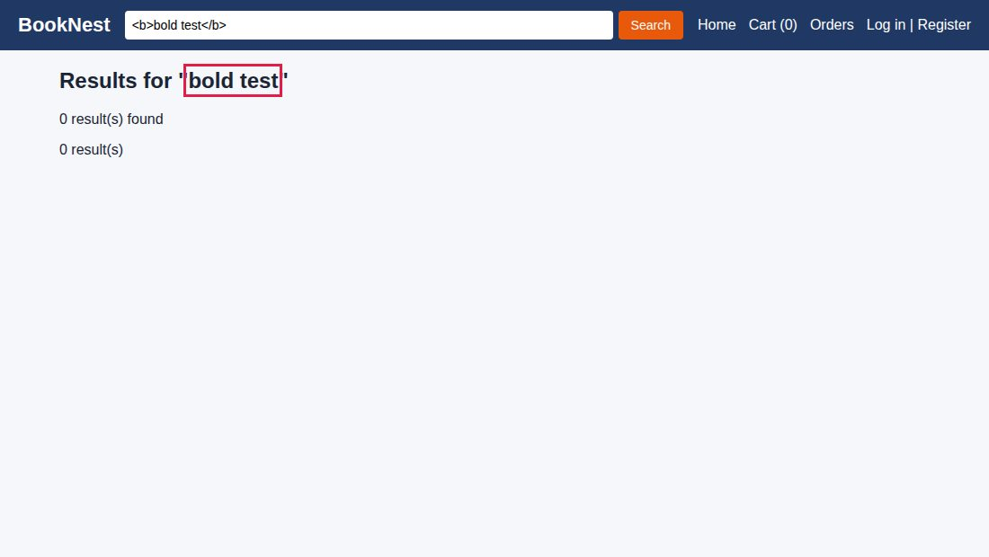
Figure 4: BUG-02: Search text rendered as HTML (bold) in the results heading
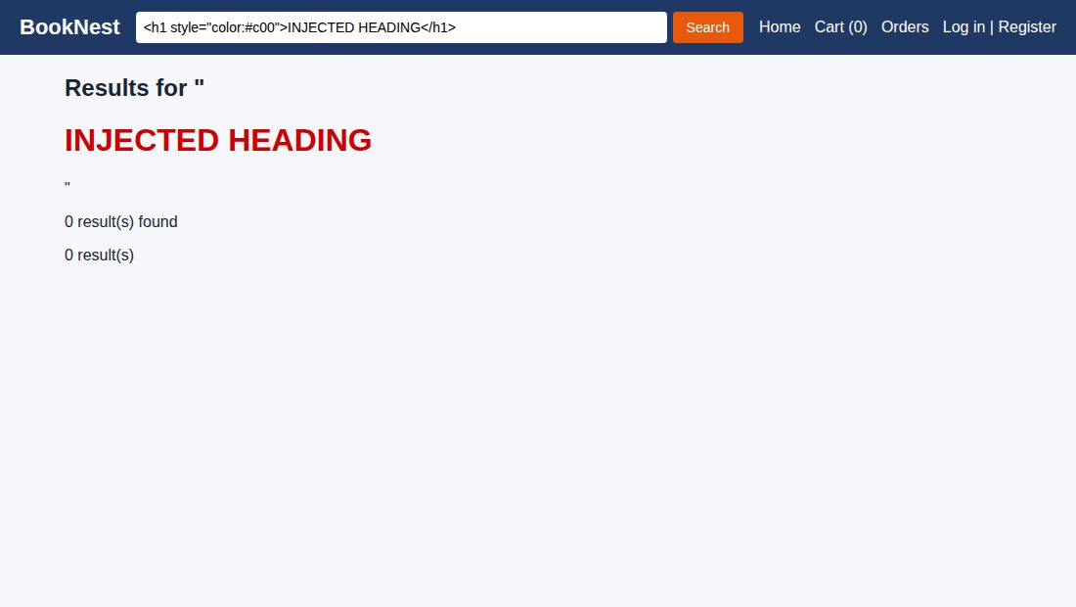
Figure 5: BUG-02: Injected heading element displayed in the page

BUG-03: Author search is case-sensitive
Bug ID | BUG-03 | Module | Search
Severity | Medium | Priority | P2
Found in | Session C1 | Status | New
Type | Functional
Environment | BookNest QA practice build 1.0-RC1, Chromium on Linux, desktop viewport 1100 x 620
Preconditions | Catalogue contains "Clean Code" by Robert C. Martin and "Refactoring" by Martin Fowler.
Test data | Martin | martin | MARTIN | fowler
Steps to reproduce | 1. Type Martin in the search box and click Search (2 results are expected).  2. Search for martin.  3. Search for MARTIN.  4. Search for fowler.
Expected result | All four searches return the same books regardless of letter case, as title search already does.
Actual result | "Martin" returns 2 results (Clean Code, Refactoring). "martin", "MARTIN" and "fowler" each return "0 result(s) found".
Reproducibility | Always
Impact | Most people type in lower case, so they will not find books by author and may leave without buying.
Suggested fix | Convert both the query and the author field to lower case before comparing.
Related items | REQ-04; TC-F-07
Evidence | 1 figure follows this report (red outline marks the relevant area).
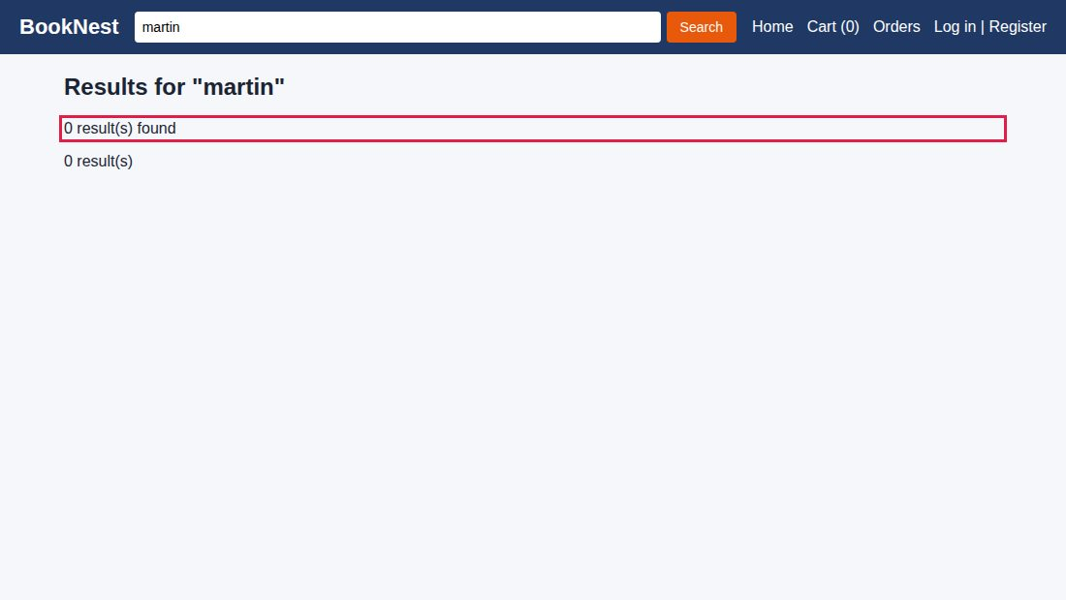
Figure 6: BUG-03: Lower-case author search returns no results

BUG-04: Double-clicking "Pay Now" creates duplicate orders
Bug ID | BUG-04 | Module | Checkout
Severity | Critical | Priority | P1
Found in | Session C3 | Status | New
Type | Functional / concurrency
Environment | BookNest QA practice build 1.0-RC1, Chromium on Linux, desktop viewport 1100 x 620
Preconditions | Logged in as alex@example.com. Cart contains one copy of "Dune" ($9.99).
Test data | Address: 12 Test Street, Springfield | Card: 4242 4242 4242 4242 | Expiry/CVC: 12/30 123
Steps to reproduce | 1. Add "Dune" to the cart, open the cart and click "Proceed to checkout".  2. Enter the address, card number and expiry/CVC from the test data.  3. Double-click "Pay Now" (two clicks within about 0.7 seconds).  4. Open "Orders" from the header.
Expected result | One order is created and the customer is charged once. The button is disabled with a progress indicator after the first click and the server rejects duplicate submissions.
Actual result | Two orders, #1001 and #1002, each for 1 item and $10.79, are created. The button stays active while the payment is processing.
Reproducibility | Always when the second click lands within the processing delay
Impact | The customer can be charged twice for one purchase. This leads to refunds, chargebacks, support effort and loss of trust. It is the payment risk (R1) in the test plan.
Suggested fix | Disable the button after the first click; send an idempotency key with each checkout; detect duplicate submissions on the server.
Related items | REQ-06; TC-F-11 (single click only); risk R1
Evidence | 1 figure follows this report (red outline marks the relevant area).
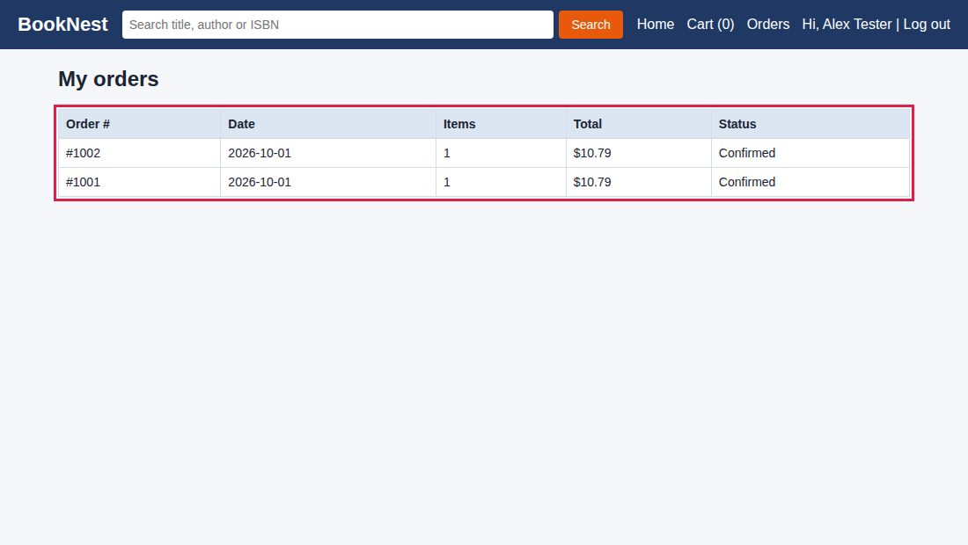
Figure 7: BUG-04: Order list shows two identical orders from one purchase

BUG-05: Tax is truncated but the total is rounded, so displayed amounts do not add up
Bug ID | BUG-05 | Module | Cart
Severity | Medium | Priority | P2
Found in | Session C2 | Status | New
Type | Functional / calculation
Environment | BookNest QA practice build 1.0-RC1, Chromium on Linux, desktop viewport 1100 x 620
Preconditions | Empty cart.
Test data | "Clean Code" x 3 at $19.99
Steps to reproduce | 1. Click "Add to cart" on "Clean Code" three times.  2. Open the cart.  3. Read Subtotal, Tax (8%) and Total and add Subtotal and Tax by hand.
Expected result | Subtotal $59.97 + Tax $4.80 (8% of 59.97 is 4.7976, rounded to 4.80) = Total $64.77. The displayed lines add up.
Actual result | Subtotal $59.97, Tax $4.79, Total $64.77. The displayed Subtotal plus Tax is $64.76, one cent less than the Total.
Reproducibility | Always
Impact | Invoice amounts that do not add up cause customer complaints and can create accounting or legal problems.
Suggested fix | Use one rounding rule (round half up to 2 decimals) for every amount, calculate in whole cents or a decimal type, and derive the total from the rounded lines.
Related items | REQ-06 (tax rules unclear, see test plan section 4.2); not covered by a scripted case
Evidence | 1 figure follows this report (red outline marks the relevant area).
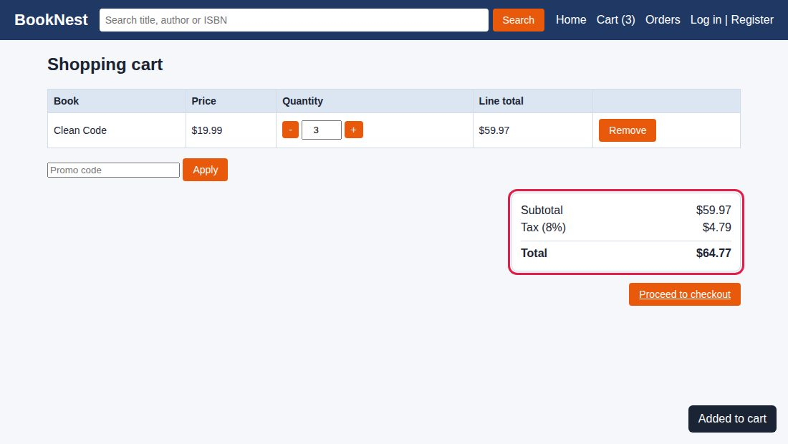
Figure 8: BUG-05: Subtotal $59.97 + Tax $4.79 does not equal Total $64.77

BUG-06: Duplicate accounts can be created with a different letter case or a trailing space in the email
Bug ID | BUG-06 | Module | Accounts
Severity | Medium | Priority | P2
Found in | Session C4 | Status | New
Type | Functional / data integrity
Environment | BookNest QA practice build 1.0-RC1, Chromium on Linux, desktop viewport 1100 x 620
Preconditions | Account alex@example.com already exists.
Test data | ALEX@EXAMPLE.COM | "alex@example.com " (trailing space) | password BookNest#2026
Steps to reproduce | 1. Open Register.  2. Enter name "Alex Clone", email ALEX@EXAMPLE.COM, password BookNest#2026 and click "Create account".  3. Log out.  4. Register again with name "Alex Space" and the email alex@example.com followed by one space.
Expected result | Both attempts are rejected as "already registered". Emails are trimmed and compared without regard to letter case.
Actual result | Both accounts are created and the user is logged in each time. The stored user list contains three entries: alex@example.com, ALEX@EXAMPLE.COM and "alex@example.com ". An exact duplicate is correctly rejected.
Reproducibility | Always
Impact | Duplicate accounts split order history, make password reset ambiguous and allow impersonation or spam registrations.
Suggested fix | Trim and lower-case emails before validation and storage; enforce a unique index on the normalised email.
Related items | REQ-01; TC-F-03 (covers the case variant, not the trailing space)
Evidence | 1 figure follows this report (red outline marks the relevant area).
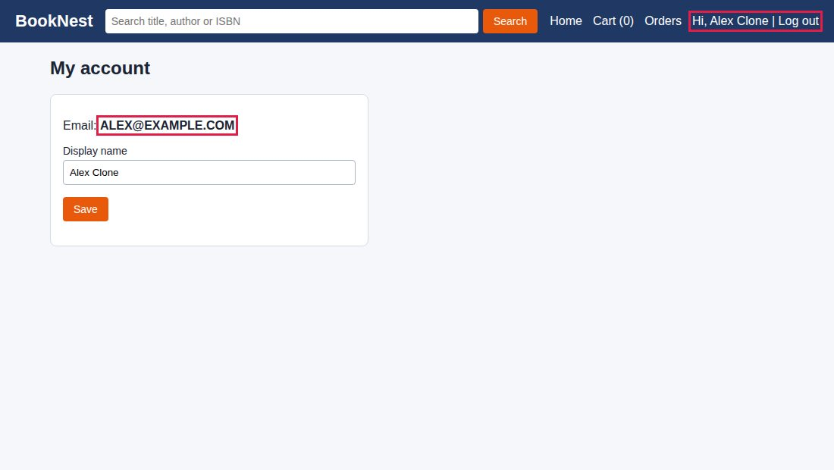
Figure 9: BUG-06: Account created for ALEX@EXAMPLE.COM although alex@example.com exists

BUG-07: Cart is emptied when a logged-in user refreshes the page
Bug ID | BUG-07 | Module | Cart
Severity | Medium | Priority | P2
Found in | Session C2 | Status | New
Type | Functional / state
Environment | BookNest QA practice build 1.0-RC1, Chromium on Linux, desktop viewport 1100 x 620
Preconditions | Logged in as alex@example.com; cart empty.
Test data | "The Pragmatic Programmer" and "Dune"
Steps to reproduce | 1. Log in as alex@example.com.  2. Add "The Pragmatic Programmer" and "Dune" to the cart. The badge shows "Cart (2)".  3. Refresh the browser page.  4. Look at the badge and open the cart.
Expected result | The cart still contains both books because the user is logged in (REQ-05).
Actual result | The user stays logged in ("Hi, Alex Tester") but the badge shows "Cart (0)" and the cart page says "Your cart is empty."
Reproducibility | Always
Impact | Customers lose their selection after an accidental refresh or a browser restart, which increases abandoned purchases.
Suggested fix | Save the cart on the server for logged-in users (and in browser storage for guests) and restore it on page load.
Related items | REQ-05; TC-F-10 (covers logout and login only, not refresh)
Evidence | 2 figures follow this report (red outline marks the relevant area).
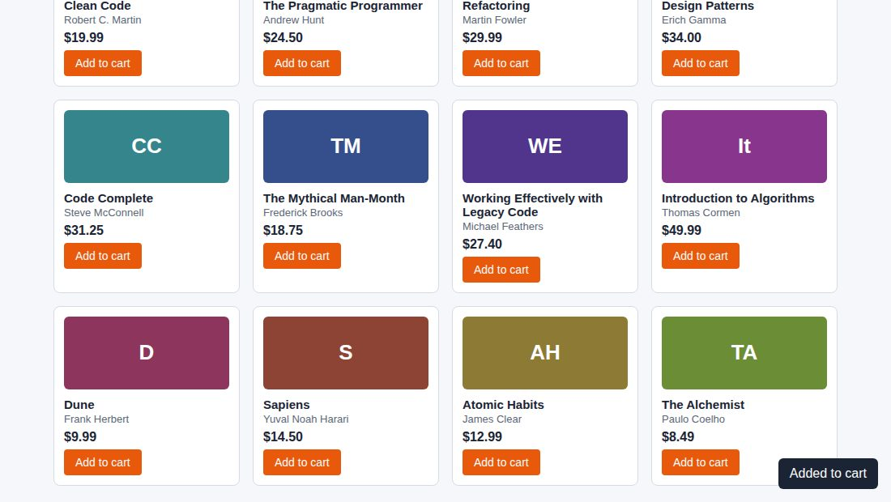
Figure 10: BUG-07: Before refresh: two items in the cart, user logged in
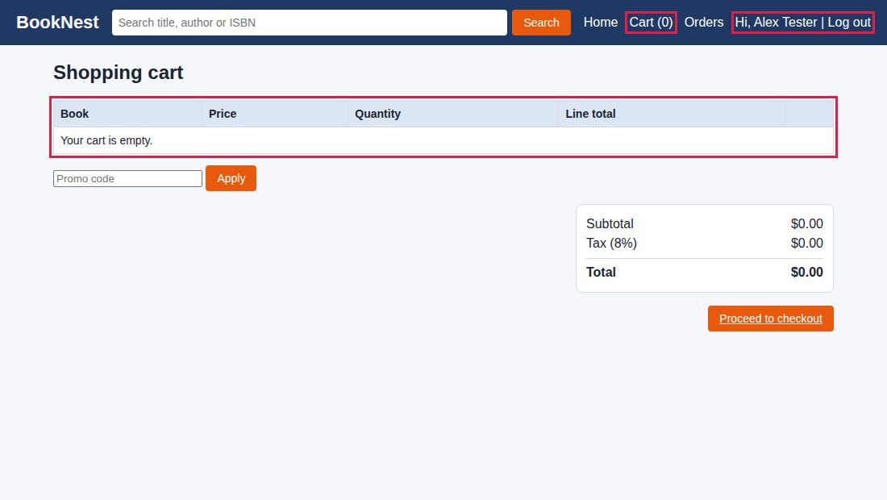
Figure 11: BUG-07: After refresh: cart empty although the user is still logged in

BUG-08: Login error messages reveal whether an email address is registered
Bug ID | BUG-08 | Module | Accounts
Severity | Medium | Priority | P2
Found in | Session C4 | Status | New
Type | Security (OWASP A07 Authentication)
Environment | BookNest QA practice build 1.0-RC1, Chromium on Linux, desktop viewport 1100 x 620
Preconditions | Account alex@example.com exists; nobody@example.com does not.
Test data | nobody@example.com / x | alex@example.com / wrongpass1
Steps to reproduce | 1. Open the Log in page.  2. Enter nobody@example.com and password x. Read the message.  3. Enter alex@example.com and password wrongpass1. Read the message.
Expected result | Both attempts show the same generic message such as "Email or password is incorrect" (test case TC-F-05).
Actual result | Step 2 shows "No account found with this email address." Step 3 shows "Incorrect password." The difference confirms which emails have accounts.
Reproducibility | Always
Impact | Attackers can build a list of registered customers for credential-stuffing or phishing attacks.
Suggested fix | Show one generic message for both cases, keep response times similar, and add rate limiting.
Related items | REQ-02, REQ-11; TC-F-05, TC-F-06
Evidence | 1 figure follows this report (red outline marks the relevant area).
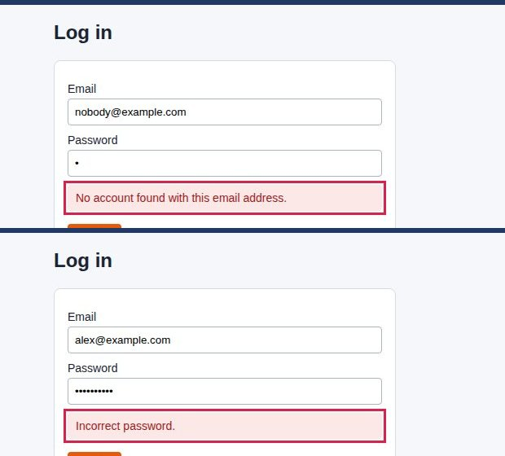
Figure 12: BUG-08: Top: unknown email message. Bottom: wrong password message

BUG-09: Very long display name pushes the header off-screen on a phone
Bug ID | BUG-09 | Module | Accounts
Severity | Low | Priority | P3
Found in | Session C4 | Status | New
Type | Usability / layout
Environment | BookNest QA practice build 1.0-RC1, Chromium on Linux, phone viewport 360 x 740
Preconditions | Phone-size viewport (360 x 740).
Test data | 104-character name: Alexandria Bartholomew Montgomery-Featherstonehaugh the Third of Greater Metropolitan Springfield County
Steps to reproduce | 1. Register an account using the long name above and email long@example.com.  2. Open the home page with the browser width set to 360 px.  3. Look at the header and try to scroll sideways.
Expected result | The name is limited at entry (for example 50 characters) or shortened with an ellipsis, and the header fits the screen.
Actual result | The header grows to 1056 px inside a 360 px viewport. The "Log out" link is off-screen and the whole page scrolls sideways. On a 1100 px desktop window there is no overflow.
Reproducibility | Always
Impact | Affected users cannot reach the Log out link easily; the page looks broken on phones.
Suggested fix | Add a maximum length to the name field and use text-overflow: ellipsis with a maximum width in the header.
Related items | REQ-08, REQ-09; no scripted case
Evidence | 1 figure follows this report (red outline marks the relevant area).
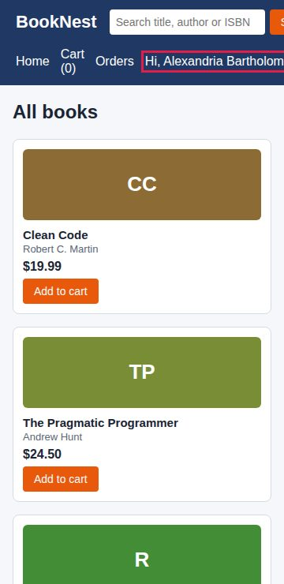
Figure 13: BUG-09: Header at 360 px: the long name runs off the right edge

BUG-10: "Add to cart" controls cannot be reached or used with the keyboard
Bug ID | BUG-10 | Module | Accessibility
Severity | High | Priority | P2
Found in | Session C5 | Status | New
Type | Accessibility (WCAG 2.1.1 Keyboard, 4.1.2 Name, Role, Value)
Environment | BookNest QA practice build 1.0-RC1, Chromium on Linux, desktop viewport 1100 x 620
Preconditions | Home page open; use only the keyboard.
Test data | Tab key, Enter key, Space key
Steps to reproduce | 1. Open the home page and click on a blank area of the page.  2. Press Tab 22 times and note what receives focus each time.  3. Try to focus an "Add to cart" control and activate it with Enter or Space.
Expected result | Every "Add to cart" control receives focus in a logical order, shows a visible focus outline and works with Enter and Space (it should be a real button).
Actual result | Focus visits the logo, search box, Search button, Home, Cart, Orders, Log in and Register, then leaves the page and starts over. None of the 12 "Add to cart" controls is ever focused because they are styled <div> elements, not buttons.
Reproducibility | Always
Impact | Keyboard-only and screen-reader users cannot add books to the cart, so they cannot buy anything. This also creates legal risk under accessibility rules.
Suggested fix | Use <button> elements with accessible names (for example "Add Clean Code to cart") and keep a visible focus style.
Related items | REQ-10; TC-U-04
Evidence | 1 figure follows this report (red outline marks the relevant area).
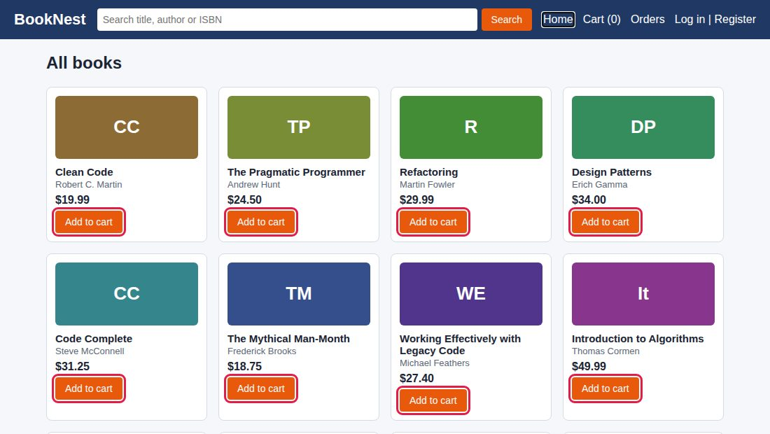
Figure 14: BUG-10: All 12 "Add to cart" controls (outlined) are skipped by keyboard navigation
Keyboard focus order recorded during the session:
Tab press | Element that received focus | Label
1 | Link | BookNest (logo)
2 | Text box | Search title, author or ISBN
3 | Button | Search
4 | Link | Home
5 | Link | Cart (0)
6 | Link | Orders
7 | Link | Log in
8 | Link | Register
9 | Page body | Focus leaves the controls; all 12 "Add to cart" controls were skipped

BUG-11: Promo code SAVE10 can be applied repeatedly and the discounts stack
Bug ID | BUG-11 | Module | Cart
Severity | High | Priority | P1
Found in | Session C2 | Status | New
Type | Functional / business logic
Environment | BookNest QA practice build 1.0-RC1, Chromium on Linux, desktop viewport 1100 x 620
Preconditions | Cart contains 2 copies of "Refactoring" ($29.99 each, subtotal $59.98).
Test data | Codes FREE (invalid) and save10 (valid, entered in lower case)
Steps to reproduce | 1. Add "Refactoring" to the cart twice and open the cart.  2. Enter FREE and click Apply ("Invalid promo code" is the correct response).  3. Enter save10 and click Apply. Note the discount.  4. Repeat step 3 two more times.
Expected result | The code is accepted once; later attempts are refused with "already applied". The discount is 10%, giving a total of about $58.30.
Actual result | Each Apply adds another 10%. After three applications the cart shows "Discount (30%)" of -$17.99 and a total of $45.34. By the same logic ten applications would make the order free.
Reproducibility | Always
Impact | Direct revenue loss and a free-goods exploit that customers can share.
Suggested fix | Enforce promo rules on the server: one code per order, usage limits, and a maximum discount.
Related items | REQ-06 (promo rules not specified; clarification raised); no scripted case
Evidence | 1 figure follows this report (red outline marks the relevant area).
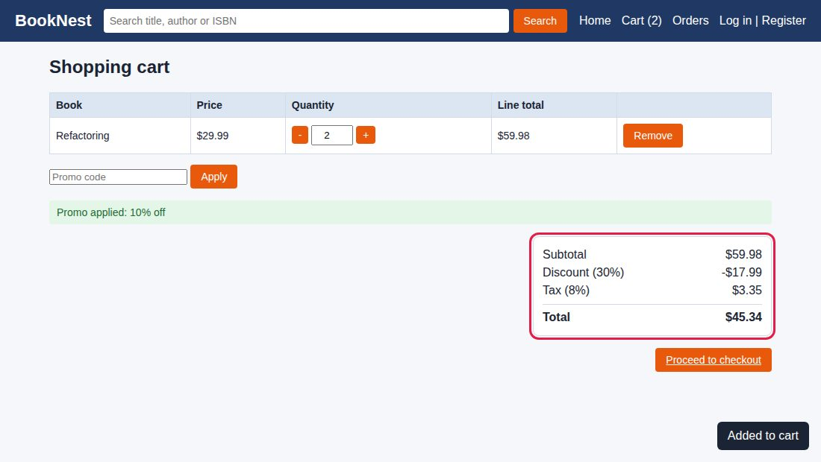
Figure 15: BUG-11: Discount of 30% after applying the same 10% code three times

BUG-12: An order can be placed with an empty cart ($0.00 order)
Bug ID | BUG-12 | Module | Checkout
Severity | Medium | Priority | P2
Found in | Session C3 | Status | New
Type | Functional / validation
Environment | BookNest QA practice build 1.0-RC1, Chromium on Linux, desktop viewport 1100 x 620
Preconditions | Logged in; cart empty (for example after completing an order).
Test data | Address: 12 Test Street | Card: 4242 4242 4242 4242
Steps to reproduce | 1. Open the checkout page directly, or click "Proceed to checkout" on the empty cart page.  2. Note "Order total: $0.00".  3. Enter an address and card number and click "Pay Now".  4. Open "Orders".
Expected result | Checkout is blocked with a message that the cart is empty and the user is sent back to the cart.
Actual result | Order #1003 with 0 items and a total of $0.00 is created with the status "Confirmed".
Reproducibility | Always
Impact | Creates meaningless orders and order numbers, can trigger fulfilment or emails, and distorts sales reports.
Suggested fix | Disable "Proceed to checkout" for an empty cart and require at least one item in the server-side order check.
Related items | REQ-06; no scripted case
Evidence | 1 figure follows this report (red outline marks the relevant area).
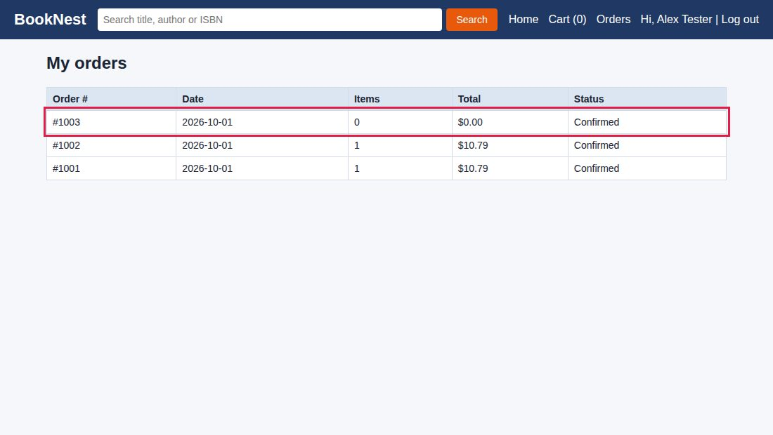
Figure 16: BUG-12: Order #1003 with 0 items and $0.00 total

BUG-13: Cart table is wider than a phone screen; Line total and Remove are cut off
Bug ID | BUG-13 | Module | Cart
Severity | Medium | Priority | P2
Found in | Session C5 | Status | New
Type | Usability / responsive design
Environment | BookNest QA practice build 1.0-RC1, Chromium on Linux, phone viewport 360 x 740
Preconditions | Phone-size viewport (360 x 740).
Test data | "Clean Code" x 1
Steps to reproduce | 1. Set the browser width to 360 px.  2. Add "Clean Code" to the cart and open the cart.  3. Look for the Line total column and the Remove button; try to scroll.
Expected result | The cart fits the screen (stacked layout) or the table scrolls inside its own container (REQ-09, TC-U-02).
Actual result | The table is 576 px wide in a 360 px viewport. The quantity controls are partly visible, Line total and Remove are off-screen and the whole page scrolls sideways.
Reproducibility | Always
Impact | Customers on phones have difficulty reviewing and editing the cart, which is the step before payment.
Suggested fix | Use a stacked card layout below about 480 px or place the table in a container with overflow-x: auto.
Related items | REQ-09; TC-U-02
Evidence | 1 figure follows this report (red outline marks the relevant area).
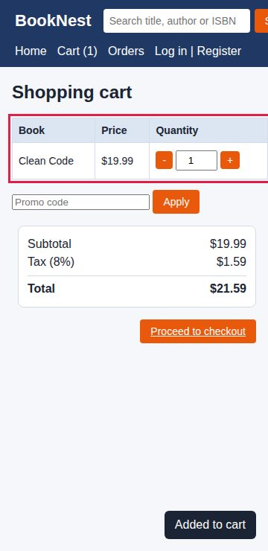
Figure 17: BUG-13: Cart table cut off at 360 px width

10. Analysis, Risk and Recommendations

10.1 Patterns behind the defects
- Missing validation on the server side. BUG-01, BUG-02, BUG-06 and BUG-12 all accept input that should be refused. Rules are enforced only in some user interface paths (for example the "+" button) and not on the value itself.
- No protection against repeated actions. BUG-04 and BUG-11 show that repeating one action (a click or a code) is not handled. Payments need idempotency; promo codes need usage rules.
- State is not kept safely. BUG-07 shows the cart lives only in page memory.
- Inconsistent number handling. BUG-05 shows that different rounding rules are used for different amounts.
- Accessibility and mobile were not built in. BUG-09, BUG-10 and BUG-13 appeared once the product was used with a keyboard or a small screen.
- Error messages leak information or give no help. BUG-08 and OBS-1.

10.2 What exploratory testing added to the scripted plan
The table compares each defect with the scripted cases written in Week 1 (those cases were not executed in this exercise, so the last column is a judgement based on their steps).
Defect | Closest scripted case | Would the scripted case likely find it?
BUG-01 | TC-F-09 | Partly: tests 11 but not negative values or the typed-value path
BUG-02 | TC-S-02 | Yes (script payload in the search box)
BUG-03 | TC-F-07 | Yes (lower-case author search is a step)
BUG-04 | TC-F-11 | No: single click only
BUG-05 | TC-F-11 | No: depends on a quantity that exposes rounding
BUG-06 | TC-F-03 | Partly: case variant yes, trailing space no
BUG-07 | TC-F-10 | No: covers logout and login, not refresh
BUG-08 | TC-F-05 | Yes: the expected result requires a generic message
BUG-09 | None | No
BUG-10 | TC-U-04 | Yes (keyboard-only step)
BUG-11 | None | No
BUG-12 | None | No
BUG-13 | TC-U-02 | Yes (phone viewport step)

Six of the 13 defects (BUG-04, BUG-05, BUG-07, BUG-09, BUG-11, BUG-12) and part of two more would probably have been missed by the scripted cases. This is the value of exploratory sessions: they find defects caused by repetition, interruption, unusual combinations and data that nobody thought to script.

10.3 Release risk
Area | Risk | Defects
Payments and orders | Double charge, junk orders | BUG-04, BUG-12
Pricing and revenue | Negative totals, unlimited discount, mismatched tax | BUG-01, BUG-05, BUG-11
Security | Script injection, account enumeration, duplicate accounts | BUG-02, BUG-08, BUG-06
Accessibility and mobile | Customers unable to buy by keyboard or on a phone | BUG-10, BUG-13, BUG-09
Customer experience | Lost carts, poor search | BUG-07, BUG-03

10.4 Recommendations
- Fix in this order: BUG-04, BUG-02, BUG-01, BUG-11, BUG-10; then the Medium defects; schedule BUG-09 with the next UI release.
- Retest every fix and run the High priority regression suite on the next build.
- Add the following scripted cases to the plan: TC-F-14 double submission of payment; TC-F-15 promo code reuse; TC-F-16 negative and non-numeric quantities; TC-F-17 tax rounding with several quantities; TC-F-18 checkout with an empty cart; TC-F-19 cart persistence after refresh; TC-U-06 very long names on a phone; TC-S-06 email normalisation (case and spaces).
- Ask the Product Owner to decide OBS-1 to OBS-5 and clarify the promo code and quantity 0 rules.
- Run a second round of exploratory sessions on the fixed build, with new charters for password reset, profile and order details once these features are delivered.
- Run a screen reader and colour contrast review (axe DevTools, NVDA) because BUG-10 suggests further accessibility gaps.

10.5 Lessons learned and limitations
- Writing a charter first kept each session focused; notes tagged as BUG, QUESTION and IDEA made it easy to build the report.
- Checking arithmetic by hand and testing with repeated actions were the most productive techniques in this build.
- The build is client-side only, so server-side injection, real payment behaviour and email could not be tested; these remain open risks.
- The sessions are samples of the product, not proof of absence of defects. Areas not yet delivered (password reset, profile) were not explored.

Appendix A. Severity and Priority Definitions
Severity | Definition | Example
Critical | Causes financial loss, data loss or a security breach, or makes the system unusable; no workaround. | BUG-04 double charge
High | Major function or requirement fails, or a serious security or accessibility problem; workaround is difficult. | BUG-02 script injection
Medium | A function works partly or has an easy workaround; limited impact. | BUG-03 case-sensitive author search
Low | Cosmetic or minor inconvenience. | BUG-09 long name layout

Priority | Meaning
P1 | Fix before the next build; blocks release.
P2 | Fix before release.
P3 | Fix when time allows or in a later release.

Appendix B. Session Note Template
This template was used to record each session. Tags: TEST = what was tried; BUG = a defect (with ID); Q = question; IDEA = a follow-up test.
Field | Content
Session ID / Charter
Tester / Date / Build
Start time / Duration
Environment and data
Notes (TEST / BUG / Q / IDEA) | TEST: ...  BUG: ...  Q: ...  IDEA: ...
Defects logged (IDs)
Debrief and next charter

Appendix C. How to Reproduce These Tests
The simulated build is provided as a single file, booknest_app_under_test.html. To repeat the sessions:
- Open the file in Chrome, Edge or Firefox (double-click it or use File, Open).
- Log in with alex@example.com and BookNest#2026 when a step requires a login.
- For phone tests, open browser developer tools and choose a 360 x 740 device size.
- Follow the steps in the bug reports in section 9. Data such as the cart and orders is kept only while the browser tab is open.

Appendix D. References
- Bach, J. and Bach, J., Session-Based Test Management, Software Testing and Quality Engineering magazine, 2000.
- Hendrickson, E., Explore It!: Reduce Risk and Increase Confidence with Exploratory Testing, Pragmatic Bookshelf, 2013.
- Whittaker, J., Exploratory Software Testing, Addison-Wesley, 2009 (tours).
- Bolton, M. and Bach, J., Rapid Software Testing: SFDIPOT product elements and HICCUPPS oracles, satisfice.com.
- ISTQB Certified Tester Foundation Level Syllabus: experience-based test techniques.
- OWASP Top 10 and OWASP Web Security Testing Guide, owasp.org.
- W3C, Web Content Accessibility Guidelines (WCAG) 2.1, w3.org.
- BookNest Test Plan and Test Cases v1.0 (Week 1 deliverable).

