STANDARD OPERATING PROCEDURE (SOP)
Comprehensive House Price Analysis
Flask Web Application and Tableau Public Dashboard
Version 1.0 | Updated: 19 July 2026

1. Purpose
This SOP explains how to prepare housing data, run the Flask application, open and verify the Tableau Public dashboard, and publish the project updates to GitHub. It applies to the DA_PROJECT repository.

2. Scope and Expected Outcome
Following this procedure produces a working local website, an accessible Tableau Public dashboard, a validated housing dataset, and a version-controlled project on GitHub.

3. Tableau Public Dashboard
Published dashboard: Comprehensive House Price Analysis on Tableau Public
Dashboard preview:
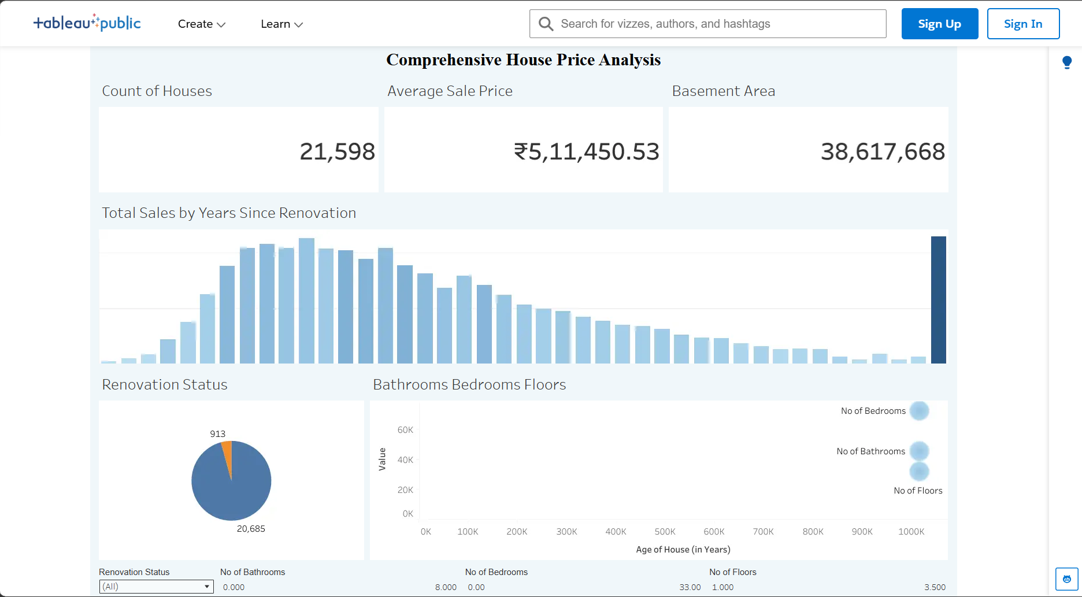
Figure 1. Tableau Public dashboard preview showing housing KPIs and charts.

4. Prerequisites
- Python 3.10 or later installed and available from PowerShell.
- Git installed and authenticated with the DA_PROJECT GitHub repository.
- An internet connection for Tableau Public and GitHub.
- Project location: C:\Users\gowth\OneDrive\Desktop\DA_PROJECT.

5. Key Project Files
File or folder | Purpose
app.py | Flask application routes.
templates/dashboard.html | Dashboard page with Tableau button, preview, and embed.
static/images/tableau-house-price-dashboard.png | Dashboard screenshot used in the website and this SOP.
static/css/styles.css | Website and embedded-dashboard styling.
scripts/prepare_housing_data.py | Transforms a raw housing CSV and writes validation output.
data/Transformed_Housing_Data.csv | Tableau-ready housing dataset.
requirements.txt | Python dependency list.

6. End-to-End Procedure

Step 1 — Open the project folder
cd C:\Users\gowth\OneDrive\Desktop\DA_PROJECT

Step 2 — Install dependencies
python -m pip install -r requirements.txt

Step 3 — Prepare source data (optional when using the included dataset)
python scripts/prepare_housing_data.py path\to\kc_house_data.csv
The script writes data/Transformed_Housing_Data.csv and data/validation_report.json. It creates Age of House (in Years), Years Since Renovation, Ever Renovated, and Sale Price Bin.

Step 4 — Start the Flask application
python app.py
Keep PowerShell open while the server is running. The app starts at http://127.0.0.1:5000.

Step 5 — Preview the website
- Open http://127.0.0.1:5000/ for the Home page.
- Open http://127.0.0.1:5000/dashboard for the Dashboard page.
- Select Open Tableau Dashboard to open the published Tableau dashboard in a new browser tab.
- Confirm that the screenshot preview and embedded Tableau dashboard are displayed.

Step 6 — Verify the Tableau dashboard
- Open the Tableau Public link in Section 3.
- Confirm the record count, average sale price, and basement-area KPI cards are displayed.
- Review the renovation-sales chart, renovation-status chart, and bedrooms/bathrooms/floors chart.
- Use the Tableau filters to review renovation status, bathrooms, bedrooms, and floors.
- When republishing a Tableau workbook, confirm that the public URL remains valid before changing templates/dashboard.html.

Step 7 — Validate project results
- Confirm data/Transformed_Housing_Data.csv exists.
- Review data/validation_report.json. Required fields must have zero null values and ready_for_tableau must be true.
- Confirm that /dashboard loads without a Flask error.
- Confirm the Tableau link opens the Comprehensive House Price Analysis dashboard.

Step 8 — Commit and push to GitHub
From the project folder, run the following commands:
git status
git add document.docx templates/dashboard.html static/css/styles.css static/images/tableau-house-price-dashboard.png
git commit -m "Update Tableau dashboard documentation"
git push origin main
Verify the new commit in the DA_PROJECT GitHub repository after the push succeeds.

7. Troubleshooting
- If python is not recognized, reinstall Python and enable the Add Python to PATH option.
- If the Tableau embed does not load, use the Open Tableau Dashboard button and verify the public URL in templates/dashboard.html.
- If port 5000 is busy, stop the existing Flask process with Ctrl+C and start the app again.
- If GitHub rejects a push because the remote branch is ahead, run git pull --rebase origin main, resolve conflicts, and then run git push origin main.

8. Completion Checklist
- The Flask application runs locally.
- The Dashboard page shows the screenshot, Tableau button, and embedded dashboard.
- The Tableau Public link opens correctly.
- The dataset validation report confirms Tableau readiness.
- The updated document.docx has been committed and pushed to GitHub.

