HOTEL_RESERVATION_SYSTEM

Theme
A hotel wants to manage hotel branches, room details, customer information, reservations, and payments in one organized database. The system helps staff check room availability, record bookings, calculate reservation costs, and track payment status.

Modules
- Hotels
- Rooms
- Customers
- Reservations
- Payments
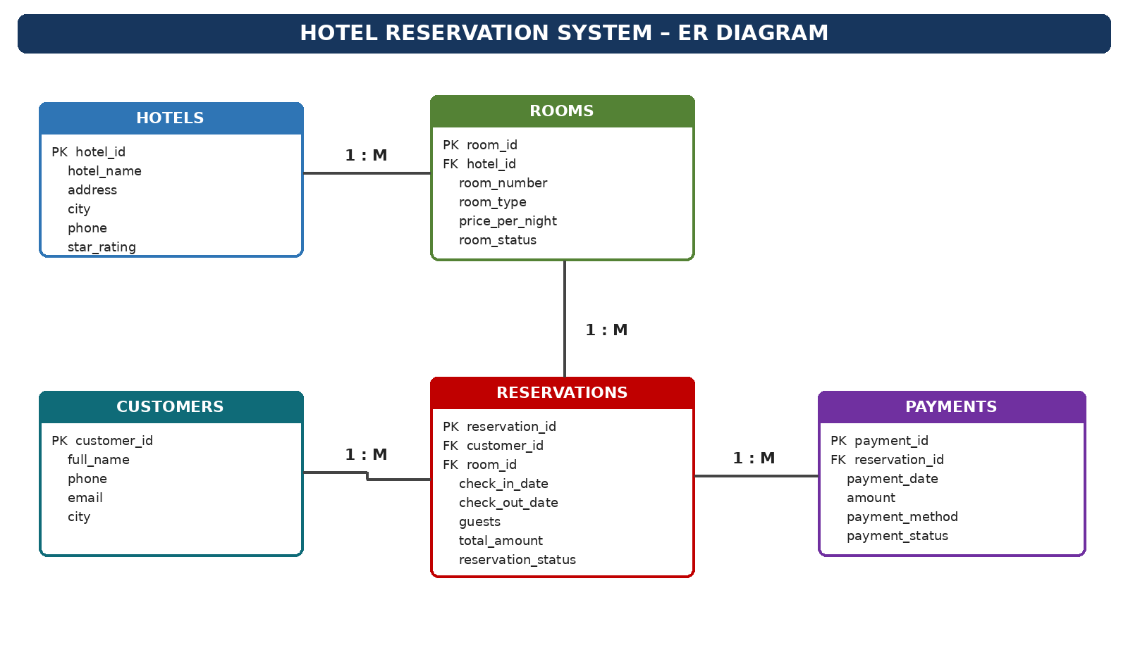
Relationship summary: One hotel has many rooms; one room can appear in many reservations over time; one customer can make many reservations; and one reservation can have one or more payment records.

Sample Data

HOTELS
ID | Hotel Name | Address | City | Phone | Stars
1 | Grand Palace Hotel | MG Road | Hyderabad | 040-40010001 | 5
2 | Coastal Comfort Inn | Beach Road | Visakhapatnam | 0891-4001002 | 4
3 | River View Residency | River Street | Vijayawada | 0866-4001003 | 3
4 | Green Park Suites | Benz Circle | Vijayawada | 0866-4001004 | 4
5 | Sunrise Business Hotel | Main Road | Guntur | 0863-4001005 | 3
6 | Royal Orchid Stay | Airport Road | Bengaluru | 080-4001006 | 5
7 | City Nest Hotel | Central Avenue | Chennai | 044-4001007 | 3
8 | Lakeview Retreat | Tank Bund Road | Hyderabad | 040-4001008 | 4

ROOMS
Room ID | Hotel ID | Room No. | Room Type | Price/Night (₹) | Status
101 | 1 | 101 | Standard | 2500 | Available
102 | 1 | 102 | Deluxe | 3800 | Occupied
103 | 1 | 201 | Suite | 6500 | Available
104 | 2 | 11 | Standard | 2200 | Available
105 | 2 | 12 | Deluxe | 3400 | Maintenance
106 | 3 | 201 | Standard | 1800 | Available
107 | 3 | 202 | Family | 4200 | Occupied
108 | 4 | 301 | Deluxe | 3600 | Available
109 | 5 | 15 | Standard | 1600 | Available
110 | 6 | 501 | Suite | 7800 | Available
111 | 7 | 22 | Standard | 2100 | Occupied
112 | 8 | 401 | Deluxe | 3900 | Available

CUSTOMERS
ID | Full Name | Phone | Email | City
1 | Aarav Sharma | 9876501001 | aarav@example.com | Hyderabad
2 | Diya Reddy | 9876501002 | diya@example.com | Vijayawada
3 | Kabir Rao | 9876501003 | kabir@example.com | Guntur
4 | Ananya Iyer | 9876501004 | ananya@example.com | Chennai
5 | Ishaan Patel | 9876501005 | ishaan@example.com | Bengaluru
6 | Meera Nair | 9876501006 | meera@example.com | Visakhapatnam
7 | Arjun Kumar | 9876501007 | arjun@example.com | Hyderabad
8 | Saanvi Das | 9876501008 | saanvi@example.com | Vijayawada
9 | Rahul Verma | 9876501009 | rahul@example.com | Guntur
10 | Tara Singh | 9876501010 | tara@example.com | Chennai

RESERVATIONS
Reservation ID | Customer ID | Room ID | Check-in | Check-out | Guests | Total (₹) | Status
1001 | 1 | 102 | 2026-11-01 | 2026-11-03 | 2 | 7600 | Confirmed
1002 | 2 | 106 | 2026-11-04 | 2026-11-06 | 1 | 3600 | Confirmed
1003 | 3 | 109 | 2026-11-07 | 2026-11-08 | 1 | 1600 | Pending
1004 | 4 | 111 | 2026-11-10 | 2026-11-12 | 2 | 4200 | Cancelled
1005 | 5 | 110 | 2026-11-12 | 2026-11-15 | 2 | 23400 | Confirmed
1006 | 6 | 104 | 2026-11-15 | 2026-11-17 | 2 | 4400 | Confirmed
1007 | 7 | 103 | 2026-11-18 | 2026-11-20 | 2 | 13000 | Pending
1008 | 8 | 108 | 2026-11-20 | 2026-11-22 | 3 | 7200 | Confirmed
1009 | 1 | 101 | 2026-12-01 | 2026-12-04 | 1 | 7500 | Confirmed
1010 | 9 | 107 | 2026-12-05 | 2026-12-07 | 4 | 8400 | Cancelled

PAYMENTS
Payment ID | Reservation ID | Payment Date | Amount (₹) | Method | Status
5001 | 1001 | 2026-10-20 | 7600 | Card | Paid
5002 | 1002 | 2026-10-21 | 3600 | UPI | Paid
5003 | 1003 | 2026-10-22 | 800 | Cash | Partial
5004 | 1004 | 2026-10-22 | 0 | Card | Refunded
5005 | 1005 | 2026-10-23 | 23400 | Net Banking | Paid
5006 | 1006 | 2026-10-24 | 4400 | UPI | Paid
5007 | 1007 | 2026-10-24 | 3000 | Card | Partial
5008 | 1008 | 2026-10-25 | 7200 | UPI | Paid
5009 | 1009 | 2026-10-25 | 7500 | Card | Paid
5010 | 1010 | 2026-10-25 | 0 | Cash | Refunded

Database Notes
The records in this document are illustrative sample data created for an academic project. Room availability should be checked against overlapping reservation dates in a real implementation. Reservation totals are sample values and may include any applicable taxes or fees as defined by the hotel.

SQL Queries
1. Find all rooms with a nightly price above ₹3,000.
SELECT * FROM rooms
WHERE price_per_night > 3000;
2. Display rooms currently available.
SELECT * FROM rooms
WHERE room_status = 'Available';
3. Show hotels located in Hyderabad.
SELECT * FROM hotels
WHERE city = 'Hyderabad';
4. Display cancelled reservations.
SELECT * FROM reservations
WHERE reservation_status = 'Cancelled';
5. Find reservations with check-in dates in November 2026.
SELECT * FROM reservations
WHERE check_in_date >= '2026-11-01'
AND check_in_date < '2026-12-01';
6. Find the total number of reservations.
SELECT COUNT(*) AS total_reservations
FROM reservations;
7. Count hotels city-wise.
SELECT city, COUNT(*) AS hotel_count
FROM hotels
GROUP BY city;
8. Calculate the average room price.
SELECT ROUND(AVG(price_per_night), 2) AS average_price
FROM rooms;
9. Find the highest nightly room price.
SELECT MAX(price_per_night) AS highest_price
FROM rooms;
10. Count rooms in each hotel.
SELECT hotel_id, COUNT(*) AS room_count
FROM rooms
GROUP BY hotel_id;
11. Count reservations made by each customer.
SELECT customer_id, COUNT(*) AS reservation_count
FROM reservations
GROUP BY customer_id
ORDER BY reservation_count DESC;
12. Find customers from Vijayawada.
SELECT * FROM customers
WHERE city = 'Vijayawada';
13. Display rooms that are suites.
SELECT * FROM rooms
WHERE room_type = 'Suite';

14. Show customer names with their reservation status.
SELECT c.full_name, r.reservation_id, r.reservation_status
FROM customers c
JOIN reservations r ON c.customer_id = r.customer_id;
15. Show hotel name, room number, and room type.
SELECT h.hotel_name, rm.room_number, rm.room_type
FROM hotels h
JOIN rooms rm ON h.hotel_id = rm.hotel_id;
16. Display reservation details with customer names.
SELECT r.reservation_id, c.full_name, r.check_in_date,
r.check_out_date, r.total_amount
FROM reservations r
JOIN customers c ON r.customer_id = c.customer_id;
17. Display payments with reservation status.
SELECT p.payment_id, p.amount, p.payment_status,
r.reservation_status
FROM payments p
JOIN reservations r ON p.reservation_id = r.reservation_id;
18. Find reservations for rooms costing more than ₹2,500 per night.
SELECT r.reservation_id, rm.room_number, rm.price_per_night
FROM reservations r
JOIN rooms rm ON r.room_id = rm.room_id
WHERE rm.price_per_night > 2500;
19. Calculate confirmed reservation revenue by hotel.
SELECT h.hotel_name, SUM(r.total_amount) AS revenue
FROM hotels h
JOIN rooms rm ON h.hotel_id = rm.hotel_id
JOIN reservations r ON rm.room_id = r.room_id
WHERE r.reservation_status = 'Confirmed'
GROUP BY h.hotel_id, h.hotel_name;
20. Find hotels with more than two rooms.
SELECT h.hotel_name, COUNT(rm.room_id) AS room_count
FROM hotels h
JOIN rooms rm ON h.hotel_id = rm.hotel_id
GROUP BY h.hotel_id, h.hotel_name
HAVING COUNT(rm.room_id) > 2;
21. Find customers who have never made a reservation.
SELECT c.customer_id, c.full_name
FROM customers c
LEFT JOIN reservations r ON c.customer_id = r.customer_id
WHERE r.reservation_id IS NULL;
22. Find the customer with the highest confirmed booking spend.
SELECT c.full_name, SUM(r.total_amount) AS total_spent
FROM customers c
JOIN reservations r ON c.customer_id = r.customer_id
WHERE r.reservation_status = 'Confirmed'
GROUP BY c.customer_id, c.full_name
ORDER BY total_spent DESC
LIMIT 1;

23. Count reservations by status.
SELECT reservation_status, COUNT(*) AS reservation_count
FROM reservations
GROUP BY reservation_status;
24. Find the number of guests for each reservation.
SELECT reservation_id, guests
FROM reservations
ORDER BY guests DESC;
25. Show reservations whose payment is still partial.
SELECT r.reservation_id, p.amount, p.payment_status
FROM reservations r
JOIN payments p ON r.reservation_id = p.reservation_id
WHERE p.payment_status = 'Partial';
26. Find rooms that are under maintenance.
SELECT * FROM rooms
WHERE room_status = 'Maintenance';
27. Calculate total paid amount by payment method.
SELECT payment_method, SUM(amount) AS total_paid
FROM payments
WHERE payment_status = 'Paid'
GROUP BY payment_method;
28. Find reservations lasting more than one night.
SELECT reservation_id, check_in_date, check_out_date,
DATEDIFF(check_out_date, check_in_date) AS nights
FROM reservations
WHERE DATEDIFF(check_out_date, check_in_date) > 1;
29. Find the hotel with the most rooms.
SELECT h.hotel_name, COUNT(rm.room_id) AS room_count
FROM hotels h
JOIN rooms rm ON h.hotel_id = rm.hotel_id
GROUP BY h.hotel_id, h.hotel_name
ORDER BY room_count DESC
LIMIT 1;
30. Create a monthly confirmed reservation revenue report.
SELECT YEAR(check_in_date) AS year,
MONTH(check_in_date) AS month,
SUM(total_amount) AS monthly_revenue
FROM reservations
WHERE reservation_status = 'Confirmed'
GROUP BY YEAR(check_in_date), MONTH(check_in_date)
ORDER BY year, month;

