Asher Smithson
DJon Harrison
Scott Johnson
Jackson Webster
Assignment: Milestone #3
Description: Summarizes supplier shipment activity, including shipment dates, on-time vs. late deliveries, and days early or late.
Tables Used: Supplier, Shipment
Purpose: Provides month-by-month delivery patterns to evaluate supplier reliability.
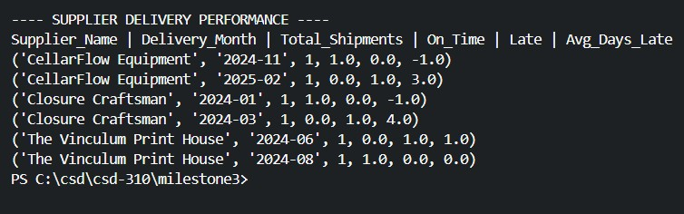

Description: Shows shipments of each wine product to distributors, including quantities shipped, and total shipment value
Tables Used: Product, Shipment, Distributor, Shipment_Detail
Purpose: Reveals sales trends by product type and distributor to support production and marketing decisions.
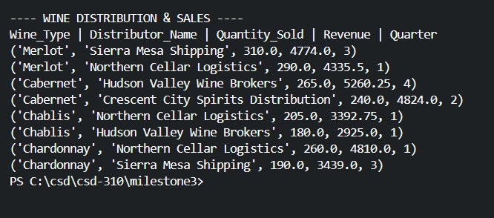

Description: Displays each employee’s total hours worked per quarter by joining hour logs with their department and employment details.
Tables Used: Employee, Department, Employee_Hour
Purpose: Identifies workload patterns to support staffing, scheduling, and labor planning.
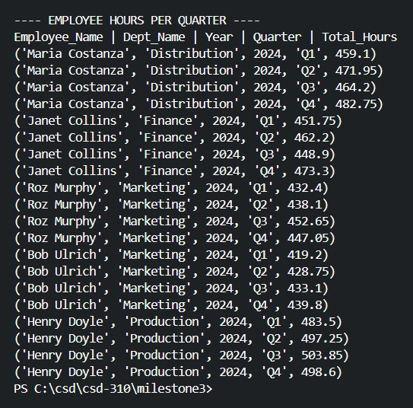

Description: Aggregates total units sold and total revenue by shipment quarter using shipment and shipment detail data.
Tables Used: Shipment, Shipment_Detail
Purpose: Provides high-level quarterly sales performance for strategic planning.
