Asher Smithson
Djon Harrison
Scott Johnson
Jackson Webster
Overview:
#1—Bacchus Winery (Favorite)
- Well-defined relationships and entities
- Clear and obvious business rules
- Practical and achievable queries
- Not too complex
#2—Outland Adventures (Okay)
- Plenty of entities
- Relationships are more narrow
- Would need lots of creative assumptions to translate for SQL
#3—Wilson Financial (Least Favorite)
- Too simple- less distinct entities and more abstract relationships (less diversity)
- It would require us to invent much of the data to make a robust ERD

Initial Notes:
Bacchus Winery-
Entities: | Need
Employees: 5 + 20  Suppliers: 3  Products: 4  Distributors: -  Shipments: - | “snapshot” reports  Trend data for:  - Inventory  - Destination  - employees

→ Find:
- late deliveries by supplier
- compare sales per distributor & wine type
- SUM employees hrs per quarter
Why this is a good candidate: has easy to define relationships (multiple), measurable metrics, and ongoing operations (easy to code)
This is good for SQL & ERD

Outland Adventures-
Entities: | Misc Info
Employees  - Guides  Customers | Trips  Equipment  Locations (Africa, Asia, (So.) Europe

Relationsips → implied (not defined)
- Rent/buy equipment
- Trips with guides & locals
- Inventory may be 5+ years old
No real relational based questions (more tend based = %)
- % of customers buying equipment
- Is downward trend in bookings? ← %
- Inventory items too old? ← again &
→ most items need assumptions
→ would have to create many undescribed entities (trip, customer, etc.)
Could build an ERD, but missing tons of relationship details ← can create

Wilson Financial (Do Not Want)-
Entities | Need
Employees: 2 (1 FT, 1 PT)  Clients  Assets  Billing  Transaction(s)* | - Clients added / month  - AVG # of assets / month  - # of clients with 10+ transactions

Product?
→ Compliance checks
Could create a column for client assets.
→ got transaction entity from “transactions per month”
- No other details are provided though
→ compliance and billing also have no other details
This would require a TON of work creating data to fill in the blanks here.
→ NOT enough INFO given. ←

Bacchus Winery ERD Notes
Main Entities
Entity | Description | Key Attributes
Department | Lists all winery divisions like Finance, Marketing, Production, and Distribution | Dept_ID (PK), Dept_Name
Employee | Stores employee information and ties each person to a department and supervisor | Employee_ID (PK), Dept_ID (FK), First_Name, Last_Name, Position, Supervisor_ID (FK), Hire_Date
Employee_Hours | Tracks how many hours each employee works per quarter and year | Hours_ID (PK), Employee_ID (FK), Quarter, Year, Hours_Worked
Supplier | Holds details on the companies that provide materials like bottles, corks, labels, boxes, vats, tubing, etc. | Supplier_ID (PK), Name, Item_Supplied, Contact_Info
Product (wine) | Lists all the winery’s products (Merlot, Cabernet, Chablis, and Chardonnay), with production details and pricing. | Product_ID (PK), Product_Name, Wine_Type, Year, Quantity_Produced, Unit_Price
Distributor | Represents the businesses that purchase and sell Bacchus wines. | Distributor_ID (PK), Name, Region, Contact_Info
Shipment | Records every shipment made to distributors, including supplier source and delivery information. | Shipment_ID (PK), Supplier_ID (FK), Distributor_ID (FK), Shipment_Date, Expected_Delivery, Actual_Delivery, Delivery_Status
Shipment_Detail | Breaks down the contents of each shipment, showing which products are included, quantity and pricing. | ShipmentDetail_ID (PK), Shipment_ID (FK), Product_ID (FK), Quantity, Unit_Price, Subtotal
(Opt) Inventory | Used to track current stock levels of each product after shipments. *This is extra but could be very useful! | Inventory_ID (PK), Product_ID (FK), Quantity_On_Hand, Last_Updated

Relationships & Cardinalities
Relationship | Type | Details
Department → Employee | 1 – to – Many | Each department manages several employees.
Employee → Employee_Hours | 1 – to – Many | One employee can have multiple hour records.
Employee → Employee (Supervisor) | 1 – to – 1 (self join) | Links employees to their supervisor within the same table.
Supplier → Shipment | 1 – to – Many | A supplier can have many shipments to the winery.
Distributor → Shipment | 1 – to – Many | Each distributor can receive multiple shipments.
Shipment → Shipment_Detail | 1 – to – Many | A shipment can include multiple products.
Product → Shipment_Detail | 1 – to – Many | Each product can appear in more than one shipment.
Distributor ↔ Product | Many – to – many (indirect) | Connected through Shipment and Shipment_Detail, representing which products go to which distributors.
Product → Inventory | 1 – to – 1 or 1 – to – Many | *Optional—tracks current product stock if included.

*There is an indirect relationship between Distributor ⇄ Product (via Shipment and Shipment_Detail).

Questions to be asked | Tables Involved
Are all suppliers delivering on time? | Supplier, Shipment
Which wines are performing best by the distributor? | Product, Shipment, Shipment_Detail, Distributor
How many hours did each employee work per quarter? | Employee, Employee_Hours
Whiat is the total amount shipped per wine type? | Product, Shipment_Detail
Which distributors carry each type of wine? | Distributor, Product (via Shipment & Shipment_Detail)

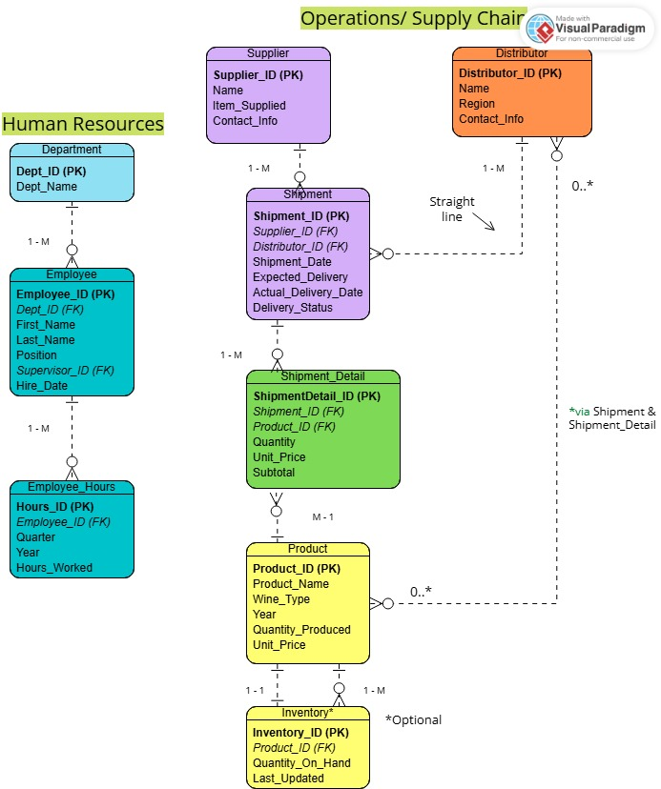
The above ERD provides the operational and human resources components of Bacchus Winery. I ensured that 3NF was followed to prevent any redundancy and for data integrity. I am still learning how to work with Visual Paradigm Online, so non-identifying relationships (dashed lines) represent logical connections (many – to – many between distributors and products via shipments and shipment details). The HR section on the left tracks all the key areas to satisfy the Winery’s questions and needs. Identifying relationships occur where child records depend on a parent’s key (e.g., Shipment_Detail depends on Shipment and Product).

Business Rules and Assumptions
Human Resources
- Each Department (identified by Dept_ID) employs one or more employees.
- Each Employee (identified by Employee_ID) belongs to exactly one department.
- Each employee records multiple Employee_Hours entries per quarter and year.
- Every employee has a supervisor (Supervisor_ID), except the top-level owner or manager.
Operations / Supply Chain
- Each Supplier (identified by Supplier_ID) provides one or more Shipments.
- Each Distributor (identified by Distributor_ID) can receive multiple Shipments.
- Each Shipment (identified by Shipment_ID) is associated with exactly one supplier and one distributor.
- Each shipment includes one or more Shipment_Detail records, describing products and quantities shipped.
- Each Product (identified by Product_ID) can appear in multiple shipment details.
- Each Product can have one or more Inventory entries (Inventory_ID) tracking stock and update dates.
Logical / Derived Relationships
- Distributors carry many products, and Products are distributed by many distributors — this many-to-many relationship exists through Shipment and Shipment_Detail.
- Customers (Customer_ID) may be included in future development to track product purchases through distributors and shipments.
Integrity and General Business Rules
- Every entity (Department, Employee, Supplier, Distributor, Product, Inventory, Customer) must have a unique primary key (*_ID).
- All foreign key values must match an existing record in their parent tables (referential integrity).
- All shipments must record both an Expected_Delivery and an Actual_Delivery_Date for performance tracking.
- Every contact entity (Supplier, Distributor, Employee) must include valid Contact_Info.
- Business operations must maintain accurate employee hours, shipment logs, and inventory levels at all times.
Assumptions
- Bacchus Winery handles HR, supplier management, distribution, and inventory internally.
- Shipments are the primary link between suppliers, distributors, and products.
- Supervisors are also employees; ownership roles (Stan and Davis Bacchus) are assumed top-level.
- Customer data is optional for future expansion but included for completeness.

