Asher Smithson  
Mod 1.2 Assignment

Link to GitHub repository:

<https://github.com/asmithson/csd-325.git>

Screenshot of GitHub repository:

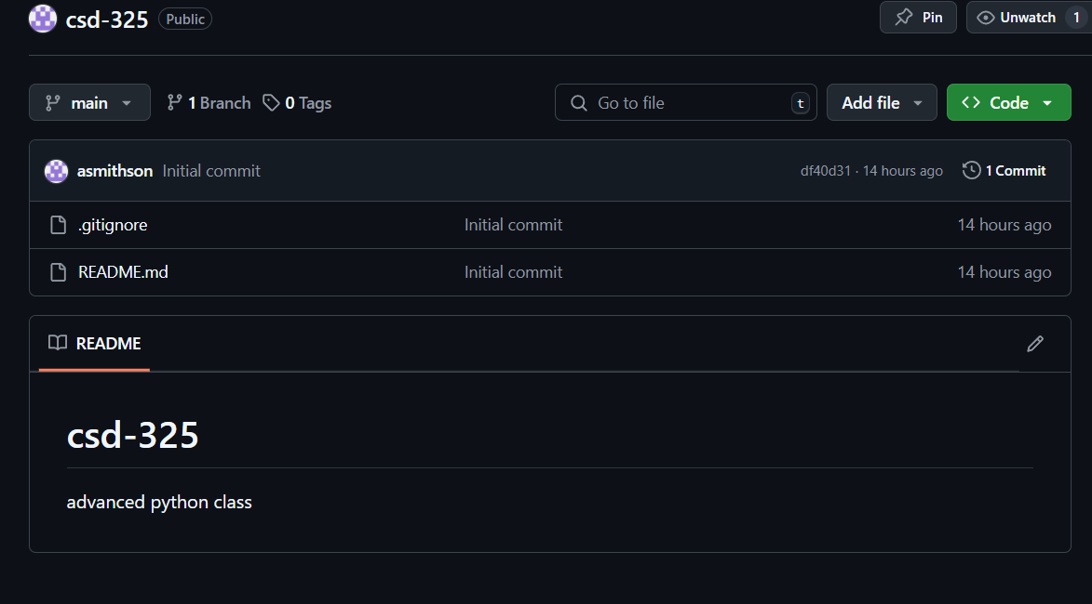  
  
Screenshot of local directory:

