Asher Smithson  
M7.2 Assignment: Test Cases  
1/26/25

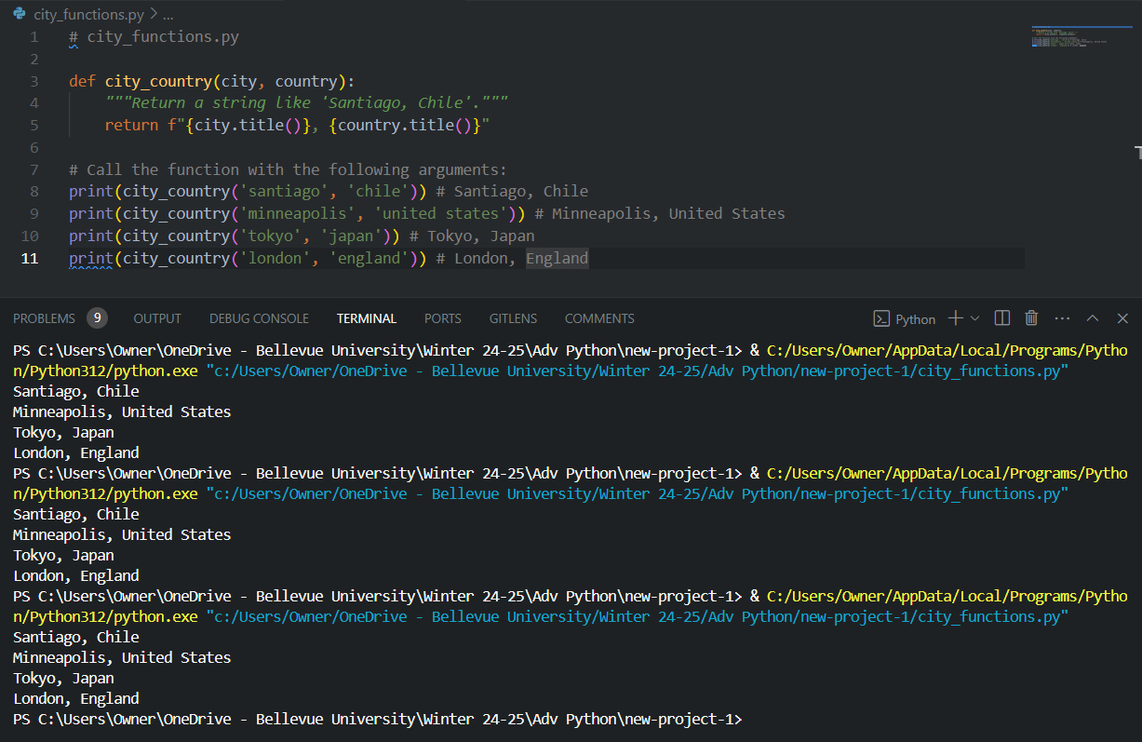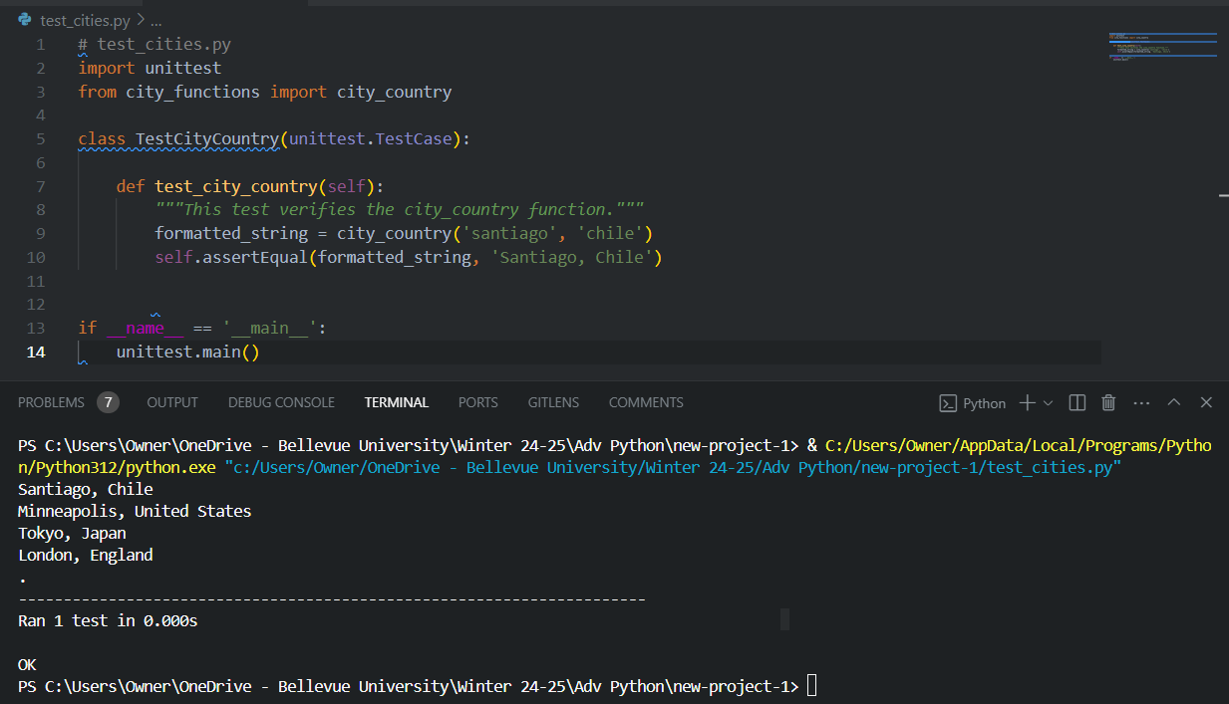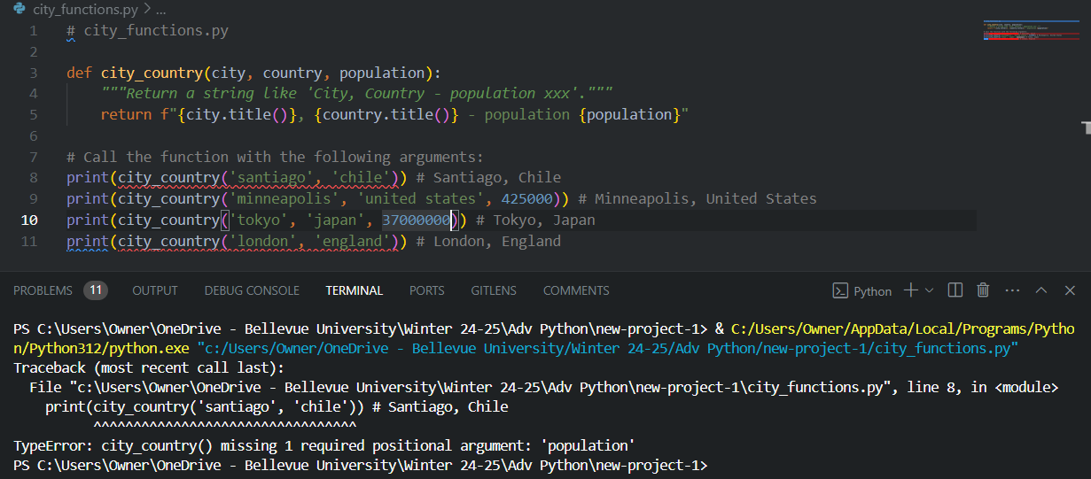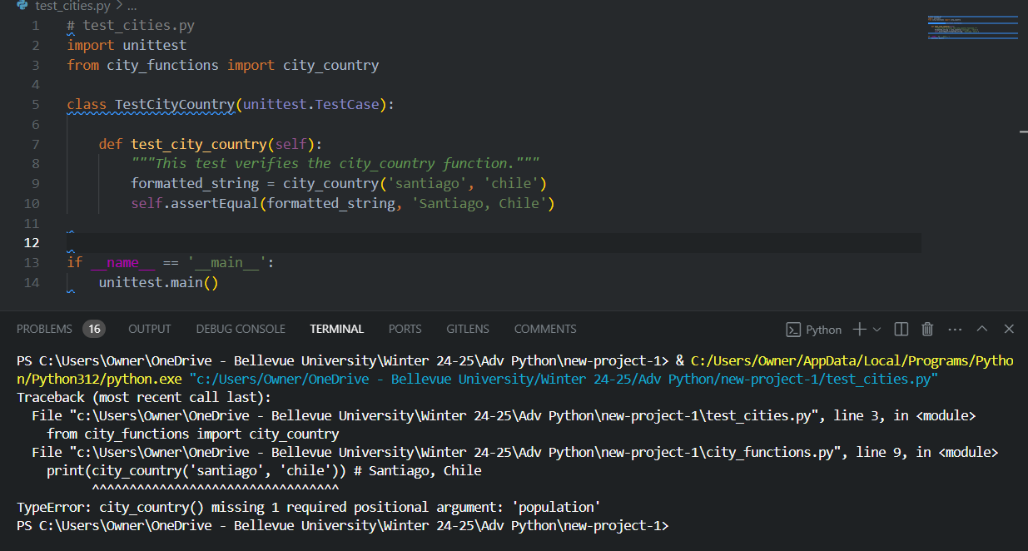

Notes:

I realized at the end of this exercise (on my 3rd go of screenshots), that I had taken the last step of calling the function of one city at a time throughout the entire assignment. Having all cities called at each step greatly helped when correcting errors. For instance, line 16 issued *‘english’* as population at first until I defined it as a language, or when there was a silly space issue on line 5 earlier in the process.

In reference to the chapter required reading, the third edition of Eric Matthews book is seated beside this monitor. That was a fun discovery.

The last note involves GitHub’s Copilot. While it made several suggestions, many were problematic and incomplete, which was favorable to aid in learning how to troubleshoot through trial and error. **Question: how often is Copilot used in the field?**

References:

GitHub. (2021, June 29). Introducing GitHub Copilot. GitHub Blog. <https://github.blog/2021-06-29-introducing-github-copilot/>

Matthes, E. (2019). *Python crash course: A hands-on, project-based introduction to programming* (3rd ed.). No Starch Press.