Asher Smithson  
M9.2 Assignment APIs  
2/7/25

STEP 4: This is the first run of the program created using the URL provided to test the connection, which resulted in the error code of: 200.

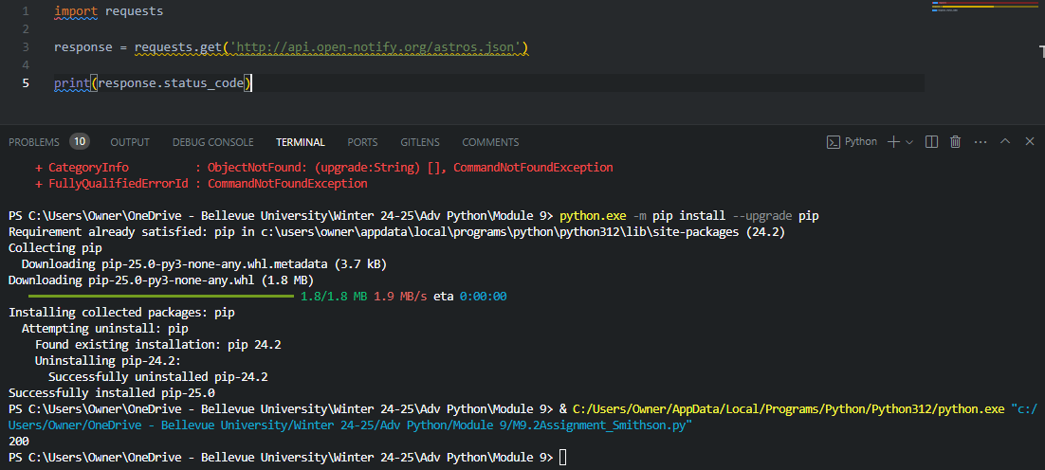

STEP 5: Correcting the code to prevent the ‘200’ error, there was a mistake in the first attempt, but easily fixed to produce the list of current astronauts.

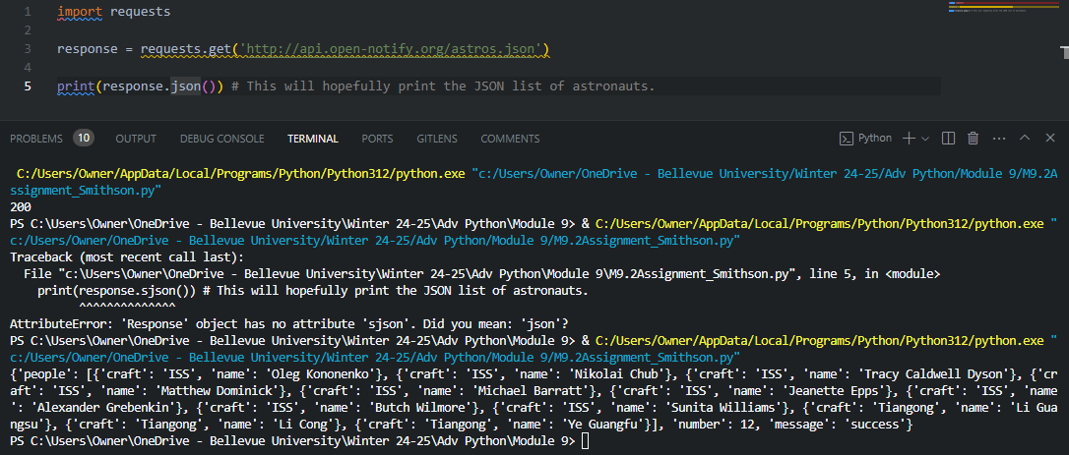

STEP 6: Choosing the D&D API from the website, the spell of choice is for “magic missile.”

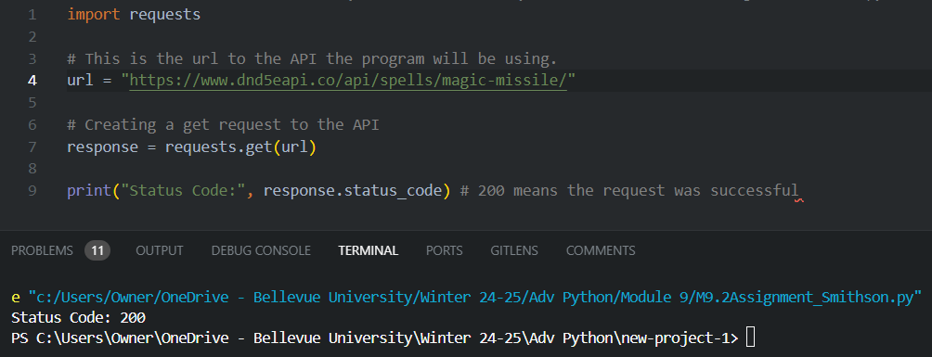

After this, I kept getting errors, so I had to try another route:

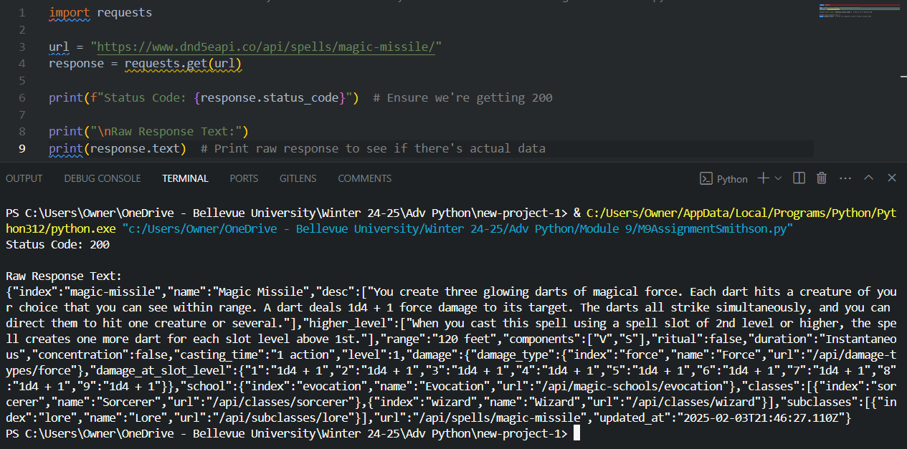

This enabled me to finally see the raw magic missile spell!

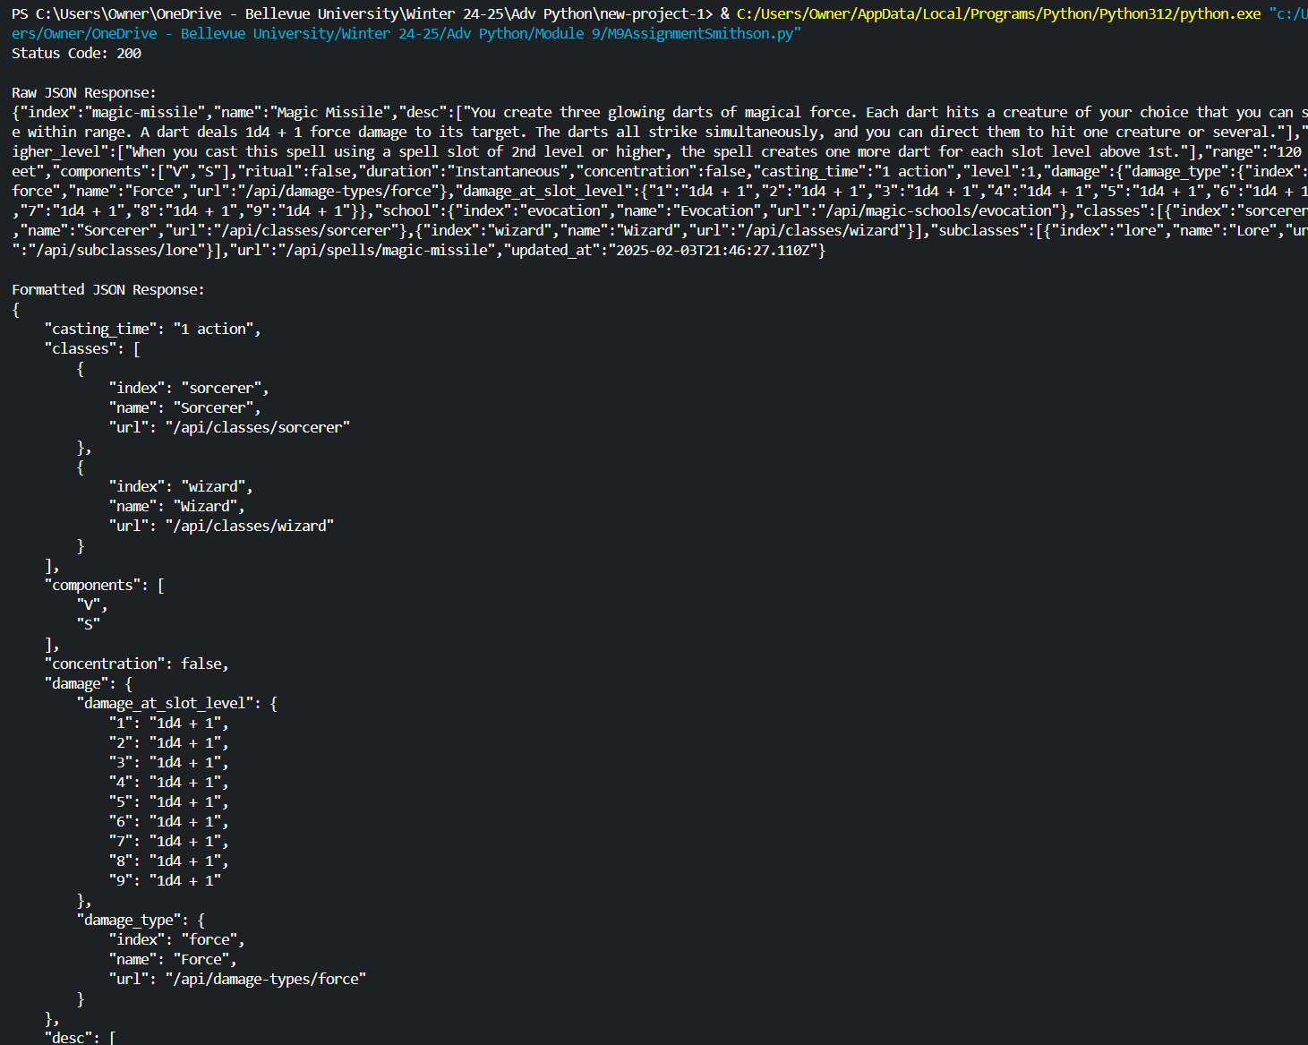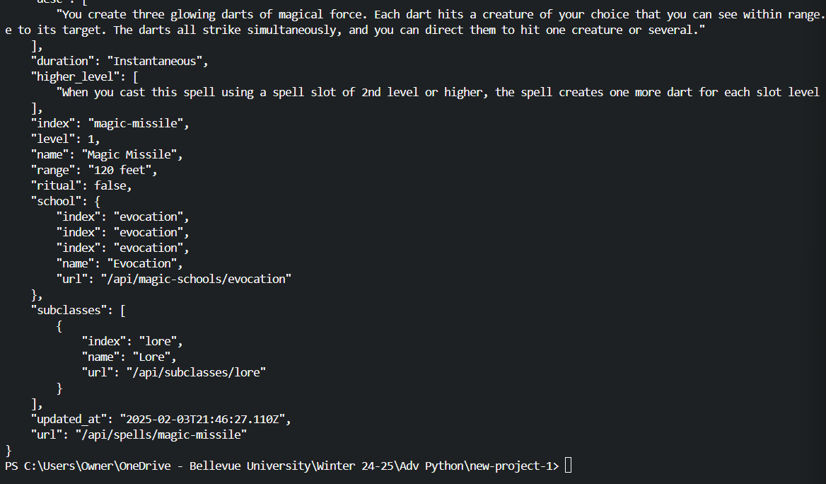

Ultimately, I chose a simpler approach rather than attempting the more complicated solutions that Copilot suggested for handling the 200-status code. A fun discovery during this process was experimenting with the placement of the def jprint(obj): function within the program. Initially, I had it positioned later in the script. Naturally, I had to use "Magic Missile" as my API example—both because of my fondness for the "casting Magic Missile at the darkness" skit and as a lifelong player,