Q1: Implement NOT, AND, OR Gates Using Only NAND Gates

1. Aim
To implement NOT, AND, and OR logic gates using only NAND gates in HDL, draw their schematic diagrams, verify their Boolean expressions, and observe the simulation output using suitable test inputs.

2. Schematic Diagram

A. NOT Gate using NAND
Both inputs of the NAND gate are connected to the same input A.
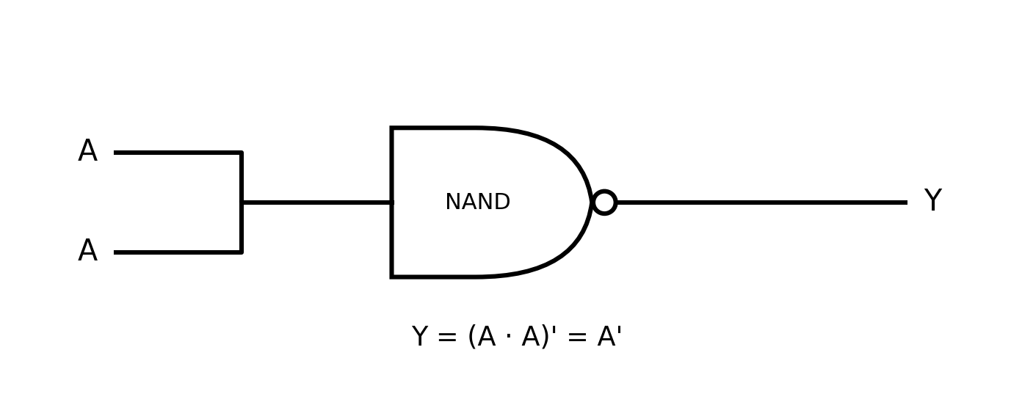
Boolean Expression: Y = (A · A)' = A'

B. AND Gate using NAND
The first NAND produces the complement of A · B. The second NAND has its two inputs tied together, so it acts as an inverter.
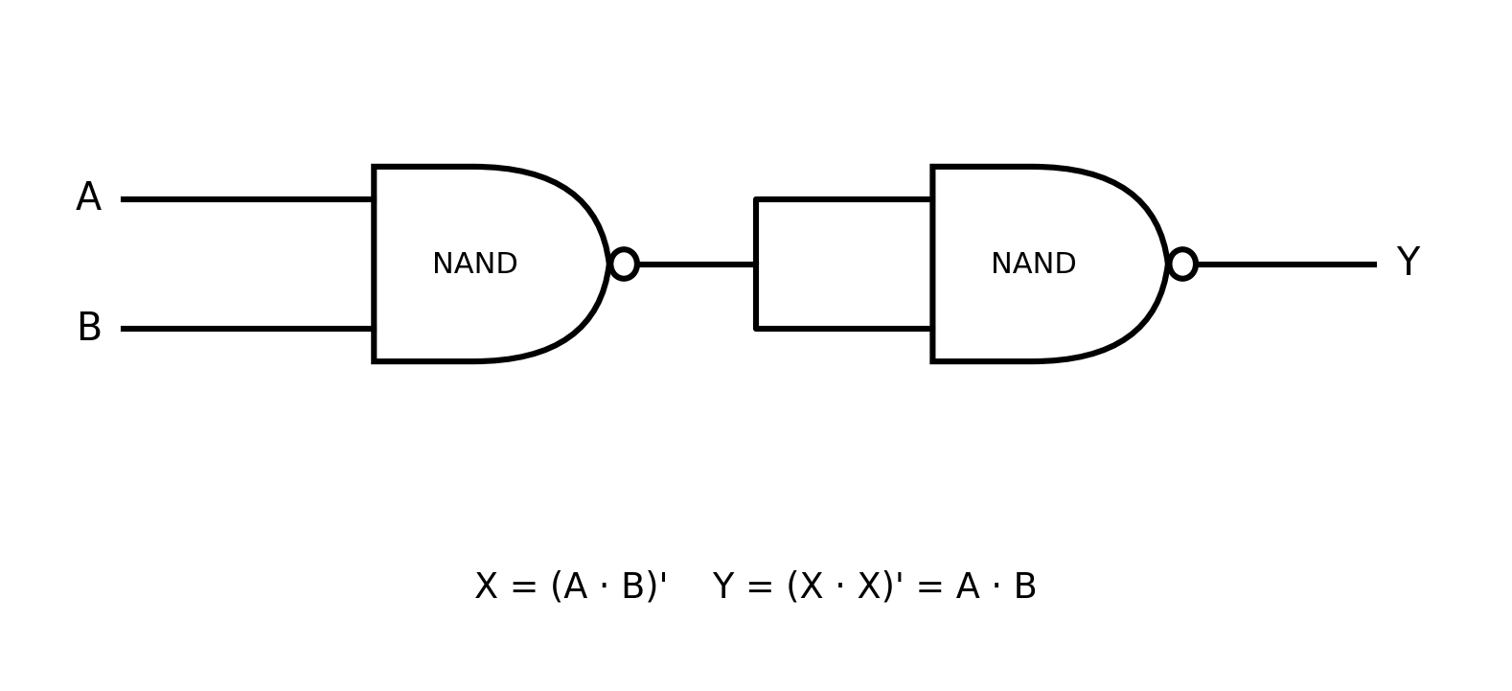
Boolean Expression: X = (A · B)' ; Y = (X · X)' = A · B

C. OR Gate using NAND
The first two NAND gates act as NOT gates for A and B. Their outputs are then connected to a third NAND gate.
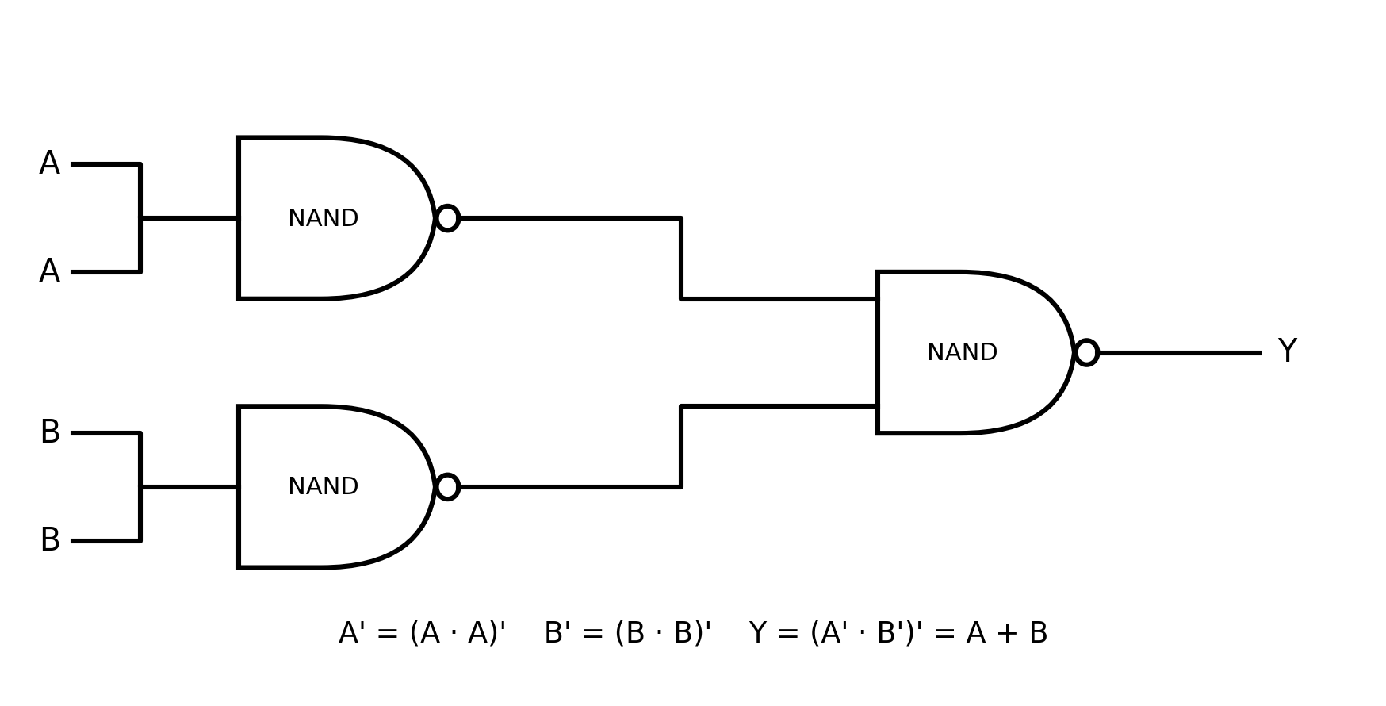
Boolean Expression: A' = (A · A)' ; B' = (B · B)' ; Y = (A' · B')' = A + B

3. HDL Code
// NOT Gate using NAND
module not_using_nand(input A, output Y);
nand(Y, A, A);
endmodule
// AND Gate using NAND
module and_using_nand(input A, input B, output Y);
wire X;
nand(X, A, B);
nand(Y, X, X);
endmodule
// OR Gate using NAND
module or_using_nand(input A, input B, output Y);
wire A_not, B_not;
nand(A_not, A, A);
nand(B_not, B, B);
nand(Y, A_not, B_not);
endmodule

4. Testbench
module tb;
reg A, B;
wire NOT_Y, AND_Y, OR_Y;
not_using_nand NOT1(.A(A), .Y(NOT_Y));
and_using_nand AND1(.A(A), .B(B), .Y(AND_Y));
or_using_nand OR1(.A(A), .B(B), .Y(OR_Y));
initial begin
$monitor("Time=%0t A=%b B=%b NOT=%b AND=%b OR=%b",
$time, A, B, NOT_Y, AND_Y, OR_Y);
A=0; B=0; #10;
A=0; B=1; #10;
A=1; B=0; #10;
A=1; B=1; #10;
$finish;
end
endmodule

5. Simulation Output
Time=0 A=0 B=0 NOT=1 AND=0 OR=0
Time=10 A=0 B=1 NOT=1 AND=0 OR=1
Time=20 A=1 B=0 NOT=0 AND=0 OR=1
Time=30 A=1 B=1 NOT=0 AND=1 OR=1

6. Truth Table
A | B | NOT A | AND | OR
0 | 0 | 1 | 0 | 0
0 | 1 | 1 | 0 | 1
1 | 0 | 0 | 0 | 1
1 | 1 | 0 | 1 | 1

7. Result
The NOT, AND, and OR gates were successfully implemented using only NAND gates. The corrected schematic diagrams, HDL implementation, and simulation results agree with the expected Boolean expressions and truth tables.

