Objective :

To solve a problem about distance with C++(object oriented programming) programming using two classes.

Problem:

Create two classes DM & DB which stores the value of distance. DM stores distances in meters & centimeters & DB in feets & inchies. Write a program that can read the values for class objects & add one object of DM to another object of DB.

Procedure:

1. Two classes should have to create.
2. A friend function should have to create.
3. The valuesv of meter,centimeter,feet & inches should have to declare.

**Sample Input & Output:**

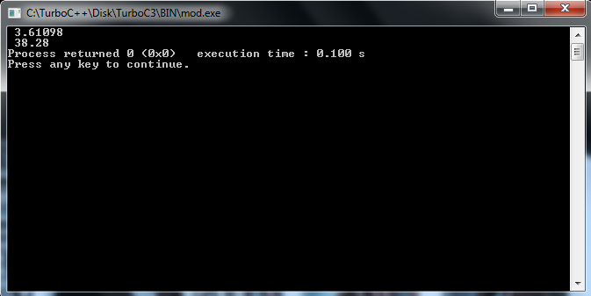

**Discussion:**

1. The errors of the code is very difficult to find out.
2. A friend function can access another class.

**Appendix:**

**Source Code:**

#include<iostream>

using namespace std;

class DB;

class DM

{

float meter,cent;

public:

void getdata(float i,float j)

{

meter=i;

cent=j;

}

friend void sum(DM,DB);

};

class DB

{

float feet,inch;

public:

void getdata(float i,float b)

{

feet=i;

inch=b;

}

friend void sum(DM,DB);

};

void sum(DM m,DB n)

{

float met,cm,x,y;

met=n.feet/3.28;

cm=n.inch/2.5;

x=m.meter+met;

y=m.cent+cm;

cout<<" "<<x;

cout<<"\n"<<" "<<y;

}

int main()

{

DM M;

M.getdata(2.3,30.2);

DB B;

B.getdata(4.3,20.2);

sum(M,B);

return 0;

}