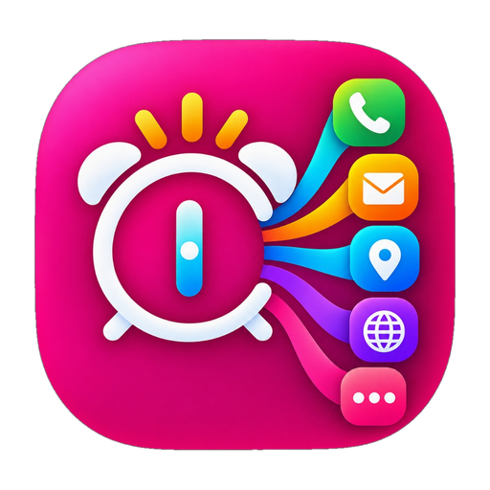
Beyond Alarm
Your alarm, with a purpose.
Complete Product Overview, Real-Life Use Cases & Visual Feature Walkthrough
Author: A.S.M. Kibria | Open Source on GitHub: github.com/asmksn/BeyondAlarm

1. The Problem with Normal Alarms & The Big Innovation
Every single smartphone user struggles with the morning routine. Traditional mobile alarms only do one thing: they make an annoying noise. You can type a label like 'Call Mom', 'Go to Gym', or 'Take Medicine', but when the alarm rings, all you can do is hit 'Snooze' or 'Dismiss'.
Once silenced, the alarm does nothing else. You are left staring at your lock screen, and within seconds, you fall into the morning trap: opening social media, doomscrolling for 30 minutes, and completely forgetting your original intention.
How Beyond Alarm Solves This: The 'Intention Bridge'
Beyond Alarm bridges intention and action. Instead of merely shutting off the sound, dismissing the alarm IMMEDIATELY EXECUTES your intended goal with zero friction. You choose what happens in advance, and with a single tap from the lockscreen, your phone unlocks and launches that task for you!

2. How It Works: The 3-Step Effortless Workflow
Step 1: Set Your Alarm Time & Schedule: Choose your alarm time (e.g. 6:30 AM). Set it for a one-time event or repeat across specific weekdays. Alarms automatically organize chronologically on your home screen.
Step 2: Pick Your Action in 'When it rings...': Select from 9 smart action modes with distinct color badges: Call a contact, draft an email with attachments, start GPS navigation, send an SMS, launch an app, check live weather, inspect a document/prescription, or read an inspiring quote.
Step 3: Wake Up & Execute with One Tap!: When the alarm rings, a vibrant full-screen card appears over your lockscreen. One tap immediately unlocks your phone and launches your intended action with zero friction.

3. Clean Home Screen: 24-Hour Timeline & Side-by-Side Controls
Natural 24-Hour Chronological Flow:  Your alarms automatically arrange themselves in natural morning-to-night chronological order. 6:29 AM appears at the top, afternoon alarms in the middle, and night alarms at the bottom—no confusing clutter.  One-Line Side-by-Side Controls:  Rather than stacking huge buttons vertically, 'Edit alarm' and 'Delete alarm' sit side-by-side on a single clean row. This cuts card height in half, making the home screen compact and easy to scan.  Zero Overlapping Text & Color Badges:  Every alarm card features an oval action badge (e.g. [📍 Get directions]) and clear, spacious schedule details (e.g. 'Once • Wed, 14 Oct • Snoozed') with zero text overlap. | 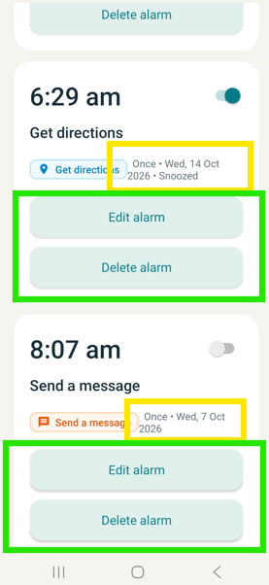  Actual App Screenshot:  Home Screen Timeline

4. The 9 Smart Action Modes (Oval-Pill Selector)
In the alarm editor, tapping 'When it rings...' opens the visual oval-pill selector. Every action has its own distinct color shade and circular icon badge:  📞 Call someone (Emerald Green): Pre-loads chosen phone number in the dialer ready to call family, coach, or coworkers.  ✉️ Send an email (Sunset Orange): Prepares an email draft with recipient, subject, body, and attached files/photos.  📍 Get directions (Sky Azure): Opens Google Maps navigation directly to your destination (gym, office, airport).  💬 Send a message (Warm Amber): Composes an SMS text draft for morning affirmations or arrival updates.  📱 Open an app (Magenta Pink): Directly launches fitness, Quran, language, or habit apps on dismiss.  ☀️ Morning weather (Sun Gold): Live local temperature and weather forecast advice for your city.  📄 Open a document (Fresh Teal): Instantly views medical prescriptions, study notes, or morning checklists.  🌐 Open a website (Royal Purple): Opens your designated news feed, portal, or morning articles in your browser.  🔔 Just ring (Cool Slate): Acoustic alarm with customizable volume (10-100%) and system tones. | 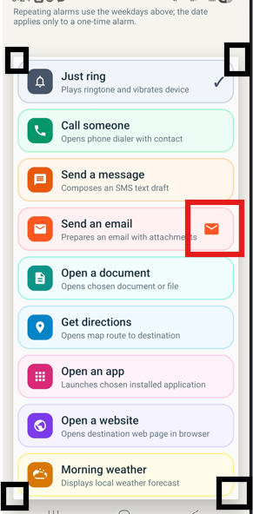  Actual App Screenshot:  Oval-Pill Action Selector

5. The Ringing Screen: One-Tap Lockscreen Launch
What Happens When the Alarm Rings?  At your set time, Beyond Alarm lights up your screen with a gorgeous, high-legibility interface over your lockscreen:  • Massive Clear Clock: Displays current time in 64pt bold typography with your alarm title.  • Action Banner & Details: Shows the specific destination, contact name, or quote on the card.  • One-Tap Primary Action: Tapping the primary button immediately requests secure lockscreen unlock and executes your task (opens dialer, maps, or app).  • Snooze & Dismiss: Features a 5-minute snooze button and safe dismiss option.  • Safety Auto-Timeout: If left unattended, ringing automatically stops after 10 minutes and logs a missed-alarm notification so your battery is never drained. | 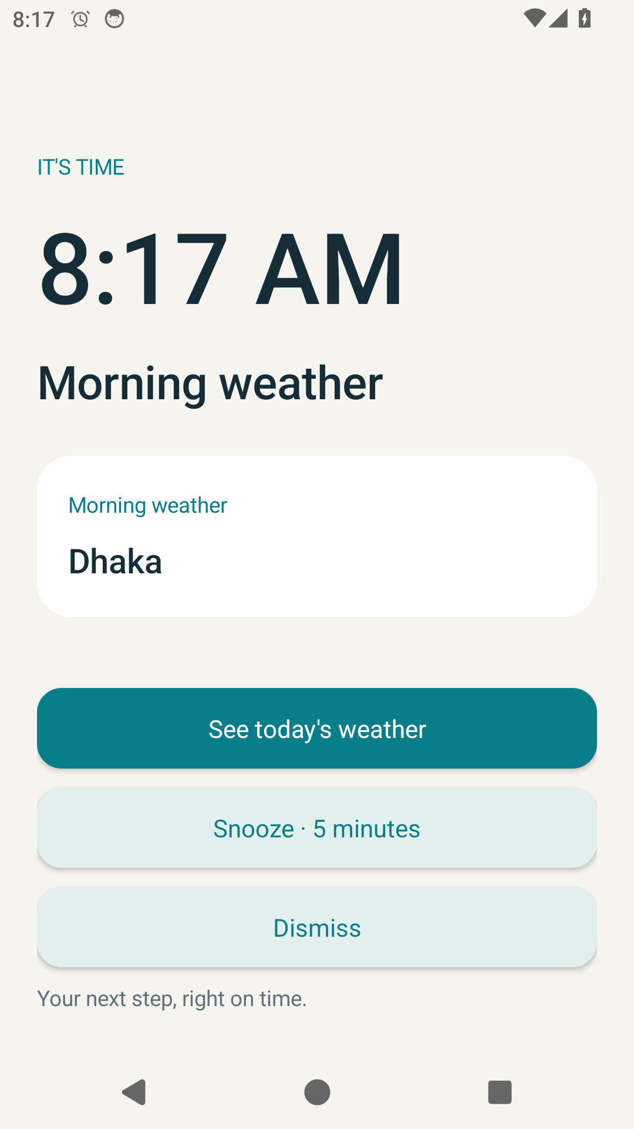  Actual App Screenshot:  Full-Screen Ringing Mode

6. Exceptional Built-In Features: Maps, Quotes & Live Weather
Beyond Alarm integrates powerful capabilities that you won't find in any standard mobile clock:
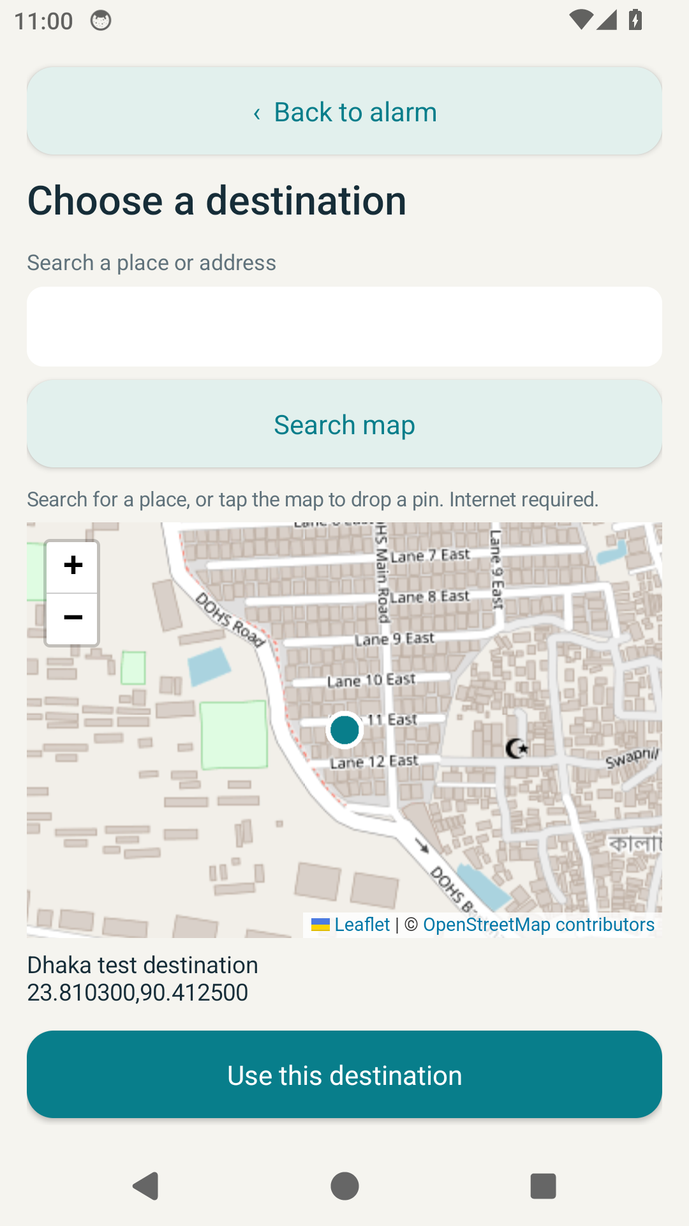  Interactive Map Search  (Google Maps & Photon) | 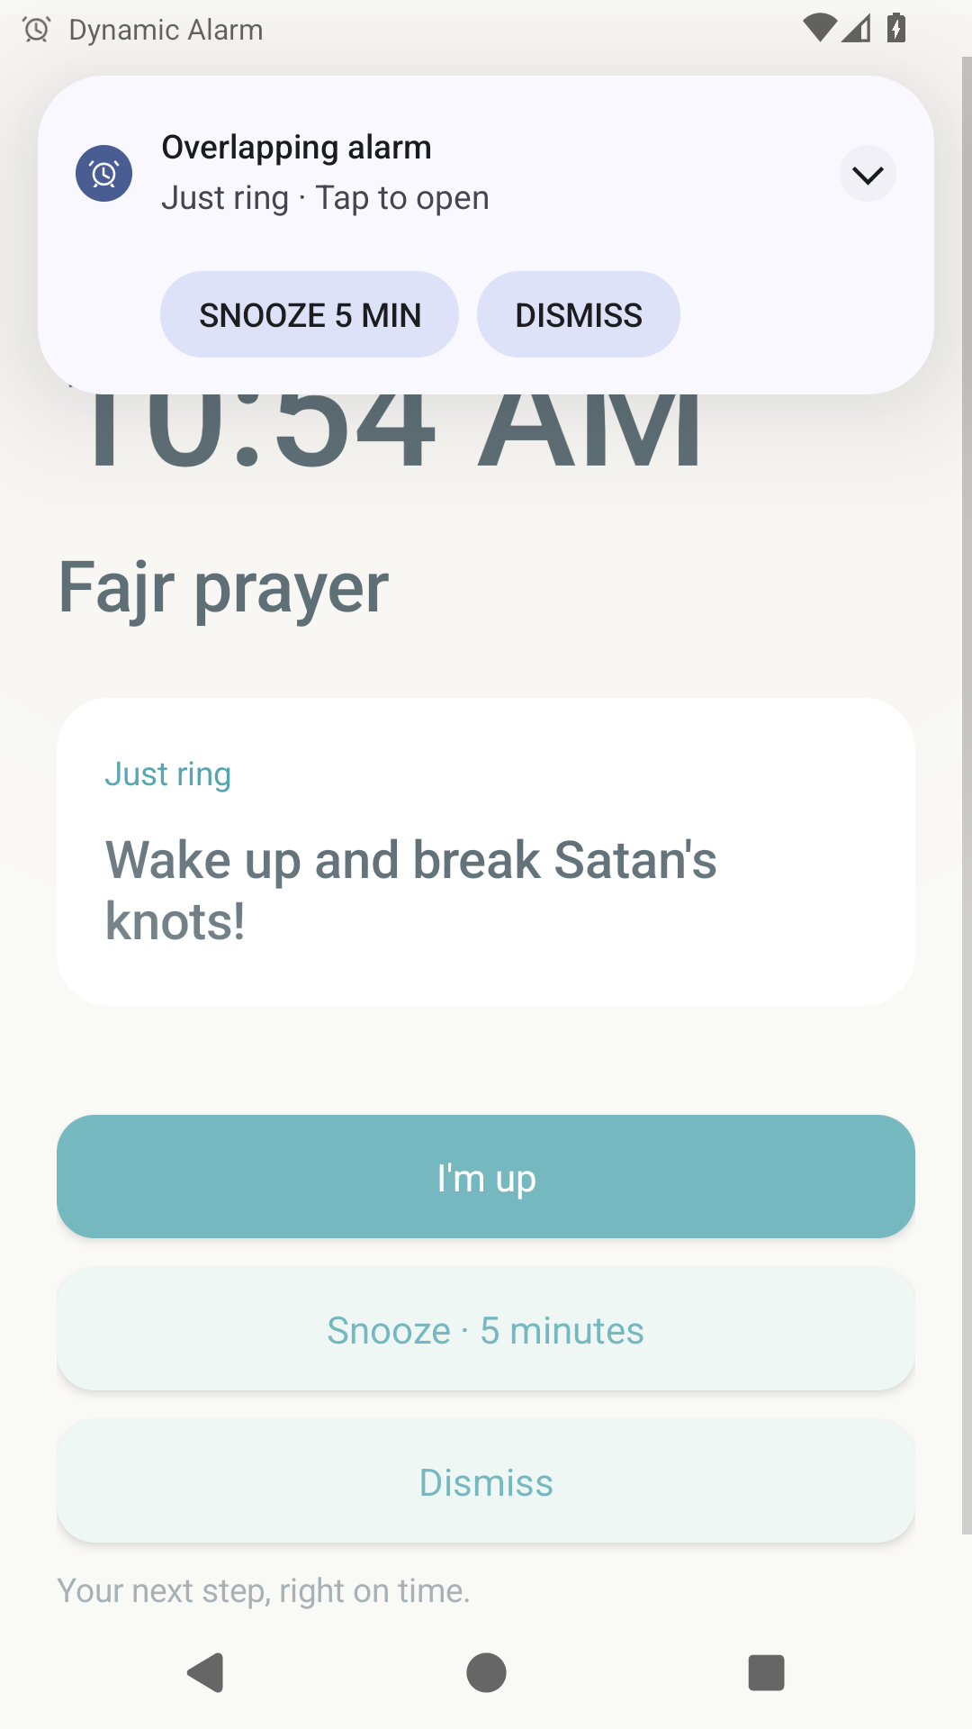  Quotes Library  (Islamic & Motivation) | 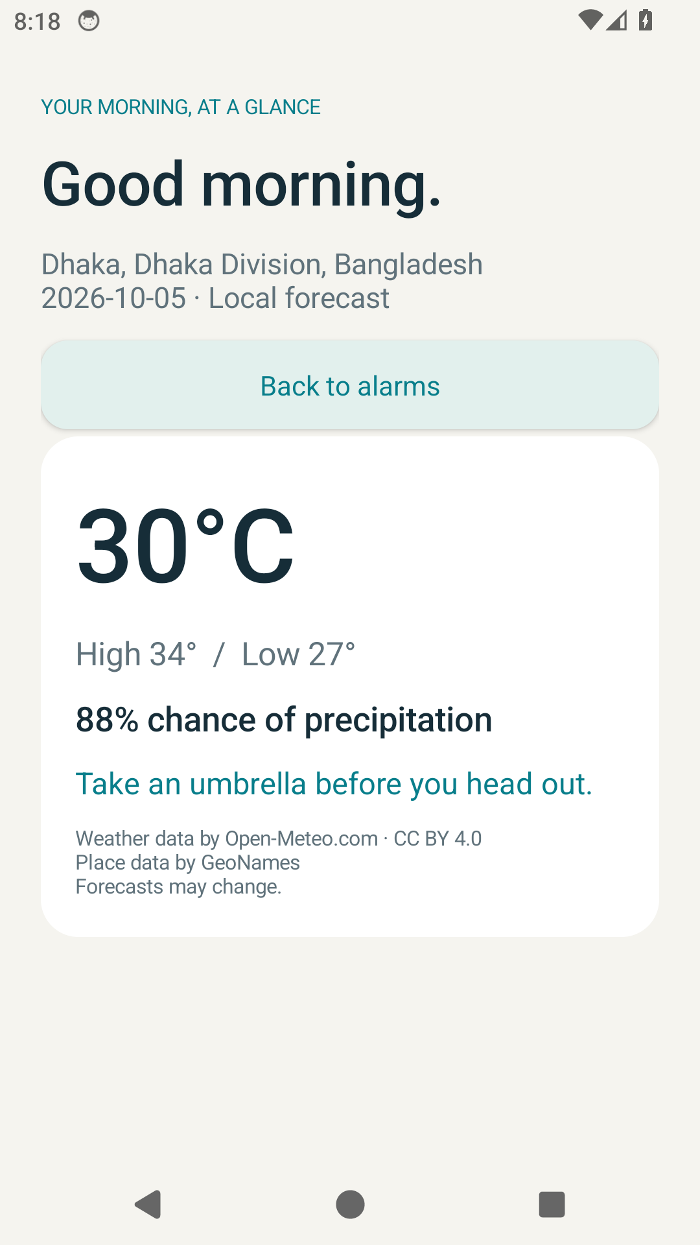  Real-Time Weather  (Live City Forecast)

7. Real-Life Everyday Scenarios: How People Actually Use It
Scenario A: The Morning Workout / Gym Route
You set an alarm for 6:00 AM with 'Get directions' set to your fitness center.
• Normal Alarm: You turn off the sound, stay in bed debating the commute, and end up skipping the gym.
• Beyond Alarm: When the alarm rings, tapping 'Get directions' instantly opens Google Maps showing you live traffic (e.g. 14 mins). The mental inertia vanishes, and you get up immediately!
Scenario B: Medicine Reminder & Doctor's Prescription
You must take specific medication at 10:00 AM.
• With 'Open a document', you attach a photo of your doctor's prescription.
• When the alarm rings, one tap brings up the prescription photo showing exact pill dosages. No more digging through gallery albums or risking wrong dosages.
Scenario C: Live Football Match / El Clásico Alert
A major match starts at 5:30 PM on your streaming app.
• You set a Beyond Alarm for 5:25 PM with 'Open an app' pointing to your live sports app.
• The alarm fires 5 minutes before kickoff. One tap opens the stream directly before kickoff—no searching or missing the opening goal!
Scenario D: Weekly Call to Parents / Sunday Morning
You want to maintain a habit of calling your mom every Sunday morning.
• You set a repeating alarm for Sunday at 9:00 AM with 'Call someone' set to Mom's contact.
• The dialer opens with Mom's number preloaded. One press of the call button connects you right away.
Scenario E: Fajr Prayer, Quran & Morning Spiritual Peace
You want your mornings grounded in spiritual calm.
• Set a 5:00 AM alarm with an authentic quote (e.g. 'Prayer is better than sleep - Hadith') and set the action to launch your preferred Quran or prayer app on dismiss.

8. The 4 Big Promises: 100% Privacy & Zero Ads
- 1. Zero Advertisements & Zero Popups: You will never wake up to an annoying video ad or promotional popup. Beyond Alarm is 100% ad-free forever.
- 2. 100% On-Device Privacy: No accounts. No sign-in. No cloud tracking of your wake-up time, destinations, or contacts. Everything stays strictly inside your phone.
- 3. Battery-Friendly & Ultra Lightweight: The entire production app is under 1 MB! Built in native Java and Android SDK without heavy cross-platform bloatware.
- 4. Exact Reliability with Reboot Recovery: Uses Android's Exact AlarmManager with BOOT_COMPLETED recovery. Even if your phone restarts overnight or changes time zones, your alarms are restored.

Beyond Alarm • Your alarm, with a purpose.
Free & Open Source for Android
GitHub: https://github.com/asmksn/BeyondAlarm | Developed by A.S.M. Kibria

