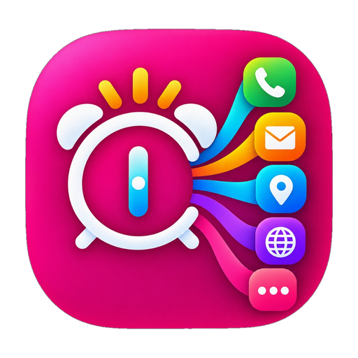
Beyond Alarm
Your alarm, with a purpose.
App Concept, How It Works & Everyday Features Guide
Created by A.S.M. Kibria | Updated for Version 2.0 (2026)

1. The Big Idea: What is Beyond Alarm?
In ordinary mobile alarm clocks, all you can do is type a title. You set an alarm and label it:
• 'Call Mom' • 'Go to Gym' • 'Mail Boss' • 'Take Medicine' • 'Watch Match'
But what actually happens when that alarm rings? It just makes a loud, annoying sound! You wake up groggy, swipe 'Dismiss' or 'Snooze', and the alarm stops. The app does nothing else. You are left on your lock screen, and within seconds, you forget your intention and start scrolling social media in bed.
Beyond Alarm changes this completely!
Instead of just ringing and turning off, Beyond Alarm lets you choose WHAT ACTION SHOULD HAPPEN when the alarm rings. When you confirm or dismiss the alarm, your phone immediately opens that task for you—with zero friction and zero searching.

2. How It Works (Simple 3-Step Process)
Step 1: Set Your Alarm Time & Schedule
Choose your alarm time (e.g., 6:30 AM). You can set it as a one-time alarm for a specific date, or repeat it on chosen weekdays (like Monday to Friday). All your saved alarms appear on the home screen in a natural 24-hour chronological order from morning to night.
Step 2: Pick Your Action in 'When it rings...'
Choose what you want to happen from the new visual oval-pill selector. Select from 9 smart options: Call a contact, draft an email, start map navigation, send an SMS, launch your favorite app, check morning weather, review a document/prescription, or read an inspiring quote.
Step 3: When the Alarm Rings -> Take Instant Action!
At your chosen time, the alarm rings loud and clear even if your phone is locked. On the ringing screen, you see your alarm title, time, and a prominent Action Button. With just ONE TAP, your phone securely unlocks and immediately takes you to that task (dialer, map route, email draft, or app).

3. The 9 Smart Action Modes (What You Can Do)
Every action mode is color-coded with its own distinctive oval pill badge and icon so you can recognize it at a glance:
Action Mode & Color | What You Configure | What Happens When Alarm Rings
📞 Call someone  (Emerald Green) | Pick a contact from your phonebook or enter a phone number. | Opens your phone dialer with that person's number already loaded so you can call them in one tap.
✉️ Send an email  (Sunset Orange) | Enter recipient, subject, email body, and attach documents or pictures. | Opens your email app (Gmail/Outlook) with the draft and attachments pre-loaded, ready to hit send.
📍 Get directions  (Sky Azure) | Search and choose a destination (like your gym, office, or airport). | Immediately launches Google Maps with turn-by-turn navigation already set up to that location.
💬 Send a message  (Warm Amber) | Enter recipient phone number and type your SMS message. | Opens your text messaging app with your pre-written text ready to review and send.
📱 Open an app  (Magenta Pink) | Select any app installed on your phone (workout, news, Quran, games). | Directly launches that specific app on your screen without having to look through your app drawer.
☀️ Morning weather  (Sun Gold) | Enter your city name (e.g. Dhaka, London, New York). | Instantly checks live temperature, rain forecast, and sky conditions so you know whether to take an umbrella.
📄 Open a document  (Fresh Teal) | Select any PDF, study notes, medical prescription, or image. | Opens your chosen file directly on your screen so you can review it immediately.
🌐 Open a website  (Royal Purple) | Enter any website link (news site, blog, portal, or video). | Opens that exact web link in your default web browser.
🔔 Just ring  (Cool Slate) | Pick an alarm ringtone, volume level (10% to 100%), and vibration. | Plays a traditional, reliable alarm sound without opening any external apps.

4. Everyday Life Scenarios (How People Actually Use It)
Scenario A: The Early Morning Workout / Gym Route
You set an alarm for 6:00 AM with the action 'Get directions' set to your fitness center.
• Normal Alarm: You turn off the sound, lay in bed thinking about the commute, and end up skipping the gym.
• Beyond Alarm: The alarm rings. You tap 'Get directions'. Google Maps instantly pops up showing you it takes only 14 minutes with clear traffic. You are immediately prompted to get up and leave!
Scenario B: Medicine Reminder & Doctor's Prescription
You need to take your prescribed medicine at 10:00 AM.
• You attach a photo of your doctor's prescription using 'Open a document'.
• When the alarm rings at 10:00 AM, one tap opens the exact prescription photo showing dosage instructions. You take the right pills without searching through your photo gallery.
Scenario C: Live Football Match / El Clásico Reminder
Real Madrid vs. Barcelona starts at 5:30 PM, broadcasted on your sports app.
• You set a Beyond Alarm for 5:25 PM with the action 'Open an app' pointing to your live streaming app.
• At 5:25 PM, the alarm notifies you, and tapping 'Open app' takes you directly to the live match before kickoff—no searching or missing the first goal!
Scenario D: Calling Mom Every Sunday Morning
You want to make sure you never forget to call your parents on Sunday mornings.
• You set a repeating alarm for Sunday at 9:00 AM with 'Call someone' set to Mom's contact.
• When it rings, the dialer is ready with Mom's number. One press of the call button connects you immediately.
Scenario E: Fajr Prayer, Quran & Morning Quotes
You want your mornings to start with spiritual peace and focus.
• You set a 5:00 AM alarm and choose an authentic Islamic quote (e.g. 'Prayer is better than sleep - Hadith').
• When the alarm rings, an inspiring reminder is displayed in bold typography on the ringing screen. You can set it to auto-launch Quran Majeed right after you wake up.

5. What's New in Beyond Alarm 2.0 (The Visual Redesign)
Following extensive user testing, Version 2.0 includes major user-experience upgrades:
- Brand New App Logo: A vibrant, eye-catching magenta icon with a white alarm clock radiating rainbow trails into action icons. Properly padded for all phone launchers (square, squircle, or round).
- Oval-Pill Action Selector: Replaced the boring default dropdown with sleek, modern oval pills featuring distinct pastel shades and dedicated icons for all 9 actions.
- One-Line Compact Controls: Combined the 'Edit alarm' and 'Delete alarm' buttons into a single horizontal line side-by-side. This cut alarm card height in half, making the home screen compact and easy to scan.
- Zero Overlapping Text: Properly organized time, schedule (e.g. 'Once • Wed, 14 Oct • Snoozed'), and action badges on separate padded rows so text is crystal clear on any screen size.
- Natural 24-Hour Timeline: Your alarms automatically sort chronologically from earliest to latest (4:00 AM on top, 1:00 PM in middle, 11:00 PM at bottom).

6. The 4 Big Promises to Every User
1. Zero Advertisements & Zero Popups
You will never wake up to an annoying video ad or popup banner. Beyond Alarm is 100% ad-free forever.
2. 100% On-Device Privacy
No user accounts. No passwords. No cloud servers tracking your wake-up time or daily habits. Everything stays strictly inside your phone.
3. Battery-Friendly & Ultra Lightweight
The entire app is less than 1 MB! It uses virtually zero background battery and runs smoothly on both modern flagships and budget phones.
4. 100% Reliable Waking
Even if your phone restarts overnight, changes time zones, or enters deep sleep mode, Beyond Alarm automatically recovers your alarms so you never miss an appointment.

Beyond Alarm • Your alarm, with a purpose.
Free & Open Source for Android
Explore on GitHub: https://github.com/asmksn/BeyondAlarm | Feedback: asmksn@gmail.com

