PROJECT TITLE: AIR QUALITY MONITORING

NAME: ASWIN.B

REG NO: 953021106010

TEAM NAME: PROJ_201035_TEAM_1

COLLEGE CODE: 9530

COLLEGE NAME: ST.MOTHER THERESA ENGINEERING COLLEGE

NANMUDHALVAN ID: au953021106010

Problem Statement: Air pollution is one of environmental issues that cannot be ignored. Inhaling pollutants for a long time causes damages in human health. This project is suitable for air quality monitoring in real time.Design a tool which will sense quality of air and display it in the form of percentage,Sense how much carbon mono-oxide(CO) is present in air and display it.

BLOCK DIAGRAM:

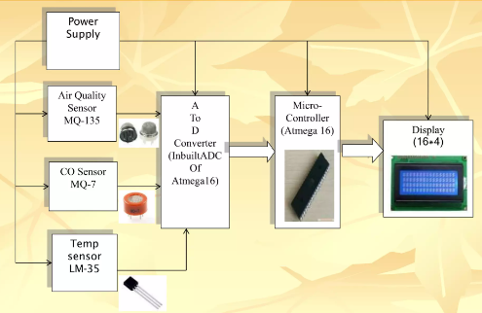

CODE:

#include <LiquidCrystal.h>

LiquidCrystal lcd(12, 11, 5, 4, 3, 2);

int pin8 = 8;

int analogPin = A0;

int sensorValue = 0;

void setup() {

pinMode(analogPin, INPUT);

pinMode(pin8, OUTPUT);

lcd.begin(16, 2);

lcd.print("What is the air ");

lcd.print("quality today?");

Serial.begin(9600);

lcd.display();

}

void loop() {

delay(1000);

sensorValue = analogRead(analogPin);

Serial.print("Air Quality in PPM = ");