CITY OF TALLAHASSEE FLEET MANAGEMENT PRESENTATION

Meeting Agenda & Presenter Guide
Meeting Goal: Share app, gain trust/confidence, get requirements from them, leave with promise of proposal. DELIVER Proposal.
Duration: 1 Hour

TIMELINE OVERVIEW
Time | Section | Duration
0:00-0:05 | Introduction & Setup | 5 min
0:05-0:10 | CTA Overview | 5 min
0:10-0:40 | Fleet App Demo | 30 min
0:40-1:00 | Q&A and Closing | 20 min

0:00-0:05 — INTRODUCTION & SETUP (5 minutes)

Activities
- Shake hands, introductions
- Get laptop connected to display
- Ensure demo environment is loaded
- Hand out any printed materials

Talking Points
- “Thank you for having us today”
- “We’re excited to show you what we’ve built specifically for municipal fleet operations”
- Quick round of introductions (names, roles)

0:05-0:10 — CTA OVERVIEW (5 minutes)

About Capital Technology Alliance
Company Information: - Legal Name: Capital Technology Alliance, LLC - Location: 2509 Lantana Lane, Tallahassee, FL 32311 - Status: Active Florida LLC (Document #L24000075432) - Founded: 2024

Key Talking Points
“We’re a Tallahassee-based technology company. We’re local, which means we understand Florida municipal operations and we’re here when you need us.”
“Our team has deep expertise in enterprise software development, cloud infrastructure, and AI/ML technologies.”
“We built this platform because we saw a gap in the market — existing solutions either do too little or are overly complex. We wanted something that just works.”

Why We’re Different
- Local presence in Tallahassee
- Purpose-built for municipal fleet operations
- Modern technology stack (not legacy software)
- AI-powered optimization
- Seamless integration with existing systems (like Samsara)

0:10-0:40 — FLEET APP DEMO (30 minutes)

Opening Statement
“Why did we build this?”
“We saw a need. Municipal fleets are using fragmented systems — one for telematics, another for fuel, spreadsheets for maintenance. We knew we could do it better.”
“Our goal was to create something simplified and streamlined — one platform that does everything you need.”

START: Fleet Dashboard Screen (2 minutes)
Screenshot: fleet-dashboard-chromium-darwin.png
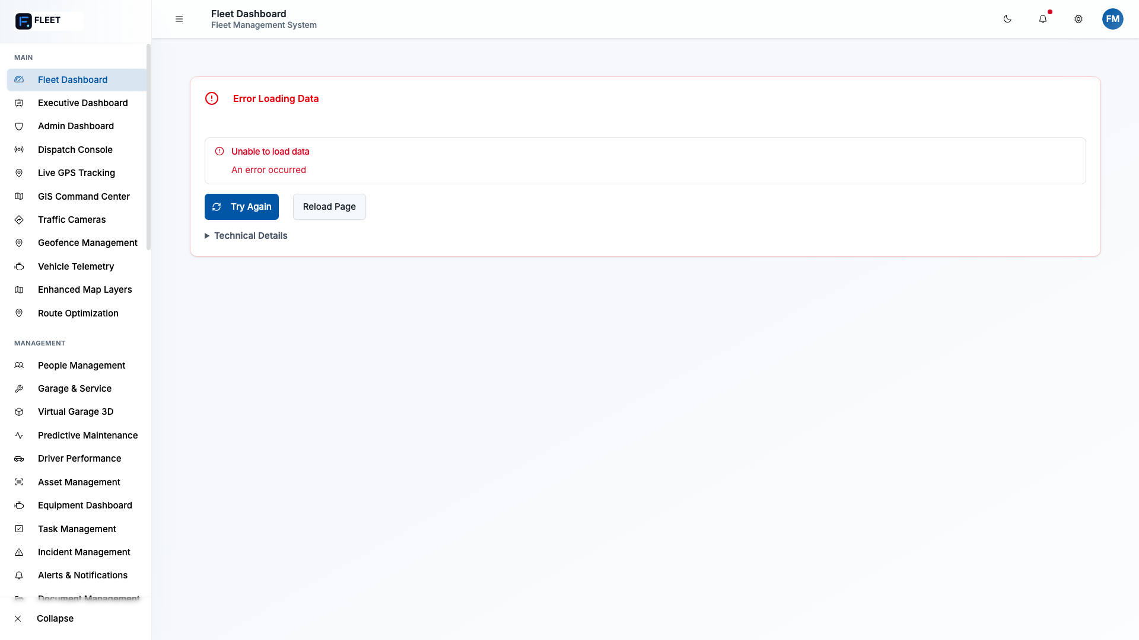
Fleet Dashboard
Discuss what they are seeing: - Real-time fleet status at a glance - Key metrics: vehicles active, maintenance due, compliance status - Quick actions for common tasks - Recent activity feed
“This is your command center. Everything starts here. At a glance, you can see the health of your entire fleet.”
Then lead into navigation options: > “From here, let me show you where you can go…”

OPERATIONS HUB (5 minutes)
Screenshot: gis-command-center-chromium-darwin.png
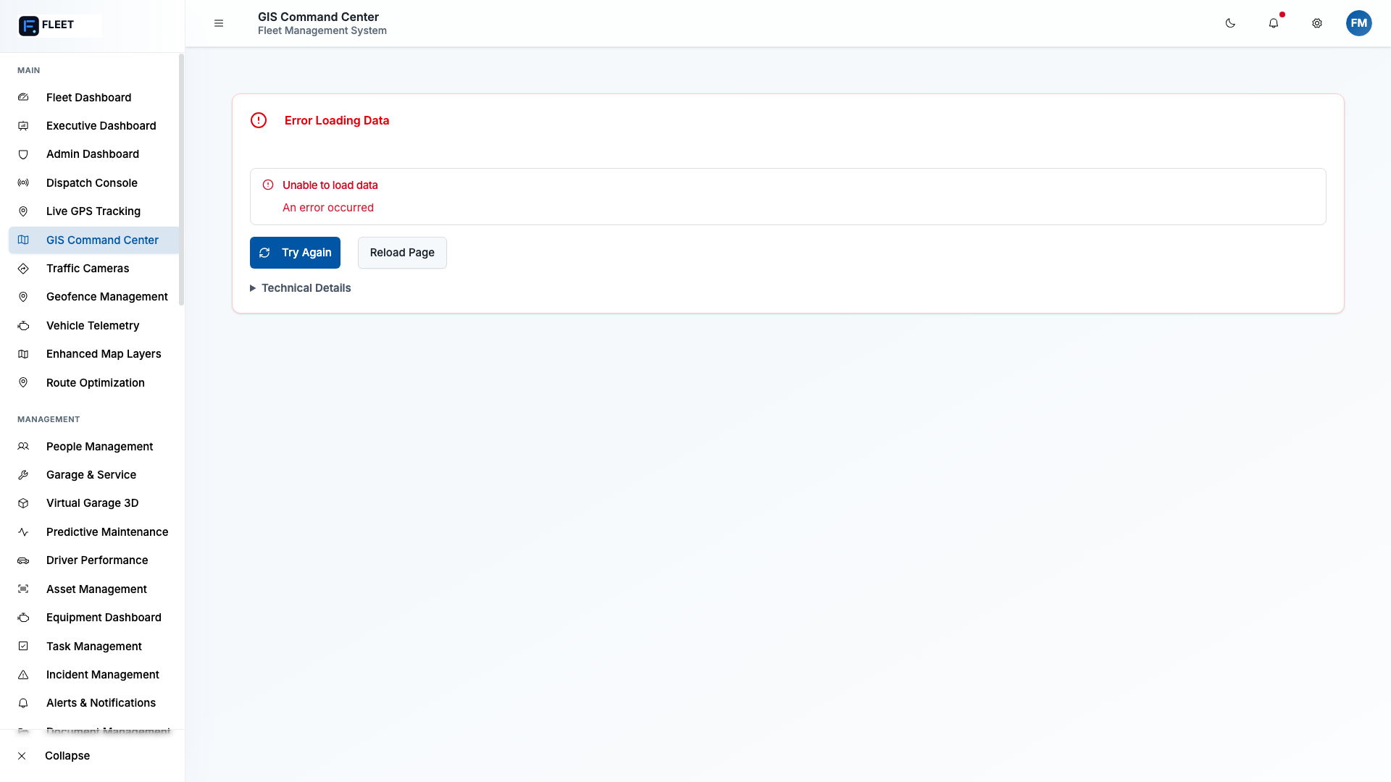
GIS Command Center

Dispatch
- Live vehicle tracking on map
- Real-time job assignment
- Driver availability status
- Route optimization
Screenshot: gps-tracking-chromium-darwin.png
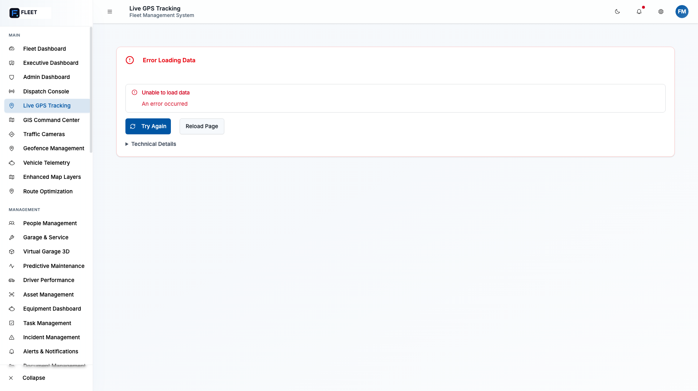
GPS Tracking
“You can see every vehicle in real-time. Dispatch jobs, track progress, and know exactly where your assets are.”

Routes
- Planned vs. actual routes
- Deviation alerts
- Fuel-efficient routing
- Historical route analysis

Tasks
- Job queue management
- Priority assignment
- Status tracking
- Completion verification

Calendar
- Scheduled maintenance
- Driver assignments
- Inspection due dates
- Recurring tasks

MAINTENANCE HUB (8 minutes)
Screenshot: garage---service-chromium-darwin.png
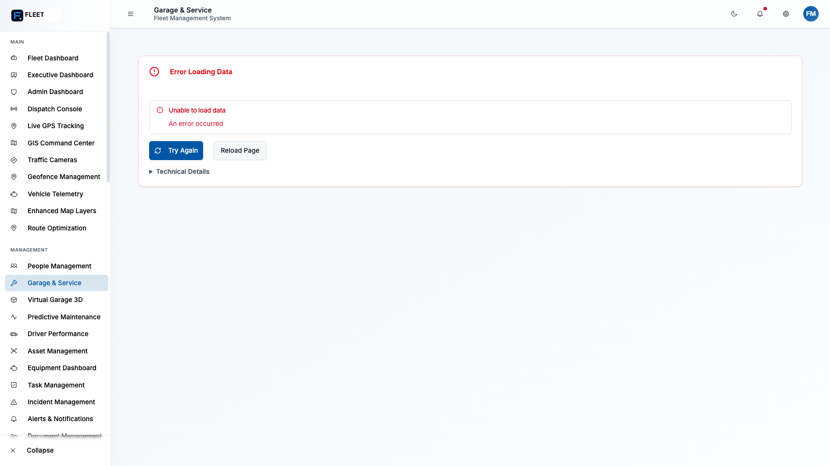
Garage & Service
“This is where Tallahassee’s needs really align with what we’ve built. You do both internal maintenance AND use external vendors. Our system handles both.”

Fuel Consumption
- Real-time fuel level tracking (via Samsara)
- Fuel purchase tracking
- Cost per mile calculations
- Idling detection and fuel waste
- AI-powered fuel price optimization
“We can replace your separate fuel management app. All fuel data flows into one system.”

Service Dates
- Preventive maintenance scheduling
- Mileage-based triggers
- Time-based triggers
- Engine hour triggers
- Automated work order creation

Maintenance Records
- Complete service history per vehicle
- Parts used and costs
- Labor hours and rates
- Warranty claim tracking
Screenshot: parts-inventory-chromium-darwin.png
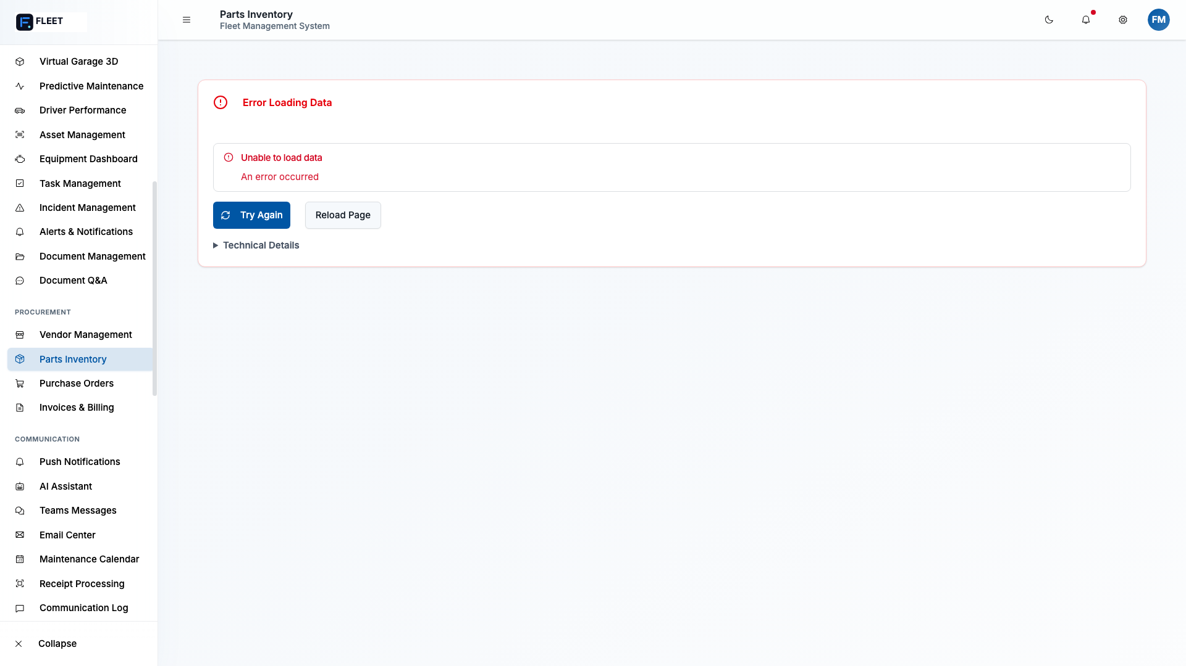
Parts Inventory
“Every part, every repair, every cost — all tracked and searchable.”

ANALYTICS (3 minutes)
Screenshot: agent-6-executive-dashboard.png
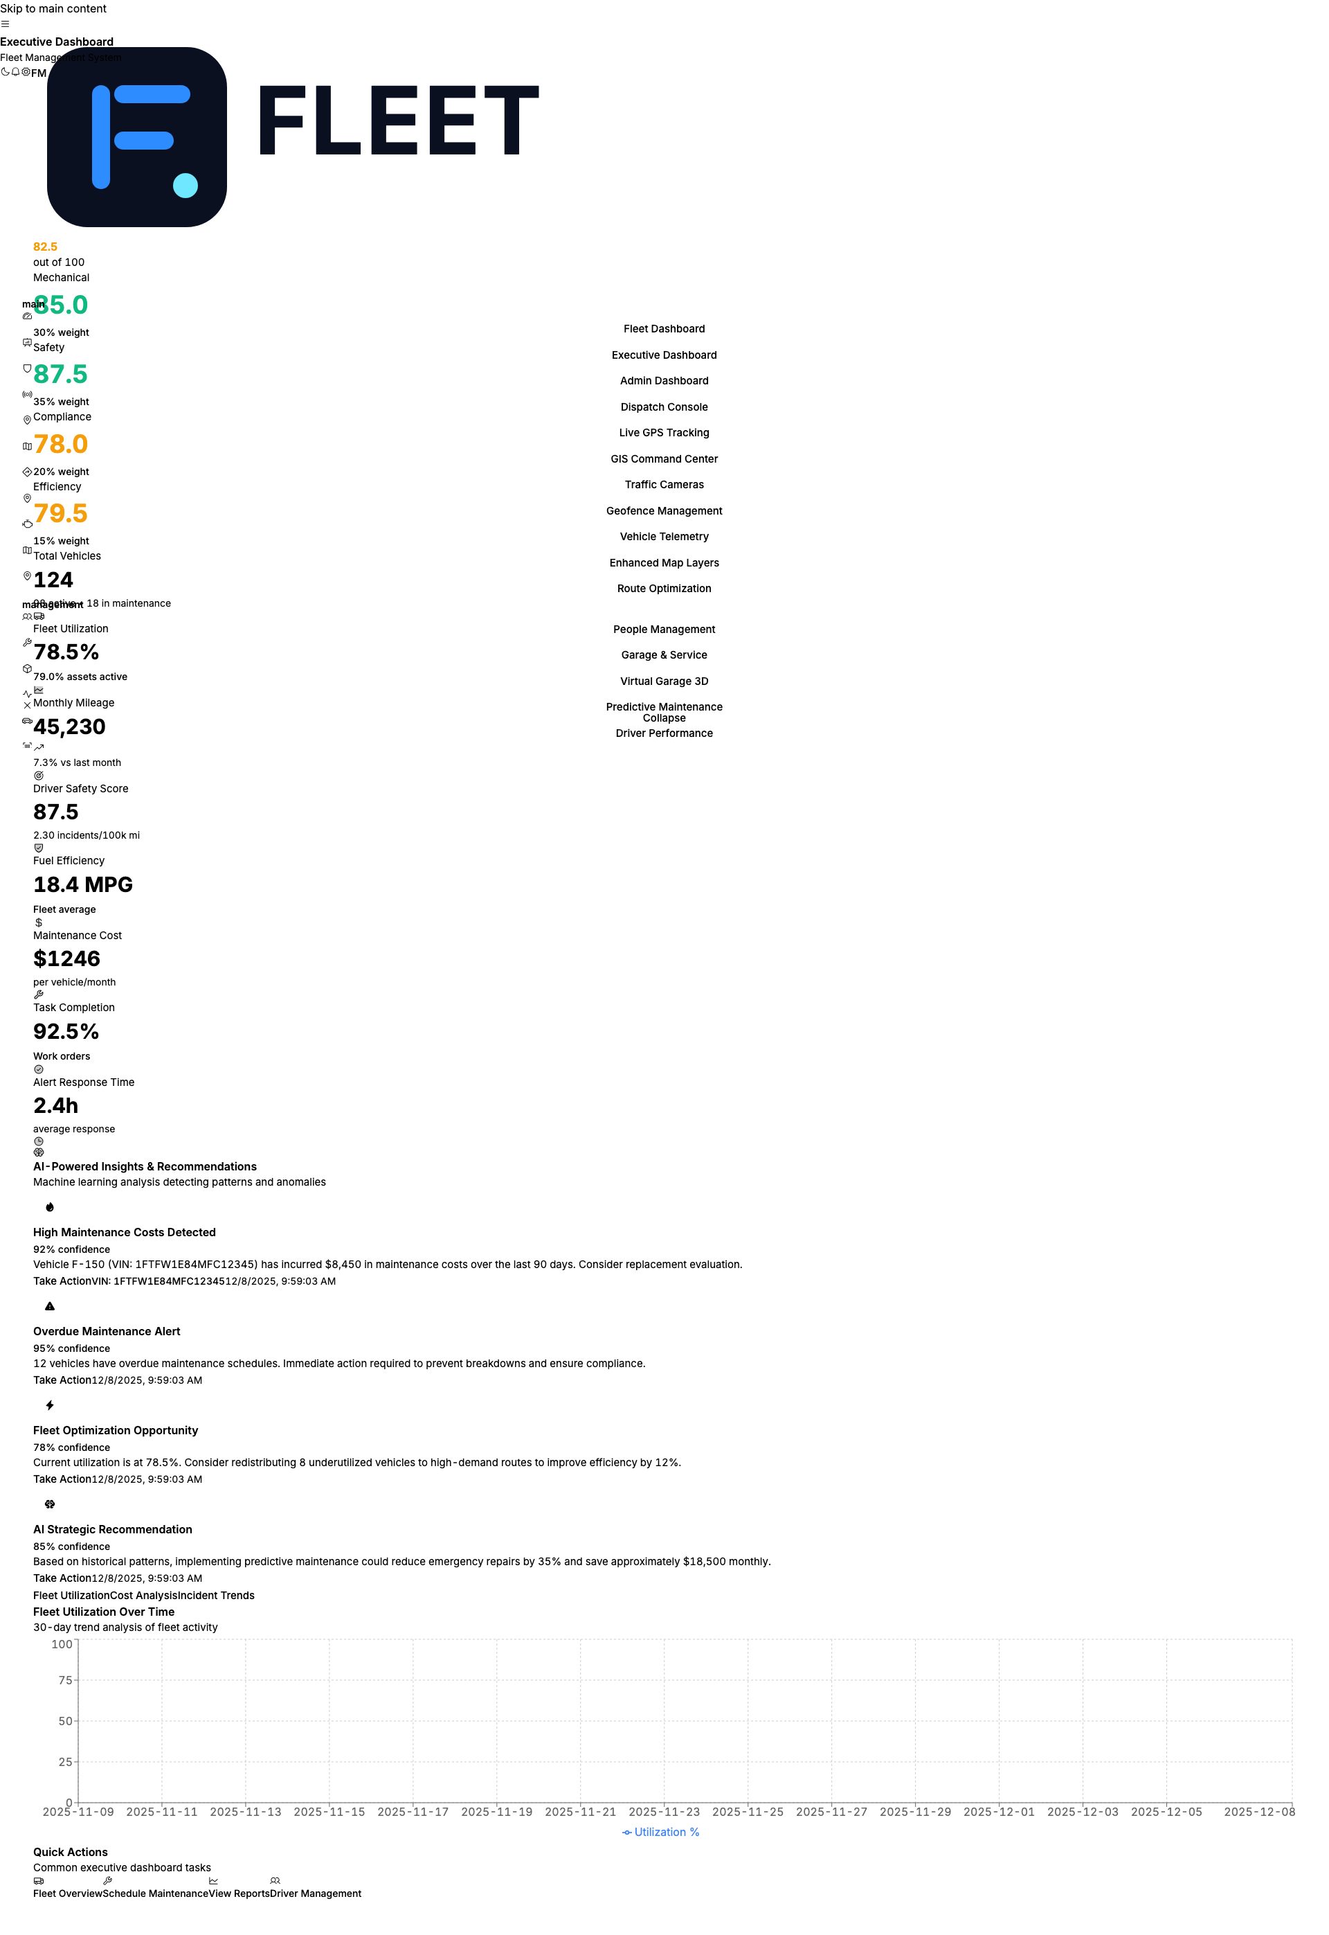
Executive Dashboard
Screenshot: agent-6-fleet-analytics.png
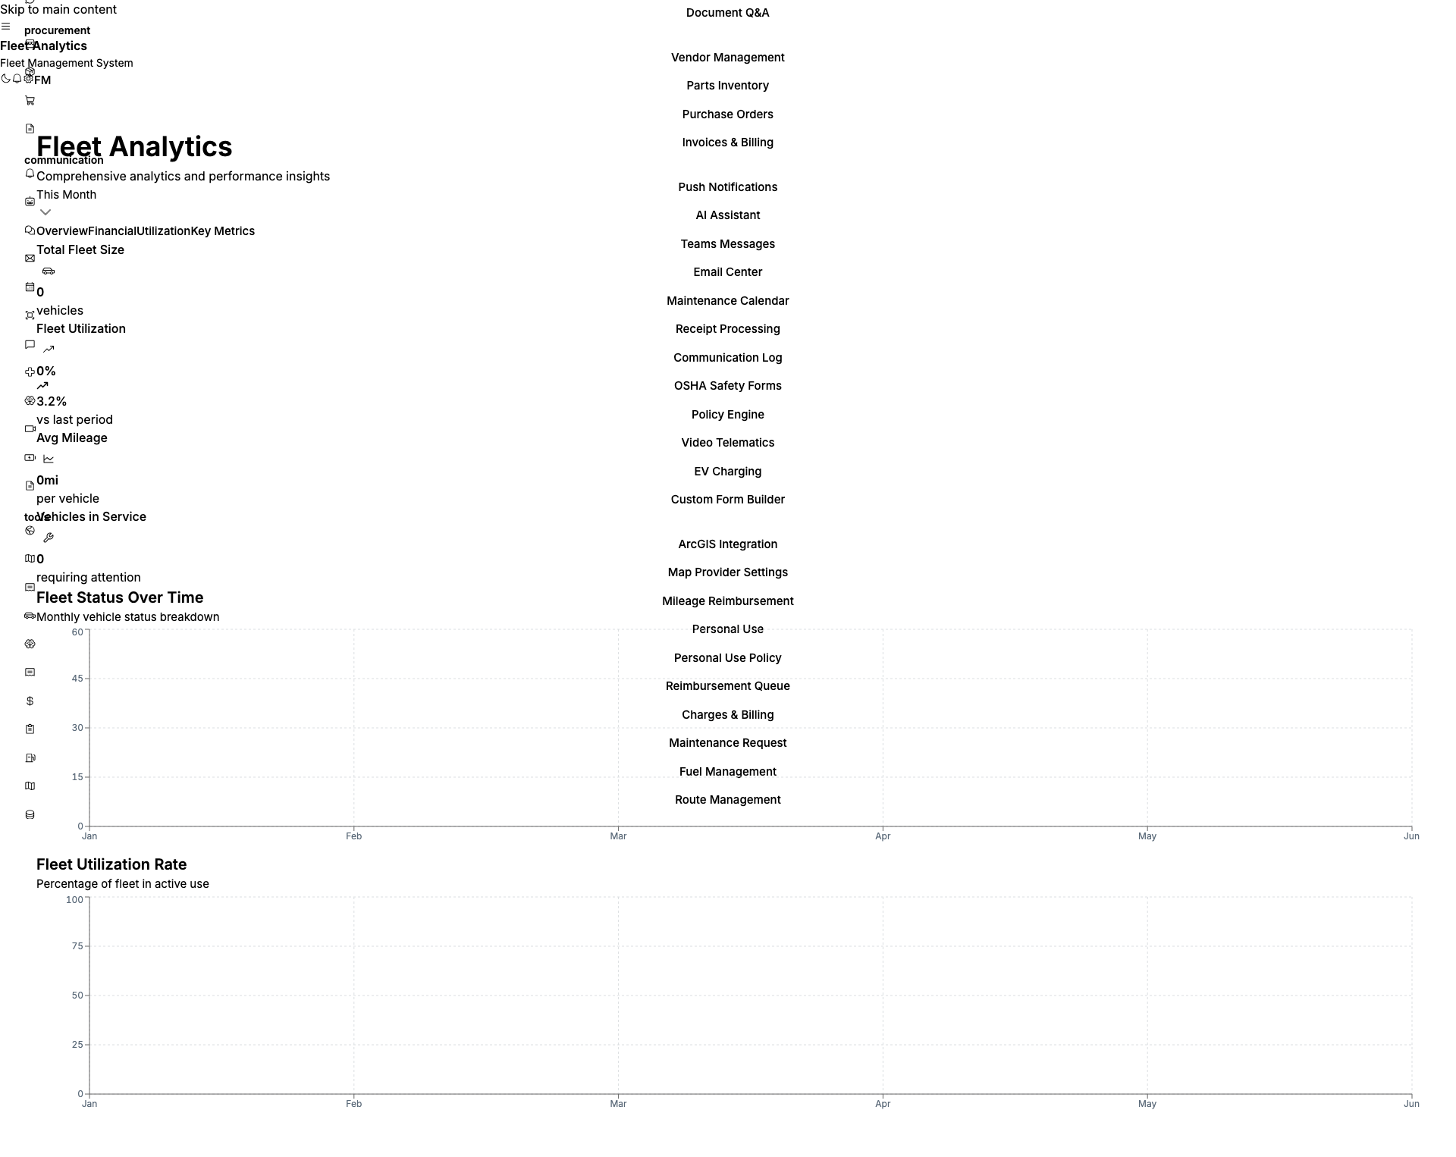
Fleet Analytics
Screenshot: agent-6-cost-analysis.png
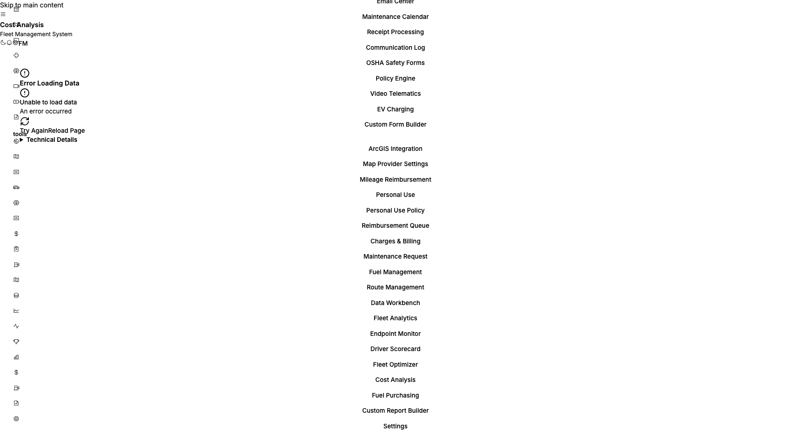
Cost Analysis
- Fleet utilization rates
- Cost per mile tracking
- Trend analysis
- Custom report builder
- Scheduled report delivery
- Excel export
“For leadership, this gives you the data you need for budget discussions, performance reviews, and strategic planning.”

COMPLIANCE (3 minutes)
Screenshot: osha-safety-forms-chromium-darwin.png
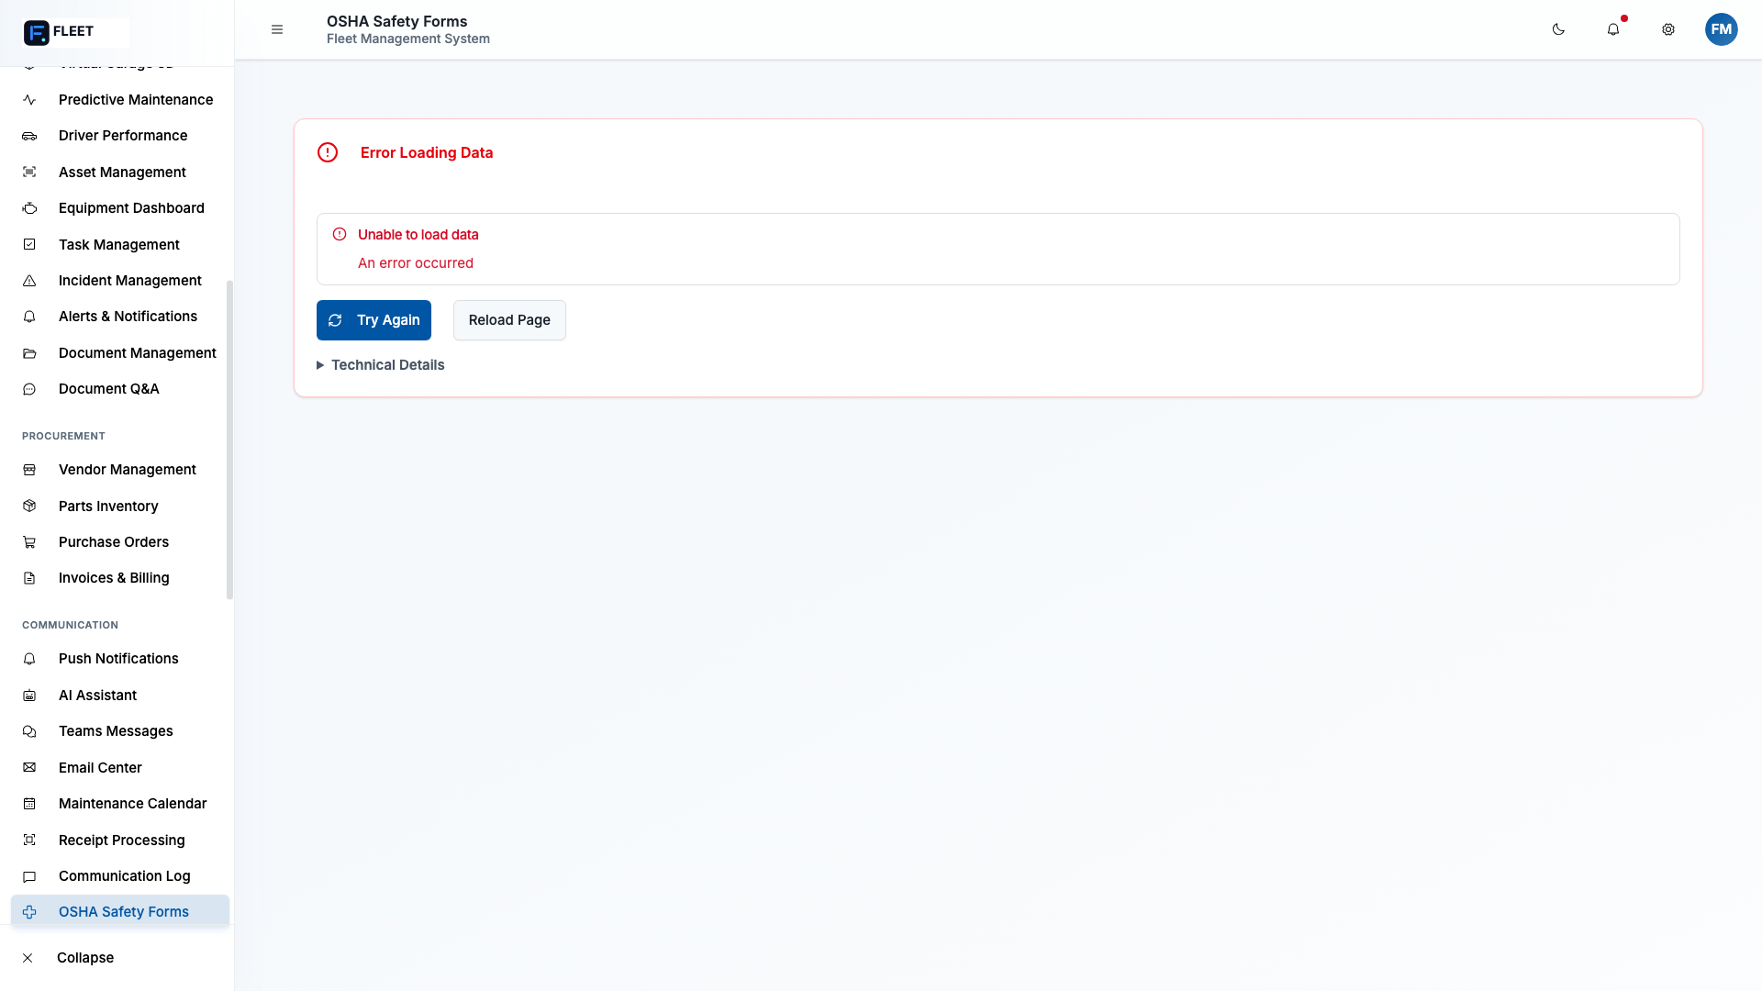
OSHA Safety Forms
Screenshot: policy-engine-chromium-darwin.png
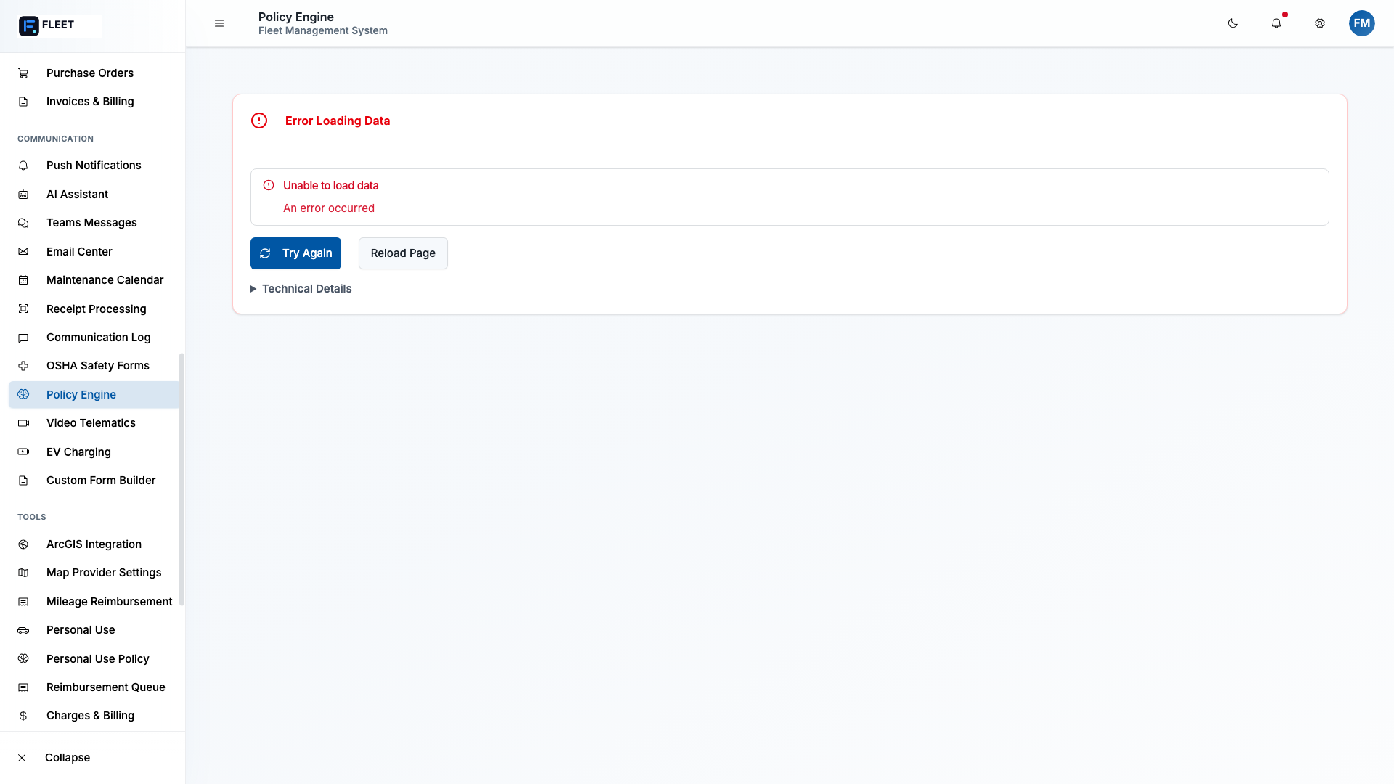
Policy Engine

DOT and OSHA Compliance
- Vehicle inspection tracking
- Hours of Service (HOS) monitoring
- ELD status (100% compliant)
- OSHA safety forms
- CSA ratings

Records, Audit, Reporting
- Complete audit trails
- One-click compliance reports
- Automated record retention
- Inspection-ready documentation
“When an auditor shows up, you can pull any record in seconds. Everything is timestamped and tamper-proof.”

SAFETY (3 minutes)
Screenshot: driver-performance-chromium-darwin.png
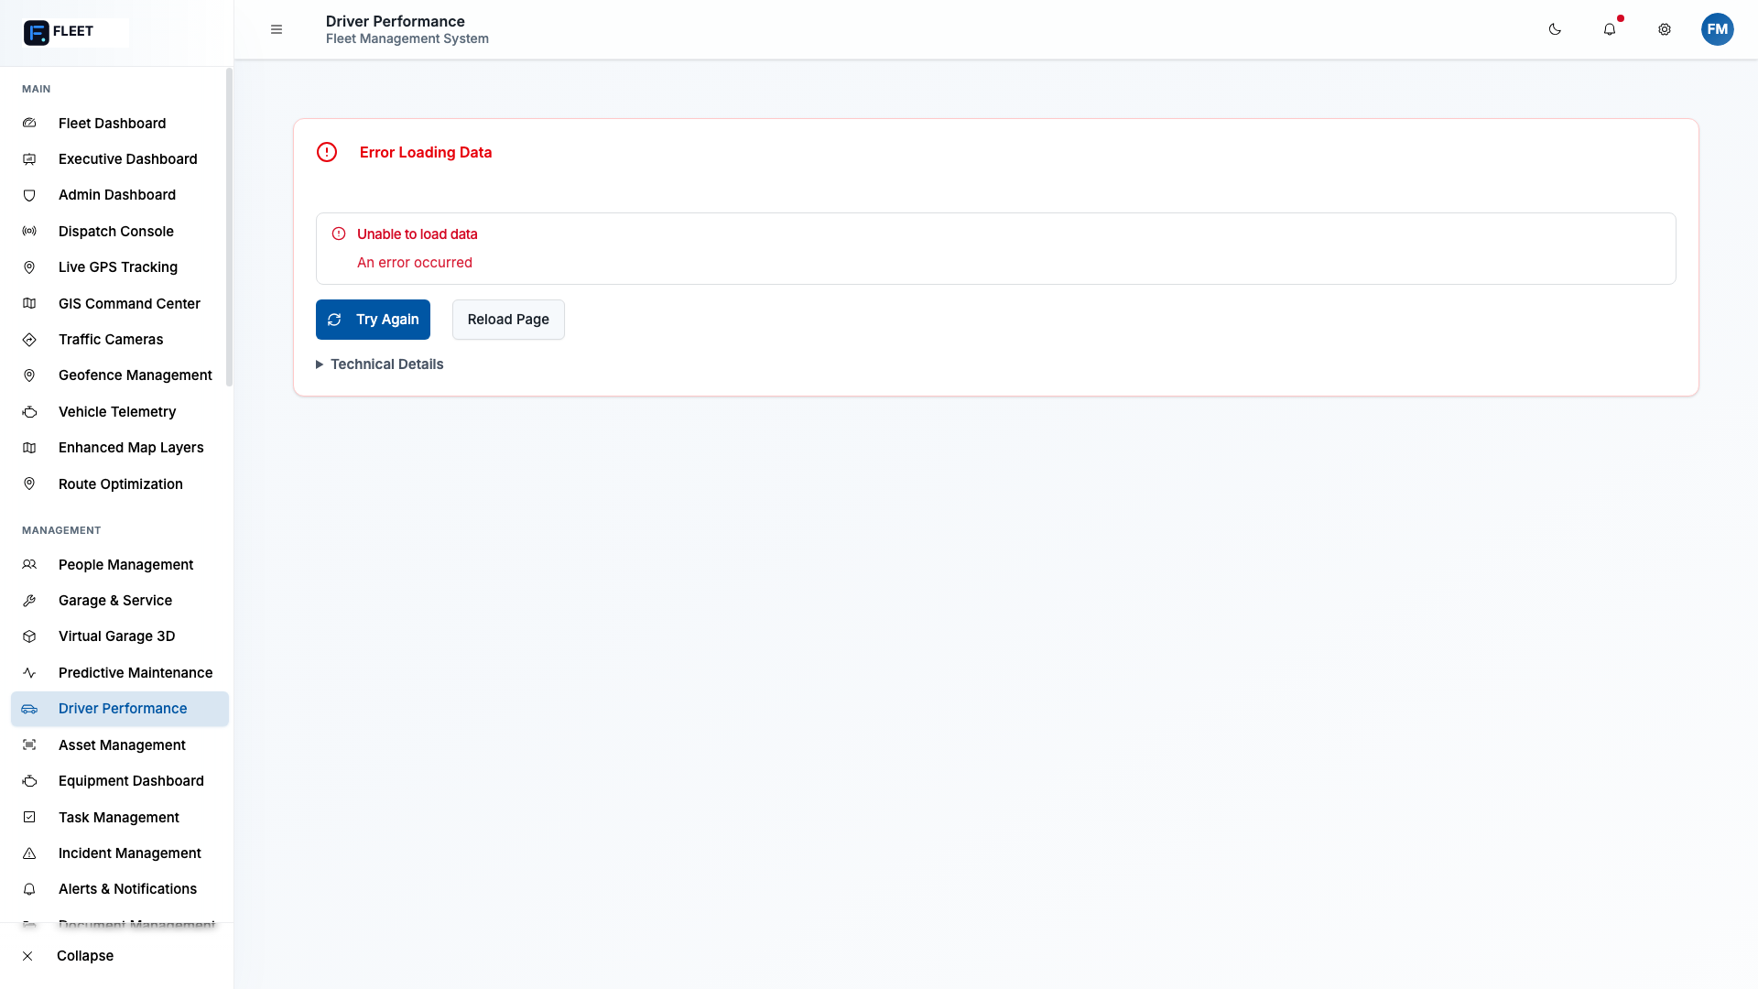
Driver Performance
Screenshot: video-telematics-chromium-darwin.png
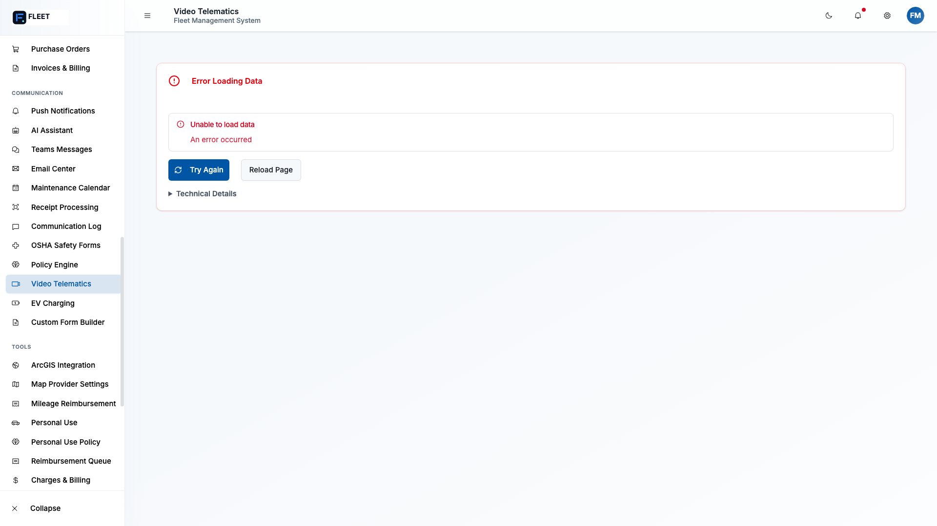
Video Telematics

Incidents
- Accident tracking and documentation
- Flat tires and breakdowns
- Incident resolution workflow
- Days-without-incident tracking

Safety Feature Tracking
- Speeding — Real-time alerts and history
- Seatbelt use — Compliance monitoring
- Harsh driving — Acceleration, braking, cornering
- Distraction detection — Via dash cam (Samsara integration)
“Safety isn’t just about tracking accidents after they happen. We give you the tools to prevent them.”

DRIVERS (2 minutes)
Screenshot: people-management-chromium-darwin.png
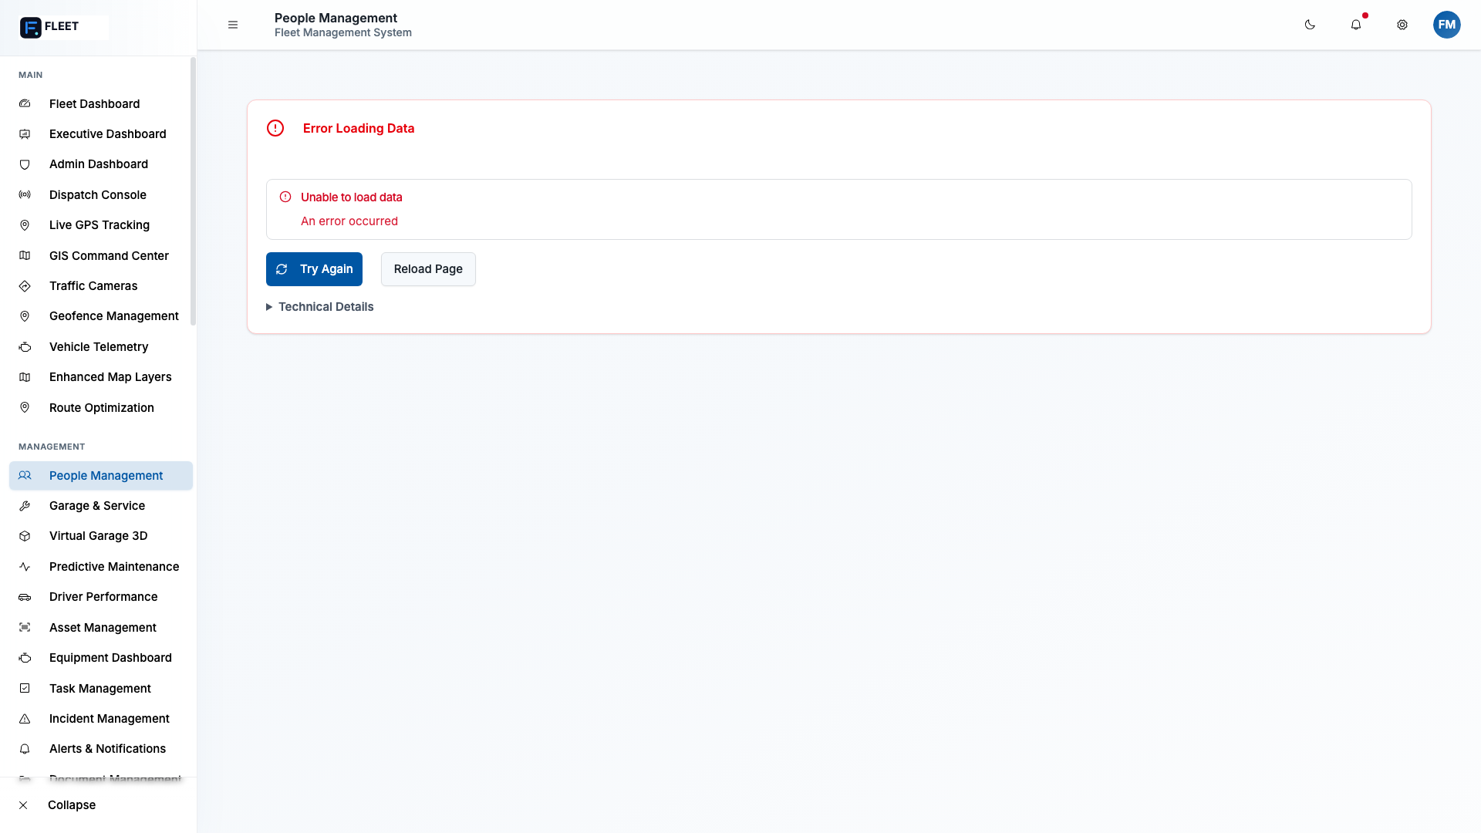
People Management
- Driver roster management
- License and certification tracking
- Expiration alerts
- Performance scoring
- Training completion
- Assignment history
“Know who’s available, who needs training, and who’s performing well.”

PROCUREMENT (3 minutes)
Screenshot: purchase-orders-chromium-darwin.png
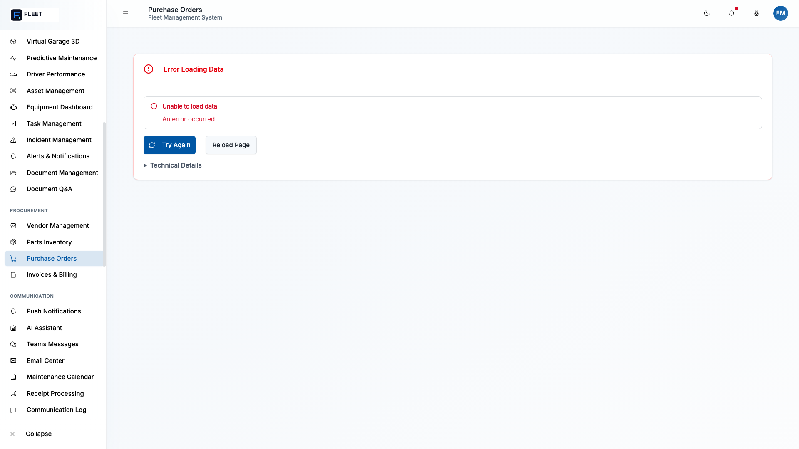
Purchase Orders
Screenshot: invoices-chromium-darwin.png
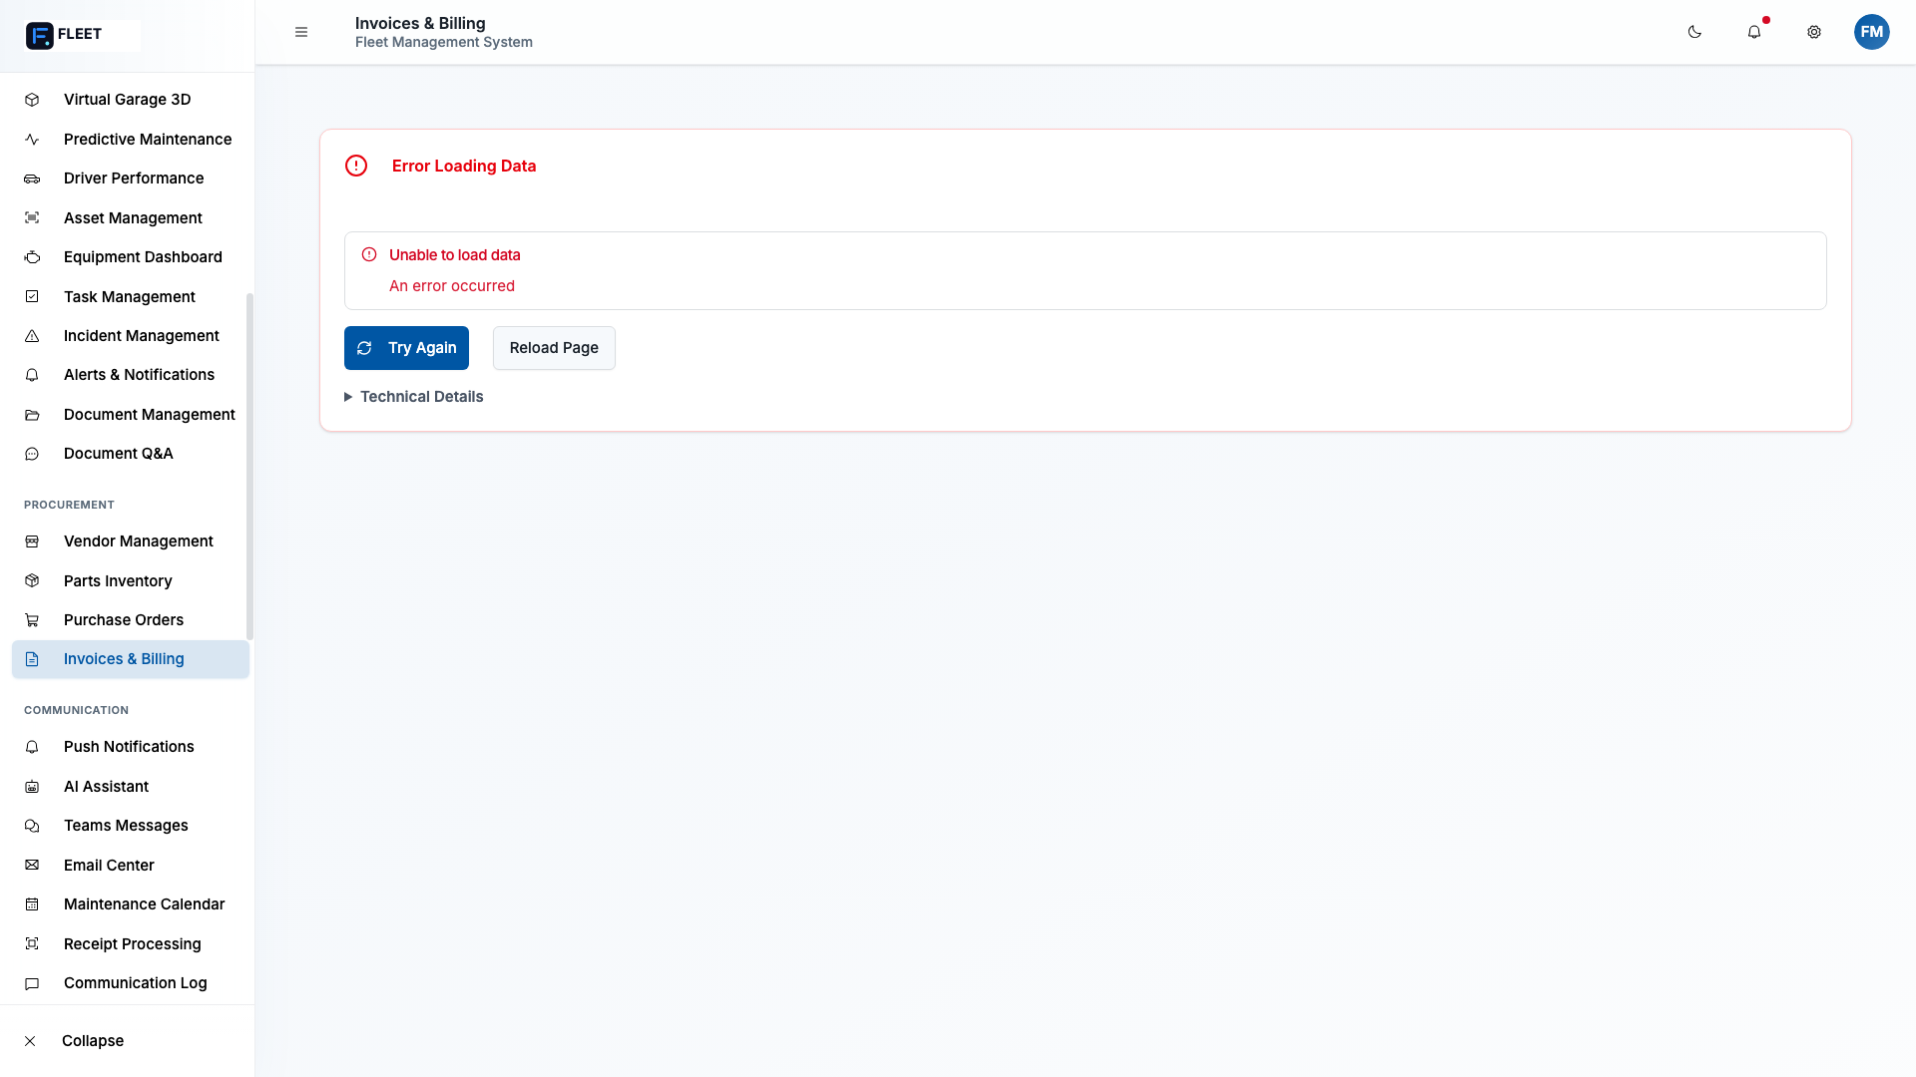
Invoices
Screenshot: vendor-management-chromium-darwin.png
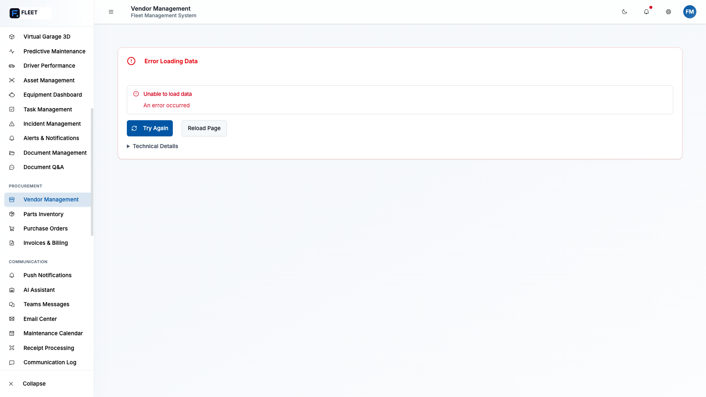
Vendor Management

Purchase Orders
- Full PO lifecycle: Draft → Submitted → Approved → Ordered → Received
- Line item tracking
- Approval workflows
- Vendor assignment

Vendor Management
- Vendor database with ratings
- Insurance verification
- Performance tracking
- Preferred vendor designation

Invoice Tracking
- Link invoices to work orders and POs
- Payment status tracking
- Audit trail
“For your vendors, we track everything — from the initial quote to the final payment. You’ll know exactly who’s performing and who isn’t.”

COMMUNICATIONS HUB (1 minute)
- In-app notifications
- Email integration
- Microsoft Teams integration
- Outlook calendar sync
- Driver messaging
“We integrate with the tools you already use — Teams, Outlook. No need to switch between systems.”

ASSETS (2 minutes)

All Assets (Not Just Vehicles)
- Heavy equipment
- Trailers
- Tools and equipment
- Inventory items
Screenshot: parts-inventory-chromium-darwin.png
- Complete asset lifecycle tracking
- Depreciation calculations
- Utilization rates
- Maintenance history for all assets
“If it has a value and needs maintenance, we track it.”

TECHNICAL OVERVIEW (2 minutes)

Security
- SSL/TLS A+ rating
- Encrypted data at rest and in transit
- Role-based access control
- Audit logging
- SSRF/CSRF protection

Authentication
- Single sign-on (SSO) capable
- Multi-factor authentication
- Azure AD integration
- Session management

Infrastructure
- Azure Cloud hosting
- 99.9% uptime SLA
- Automatic backups
- Disaster recovery

Hardware
- Works with existing Samsara devices
- No hardware replacement needed
- OBD-II integration
- Dash cam support
“Your investment in Samsara is protected. We integrate directly with your existing hardware.”

POLICY HUB (1 minute)
- Upload standard procedures
- Document management
- Policy templates
- Version control
- Acknowledgment tracking
“Build and distribute policies right from the platform. Track who’s read and acknowledged them.”

0:40-1:00 — Q&A AND CLOSING (20 minutes)

Anticipated Questions
“How does this work with our Samsara devices?” > “We integrate directly with Samsara’s API. All your telemetry data — GPS, fuel levels, harsh events, dash cam footage — flows into our platform in real-time. No new hardware needed.”
“What about our existing fuel management app?” > “Our platform replaces it entirely. You’ll have better fuel tracking plus AI-powered optimization that finds savings opportunities.”
“Can we do internal AND vendor maintenance?” > “Absolutely. That’s exactly what we built for. Assign work orders to your technicians or to external vendors. Track labor and invoices either way. See the cost split between internal and outsourced work.”
“How long does implementation take?” > “Typically 6-8 weeks for full deployment. We start with Samsara integration and core features, then add customizations based on your specific needs.”
“What about training?” > “We provide on-site training at your facilities. We’re local, so we’re here when you need us.”

Connected Vehicle Discussion

Sensor-Based (OBD-II / Samsara)
- Sensor has cellular connectivity
- Real-time data transmission
- GPS, fuel, engine diagnostics
- Dash cam integration

Through Driver/Operator Cellular Device
- Limited functionality
- Location tracking
- Basic status updates
- Good for backup/secondary tracking
“Your Samsara devices give us the richest data. For vehicles without sensors, we can use driver mobile apps as a backup.”

Closing & Next Steps
Key Takeaways: 1. One platform for everything — no more fragmented systems 2. Keeps your Samsara investment — native integration 3. Replaces your fuel app — with better features 4. Handles both internal and vendor maintenance 5. Built for government compliance 6. Local Tallahassee support
Ask for Requirements: > “What are the specific pain points you’re facing today?” > “Which features are most important to you?” > “What would make this a success for your team?”
Promise of Proposal: > “Based on what we’ve discussed today, we’ll prepare a detailed proposal tailored to Tallahassee’s specific needs. We can have that to you within [X days].”
Leave Behind: - Business cards - Printed overview (if applicable) - Contact information for follow-up

APPENDIX: SCREENSHOT QUICK REFERENCE
Demo Section | Screenshot File
Fleet Dashboard | fleet-dashboard-chromium-darwin.png
GIS Command Center | gis-command-center-chromium-darwin.png
GPS Tracking | gps-tracking-chromium-darwin.png
Garage & Service | garage---service-chromium-darwin.png
Parts Inventory | parts-inventory-chromium-darwin.png
Executive Dashboard | agent-6-executive-dashboard.png
Fleet Analytics | agent-6-fleet-analytics.png
Cost Analysis | agent-6-cost-analysis.png
OSHA Safety Forms | osha-safety-forms-chromium-darwin.png
Policy Engine | policy-engine-chromium-darwin.png
Driver Performance | driver-performance-chromium-darwin.png
Video Telematics | video-telematics-chromium-darwin.png
People Management | people-management-chromium-darwin.png
Purchase Orders | purchase-orders-chromium-darwin.png
Invoices | invoices-chromium-darwin.png
Vendor Management | vendor-management-chromium-darwin.png
EV Charging | ev-charging-chromium-darwin.png
Tablet View | tablet-view-chromium-darwin.png
Screenshot Locations: - E2E snapshots: tests/e2e/complete-system.spec.ts-snapshots/ - Agent screenshots: tests/screenshots/

PRE-MEETING CHECKLIST
- ☐ Demo environment loaded and tested
- ☐ Laptop charged and display adapter ready
- ☐ Screenshots loaded as backup
- ☐ Business cards available
- ☐ Printed materials (if any)
- ☐ Know attendee names and roles
- ☐ Proposal template ready for customization

Prepared for City of Tallahassee Fleet Management Meeting Capital Technology Alliance, LLC January 2026

