HEY GUYS,

Today let us talk about BIOS

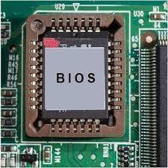

BIOS is a Basic Input/Output System. Basic Input/Output System, also known as the System BIOS, ROM BIOS, BIOS ROM or PC BIOS. When you turn on your computer, BIOS is the first software to run on your computer and responsible for initializing, testing and configuring the hardware components such as the CPU, Chipset, RAM, keyboard, Video Card, and other peripheral devices.

Think of BIOS as your brain and how your brain controls your body, just like that BIOS controls your computer. It wakes up first when you turn on the computer.

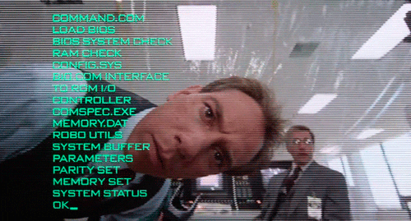

It is a tiny program that’s stored in a chip of your computer’s motherboard. It contains all the basic code for controlling your computer hardware. older computers stored the BIOS in ROM chips, modern computers typically store the BIOS firmware in **flash memory** (type of non-volatile memory), which can be updated and upgraded to fix bugs or add new features.

BIOS loads a **boot loader** from a mass storage device which then initializes a **kernel.**

To change some settings in the BIOS you can access by pressing certain keys (F2, Esc, Delete, etc.) only during the boot process. BIOS provides the basic interface to hardware settings, manage system behaviors (such as boot sequence, system date and time) and power management settings. From the BIOS menu, user can view or modify the BIOS settings, update the firmware and other maintenance tasks.

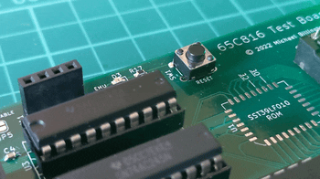

POST is a diagnostic test that computer BIOS performs during the boot process to verify that the hardware components are functioning correctly and detects any error, typically displays error message or beep code to indicate the issue.so that the user can use the information to troubleshoot and resolve the problem. POST is a vital component (not hardware part, **it is a software designed to check the hardware components**) in the boot process as it helps to ensure that the computer is in stable condition and functional state before the Operating System is loaded, Which prevent system crashes, errors and other issues that may arise due to hardware problems.

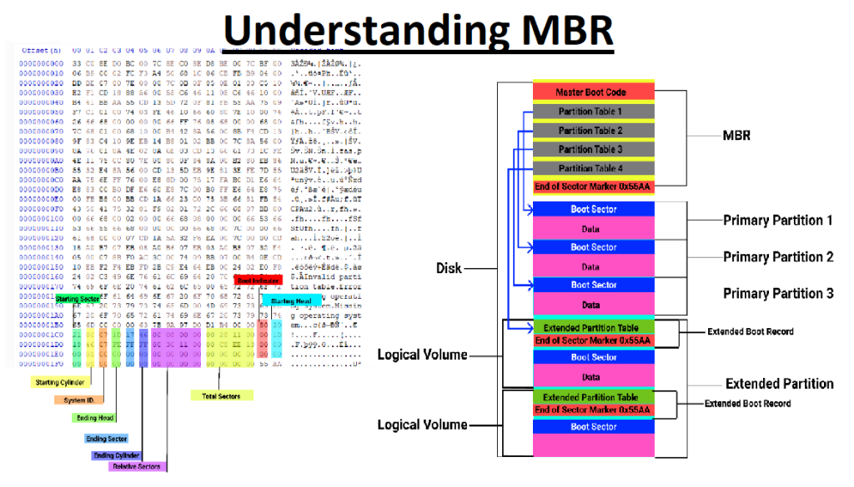

The MBR(Master Boot Record) contains information about the partition layout of the storage device, as well as the boot loader code that is used to load the operating system. When the computer is turned on, the BIOS reads the MBR from the storage device and executes the boot loader code to load the operating system. In older computers, the MBR was used as the primary boot loader mechanism, and the BIOS relied on it to load the operating system. However, in modern computers with UEFI (Unified Extensible Firmware Interface) firmware, the MBR has largely been replaced by the GPT (GUID Partition Table) partitioning scheme, which provides more features and flexibility than the MBR.

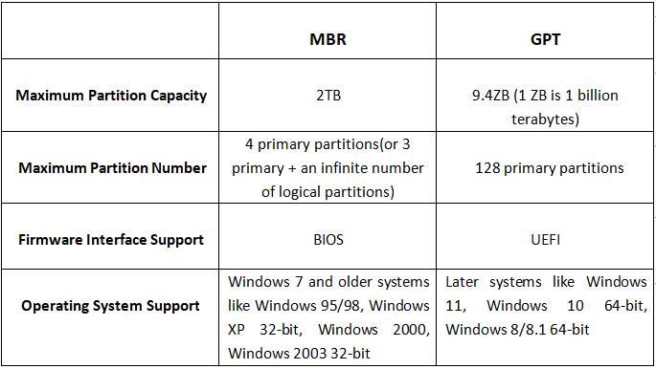

While the traditional BIOS has been replaced by the newer UEFI (Unified Extensible Firmware Interface) firmware in modern computers, the term "BIOS" is still commonly used to refer to the **firmware** that performs the same basic functions as the original BIOS.