**Washington State University**

**EE 362 Power Systems Laboratory**

**Final Lab**

**Synchronous Motor**

***Proposed design***

Alexis Mekueko

**Team members:** **Chase eels, Drew Peters**

**Group 7**

**Date: April. 28, 2016**

# I. Objective

In this laboratory exercise we will investigate and analyze the performance of a synchronous motor.

1. Understand how synchronous motor works.
2. Learn how to draw the wiring diagrams and how to connect synchronous motor.
3. Performance under load-from minimum torque to 0.5 Nm.
4. Acquire data to plot Output Vs. Torque, Input Power Vs. Torque and Efficiency Vs. Torque.
5. Power Factor control, to produce the V-Curves of the synchronous motor for three different values of load (torque) for minimum torque 0.2 Nm and 0.3Nm.
6. Write a Matlab function to calculate the performance of the machine based on the circuit model.

# II. Instruments and components

In addition to the standard laboratory data acquisition system that you have been using so far, in this laboratory exercise you will also be using the following instruments and components:

300 W, 60 Hz, 2 poles, 208 V (Y-connected) or 120 V (Δ-connected), round rotor synchronous machine (64-501-120); rotor supply 150 V DC nominal.

250 W, 0-5000 rpm, Swinging Field Dynamometer (67-502) in conjunction with the Torque/Speed controller (68-441). Synchronizing Lamps (68-120-120).

# III. Procedure and Measurements

## **Synchronization**

The synchronous motor must be synchronized with the three-phase power supply in other to perform all the test. The synchronization takes place when the rotor mechanical speed is locked with the electrical frequency of the stator (meaning both field are aligned) or in other way, the machine must be synchronized to the power source. To accomplish the synchronization, we will take the following steps:

Pair up the dynamometer and the synchronous generator as shown Appendix A

After pairing up the two machines, connect the synchronous generator with the lab panel instrument for the following measurements: VAB, VCB, IA, IC, IF, torque, three-phase power factor and three-phase real power (Appendix B). Activate the software package for these measurements and make sure the synchronizing lamps are off.

From the wiring diagram: three-phase winding (U, V, W) of the stator supplied by the three-phase constant power supply and the rotor is supplied with DC, We want to bring the motor on line to operate at the rated voltage and rated speed (3600rpm).

Measured the three-phase constant supply voltage with a digital multimeter.

Switch the dynamometer on speed mode and slowly increase the speed of the dynamometer.

When the synchronous motor reaches 95% of the 3600rpm, switch the DC power on and slowly increase the field current to get the voltage of the synchronous motor to match up the supplied voltage (compare to the DMM measurement). Observe the synchronizing lamp pattern appear to rotate (LP1 LP2 LP3). Adjust the speed so that lamp LP1 and LP2 are almost equal brightness and LP3 is out. Turn on the switch on the lamp panel. Slowly reduce the speed control on the virtual instrumentation panel. At this point, the synchronization is completed. **Increase the field current to 300mA or higher to guarantee a higher value of pullout torque and switch the dynamometer to torque mode.**

## **Performance measurements**

Make sure all the meters are properly connected and the dynamometer is switched to torque mode.

Increase torque of the dynamometer (increasing load on the motor to get shaft power output) on the synchronous motor in step of 0.1 N.m till 0.5 N.m.

For each step, collect data from all the measurement for the following plots:

* Output power Vs. Torque
* Input power Vs. Torque
* Efficiency Vs. Torque

## **Power Factor Control**

Reduce the torque of the dynamometer to 0.1 N.m and slowly increase the field current (DC voltage).

For each step of 0.1 A (IF), collect the data of the measurements till 110% of the rated current (1.0 A) of the stator winding. Repeat this procedure for 0.2 N.m and 0.3 N.m.

Plot the V-curves (IF Vs. IA) of the synchronous motor.

## **Appendix A**

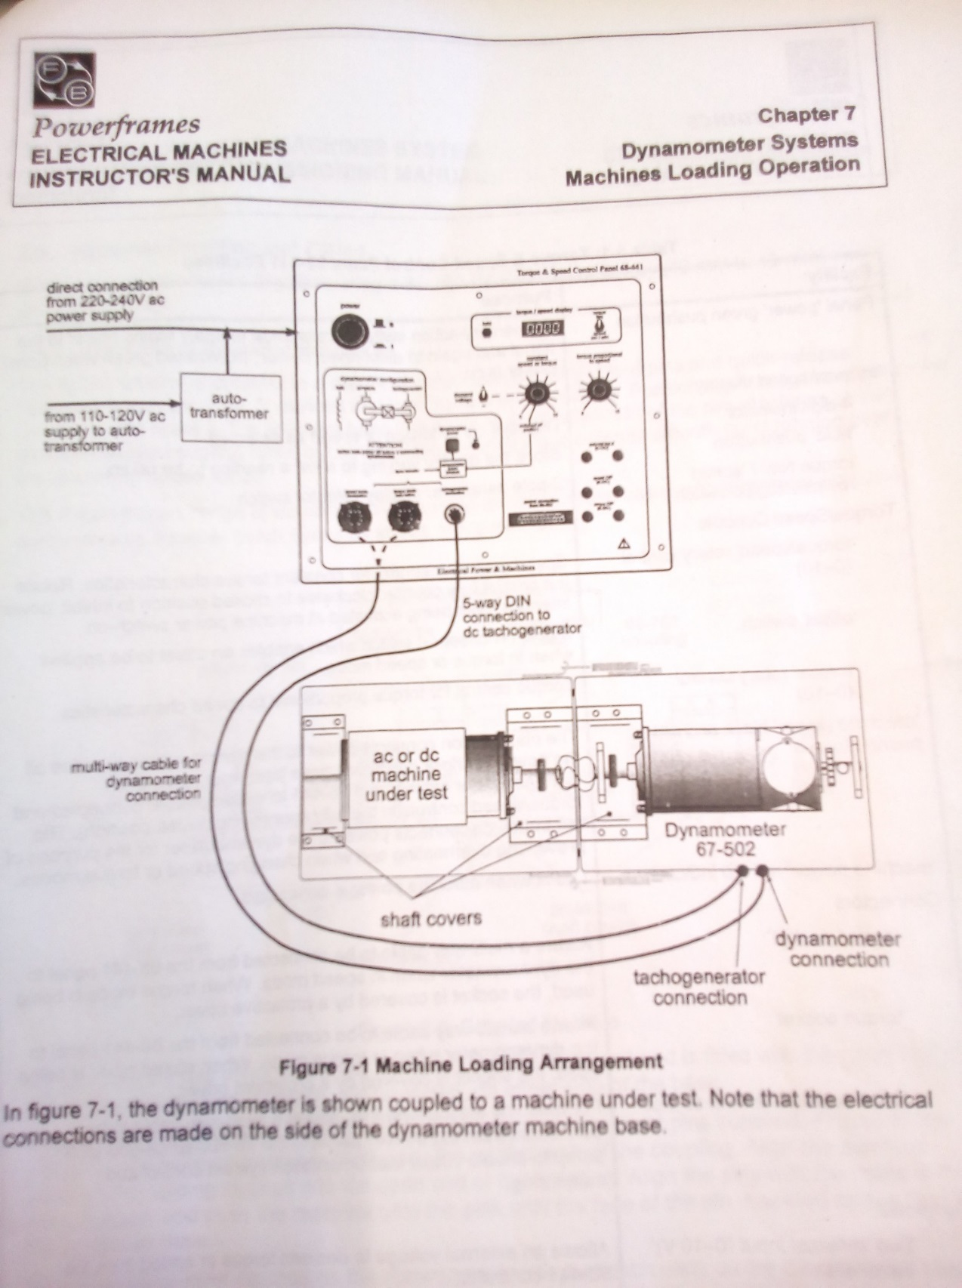

## **Appendix B**

