NexHire AI – Smart Employee Recruitment & AI Hiring System
Use Cases & Use Case Model (FYP-I and FYP-II)
Project Team: Aarian Kumar (2312101), Shivani (2312133)
Project Supervisor: Sir Asim Riaz
Bachelor of Science in Computer Science
SZABIST University, Karachi Campus

1. Actors
NexHire AI has four human actors and four system actors. HR Admin and Candidate drive almost every use case, while the AI Engine supports them in the background.
Actor | Type | Role in the system | Appears in
HR Admin | Primary (human) | Posts vacancies, builds application forms, reviews AI rankings, schedules interviews, records feedback, issues offers, views analytics | FYP-I, FYP-II
Candidate | Primary (human) | Registers, manages profile, browses vacancies, fills position-specific forms, tracks status, uses chatbot | FYP-I, FYP-II
Interviewer / Panel Member | Primary (human) | Views assigned interviews, uses AI questions, submits structured feedback | FYP-II
Employee (Referrer) | Primary (human) | Refers candidates and tracks referral outcome | FYP-II
AI Engine (n8n / LangGraph + Gemini) | Secondary (system) | Scores and ranks applications, detects duplicates, tags matches, generates questions, drafts offer letters, analyses feedback, answers FAQs | FYP-I, FYP-II
Email Service | Secondary (system) | Sends submission, shortlist, interview and offer emails | FYP-I, FYP-II
Google Calendar API | Secondary (system) | Two-way sync of interview slots | FYP-II
Job Board (LinkedIn / Indeed – mocked) | Secondary (system) | Returns a simulated posting response | FYP-II

Use case IDs follow the pattern UC-1.x for FYP-I and UC-2.x for FYP-II, grouped under the feature numbers used in Section 11 of the proposal.

2. FYP-I Use Cases
FYP-I's 7 features break down into 32 use cases, covering authentication, vacancies, the candidate portal and the mandatory AI screening pipeline.

F1 – Project Setup & Authentication
ID | Use Case | Actor(s) | Description | Relation
UC-1.1 | Register Account | Candidate | Candidate signs up with name, email and password; password stored hashed | –
UC-1.2 | Login | HR Admin, Candidate | User logs in; system issues a JWT and routes to HR panel or candidate portal by role | –
UC-1.3 | Logout | HR Admin, Candidate | User ends the session and the token is invalidated on the client | –
UC-1.4 | Reset Password | HR Admin, Candidate | User requests a reset link by email and sets a new password | extends UC-1.2
UC-1.5 | Manage HR Accounts | HR Admin | HR Admin creates, deactivates or updates other HR user accounts | –

F2 – Job Vacancy Module
ID | Use Case | Actor(s) | Description | Relation
UC-1.6 | Create Vacancy | HR Admin | HR enters title, description, department and location for a new vacancy | includes UC-1.7, UC-1.8
UC-1.7 | Define Structured Requirements | HR Admin | HR adds required skills, experience, qualifications and certifications with mandatory flags and weightage | –
UC-1.8 | Build Application Form | HR Admin | Generic form mechanism generates the position-specific form from the requirements; HR can adjust fields | –
UC-1.9 | Edit Vacancy | HR Admin | HR updates vacancy details or requirements while it is open | –
UC-1.10 | Close Vacancy | HR Admin | HR closes the vacancy so no new applications are accepted | –
UC-1.11 | View / Search Vacancies (HR) | HR Admin | HR lists all vacancies with status (open, closed) and filters by department | –

F3 – Candidate Portal
ID | Use Case | Actor(s) | Description | Relation
UC-1.12 | Manage Profile | Candidate | Candidate edits personal and contact details | –
UC-1.13 | Browse / Search Vacancies | Candidate | Candidate views open vacancies and searches by title or department | –
UC-1.14 | View Vacancy Details | Candidate | Candidate reads requirements and description of one vacancy | extends UC-1.13
UC-1.15 | Fill & Submit Application Form | Candidate | Candidate fills the position-specific structured form (no CV upload) and submits it | includes UC-1.17, UC-1.22, UC-1.28
UC-1.16 | Add Portfolio / Context Link | Candidate | Optional free-text or portfolio link for HR context; not used in scoring | extends UC-1.15
UC-1.17 | Send Submission Confirmation | Email Service | System emails the candidate that the application was received | –
UC-1.18 | View My Applications | Candidate | Candidate sees the list of vacancies they have applied to | –

F4 – Application Inbox
ID | Use Case | Actor(s) | Description | Relation
UC-1.19 | View Application Inbox | HR Admin | HR sees a single queue of applications for each vacancy | –
UC-1.20 | Filter / Search Applications | HR Admin | HR filters by vacancy, date, score or match tag; results paginated | extends UC-1.19
UC-1.21 | View Application Details | HR Admin | HR opens one submitted form with its answers and portfolio link | extends UC-1.19

F5 – AI Application Form Evaluation & Ranking
ID | Use Case | Actor(s) | Description | Relation
UC-1.22 | Evaluate Application | AI Engine | Triggered on submission; evaluates the form against the vacancy's required fields | includes UC-1.23, UC-1.24
UC-1.23 | Match Skills Semantically | AI Engine | Recognises equivalent skills (e.g. "JS" = "JavaScript") | –
UC-1.24 | Calculate Requirement Fulfilment % | AI Engine | Applies mandatory flags and weightage to produce a percentage score; score is logged | –
UC-1.25 | Rank Candidates | AI Engine | Orders all applicants of a vacancy by score | –
UC-1.26 | View Ranked Candidate List | HR Admin | HR views candidates in ranked order per vacancy | includes UC-1.25
UC-1.27 | View Score Breakdown | HR Admin | HR sees which requirements were met or missed and how each was weighted | extends UC-1.26

F6 – AI Duplicate Candidate Detection
ID | Use Case | Actor(s) | Description | Relation
UC-1.28 | Detect Duplicate Applicant | AI Engine | Compares a new submission with existing ones (email, phone, similar answers) and flags likely duplicates | –
UC-1.29 | Review Flagged Duplicates | HR Admin | HR confirms a duplicate (merge / discard) or dismisses the flag | –

F7 – Candidate Match Tagging
ID | Use Case | Actor(s) | Description | Relation
UC-1.30 | Tag Candidate Match | AI Engine | Tags each ranked candidate as Strong Match, Possible Match or Not a Fit | extends UC-1.22
UC-1.31 | Filter by Match Tag | HR Admin | HR views only candidates of a chosen tag | extends UC-1.26
UC-1.32 | Manually Review Possible Match | HR Admin | HR reviews borderline candidates, including portfolio link, and decides to keep or drop | –

3. FYP-I Use Case Diagram
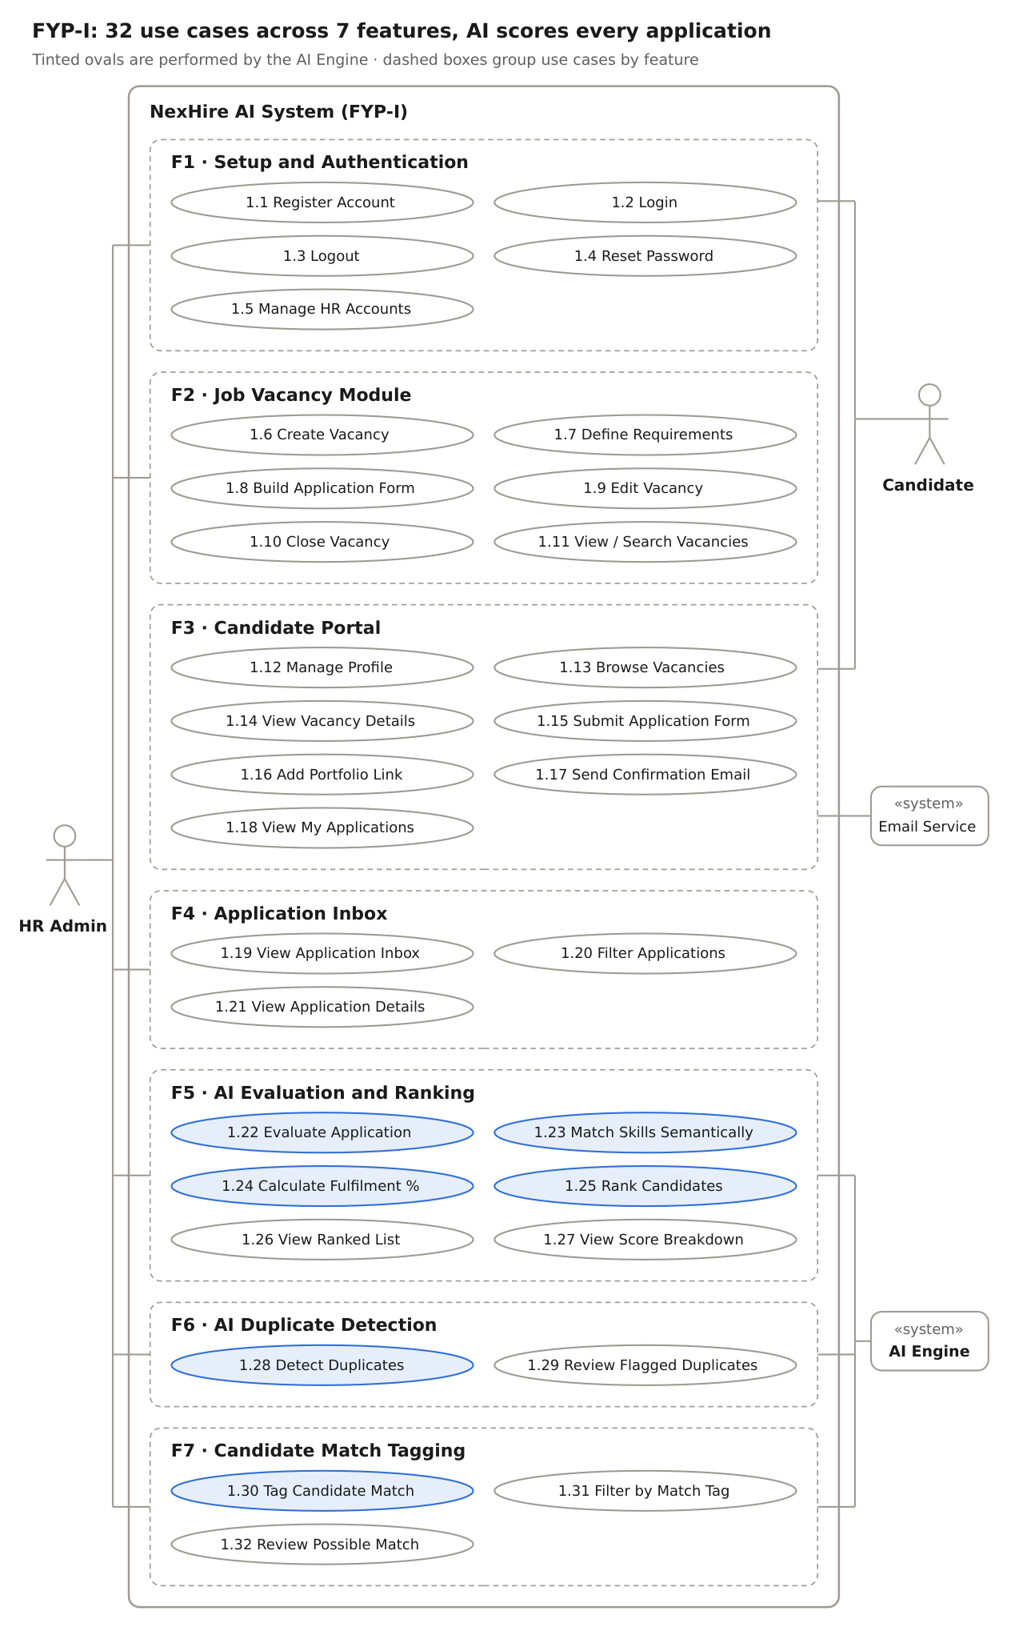
Figure 1: FYP-I use case model – 4 actors, 7 features, 32 use cases
HR Admin touches six of the seven features; Candidate works only through authentication and the portal, and every submission flows to the AI Engine for scoring. Tinted ovals are performed by the AI Engine. Include/extend relations are listed in the Relation column of the tables.

4. FYP-II Use Cases
FYP-II's 13 functional features break down into 39 use cases. Feature 14 (Testing, Deployment & Documentation) is project work with no actor goal, so it has no use case.

F1 – Interview Scheduling
ID | Use Case | Actor(s) | Description | Relation
UC-2.1 | Create Interview Slots | HR Admin | HR defines available date/time slots and venue for a vacancy | –
UC-2.2 | Schedule Interview | HR Admin | HR books a slot for a shortlisted candidate | includes UC-2.3, UC-2.4
UC-2.3 | Assign Interviewer / Panel | HR Admin | HR assigns one or more interviewers to the interview | –
UC-2.4 | Send Interview Notification | Email Service | Candidate receives date, time and venue by email | –
UC-2.5 | Reschedule / Cancel Interview | HR Admin | HR changes or cancels a booked interview; candidate is re-notified | extends UC-2.2

F2 – Interview Management
ID | Use Case | Actor(s) | Description | Relation
UC-2.6 | Track Physical Interview | HR Admin | HR marks the interview as conducted, no-show or postponed | –
UC-2.7 | Record Private Feedback | HR Admin, Interviewer | Free-text feedback saved against the application; never visible to the candidate | includes UC-2.8
UC-2.8 | Analyse Interview Feedback | AI Engine | AI summarises the feedback into strengths, concerns and decision-support insights | –
UC-2.9 | View AI Decision Insights | HR Admin | HR reads AI insights; final hiring decision stays with HR | –

F3 – Structured Interview Feedback
ID | Use Case | Actor(s) | Description | Relation
UC-2.10 | Submit Structured Feedback | Interviewer | Interviewer rates fixed criteria (e.g. technical, communication) for each interview round | –
UC-2.11 | View Feedback by Round | HR Admin | HR compares feedback across all rounds for one candidate | –

F4 – Shortlist / Reject Pipeline
ID | Use Case | Actor(s) | Description | Relation
UC-2.12 | Shortlist Candidate | HR Admin | One action moves the candidate to Shortlisted | includes UC-2.15
UC-2.13 | Reject Candidate | HR Admin | One action moves the candidate to Rejected | includes UC-2.15
UC-2.14 | Move Candidate Between Stages | HR Admin | HR moves a candidate across stages (Applied → Screened → Interview → Offer → Hired) | –
UC-2.15 | Send Status Update Email | Email Service | Candidate is emailed when shortlisted or rejected | –

F5 – AI Generated Interview Questions & Score Prediction
ID | Use Case | Actor(s) | Description | Relation
UC-2.16 | Generate Interview Questions | HR Admin, AI Engine | AI (Gemini) generates role-specific questions from the vacancy's requirements | –
UC-2.17 | Review / Edit Questions | HR Admin | HR edits, removes or approves generated questions | extends UC-2.16
UC-2.18 | View Interview Questions | Interviewer | Interviewer sees approved questions for the assigned interview | –
UC-2.19 | View Candidate Score Prediction | HR Admin, AI Engine | Widget predicts a candidate's likely score from mandatory flags and weightage | –

F6 – AI Drafted Offer Letters
ID | Use Case | Actor(s) | Description | Relation
UC-2.20 | Set Offer Guidelines | HR Admin | HR enters salary band, start date and role terms for the selected candidate | –
UC-2.21 | Draft Offer Letter | AI Engine | AI drafts the complete offer letter linked to the correct application | –
UC-2.22 | Review & Approve Offer Letter | HR Admin | HR edits and approves the draft before it goes out | includes UC-2.23
UC-2.23 | Send Offer Letter | Email Service | Approved offer is emailed to the candidate | –
UC-2.24 | View Offer Letter | Candidate | Candidate views the offer on their dashboard | –

F7 – Hiring Dashboard
ID | Use Case | Actor(s) | Description | Relation
UC-2.25 | View Pipeline Counts by Stage | HR Admin | Number of candidates in each stage, per vacancy | –
UC-2.26 | View Vacancy Status | HR Admin | Open, closed and filled vacancies at a glance | –
UC-2.27 | View Department-wise Analytics | HR Admin | Hiring numbers broken down by department | –
UC-2.28 | Export Hiring Report | HR Admin | Download the monthly hiring report | extends UC-2.25

F8 – AI Chatbot for Candidates
ID | Use Case | Actor(s) | Description | Relation
UC-2.29 | Ask FAQ Chatbot | Candidate, AI Engine | Candidate asks recruitment or company questions and gets AI answers | –
UC-2.30 | Manage FAQ Knowledge Base | HR Admin | HR adds or edits the FAQs and company info the chatbot answers from | –

F9 – Candidate Dashboard
ID | Use Case | Actor(s) | Description | Relation
UC-2.31 | View Application Status | Candidate | Candidate sees the current stage of each application | –
UC-2.32 | View Interview Schedule | Candidate | Candidate sees upcoming interview date, time and venue | –

F10 – Job Board Syndication (simulated)
ID | Use Case | Actor(s) | Description | Relation
UC-2.33 | Post Vacancy to Job Board | HR Admin, Job Board (mock) | HR clicks "Post to LinkedIn/Indeed"; module returns a mocked success response | –

F11 – Calendar Sync
ID | Use Case | Actor(s) | Description | Relation
UC-2.34 | Sync Interview with Google Calendar | HR Admin, Google Calendar API | Scheduled interviews are pushed to and updated from Google Calendar (two-way) | extends UC-2.2

F12 – Referral Tracking
ID | Use Case | Actor(s) | Description | Relation
UC-2.35 | Refer Candidate | Employee | Employee submits a referral for a vacancy | –
UC-2.36 | Track Referral Status | Employee | Employee sees the stage reached by their referred candidate | –
UC-2.37 | View Referral Outcomes | HR Admin | HR sees all referrals and how many led to hires | –

F13 – Bias / Fairness Audit Dashboard
ID | Use Case | Actor(s) | Description | Relation
UC-2.38 | View Fairness Audit Dashboard | HR Admin | Shows whether AI scoring filters out particular applicant groups disproportionately | –
UC-2.39 | Review AI Score Audit Log | HR Admin | HR inspects logged scores and the requirements behind them | extends UC-2.38

Open question: the Employee (Referrer) actor needs a login role that the proposal's two roles (HR Admin, Candidate) do not yet cover.

5. FYP-II Use Case Diagrams
FYP-II has 8 actors, so its model is drawn in two parts: part A follows a candidate from interview to offer (F1–F6), part B covers dashboards, candidate tools and the extra features (F7–F13). A small hop marks where two association lines cross without connecting.
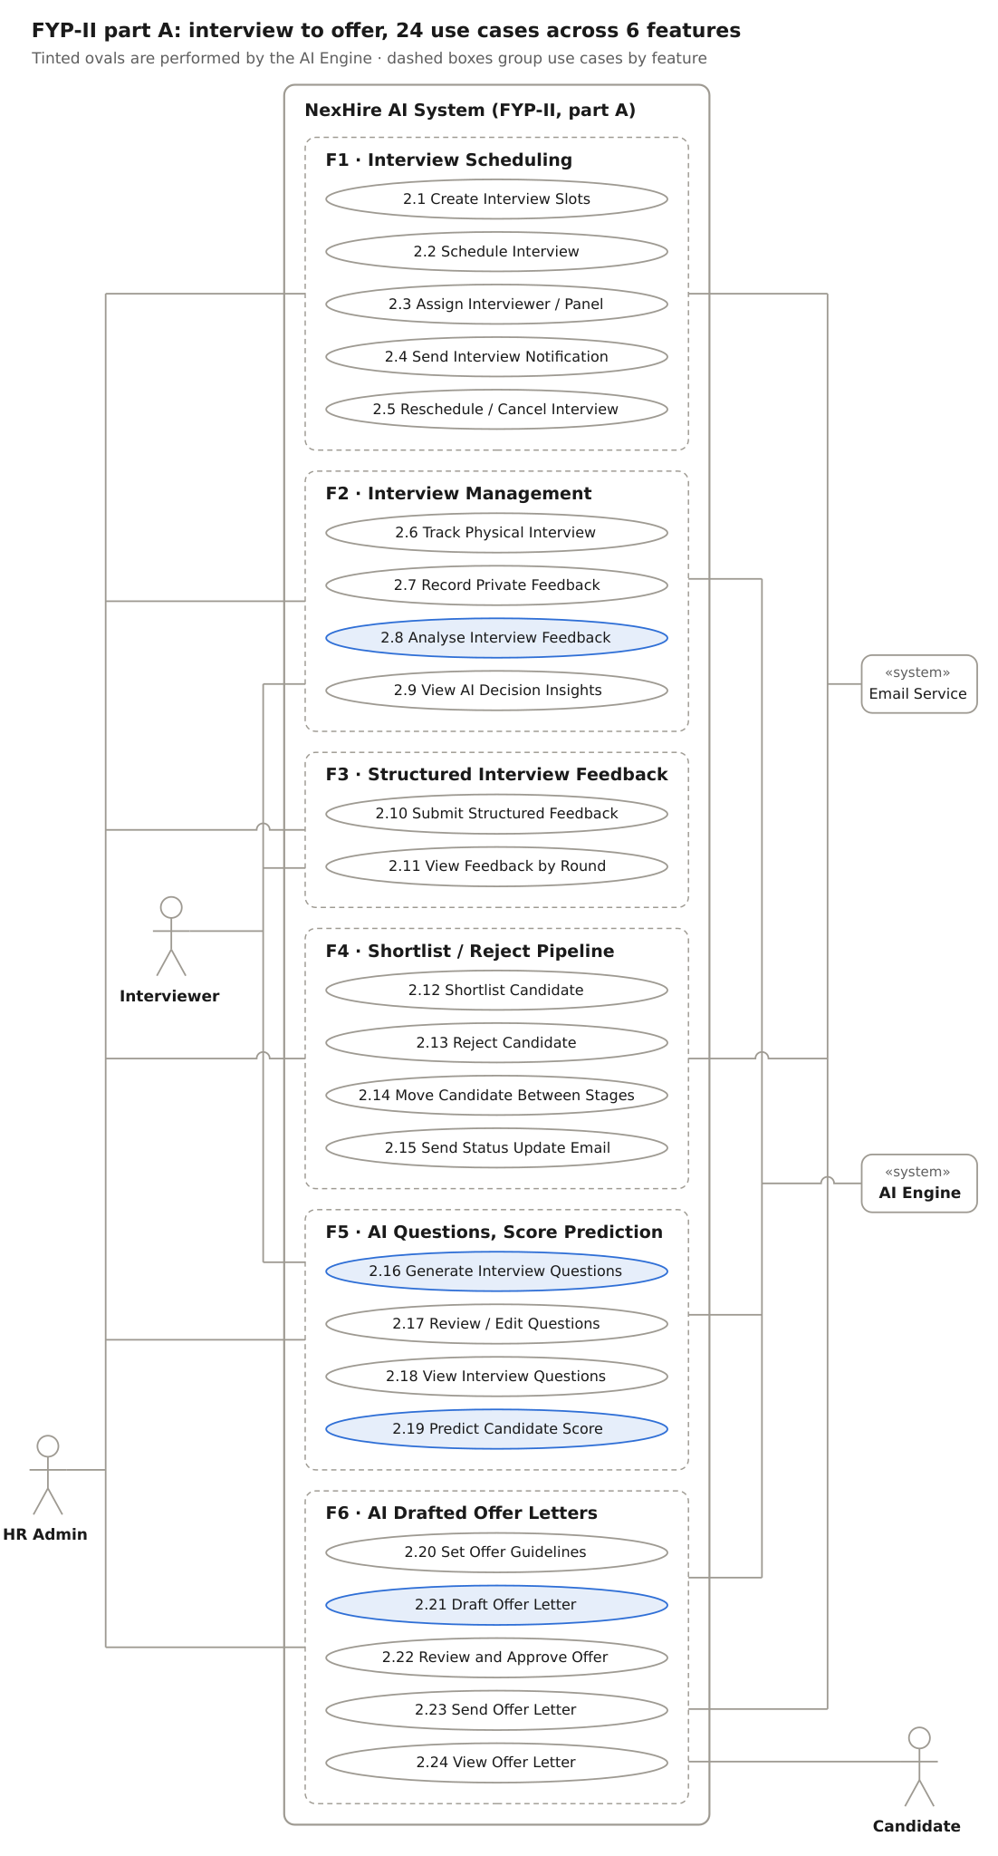
Figure 2: FYP-II use case model, part A – F1 to F6, 5 actors, 24 use cases

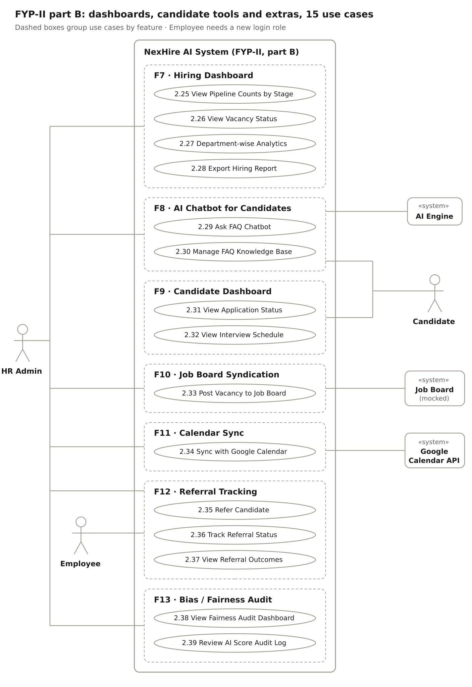
Figure 3: FYP-II use case model, part B – F7 to F13, 6 actors, 15 use cases

6. Detailed Use Cases – FYP-I Features
Each feature below is written in the same format as the Sign Up use case: a description, the feature's own use case model, the stimulus/response sequences (main flow as User Action / System Response steps, alternate flows, exception flows and post-conditions) and the functional requirements derived from it. Requirement IDs follow FR-<FYP>.<Feature>-<No.>, e.g. FR-1.2-03 is the third requirement of FYP-I Feature 2.

6.1 F1 – Project Setup & Authentication

Description:
The authentication feature lets candidates create an account and lets HR Admins and candidates log in securely. On login the system issues a JWT and routes the user to the HR panel or the candidate portal according to their role. It also covers logout, password reset by email, and HR Admin management of other HR accounts.
Use cases covered: UC-1.1 to UC-1.5

Use Case Model:
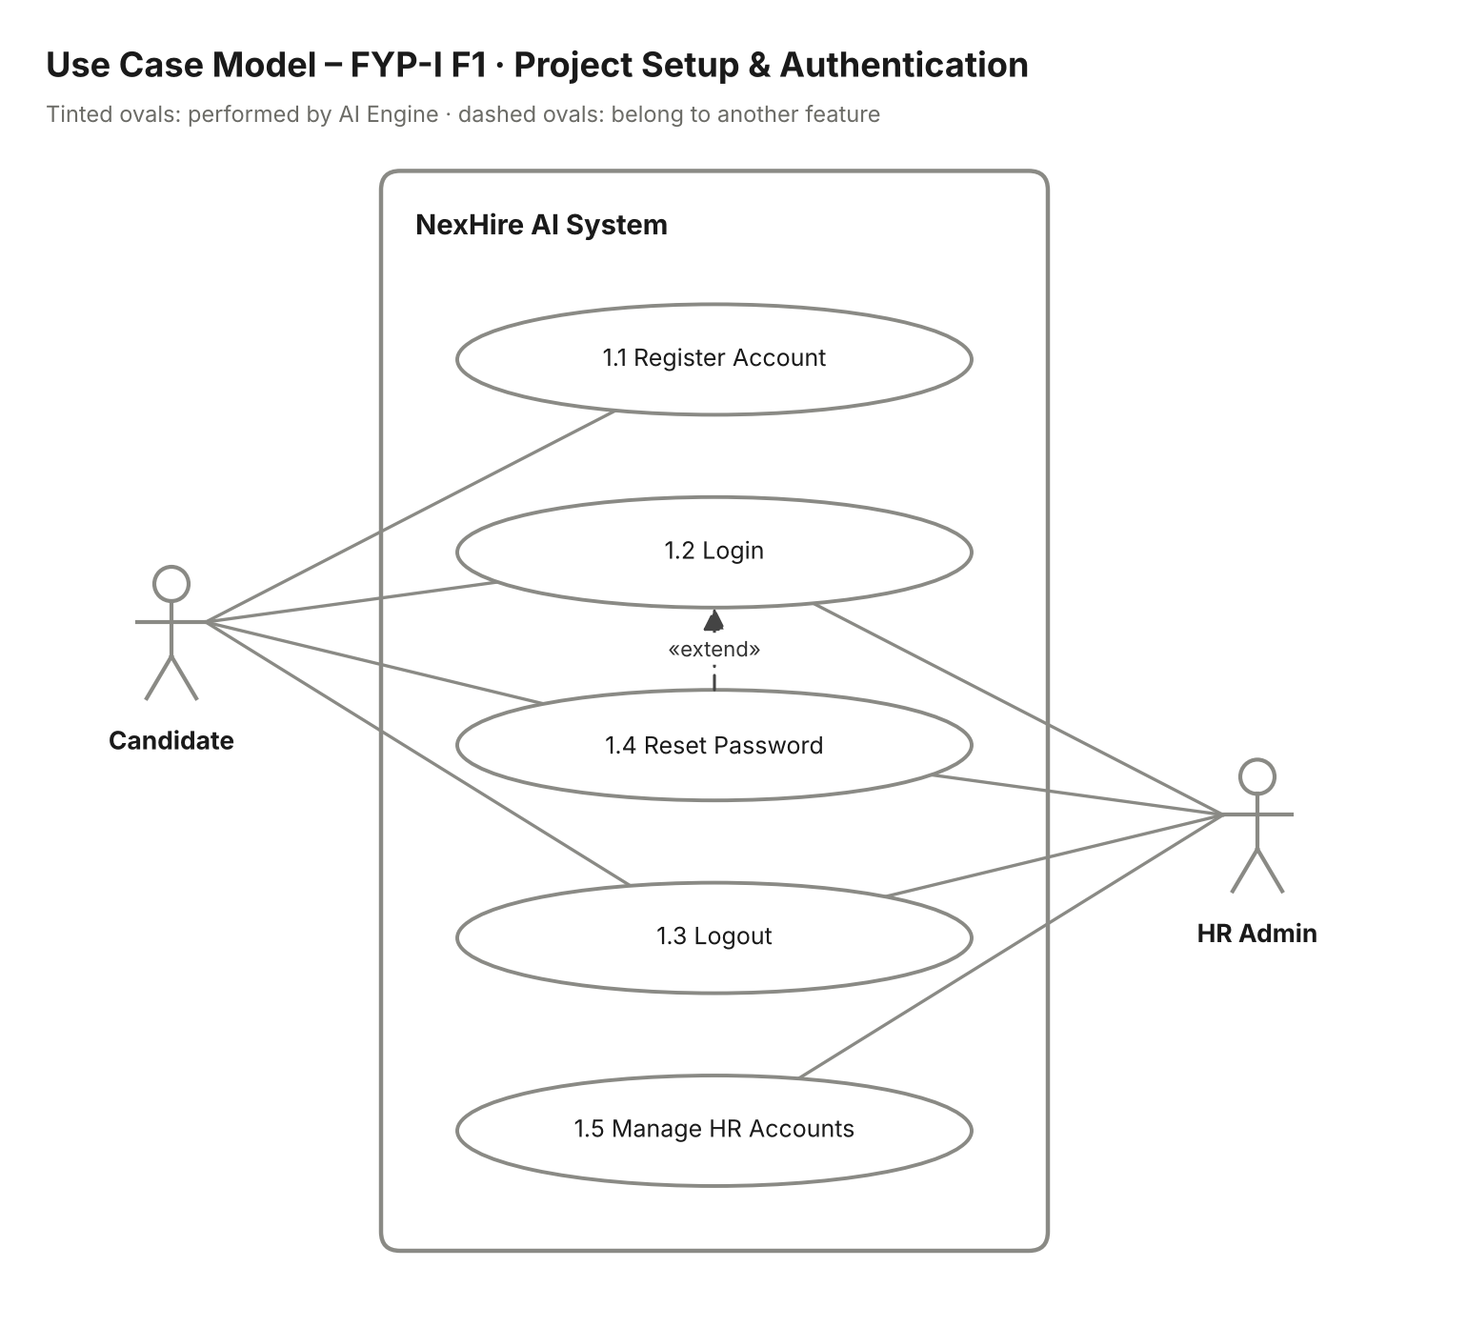
Figure 4: FYP-I F1 Project Setup & Authentication – use case model

Stimulus/Response Sequences:
Use Case Name: Register, Login & Manage Access
Description: A candidate registers for an account; any user logs in, logs out or resets a forgotten password; an HR Admin manages HR user accounts.
Actors: Candidate, HR Admin.
Goal: Give every user secure, role-based access to NexHire AI.
Pre-Conditions: For registration the candidate must not already have an account and must have a valid email address. For login the user must have an active account.
Basic Course of Events / Main Flow
1. User Action (Step 1):
The candidate opens NexHire AI and clicks the "Sign Up" button (UC-1.1).
System Response:
The system shows a registration form with fields for full name, email, password and confirm password.
2. User Action (Step 2):
The candidate fills in the form and clicks "Register".
System Response:
The system validates the input:
- Checks for a valid email format.
- Verifies password strength (minimum 8 characters, includes letters and numbers).
- Checks that the email is not already registered.
- Stores the account with the password hashed (bcrypt) and shows "Account created, please log in".
3. User Action (Step 3):
The user (Candidate or HR Admin) enters email and password on the login page and clicks "Login" (UC-1.2).
System Response:
The system verifies the credentials, issues a JWT and redirects the user by role:
- HR Admin is taken to the HR panel.
- Candidate is taken to the candidate portal.
4. User Action (Step 4):
An HR Admin opens "Manage HR Accounts" and creates, updates or deactivates an HR user (UC-1.5).
System Response:
The system saves the change; a deactivated HR user can no longer log in.
5. User Action (Step 5):
The user clicks "Logout" (UC-1.3).
System Response:
The system removes the token from the client, ends the session and returns the user to the login page.
Alternate Flows
Alternate Flow (Forgot Password – UC-1.4, extends Login)
User Action:
The user clicks "Forgot Password" on the login page and enters the registered email.
System Response:
The system emails a time-limited reset link. When the user opens the link and enters a new valid password, the system updates the hashed password and shows "Password reset successful, please log in".
Alternate Flow (Invalid Inputs)
User Action:
The user submits the registration or login form with invalid data.
System Response:
The system highlights the invalid fields and shows messages such as:
- "Please enter a valid email address."
- "This email is already in use. Please log in or use a different email."
- "Incorrect email or password."
Exception Flow (System Errors)
System Failure
Condition:
The database or authentication service is unavailable during registration or login.
System Response:
The system shows "System temporarily unavailable. Please try again later." and no partial account is created.
Expired Token / Reset Link
Condition:
The JWT or the password-reset link has expired.
System Response:
The system rejects the request and asks the user to log in again or request a new reset link.
Post Conditions: The user is logged in and sees the HR panel or candidate portal according to their role.
Table 1. Project Setup & Authentication Stimulus/Response Sequences

Functional Requirements:
Req. ID | Description | Priority | Status
FR-1.1-01 | The system shall provide a registration form for candidates with name, email, password and confirm-password fields. | High | Pending
FR-1.1-02 | The system shall validate email format and password strength and reject duplicate emails. | High | Pending
FR-1.1-03 | The system shall store all passwords in hashed form only. | High | Pending
FR-1.1-04 | The system shall authenticate users and issue a JWT on successful login. | High | Pending
FR-1.1-05 | The system shall route users to the HR panel or candidate portal according to their role. | High | Pending
FR-1.1-06 | The system shall allow users to reset a forgotten password through an emailed, time-limited link. | Medium | Pending
FR-1.1-07 | The system shall allow an HR Admin to create, update and deactivate HR user accounts. | Medium | Pending
FR-1.1-08 | The system shall end the session and invalidate the client token on logout. | Medium | Pending
Table 2. Project Setup & Authentication Functional Requirements

6.2 F2 – Job Vacancy Module

Description:
The job vacancy module lets the HR Admin create a vacancy with its title, description, department and location, define structured requirements (skills, experience, qualifications, certifications) with mandatory flags and weightage, and have the system generate a position-specific application form from those requirements. HR can also edit, close and search vacancies.
Use cases covered: UC-1.6 to UC-1.11

Use Case Model:
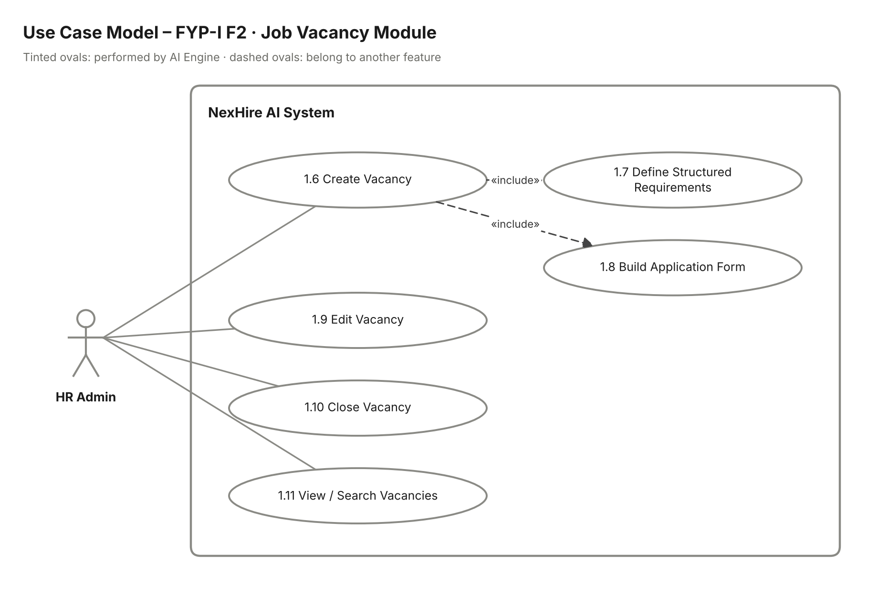
Figure 5: FYP-I F2 Job Vacancy Module – use case model

Stimulus/Response Sequences:
Use Case Name: Create & Manage Job Vacancy
Description: HR Admin creates a vacancy, defines its structured requirements, generates its application form and later edits, closes or searches vacancies.
Actors: HR Admin.
Goal: Publish an open vacancy with a position-specific application form on the candidate portal.
Pre-Conditions: HR Admin is logged in.
Basic Course of Events / Main Flow
1. User Action (Step 1):
HR Admin clicks "New Vacancy" in the HR panel (UC-1.6).
System Response:
The system shows the vacancy form with fields for title, description, department and location.
2. User Action (Step 2):
HR Admin enters the vacancy details and adds the required skills, experience, qualifications and certifications (UC-1.7).
System Response:
The system lets HR mark each requirement as mandatory or optional and assign a weightage to it.
3. User Action (Step 3):
HR Admin clicks "Generate Form".
System Response:
The system validates the requirements and generates the application form (UC-1.8):
- Checks that the total weightage equals 100%.
- Creates one structured field per requirement (e.g. years of experience, skill list, degree).
- Shows a preview of the form that HR can adjust.
4. User Action (Step 4):
HR Admin reviews the preview and clicks "Publish".
System Response:
The system saves the vacancy with status Open and makes its form visible on the candidate portal.
5. User Action (Step 5):
HR Admin opens the vacancy list, searches or filters by department and selects a vacancy to edit or close (UC-1.9, UC-1.10, UC-1.11).
System Response:
The system saves the edits; when a vacancy is closed its status changes to Closed and no new applications are accepted.
Alternate Flows
Alternate Flow (Invalid Requirements)
User Action:
HR Admin submits requirements whose weightage does not total 100% or leaves the title empty.
System Response:
The system highlights the problem and shows "Total weightage must equal 100%" or "Title is required"; the vacancy is not published.
Alternate Flow (Edit Open Vacancy with Applications)
User Action:
HR Admin edits the requirements of a vacancy that already has applications.
System Response:
The system warns that existing scores will be recalculated and, on confirmation, re-runs AI evaluation for that vacancy.
Exception Flow (System Errors)
System Failure
Condition:
A database or network error occurs while saving or publishing.
System Response:
The system shows "Vacancy could not be saved. Please try again." and keeps the entered data as a draft.
Post Conditions: The vacancy is Open and its position-specific application form is visible to candidates (or Closed, if HR closed it).
Table 3. Job Vacancy Module Stimulus/Response Sequences

Functional Requirements:
Req. ID | Description | Priority | Status
FR-1.2-01 | The system shall allow HR Admin to create a vacancy with title, description, department and location. | High | Pending
FR-1.2-02 | The system shall allow HR Admin to define required skills, experience, qualifications and certifications with mandatory flags and weightage. | High | Pending
FR-1.2-03 | The system shall ensure that requirement weightage totals 100% before publishing. | High | Pending
FR-1.2-04 | The system shall generate a position-specific application form from the vacancy's requirements. | High | Pending
FR-1.2-05 | The system shall allow HR Admin to edit an open vacancy and close it to stop new applications. | Medium | Pending
FR-1.2-06 | The system shall list vacancies with their status and allow search and filtering by department. | Medium | Pending
Table 4. Job Vacancy Module Functional Requirements

6.3 F3 – Candidate Portal

Description:
The candidate portal is where candidates manage their profile, browse and search open vacancies, read vacancy details and fill the position-specific structured application form (no CV upload). Candidates may add an optional portfolio or context link. On submission the system sends a confirmation email and triggers AI evaluation and duplicate detection.
Use cases covered: UC-1.12 to UC-1.18

Use Case Model:
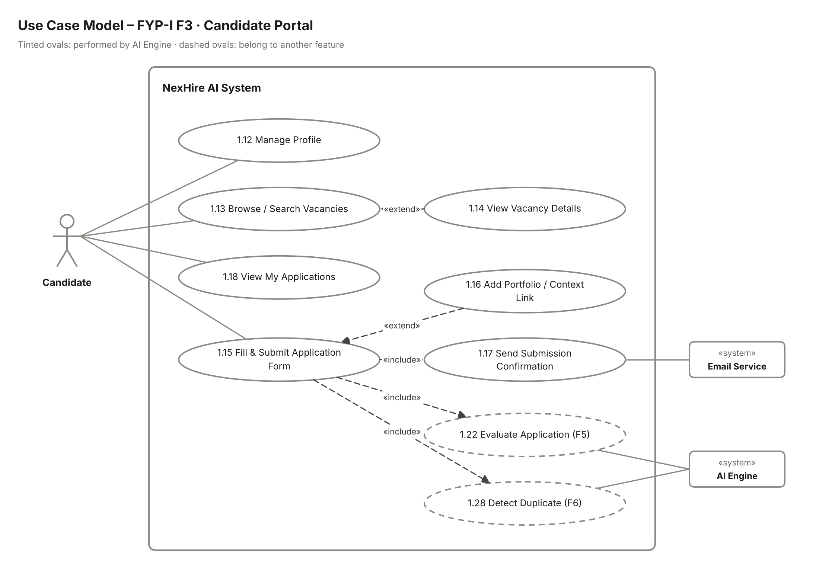
Figure 6: FYP-I F3 Candidate Portal – use case model

Stimulus/Response Sequences:
Use Case Name: Browse Vacancies & Submit Application
Description: Candidate manages their profile, finds a vacancy, fills its structured application form and tracks the applications they have submitted.
Actors: Candidate (primary); Email Service and AI Engine (secondary).
Goal: Submit a complete, structured application for an open vacancy.
Pre-Conditions: Candidate is logged in. The vacancy is Open.
Basic Course of Events / Main Flow
1. User Action (Step 1):
The candidate opens "My Profile" and updates personal and contact details (UC-1.12).
System Response:
The system validates and saves the profile; these details pre-fill future application forms.
2. User Action (Step 2):
The candidate opens "Vacancies" and searches by title or department (UC-1.13), then opens one vacancy (UC-1.14).
System Response:
The system lists matching open vacancies and shows the selected vacancy's description and requirements.
3. User Action (Step 3):
The candidate clicks "Apply".
System Response:
The system shows the position-specific structured form generated for that vacancy, with an optional portfolio / context link field (UC-1.16).
4. User Action (Step 4):
The candidate fills in the form and clicks "Submit" (UC-1.15).
System Response:
The system validates the input:
- Ensures all mandatory fields are filled.
- Checks field formats (numbers, dates, URL for portfolio link).
- Checks that the candidate has not already applied to this vacancy.
5. User Action (Step 5):
The candidate submits the form with valid data.
System Response:
The system:
- Saves the application with status Applied.
- Triggers AI evaluation (UC-1.22) and duplicate detection (UC-1.28).
- Sends a submission confirmation email through the Email Service (UC-1.17).
6. User Action (Step 6):
The candidate opens "My Applications" (UC-1.18).
System Response:
The system lists every vacancy the candidate has applied to with the submission date.
Alternate Flows
Alternate Flow (Invalid Inputs)
User Action:
The candidate submits the form with an empty mandatory field or an invalid value.
System Response:
The system highlights the invalid fields with messages such as "This field is required" or "Please enter a valid URL"; the form is not submitted.
Alternate Flow (Already Applied)
User Action:
The candidate tries to apply again to a vacancy they have already applied to.
System Response:
The system blocks the submission and shows "You have already applied for this vacancy."
Alternate Flow (Vacancy Closed)
User Action:
The vacancy is closed while the candidate is filling the form.
System Response:
On submit the system shows "This vacancy is no longer accepting applications."
Exception Flow (System Errors)
System Failure
Condition:
A database or network error occurs during submission.
System Response:
The system shows "System temporarily unavailable. Please try again later." and keeps the form data on screen.
Email Service Failure
Condition:
The confirmation email cannot be sent.
System Response:
The application is still saved; the email is queued and retried.
Post Conditions: The application is saved with status Applied, appears in the HR inbox and in the candidate's "My Applications" list.
Table 5. Candidate Portal Stimulus/Response Sequences

Functional Requirements:
Req. ID | Description | Priority | Status
FR-1.3-01 | The system shall allow candidates to view and edit their personal and contact details. | Medium | Pending
FR-1.3-02 | The system shall list open vacancies and allow search by title or department. | High | Pending
FR-1.3-03 | The system shall display the full description and requirements of a selected vacancy. | High | Pending
FR-1.3-04 | The system shall present the position-specific structured application form without CV upload. | High | Pending
FR-1.3-05 | The system shall validate mandatory fields and block duplicate applications to the same vacancy. | High | Pending
FR-1.3-06 | The system shall allow an optional portfolio / context link that is not used in scoring. | Low | Pending
FR-1.3-07 | The system shall send a submission confirmation email after a successful application. | Medium | Pending
FR-1.3-08 | The system shall show candidates a list of all applications they have submitted. | Medium | Pending
Table 6. Candidate Portal Functional Requirements

6.4 F4 – Application Inbox

Description:
The application inbox gives the HR Admin a single queue of all applications received for each vacancy. HR can filter and search the queue by vacancy, date, score or match tag, page through results and open any application to see the submitted answers and portfolio link.
Use cases covered: UC-1.19 to UC-1.21

Use Case Model:
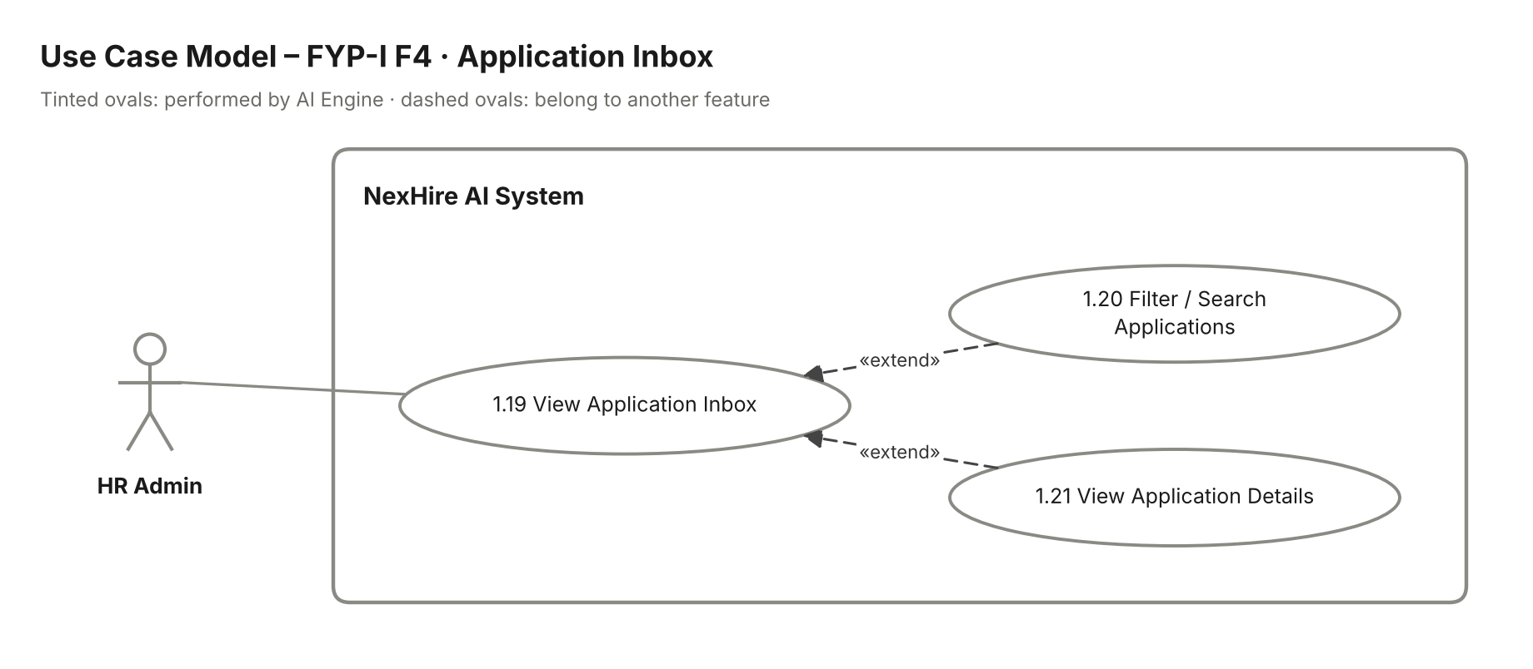
Figure 7: FYP-I F4 Application Inbox – use case model

Stimulus/Response Sequences:
Use Case Name: Review Application Inbox
Description: HR Admin views, filters and opens submitted applications.
Actors: HR Admin.
Goal: Let HR find and read any submitted application quickly.
Pre-Conditions: HR Admin is logged in. At least one vacancy exists.
Basic Course of Events / Main Flow
1. User Action (Step 1):
HR Admin opens "Application Inbox" (UC-1.19).
System Response:
The system shows a paginated list of applications with candidate name, vacancy, submission date, AI score and match tag.
2. User Action (Step 2):
HR Admin applies filters for vacancy, date range, score range or match tag, or searches by candidate name (UC-1.20).
System Response:
The system refreshes the list with matching applications only and keeps the filters while paging.
3. User Action (Step 3):
HR Admin clicks an application (UC-1.21).
System Response:
The system shows the full submitted form with all answers, the portfolio / context link and the current pipeline stage.
Alternate Flows
Alternate Flow (No Results)
User Action:
The selected filters match no applications.
System Response:
The system shows "No applications match your filters" with an option to clear filters.
Alternate Flow (Score Pending)
User Action:
An application has not yet been evaluated by the AI Engine.
System Response:
The system shows the application with the label "Pending evaluation" in place of a score.
Exception Flow (System Errors)
System Failure
Condition:
The inbox cannot be loaded because of a database or network error.
System Response:
The system shows "Unable to load applications. Please refresh."
Post Conditions: HR Admin has viewed the required applications; no data is changed.
Table 7. Application Inbox Stimulus/Response Sequences

Functional Requirements:
Req. ID | Description | Priority | Status
FR-1.4-01 | The system shall display all applications for each vacancy in a single inbox. | High | Pending
FR-1.4-02 | The system shall allow filtering by vacancy, date, score and match tag, and search by candidate name. | High | Pending
FR-1.4-03 | The system shall paginate inbox results. | Medium | Pending
FR-1.4-04 | The system shall display the full details of a selected application, including the portfolio link. | High | Pending
FR-1.4-05 | The system shall clearly mark applications whose AI evaluation is still pending. | Medium | Pending
Table 8. Application Inbox Functional Requirements

6.5 F5 – AI Application Form Evaluation & Ranking

Description:
Every submitted application is evaluated automatically by the AI Engine (n8n / LangGraph + Gemini). The engine compares the answers with the vacancy's required fields, recognises equivalent skills semantically, applies mandatory flags and weightage to calculate a requirement-fulfilment percentage, logs the score and ranks all applicants of the vacancy. HR views the ranked list and a breakdown of each score.
Use cases covered: UC-1.22 to UC-1.27

Use Case Model:
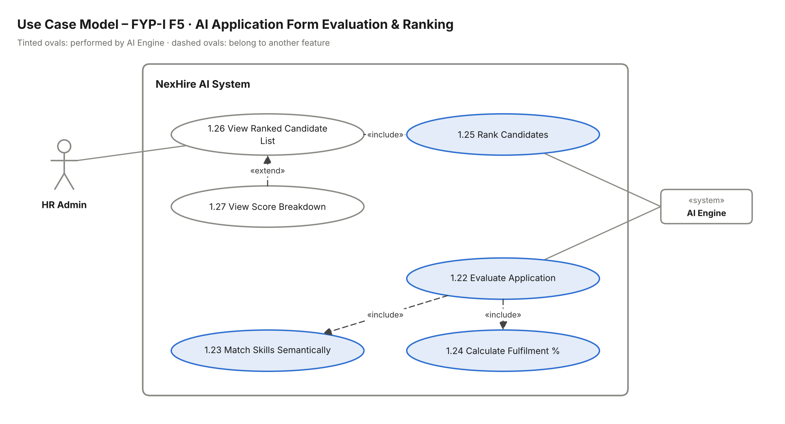
Figure 8: FYP-I F5 AI Application Form Evaluation & Ranking – use case model

Stimulus/Response Sequences:
Use Case Name: Evaluate, Score & Rank Applications
Description: AI Engine scores each application against the vacancy's requirements and ranks candidates; HR Admin views the ranking and score breakdown.
Actors: AI Engine (primary for scoring); HR Admin (views results).
Goal: Give HR an objective, explainable ranking of all applicants for a vacancy.
Pre-Conditions: An application has been submitted for an open vacancy that has structured requirements with weightage.
Basic Course of Events / Main Flow
1. System Event (Step 1):
A new application is submitted (trigger from UC-1.15).
System Response:
The AI Engine loads the vacancy's required fields, mandatory flags and weightage and starts evaluation (UC-1.22).
2. System Event (Step 2):
The AI Engine compares each answer with the matching requirement.
System Response:
It matches skills semantically (UC-1.23), for example:
- "JS" is treated as "JavaScript".
- "ML" is treated as "Machine Learning".
- Experience and qualification values are compared with the required minimums.
3. System Event (Step 3):
The AI Engine calculates the score (UC-1.24).
System Response:
It applies mandatory flags and weightage to produce a requirement-fulfilment percentage and logs the score with the met and missed requirements.
4. System Event (Step 4):
The score is saved.
System Response:
The AI Engine re-ranks all applicants of the vacancy by score (UC-1.25).
5. User Action (Step 5):
HR Admin opens a vacancy and clicks "Ranked Candidates" (UC-1.26).
System Response:
The system shows candidates in ranked order with their percentage score.
6. User Action (Step 6):
HR Admin clicks a candidate's score (UC-1.27).
System Response:
The system shows the score breakdown: each requirement, whether it was met or missed, and its weightage.
Alternate Flows
Alternate Flow (Mandatory Requirement Missing)
User Action:
The candidate does not meet a requirement marked mandatory.
System Response:
The AI Engine records the missing requirement, caps the candidate's score and tags the candidate Not a Fit (UC-1.30).
Alternate Flow (Vacancy Requirements Changed)
User Action:
HR edits the requirements of a vacancy that already has scored applications.
System Response:
The AI Engine re-evaluates all applications of that vacancy and updates the ranking.
Exception Flow (System Errors)
AI Service Unavailable
Condition:
The Gemini / n8n service does not respond or returns an error.
System Response:
The application is queued with status "Pending evaluation" and retried automatically; HR sees it as pending in the inbox.
Post Conditions: Score, rank and score log are stored against the application, and HR can see the ranked list.
Table 9. AI Application Form Evaluation & Ranking Stimulus/Response Sequences

Functional Requirements:
Req. ID | Description | Priority | Status
FR-1.5-01 | The system shall automatically evaluate every submitted application against the vacancy's required fields. | High | Pending
FR-1.5-02 | The system shall recognise semantically equivalent skills when matching answers to requirements. | High | Pending
FR-1.5-03 | The system shall calculate a requirement-fulfilment percentage using mandatory flags and weightage. | High | Pending
FR-1.5-04 | The system shall log every score with the requirements met and missed. | High | Pending
FR-1.5-05 | The system shall rank all applicants of a vacancy by score. | High | Pending
FR-1.5-06 | The system shall show HR the ranked list and a per-requirement score breakdown. | High | Pending
FR-1.5-07 | The system shall queue and retry evaluation when the AI service is unavailable. | Medium | Pending
Table 10. AI Application Form Evaluation & Ranking Functional Requirements

6.6 F6 – AI Duplicate Candidate Detection

Description:
When an application is submitted, the AI Engine compares it with existing applications using email, phone number and similarity of answers, and flags likely duplicates. HR reviews each flag and either confirms it (merge or discard) or dismisses it.
Use cases covered: UC-1.28 to UC-1.29

Use Case Model:
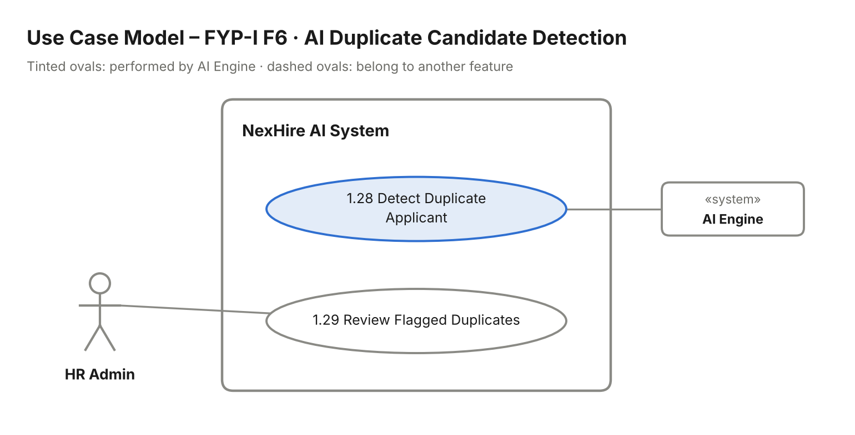
Figure 9: FYP-I F6 AI Duplicate Candidate Detection – use case model

Stimulus/Response Sequences:
Use Case Name: Detect & Review Duplicate Applicants
Description: AI Engine flags likely duplicate applications; HR Admin reviews and resolves each flag.
Actors: AI Engine, HR Admin.
Goal: Keep one clean record per real applicant.
Pre-Conditions: A new application has been submitted; earlier applications exist in the system.
Basic Course of Events / Main Flow
1. System Event (Step 1):
A new application is submitted (trigger from UC-1.15).
System Response:
The AI Engine compares it with existing applications (UC-1.28):
- Exact match on email or phone number.
- High similarity of names and answers.
2. System Event (Step 2):
A likely duplicate is found.
System Response:
The system flags both applications as "Possible duplicate" and shows the flag in HR's inbox.
3. User Action (Step 3):
HR Admin opens "Flagged Duplicates" and selects a flag (UC-1.29).
System Response:
The system shows the two applications side by side with the matching fields highlighted.
4. User Action (Step 4):
HR Admin chooses Merge, Discard or Dismiss.
System Response:
The system merges the records, discards the duplicate or removes the flag, and logs HR's decision.
Alternate Flows
Alternate Flow (No Duplicate Found)
User Action:
The new application matches no existing record.
System Response:
No flag is created and the application continues normally.
Exception Flow (System Errors)
AI Service Unavailable
Condition:
The duplicate check cannot run.
System Response:
The application is saved without a flag and the check is retried later.
Post Conditions: Duplicate flags are resolved and only valid applications remain active.
Table 11. AI Duplicate Candidate Detection Stimulus/Response Sequences

Functional Requirements:
Req. ID | Description | Priority | Status
FR-1.6-01 | The system shall compare each new application with existing ones using email, phone and answer similarity. | High | Pending
FR-1.6-02 | The system shall flag likely duplicates and display them to HR. | High | Pending
FR-1.6-03 | The system shall show flagged applications side by side with matching fields highlighted. | Medium | Pending
FR-1.6-04 | The system shall allow HR to merge, discard or dismiss a duplicate flag and log the decision. | Medium | Pending
Table 12. AI Duplicate Candidate Detection Functional Requirements

6.7 F7 – Candidate Match Tagging

Description:
After scoring, the AI Engine tags each ranked candidate as Strong Match, Possible Match or Not a Fit. HR can filter the ranked list by tag and manually review borderline Possible Match candidates, including their portfolio link, before deciding to keep or drop them.
Use cases covered: UC-1.30 to UC-1.32

Use Case Model:
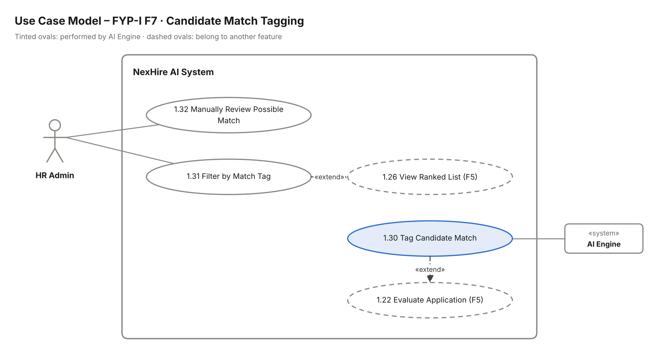
Figure 10: FYP-I F7 Candidate Match Tagging – use case model

Stimulus/Response Sequences:
Use Case Name: Tag & Review Candidate Matches
Description: AI Engine assigns a match tag to each candidate; HR Admin filters by tag and reviews Possible Match candidates.
Actors: AI Engine, HR Admin.
Goal: Let HR focus on the right candidates quickly while keeping the final call human.
Pre-Conditions: The application has been scored by the AI Engine (UC-1.22).
Basic Course of Events / Main Flow
1. System Event (Step 1):
An application's score is calculated (extends UC-1.22).
System Response:
The AI Engine assigns a tag (UC-1.30):
- Strong Match – high score and all mandatory requirements met.
- Possible Match – borderline score.
- Not a Fit – low score or a mandatory requirement missing.
2. User Action (Step 2):
HR Admin opens the ranked list and selects a tag filter (UC-1.31).
System Response:
The system shows only the candidates with the chosen tag.
3. User Action (Step 3):
HR Admin opens a Possible Match candidate (UC-1.32).
System Response:
The system shows the answers, score breakdown and portfolio link.
4. User Action (Step 4):
HR Admin clicks "Keep" or "Drop".
System Response:
The system records HR's decision; kept candidates stay in the pipeline and dropped candidates are moved out of the active list.
Alternate Flows
Alternate Flow (HR Overrides Tag)
User Action:
HR disagrees with the AI tag.
System Response:
HR changes the tag manually; the system saves the new tag and logs the override.
Exception Flow (System Errors)
System Failure
Condition:
The tag or decision cannot be saved.
System Response:
The system shows "Could not save. Please try again." and keeps the previous tag.
Post Conditions: Every scored candidate has a match tag, and Possible Match candidates have an HR decision.
Table 13. Candidate Match Tagging Stimulus/Response Sequences

Functional Requirements:
Req. ID | Description | Priority | Status
FR-1.7-01 | The system shall tag each scored candidate as Strong Match, Possible Match or Not a Fit. | High | Pending
FR-1.7-02 | The system shall allow HR to filter the ranked list by match tag. | High | Pending
FR-1.7-03 | The system shall allow HR to review Possible Match candidates with their portfolio link and keep or drop them. | Medium | Pending
FR-1.7-04 | The system shall log any manual change HR makes to a match tag. | Low | Pending
Table 14. Candidate Match Tagging Functional Requirements

7. Detailed Use Cases – FYP-II Features
FYP-II's 13 functional features follow the same format. Feature 14 (Testing, Deployment & Documentation) is project work with no actor goal, so it has no use case.

7.1 F1 – Interview Scheduling

Description:
HR defines interview slots, books a slot for a shortlisted candidate, assigns one or more interviewers, and the candidate is notified by email. HR can reschedule or cancel a booked interview, and the candidate is notified again.
Use cases covered: UC-2.1 to UC-2.5

Use Case Model:
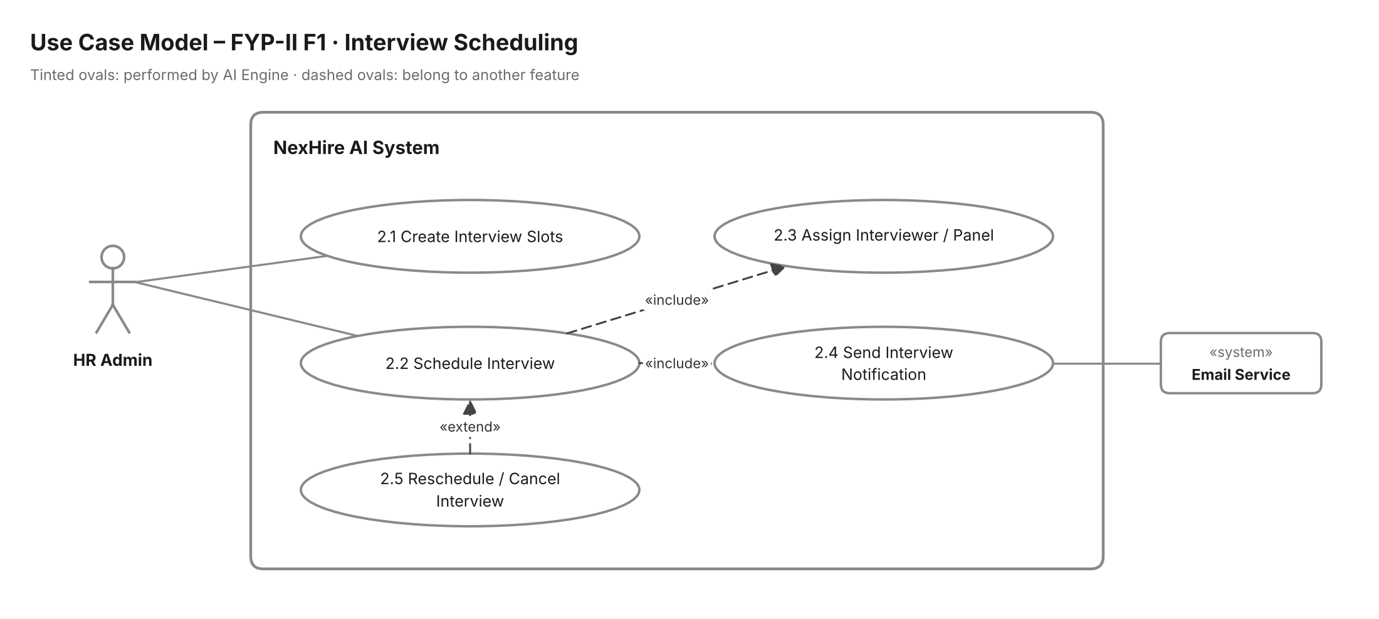
Figure 11: FYP-II F1 Interview Scheduling – use case model

Stimulus/Response Sequences:
Use Case Name: Schedule Interview
Description: HR Admin creates slots and schedules, reschedules or cancels interviews for shortlisted candidates.
Actors: HR Admin (primary); Email Service (secondary).
Goal: Book an interview with a date, time, venue and panel, and inform the candidate.
Pre-Conditions: HR Admin is logged in. The candidate is Shortlisted.
Basic Course of Events / Main Flow
1. User Action (Step 1):
HR Admin opens "Interview Slots" for a vacancy and adds dates, times and venue (UC-2.1).
System Response:
The system saves the slots and shows them as available.
2. User Action (Step 2):
HR Admin clicks "Schedule Interview" on a shortlisted candidate (UC-2.2).
System Response:
The system shows the available slots for that vacancy.
3. User Action (Step 3):
HR Admin selects a slot and assigns one or more interviewers (UC-2.3).
System Response:
The system validates the booking:
- Checks the slot is still free.
- Checks the interviewers have no clash at that time.
4. User Action (Step 4):
HR Admin confirms the booking.
System Response:
The system:
- Books the slot and moves the candidate to the Interview stage.
- Emails the candidate the date, time and venue (UC-2.4).
- Adds the interview to each interviewer's list and syncs it to Google Calendar (UC-2.34).
Alternate Flows
Alternate Flow (Reschedule / Cancel – UC-2.5, extends Schedule Interview)
User Action:
HR Admin opens a booked interview and chooses a new slot or clicks "Cancel".
System Response:
The system frees the old slot, saves the change and emails the candidate the new details or the cancellation.
Alternate Flow (No Free Slot / Clash)
User Action:
No slot is free or an interviewer already has an interview at that time.
System Response:
The system shows "No free slot" or "Interviewer unavailable" and asks HR to create a new slot or choose another interviewer.
Exception Flow (System Errors)
Email Service Failure
Condition:
The notification email cannot be sent.
System Response:
The interview stays booked; the email is queued and retried and HR sees a warning.
Post Conditions: The interview is booked and visible to HR, the interviewers and the candidate.
Table 15. Interview Scheduling Stimulus/Response Sequences

Functional Requirements:
Req. ID | Description | Priority | Status
FR-2.1-01 | The system shall allow HR to create interview slots with date, time and venue for a vacancy. | High | Pending
FR-2.1-02 | The system shall allow HR to book a slot for a shortlisted candidate. | High | Pending
FR-2.1-03 | The system shall allow HR to assign one or more interviewers and prevent time clashes. | High | Pending
FR-2.1-04 | The system shall email the candidate the interview date, time and venue. | High | Pending
FR-2.1-05 | The system shall allow HR to reschedule or cancel an interview and notify the candidate. | Medium | Pending
Table 16. Interview Scheduling Functional Requirements

7.2 F2 – Interview Management

Description:
Physical interviews are tracked in the system. HR marks each interview as conducted, no-show or postponed. HR or interviewers record private free-text feedback against the application, which is never visible to the candidate. The AI Engine summarises the feedback into strengths, concerns and decision-support insights; the final hiring decision stays with HR.
Use cases covered: UC-2.6 to UC-2.9

Use Case Model:
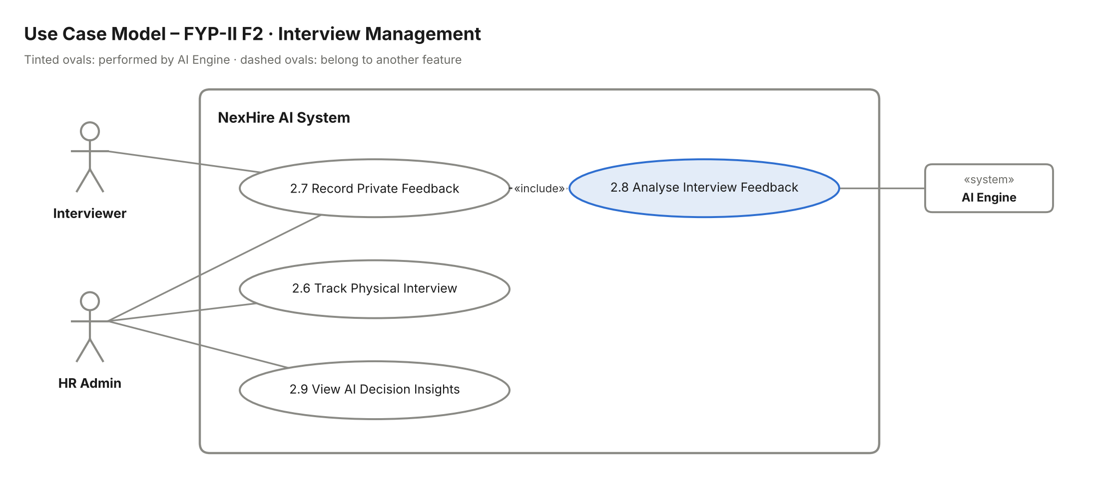
Figure 12: FYP-II F2 Interview Management – use case model

Stimulus/Response Sequences:
Use Case Name: Track Interview & Record Feedback
Description: HR tracks interview outcomes; HR or interviewers record private feedback; AI analyses it into insights for HR.
Actors: HR Admin, Interviewer (primary); AI Engine (secondary).
Goal: Capture interview outcomes and feedback and give HR AI-supported insights.
Pre-Conditions: An interview has been scheduled (UC-2.2).
Basic Course of Events / Main Flow
1. User Action (Step 1):
After the interview, HR Admin opens it and sets its status to Conducted, No-show or Postponed (UC-2.6).
System Response:
The system saves the status and updates the candidate's timeline.
2. User Action (Step 2):
HR Admin or an assigned Interviewer clicks "Add Feedback" and writes free-text notes (UC-2.7).
System Response:
The system saves the feedback against the application as private (never visible to the candidate).
3. System Event (Step 3):
Feedback is saved (includes UC-2.8).
System Response:
The AI Engine analyses the feedback and produces:
- Key strengths.
- Concerns or risks.
- A short decision-support summary.
4. User Action (Step 4):
HR Admin opens "AI Insights" for the candidate (UC-2.9).
System Response:
The system shows the AI summary next to the original feedback with the note "Final decision rests with HR".
Alternate Flows
Alternate Flow (No-show / Postponed)
User Action:
HR marks the interview as No-show or Postponed.
System Response:
The system skips feedback and offers HR the option to reschedule (UC-2.5).
Exception Flow (System Errors)
AI Service Unavailable
Condition:
The AI Engine cannot analyse the feedback.
System Response:
The feedback is saved; insights show as "Pending" and analysis is retried.
Post Conditions: Interview status and private feedback are stored, and AI insights are available to HR.
Table 17. Interview Management Stimulus/Response Sequences

Functional Requirements:
Req. ID | Description | Priority | Status
FR-2.2-01 | The system shall allow HR to mark an interview as conducted, no-show or postponed. | High | Pending
FR-2.2-02 | The system shall allow HR and assigned interviewers to record free-text feedback. | High | Pending
FR-2.2-03 | The system shall never show interview feedback to the candidate. | High | Pending
FR-2.2-04 | The system shall use AI to summarise feedback into strengths, concerns and decision-support insights. | Medium | Pending
FR-2.2-05 | The system shall present AI insights as support only, leaving the hiring decision to HR. | Medium | Pending
Table 18. Interview Management Functional Requirements

7.3 F3 – Structured Interview Feedback

Description:
Interviewers rate each candidate on a fixed set of criteria (for example technical skill, communication and problem solving) for every interview round. HR can compare these ratings across all rounds for one candidate.
Use cases covered: UC-2.10 to UC-2.11

Use Case Model:
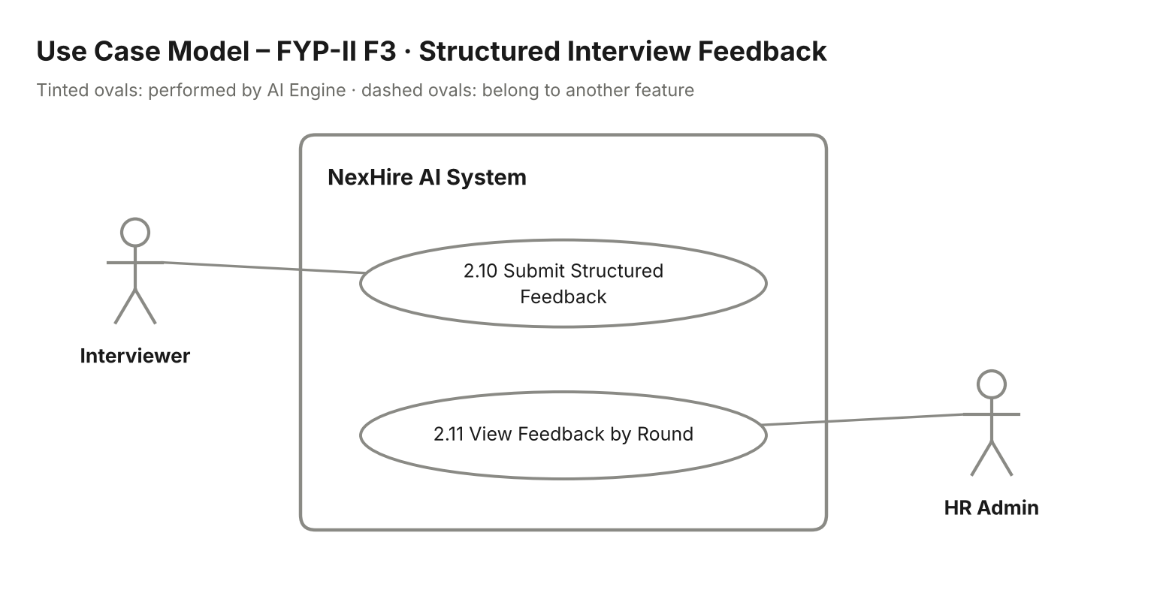
Figure 13: FYP-II F3 Structured Interview Feedback – use case model

Stimulus/Response Sequences:
Use Case Name: Submit & Compare Structured Feedback
Description: Interviewer submits criteria-based ratings per round; HR Admin compares feedback across rounds.
Actors: Interviewer, HR Admin.
Goal: Make interview evaluation consistent and comparable across rounds.
Pre-Conditions: Interviewer is logged in and assigned to a conducted interview.
Basic Course of Events / Main Flow
1. User Action (Step 1):
The interviewer opens an assigned interview and clicks "Structured Feedback" (UC-2.10).
System Response:
The system shows the fixed criteria with a 1–5 rating scale and an optional comment for each.
2. User Action (Step 2):
The interviewer rates every criterion and clicks "Submit".
System Response:
The system checks that all criteria are rated, saves the ratings against the round and locks them from further edits.
3. User Action (Step 3):
HR Admin opens the candidate and clicks "Feedback by Round" (UC-2.11).
System Response:
The system shows a table of each round, each interviewer's ratings and the average per criterion.
Alternate Flows
Alternate Flow (Incomplete Ratings)
User Action:
The interviewer submits without rating every criterion.
System Response:
The system highlights the missing ratings and shows "Please rate all criteria."
Exception Flow (System Errors)
System Failure
Condition:
The ratings cannot be saved.
System Response:
The system shows "Could not submit feedback. Please try again." and keeps the entered ratings.
Post Conditions: Structured ratings are stored per round and HR can compare them.
Table 19. Structured Interview Feedback Stimulus/Response Sequences

Functional Requirements:
Req. ID | Description | Priority | Status
FR-2.3-01 | The system shall provide a fixed set of rating criteria for each interview round. | High | Pending
FR-2.3-02 | The system shall require interviewers to rate every criterion before submitting. | Medium | Pending
FR-2.3-03 | The system shall store ratings per round and per interviewer. | High | Pending
FR-2.3-04 | The system shall let HR compare ratings across rounds with per-criterion averages. | Medium | Pending
Table 20. Structured Interview Feedback Functional Requirements

7.4 F4 – Shortlist / Reject Pipeline

Description:
HR moves candidates through the hiring pipeline (Applied → Screened → Interview → Offer → Hired). One action shortlists or rejects a candidate, and the candidate is emailed automatically whenever they are shortlisted or rejected.
Use cases covered: UC-2.12 to UC-2.15

Use Case Model:
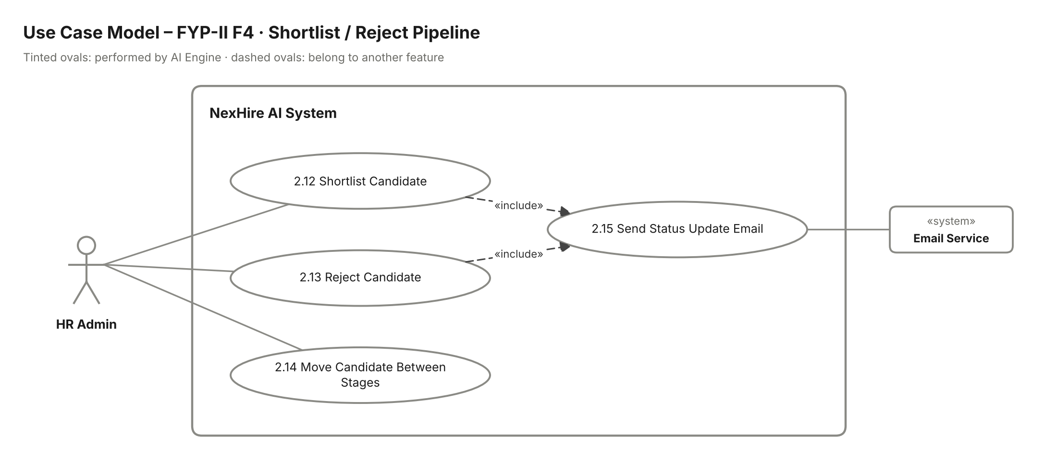
Figure 14: FYP-II F4 Shortlist / Reject Pipeline – use case model

Stimulus/Response Sequences:
Use Case Name: Move Candidate Through Pipeline
Description: HR Admin shortlists, rejects or moves a candidate between stages; the candidate is notified by email.
Actors: HR Admin (primary); Email Service (secondary).
Goal: Keep every candidate's stage up to date and inform them of key decisions.
Pre-Conditions: HR Admin is logged in. The candidate has an application in the system.
Basic Course of Events / Main Flow
1. User Action (Step 1):
HR Admin opens a candidate from the ranked list or inbox and clicks "Shortlist" (UC-2.12).
System Response:
The system moves the candidate to Shortlisted and sends a status update email (UC-2.15).
2. User Action (Step 2):
HR Admin clicks "Reject" on a candidate (UC-2.13).
System Response:
The system asks for confirmation, moves the candidate to Rejected and sends a polite rejection email (UC-2.15).
3. User Action (Step 3):
HR Admin drags the candidate to another stage on the pipeline board (UC-2.14).
System Response:
The system checks the move is valid, updates the stage and records the date and HR user in the candidate's history.
Alternate Flows
Alternate Flow (Invalid Stage Move)
User Action:
HR tries to move a candidate to a stage that skips a required step (e.g. Applied directly to Hired).
System Response:
The system blocks the move and shows "Candidate must pass through the Interview and Offer stages first."
Alternate Flow (Undo Reject)
User Action:
HR rejected a candidate by mistake.
System Response:
HR moves the candidate back to the previous stage; the system logs the change.
Exception Flow (System Errors)
Email Service Failure
Condition:
The status email cannot be sent.
System Response:
The stage change is saved; the email is queued and retried.
Post Conditions: The candidate's stage is updated and they have been emailed when shortlisted or rejected.
Table 21. Shortlist / Reject Pipeline Stimulus/Response Sequences

Functional Requirements:
Req. ID | Description | Priority | Status
FR-2.4-01 | The system shall allow HR to shortlist or reject a candidate with a single action. | High | Pending
FR-2.4-02 | The system shall support the stages Applied, Screened, Interview, Offer and Hired. | High | Pending
FR-2.4-03 | The system shall allow HR to move candidates between stages and record each move. | High | Pending
FR-2.4-04 | The system shall email the candidate automatically when shortlisted or rejected. | Medium | Pending
Table 22. Shortlist / Reject Pipeline Functional Requirements

7.5 F5 – AI Generated Interview Questions & Score Prediction

Description:
The AI Engine (Gemini) generates role-specific interview questions from the vacancy's requirements. HR reviews, edits or removes them before approving, and interviewers see the approved questions for their assigned interviews. A score-prediction widget estimates a candidate's likely score from mandatory flags and weightage.
Use cases covered: UC-2.16 to UC-2.19

Use Case Model:
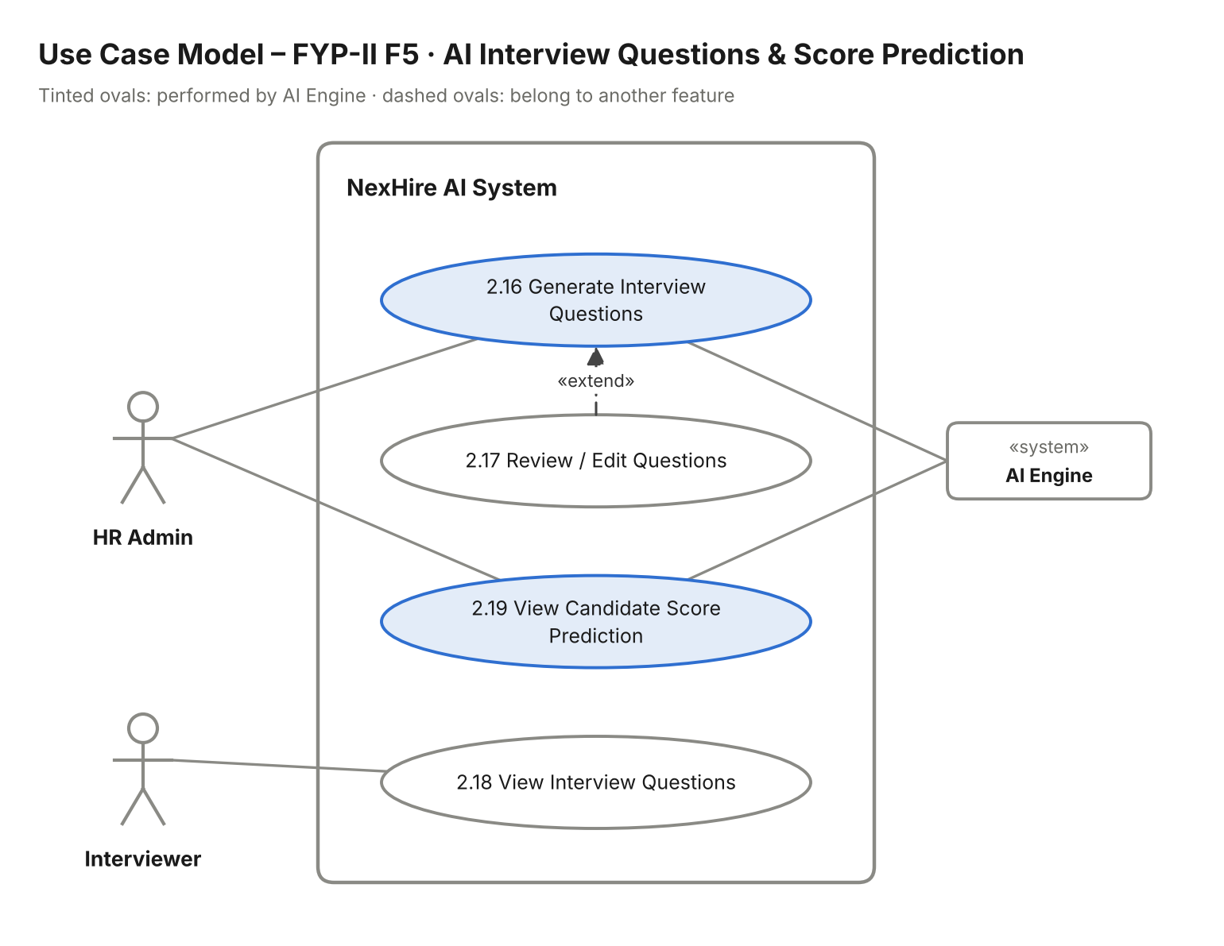
Figure 15: FYP-II F5 AI Generated Interview Questions & Score Prediction – use case model

Stimulus/Response Sequences:
Use Case Name: Generate Interview Questions & Predict Score
Description: AI generates interview questions that HR approves for interviewers; AI predicts a candidate's likely score for HR.
Actors: HR Admin, Interviewer (primary); AI Engine (secondary).
Goal: Prepare relevant, approved interview questions and an early score estimate for each candidate.
Pre-Conditions: The vacancy has structured requirements. HR Admin is logged in.
Basic Course of Events / Main Flow
1. User Action (Step 1):
HR Admin opens a vacancy and clicks "Generate Interview Questions" (UC-2.16).
System Response:
The AI Engine generates role-specific technical and behavioural questions from the vacancy's requirements and the system displays them.
2. User Action (Step 2):
HR Admin edits, removes or adds questions and clicks "Approve" (UC-2.17).
System Response:
The system saves the approved question set for the vacancy.
3. User Action (Step 3):
The interviewer opens an assigned interview (UC-2.18).
System Response:
The system shows the approved questions for that interview.
4. User Action (Step 4):
HR Admin opens a candidate and views the "Score Prediction" widget (UC-2.19).
System Response:
The AI Engine estimates the candidate's likely score from mandatory flags and weightage and the system shows it with a short explanation.
Alternate Flows
Alternate Flow (Regenerate)
User Action:
HR is not satisfied with the generated questions.
System Response:
HR clicks "Regenerate" with optional notes; the AI Engine produces a new set.
Alternate Flow (Questions Not Approved)
User Action:
An interviewer opens an interview before HR has approved questions.
System Response:
The system shows "Questions not yet approved by HR."
Exception Flow (System Errors)
AI Service Unavailable
Condition:
The AI Engine does not respond.
System Response:
The system shows "Question generation is unavailable right now. Please try again later."
Post Conditions: An approved question set exists for the vacancy and HR can see a predicted score for each candidate.
Table 23. AI Generated Interview Questions & Score Prediction Stimulus/Response Sequences

Functional Requirements:
Req. ID | Description | Priority | Status
FR-2.5-01 | The system shall generate role-specific interview questions from the vacancy requirements using AI. | High | Pending
FR-2.5-02 | The system shall allow HR to edit, remove, add and approve generated questions. | High | Pending
FR-2.5-03 | The system shall show only approved questions to assigned interviewers. | Medium | Pending
FR-2.5-04 | The system shall predict a candidate's likely score from mandatory flags and weightage. | Medium | Pending
Table 24. AI Generated Interview Questions & Score Prediction Functional Requirements

7.6 F6 – AI Drafted Offer Letters

Description:
HR enters the offer guidelines (salary band, start date, role terms) for a selected candidate. The AI Engine drafts a complete offer letter linked to the correct application. HR reviews, edits and approves it, the letter is emailed to the candidate and the candidate can view it on their dashboard.
Use cases covered: UC-2.20 to UC-2.24

Use Case Model:
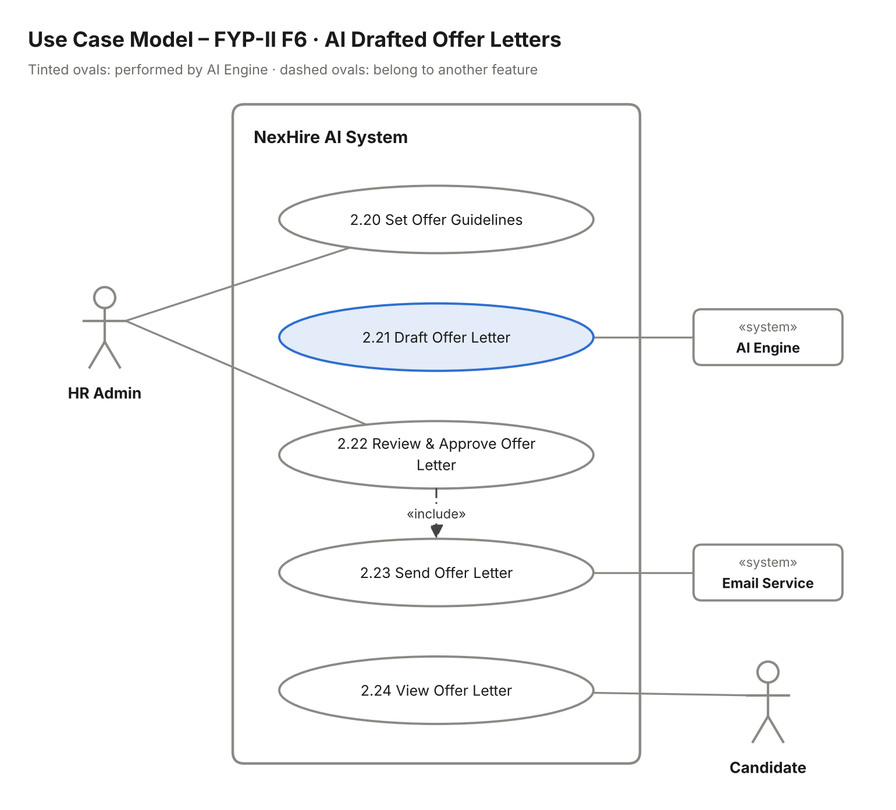
Figure 16: FYP-II F6 AI Drafted Offer Letters – use case model

Stimulus/Response Sequences:
Use Case Name: Generate & Send Offer Letter
Description: HR sets offer terms; AI drafts the letter; HR approves; the letter is emailed and shown to the candidate.
Actors: HR Admin (primary); AI Engine, Email Service, Candidate (secondary).
Goal: Send an accurate, approved offer letter to the selected candidate.
Pre-Conditions: The candidate is in the Offer stage. HR Admin is logged in.
Basic Course of Events / Main Flow
1. User Action (Step 1):
HR Admin clicks "Create Offer" and enters salary band, start date and role terms (UC-2.20).
System Response:
The system validates the fields and sends the terms with the candidate and vacancy details to the AI Engine.
2. System Event (Step 2):
The AI Engine receives the offer terms (UC-2.21).
System Response:
It drafts a complete offer letter linked to the correct application and the system shows the draft in an editor.
3. User Action (Step 3):
HR Admin reviews and edits the draft and clicks "Approve & Send" (UC-2.22).
System Response:
The system saves the final letter, emails it to the candidate (UC-2.23) and sets the offer status to Sent.
4. User Action (Step 4):
The candidate opens their dashboard (UC-2.24).
System Response:
The system shows the offer letter with the option to download it.
Alternate Flows
Alternate Flow (Draft Rejected)
User Action:
HR is not happy with the draft.
System Response:
HR clicks "Regenerate" with notes; the AI Engine produces a revised draft.
Alternate Flow (Missing Terms)
User Action:
HR leaves salary band or start date empty.
System Response:
The system highlights the field and shows "This field is required."
Exception Flow (System Errors)
AI Service Unavailable
Condition:
The AI Engine cannot draft the letter.
System Response:
The system offers HR a standard template to complete manually.
Email Service Failure
Condition:
The offer email cannot be sent.
System Response:
The letter is still shown on the candidate dashboard; the email is queued and retried.
Post Conditions: Offer status is Sent, the candidate can view the letter and the offer is recorded in hiring analytics.
Table 25. AI Drafted Offer Letters Stimulus/Response Sequences

Functional Requirements:
Req. ID | Description | Priority | Status
FR-2.6-01 | The system shall allow HR to enter salary band, start date and role terms for an offer. | High | Pending
FR-2.6-02 | The system shall use AI to draft a complete offer letter linked to the correct application. | High | Pending
FR-2.6-03 | The system shall require HR approval before any offer letter is sent. | High | Pending
FR-2.6-04 | The system shall email the approved offer letter to the candidate. | High | Pending
FR-2.6-05 | The system shall display the offer letter on the candidate's dashboard. | Medium | Pending
Table 26. AI Drafted Offer Letters Functional Requirements

7.7 F7 – Hiring Dashboard

Description:
The hiring dashboard gives HR an overview of recruitment: number of candidates in each pipeline stage per vacancy, open / closed / filled vacancies, department-wise hiring numbers and a downloadable monthly hiring report.
Use cases covered: UC-2.25 to UC-2.28

Use Case Model:
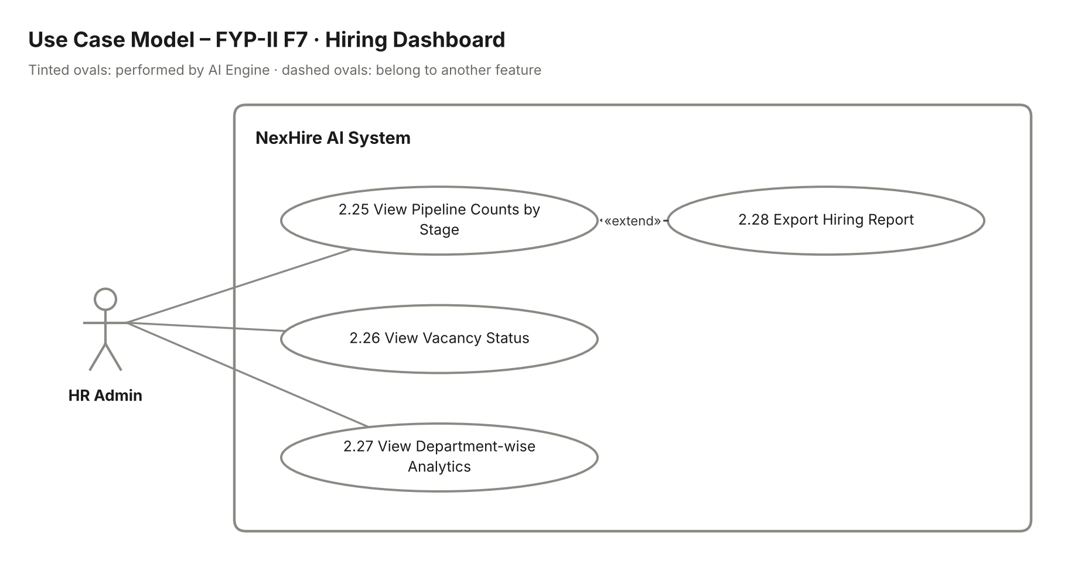
Figure 17: FYP-II F7 Hiring Dashboard – use case model

Stimulus/Response Sequences:
Use Case Name: View Hiring Analytics
Description: HR Admin views pipeline, vacancy and department analytics and exports a monthly report.
Actors: HR Admin.
Goal: Give HR a clear picture of hiring progress at a glance.
Pre-Conditions: HR Admin is logged in.
Basic Course of Events / Main Flow
1. User Action (Step 1):
HR Admin opens "Hiring Dashboard".
System Response:
The system shows the candidate count in each stage for each vacancy (UC-2.25).
2. User Action (Step 2):
HR Admin looks at the vacancy status panel (UC-2.26).
System Response:
The system shows the number of open, closed and filled vacancies.
3. User Action (Step 3):
HR Admin selects the "Departments" tab (UC-2.27).
System Response:
The system shows hiring numbers broken down by department.
4. User Action (Step 4):
HR Admin selects a month and clicks "Export Report" (UC-2.28).
System Response:
The system generates the monthly hiring report and downloads it.
Alternate Flows
Alternate Flow (No Data)
User Action:
There is no hiring activity for the selected period.
System Response:
The system shows empty charts with "No data for this period."
Exception Flow (System Errors)
System Failure
Condition:
Analytics cannot be loaded or the report cannot be generated.
System Response:
The system shows "Unable to load analytics. Please try again later."
Post Conditions: HR has viewed the analytics and, if requested, downloaded the report.
Table 27. Hiring Dashboard Stimulus/Response Sequences

Functional Requirements:
Req. ID | Description | Priority | Status
FR-2.7-01 | The system shall show the number of candidates in each pipeline stage per vacancy. | High | Pending
FR-2.7-02 | The system shall show the number of open, closed and filled vacancies. | Medium | Pending
FR-2.7-03 | The system shall show hiring numbers by department. | Medium | Pending
FR-2.7-04 | The system shall allow HR to export a monthly hiring report. | Medium | Pending
Table 28. Hiring Dashboard Functional Requirements

7.8 F8 – AI Chatbot for Candidates

Description:
Candidates can ask the AI chatbot questions about the recruitment process and the company. The chatbot answers from an FAQ knowledge base that HR maintains.
Use cases covered: UC-2.29 to UC-2.30

Use Case Model:
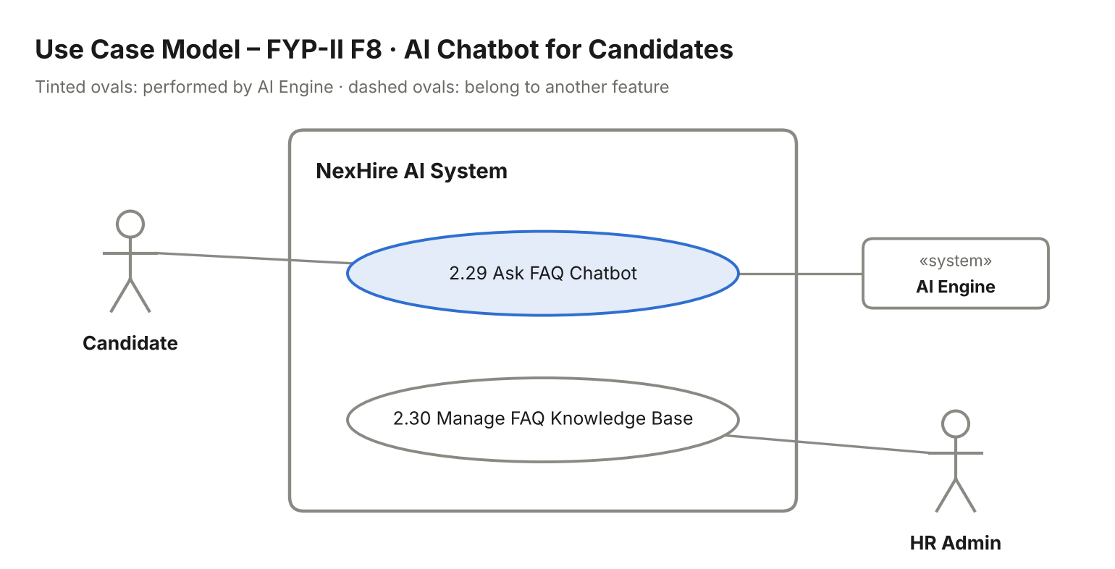
Figure 18: FYP-II F8 AI Chatbot for Candidates – use case model

Stimulus/Response Sequences:
Use Case Name: Ask Recruitment Chatbot
Description: Candidate asks questions and receives AI answers; HR Admin manages the FAQ knowledge base.
Actors: Candidate, HR Admin (primary); AI Engine (secondary).
Goal: Answer common candidate questions instantly and accurately.
Pre-Conditions: The FAQ knowledge base has content. The candidate has the portal open.
Basic Course of Events / Main Flow
1. User Action (Step 1):
HR Admin opens "FAQ Knowledge Base" and adds or edits questions, answers and company information (UC-2.30).
System Response:
The system saves the entries and makes them available to the chatbot.
2. User Action (Step 2):
The candidate opens the chatbot and types a question (UC-2.29).
System Response:
The AI Engine searches the knowledge base and generates an answer based on it.
3. User Action (Step 3):
The candidate reads the answer and asks a follow-up question.
System Response:
The chatbot keeps the conversation context and answers the follow-up.
Alternate Flows
Alternate Flow (Question Not Covered)
User Action:
The question is not covered by the knowledge base.
System Response:
The chatbot replies "I don't have that information yet. Please contact HR." instead of guessing.
Exception Flow (System Errors)
AI Service Unavailable
Condition:
The AI Engine does not respond.
System Response:
The chatbot shows "The assistant is unavailable right now. Please try again later."
Post Conditions: The candidate has received an answer, and the knowledge base reflects HR's latest content.
Table 29. AI Chatbot for Candidates Stimulus/Response Sequences

Functional Requirements:
Req. ID | Description | Priority | Status
FR-2.8-01 | The system shall provide an AI chatbot that answers recruitment and company questions. | Medium | Pending
FR-2.8-02 | The system shall base chatbot answers only on the HR-managed knowledge base. | High | Pending
FR-2.8-03 | The system shall allow HR to add, edit and delete FAQ entries. | Medium | Pending
FR-2.8-04 | The system shall tell the candidate to contact HR when a question is not covered. | Low | Pending
Table 30. AI Chatbot for Candidates Functional Requirements

7.9 F9 – Candidate Dashboard

Description:
The candidate dashboard shows the current stage of each application and the date, time and venue of any upcoming interviews.
Use cases covered: UC-2.31 to UC-2.32

Use Case Model:
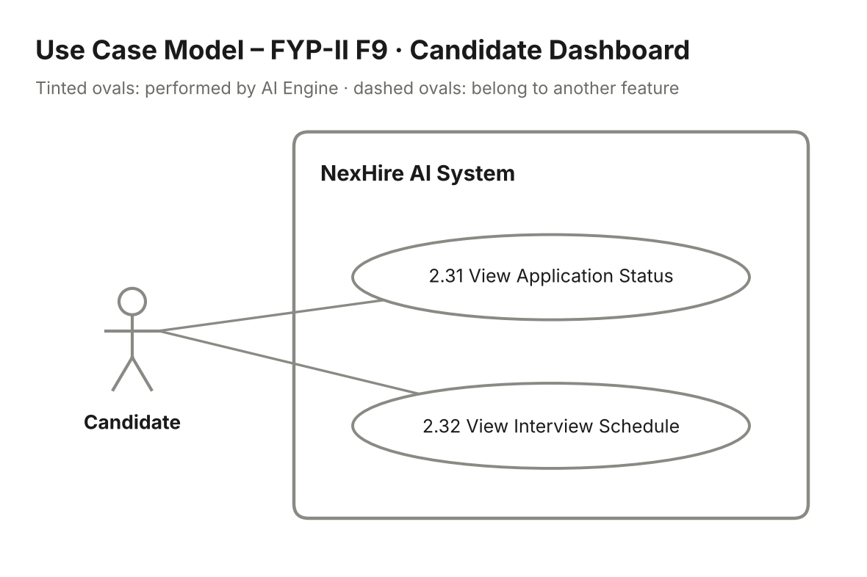
Figure 19: FYP-II F9 Candidate Dashboard – use case model

Stimulus/Response Sequences:
Use Case Name: Track Application & Interview
Description: Candidate views application status and upcoming interview schedule.
Actors: Candidate.
Goal: Keep the candidate informed about their applications without contacting HR.
Pre-Conditions: Candidate is logged in and has at least one application.
Basic Course of Events / Main Flow
1. User Action (Step 1):
The candidate opens "My Dashboard".
System Response:
The system shows each application with its current stage (UC-2.31): Applied, Screened, Interview, Offer, Hired or Rejected.
2. User Action (Step 2):
The candidate opens the "Upcoming Interviews" section (UC-2.32).
System Response:
The system shows the date, time and venue of each scheduled interview.
Alternate Flows
Alternate Flow (No Interviews)
User Action:
The candidate has no scheduled interview.
System Response:
The system shows "No upcoming interviews."
Exception Flow (System Errors)
System Failure
Condition:
The dashboard cannot load.
System Response:
The system shows "Unable to load your dashboard. Please refresh."
Post Conditions: The candidate knows the status of each application and any upcoming interviews.
Table 31. Candidate Dashboard Stimulus/Response Sequences

Functional Requirements:
Req. ID | Description | Priority | Status
FR-2.9-01 | The system shall show candidates the current stage of each of their applications. | High | Pending
FR-2.9-02 | The system shall show candidates the date, time and venue of upcoming interviews. | High | Pending
FR-2.9-03 | The system shall never show internal scores or interview feedback to candidates. | High | Pending
Table 32. Candidate Dashboard Functional Requirements

7.10 F10 – Job Board Syndication (simulated)

Description:
HR can post a vacancy to external job boards (LinkedIn / Indeed). In this project the integration is simulated: the module returns a mocked success response instead of calling the real job board.
Use cases covered: UC-2.33

Use Case Model:
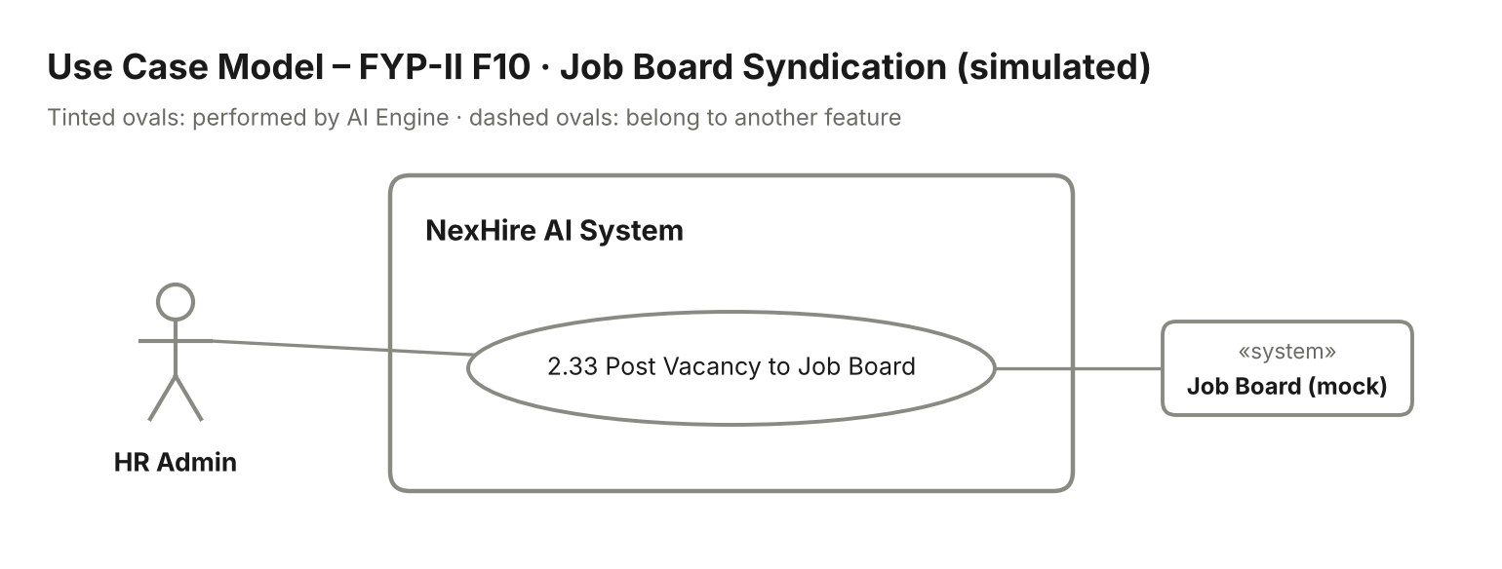
Figure 20: FYP-II F10 Job Board Syndication (simulated) – use case model

Stimulus/Response Sequences:
Use Case Name: Post Vacancy to Job Board
Description: HR Admin posts an open vacancy to a (mocked) external job board.
Actors: HR Admin (primary); Job Board – LinkedIn / Indeed, mocked (secondary).
Goal: Demonstrate how a vacancy would be syndicated to external job boards.
Pre-Conditions: The vacancy is Open.
Basic Course of Events / Main Flow
1. User Action (Step 1):
HR Admin opens an open vacancy and clicks "Post to LinkedIn / Indeed" (UC-2.33).
System Response:
The system shows the posting preview and the target job boards.
2. User Action (Step 2):
HR Admin confirms.
System Response:
The syndication module sends the vacancy to the mocked job board, which returns a simulated success response with a posting ID; the system shows "Posted successfully" and records the posting.
Alternate Flows
Alternate Flow (Already Posted)
User Action:
The vacancy has already been posted to that board.
System Response:
The system shows the existing posting ID and asks whether to update it.
Exception Flow (System Errors)
Mock Error Response
Condition:
The mocked job board returns an error.
System Response:
The system shows "Posting failed. Please try again." and records the attempt.
Post Conditions: The vacancy shows a (simulated) posting status for each job board.
Table 33. Job Board Syndication (simulated) Stimulus/Response Sequences

Functional Requirements:
Req. ID | Description | Priority | Status
FR-2.10-01 | The system shall allow HR to post an open vacancy to LinkedIn / Indeed through a simulated module. | Low | Pending
FR-2.10-02 | The system shall display the mocked posting response and store the posting status. | Low | Pending
Table 34. Job Board Syndication (simulated) Functional Requirements

7.11 F11 – Calendar Sync

Description:
Scheduled interviews are synced with Google Calendar in both directions: new, changed or cancelled interviews are pushed to Google Calendar, and changes made in Google Calendar are pulled back into NexHire AI.
Use cases covered: UC-2.34

Use Case Model:
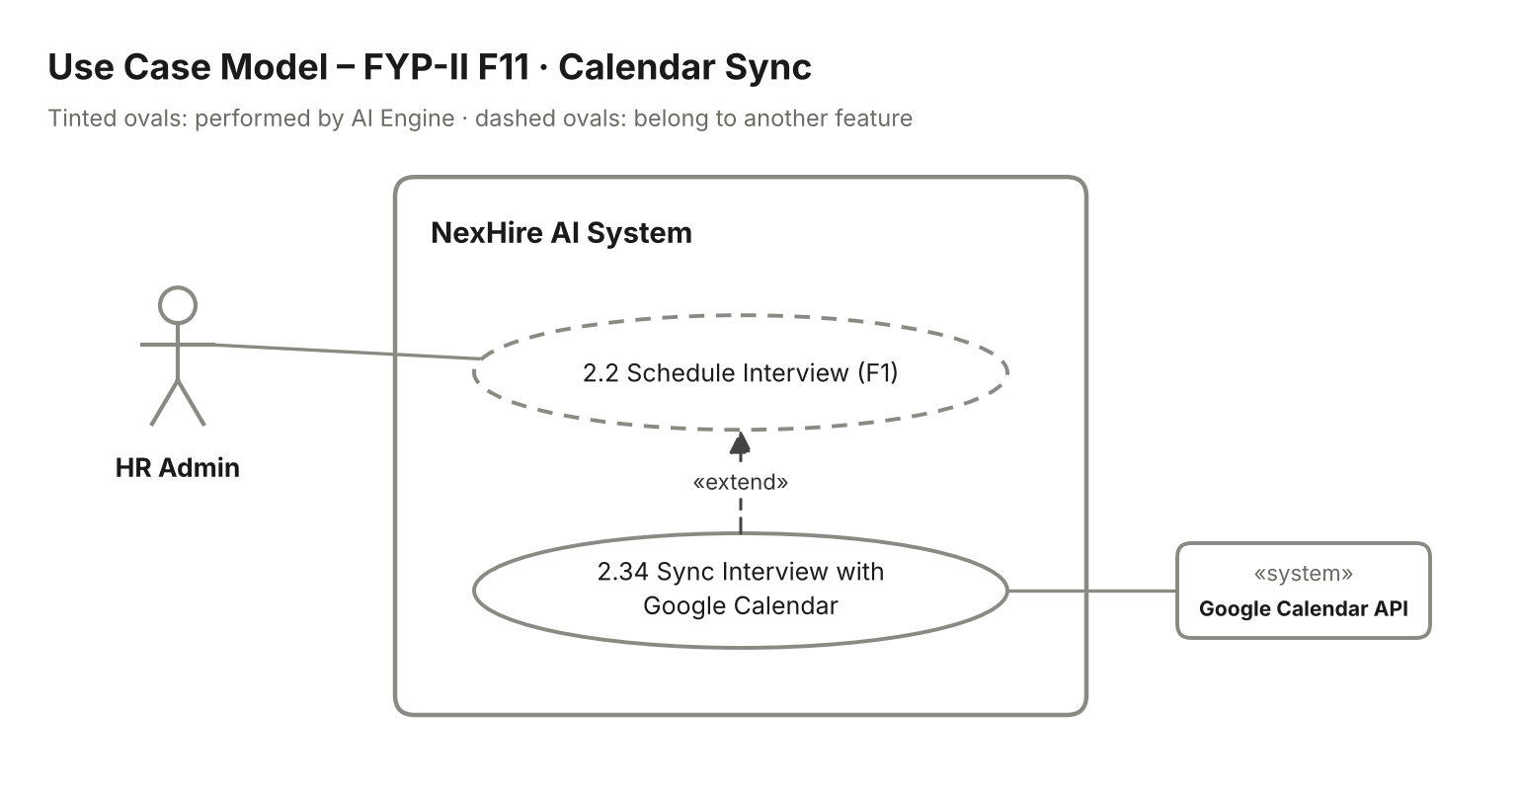
Figure 21: FYP-II F11 Calendar Sync – use case model

Stimulus/Response Sequences:
Use Case Name: Sync Interview with Google Calendar
Description: Interview bookings are kept in two-way sync with Google Calendar.
Actors: HR Admin (primary); Google Calendar API (secondary).
Goal: Keep interview times consistent between NexHire AI and HR's calendar.
Pre-Conditions: HR Admin has connected a Google account. An interview is scheduled (UC-2.2).
Basic Course of Events / Main Flow
1. User Action (Step 1):
HR Admin connects Google Calendar from "Settings".
System Response:
The system completes Google sign-in (OAuth) and stores the access token securely.
2. System Event (Step 2):
An interview is scheduled, rescheduled or cancelled (extends UC-2.2).
System Response:
The system creates, updates or deletes the matching Google Calendar event with candidate, time, venue and panel.
3. System Event (Step 3):
The event is moved or deleted in Google Calendar.
System Response:
The system receives the change and updates the interview in NexHire AI, notifying HR of the change.
Alternate Flows
Alternate Flow (Calendar Not Connected)
User Action:
HR has not connected Google Calendar.
System Response:
The interview is booked normally; the system shows "Connect Google Calendar to sync interviews."
Exception Flow (System Errors)
Sync Failure
Condition:
The Google Calendar API returns an error or the token has expired.
System Response:
The interview stays booked; sync is retried and HR is asked to reconnect if the token is invalid.
Post Conditions: Interview details match in NexHire AI and Google Calendar.
Table 35. Calendar Sync Stimulus/Response Sequences

Functional Requirements:
Req. ID | Description | Priority | Status
FR-2.11-01 | The system shall allow HR to connect a Google Calendar account. | Medium | Pending
FR-2.11-02 | The system shall push new, changed and cancelled interviews to Google Calendar. | Medium | Pending
FR-2.11-03 | The system shall pull changes made in Google Calendar back into NexHire AI. | Medium | Pending
FR-2.11-04 | The system shall retry failed sync attempts without losing the booking. | Low | Pending
Table 36. Calendar Sync Functional Requirements

7.12 F12 – Referral Tracking

Description:
Employees can refer candidates for open vacancies and follow the stage their referred candidate has reached. HR sees all referrals and how many of them led to hires.
Use cases covered: UC-2.35 to UC-2.37

Use Case Model:
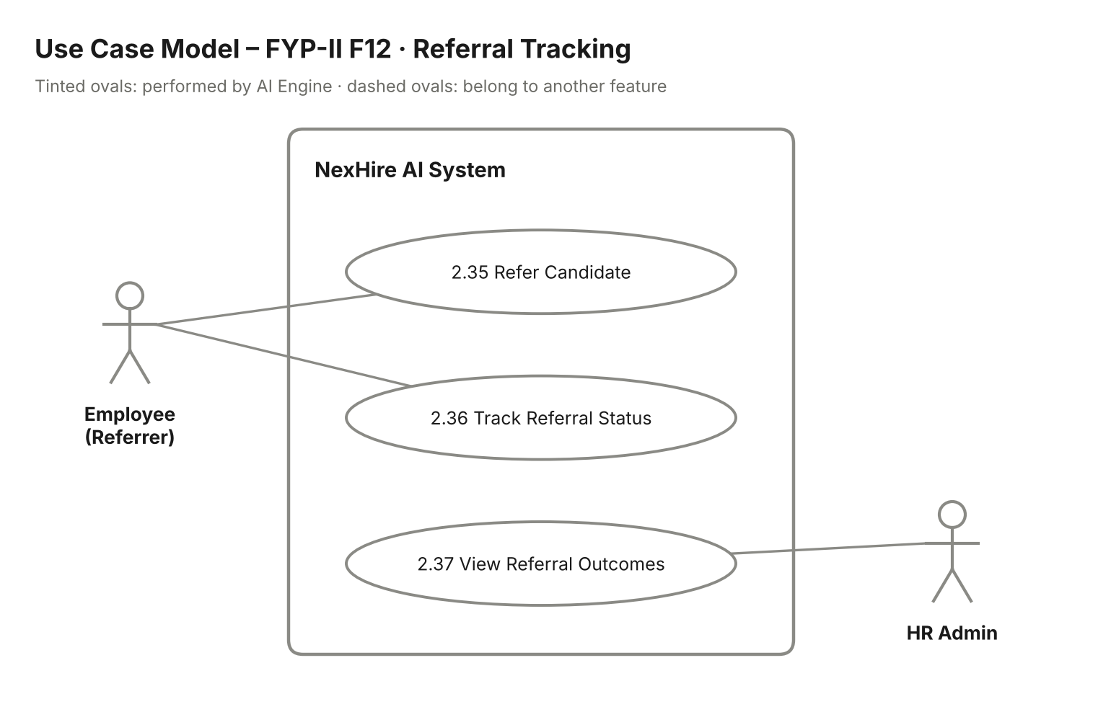
Figure 22: FYP-II F12 Referral Tracking – use case model

Stimulus/Response Sequences:
Use Case Name: Refer Candidate & Track Referral
Description: Employee refers a candidate and tracks the outcome; HR Admin views referral outcomes.
Actors: Employee (Referrer), HR Admin.
Goal: Encourage and measure employee referrals.
Pre-Conditions: The employee is logged in with an Employee role. The vacancy is Open.
Basic Course of Events / Main Flow
1. User Action (Step 1):
The employee opens an open vacancy and clicks "Refer a Candidate" (UC-2.35).
System Response:
The system shows a referral form for the candidate's name, email, phone and a short note.
2. User Action (Step 2):
The employee fills in the form and submits it.
System Response:
The system validates the fields, saves the referral linked to the employee and invites the candidate by email to apply.
3. User Action (Step 3):
The employee opens "My Referrals" (UC-2.36).
System Response:
The system shows each referred candidate and the stage they have reached.
4. User Action (Step 4):
HR Admin opens "Referral Outcomes" (UC-2.37).
System Response:
The system lists all referrals with their status and shows how many led to hires.
Alternate Flows
Alternate Flow (Duplicate Referral)
User Action:
The candidate has already applied or been referred for the same vacancy.
System Response:
The system shows "This candidate is already in the pipeline for this vacancy."
Exception Flow (System Errors)
System Failure
Condition:
The referral cannot be saved.
System Response:
The system shows "Referral could not be submitted. Please try again."
Post Conditions: The referral is recorded and its outcome is visible to the employee and HR.
Table 37. Referral Tracking Stimulus/Response Sequences

Functional Requirements:
Req. ID | Description | Priority | Status
FR-2.12-01 | The system shall allow employees to refer a candidate for an open vacancy. | Medium | Pending
FR-2.12-02 | The system shall link each referral to the referring employee. | Medium | Pending
FR-2.12-03 | The system shall show employees the stage reached by their referred candidates. | Medium | Pending
FR-2.12-04 | The system shall show HR all referrals and the number that led to hires. | Low | Pending
FR-2.12-05 | The system shall provide an Employee login role for referrers. | Medium | Pending
Table 38. Referral Tracking Functional Requirements

7.13 F13 – Bias / Fairness Audit Dashboard

Description:
The fairness audit dashboard shows whether AI scoring filters out any applicant group disproportionately. HR can drill into the logged AI scores and the requirements behind each score.
Use cases covered: UC-2.38 to UC-2.39

Use Case Model:
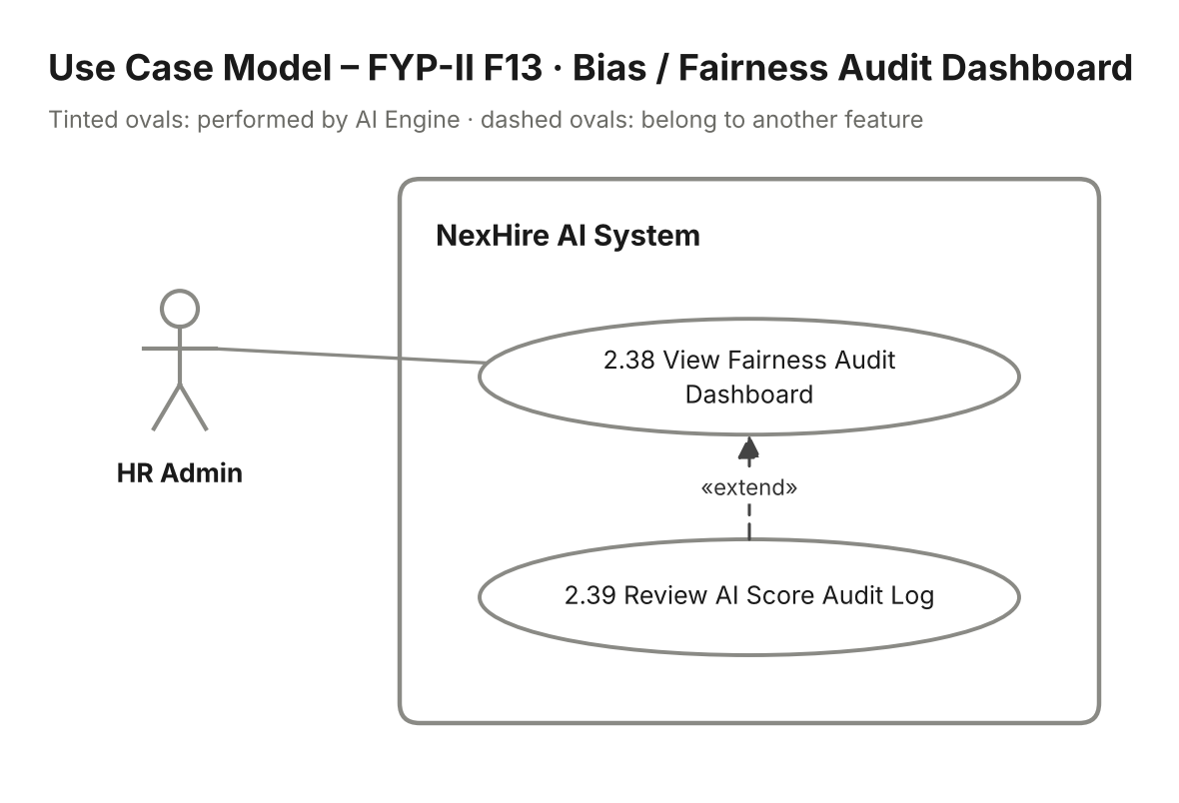
Figure 23: FYP-II F13 Bias / Fairness Audit Dashboard – use case model

Stimulus/Response Sequences:
Use Case Name: Audit AI Scoring Fairness
Description: HR Admin reviews fairness indicators of AI scoring and inspects the score audit log.
Actors: HR Admin.
Goal: Make AI screening transparent and detect possible bias.
Pre-Conditions: HR Admin is logged in. Scored applications exist.
Basic Course of Events / Main Flow
1. User Action (Step 1):
HR Admin opens "Fairness Audit" and selects a vacancy and date range (UC-2.38).
System Response:
The system shows pass and rejection rates of AI scoring by applicant group and highlights any group whose rate differs beyond a set threshold.
2. User Action (Step 2):
HR Admin clicks "View Audit Log" (UC-2.39).
System Response:
The system lists logged scores with the requirements met or missed and the weightage behind each score.
3. User Action (Step 3):
HR Admin opens one log entry.
System Response:
The system shows the full scoring detail for that application.
Alternate Flows
Alternate Flow (Insufficient Data)
User Action:
Too few applications exist to compare groups.
System Response:
The system shows "Not enough data for a reliable fairness comparison."
Exception Flow (System Errors)
System Failure
Condition:
The audit data cannot be loaded.
System Response:
The system shows "Unable to load audit data. Please try again later."
Post Conditions: HR has reviewed fairness indicators and the score audit trail.
Table 39. Bias / Fairness Audit Dashboard Stimulus/Response Sequences

Functional Requirements:
Req. ID | Description | Priority | Status
FR-2.13-01 | The system shall show AI scoring outcomes by applicant group for a selected vacancy and period. | Medium | Pending
FR-2.13-02 | The system shall highlight groups whose outcomes differ beyond a set threshold. | Medium | Pending
FR-2.13-03 | The system shall provide an audit log of AI scores with the requirements behind each score. | Medium | Pending
Table 40. Bias / Fairness Audit Dashboard Functional Requirements

