
Final Year Project
NexHire-AI – Smart Employee Recruitment & AI Hiring System

Project Team:
Aarian Kumar
2312101
Shivani
2312133
Project Supervisor:
Sir Asim Riaz
16th September 2026
Submitted in partial fulfillment of the requirements for the degree of
Bachelor of Science in Computer Science
in the
Faculty of Computing and Engineering Sciences
Shaheed Zulfiqar Ali Bhutto Institute of Science and Technology University
(SZABIST University) Karachi Campus

Contents
Contents 2
1. Introduction 3
2. Objective 3
3. Problem Description 3
4. Target Industry 3
5. Methodology 4
6. Project Scope 5
Non-Functional Requirements 5
Out of Scope 6
7. Feasibility Study 6
7.1 Risks Involved 6
7.2 Resource Requirement 7
8. Solution Application Areas 8
9. Tools/Technology 8
10. Expertise of the Team Members 9
11. Milestones 9
11.1 FYP-I Features 9
11.2 FYP-II Features 9
12. Project Schedule 10
13. Work Breakdown Structure 11
FYP-I — Semester 1 WBS (Weeks 1–14) 11
FYP-II — Semester 2 WBS (Weeks 15–28) 12
14. References 13

1. Introduction
NexHire-AI is a web-based Smart Employee Recruitment & AI Hiring System designed to take a company's hiring process from the moment a vacancy is posted through to a signed offer letter and onboarding. The platform combines an internal HR panel, a self-service candidate portal, and an AI engine into a single pipeline, so that every vacancy, applicant, interview, and hiring decision is tracked and auditable in one place instead of being scattered across emails, spreadsheets, and manual notes.

2. Objective
To design and develop an AI-assisted recruitment management system that scores each applicant against a vacancy's requirements through a position-specific structured application form, and that manages the complete hiring lifecycle of job posting, screening, interviewing, and offer generation on a role-based web platform for HR staff and candidates.

3. Problem Description
Most organizations still run recruitment through scattered emails, spreadsheets, and manual interview notes. Free-text resumes are screened by hand, which is slow, inconsistent, and biased candidates with the same underlying skills can be judged differently depending on how they present them on paper and there is no single view of how many candidates are in the pipeline or what stage each one has reached. As volume grows, good candidates fall through the cracks, screening criteria vary between reviewers, interview scheduling becomes an email back-and-forth, and there is no audit trail linking an application to its interview feedback and final decision. NexHire-AI solves this by centralizing every vacancy and applicant into one AI-assisted pipeline: each vacancy has a position-specific structured application form built from its required skills and qualifications, so every candidate's data arrives in the same comparable shape, the AI engine then scores how completely each submission fulfils the job's requirements, flags duplicate applicants before they reach HR, logs interviews and feedback against a single application record, and generates offer letters, making the process from first application to signed offer fast, consistent, and fully traceable.

4. Target Industry
Information Technology and Human Resources / HR-Technology (HR-Tech). The platform is designed as an industry-agnostic recruitment tool and is directly applicable to any organization that hires staff on an ongoing basis, including IT, Education, Finance, E-commerce, and Manufacturing, but its primary application area is corporate HR departments and recruitment agencies.

5. Methodology
The project will be developed following an Agile methodology, with work organized into weekly sprints across two semesters (FYP-I and FYP-II). This allows the AI engine, HR panel, and candidate portal to be built and tested incrementally. The intended technical approach includes:
- A React-based frontend serving both the HR panel and the candidate portal, with role-based routing.
- A REST API backend (Node.js/Express) handling authentication, vacancy and application workflows.
- A Python-based AI microservice for structured application-form evaluation (matching submitted skills/qualifications against each job's required fields), candidate ranking, duplicate-candidate detection (using profile/contact similarity), AI-generated interview questions, and candidate score prediction.
- No resume/CV upload: each vacancy has a dynamic, position-specific application form (built by HR from the job's required skills/qualifications), and candidates apply by filling that structured form rather than attaching a PDF/DOCX resume, so every applicant's data arrives in a consistent, directly comparable shape.
- Two candidate approaches for implementing the AI integration have been identified: (1) custom-coded AI logic, where the scoring, matching, and generative features are built directly into the Python microservice using AI APIs and/or the team's own algorithms; or (2) a visual workflow-automation tool such as n8n, where AI calls and data hand-offs are configured as automation nodes rather than hand-written code. One of these two approaches will be selected during early FYP-I based on the team's technical comfort, integration depth needed with the platform's own authentication/database layer, and development time available, and used consistently across the AI engine.
- JWT-based authentication with role-based access control (HR Admin vs. Candidate).
- A relational MySQL database, since hiring data : candidates, jobs, applications, interviews, offers is inherently relational.
- Automated testing and CI for each module: unit tests run automatically on every push via GitHub Actions, so a broken function is caught before it merges into the main branch.
- Third-party integrations for calendar sync (Google APIs) alongside an AI chatbot. Job-board syndication (LinkedIn/Indeed) will be built as a simulated/mocked integration, since both platforms restrict their real posting APIs to approved enterprise/ATS partners and are not accessible for a student project; the module will be designed so a real API key can be dropped in later without redesigning the feature.

6. Project Scope
The project will cover the following major functionalities:
- HR Vacancy Management: Create, edit, close, and manage vacancies with structured requirements such as skills, experience, and certifications.
- Candidate Portal: Candidate registration, profile management, vacancy browsing, and position-specific structured application forms.
- Application Management: Centralized application inbox for HR to manage applications received for each vacancy.
- AI-Based Screening & Ranking: Automatically evaluate applications against vacancy requirements and generate a requirement-fulfillment percentage, ranking, and match categories.
- AI Duplicate Detection: Identify and flag potential duplicate candidate applications.
- Interview & Feedback Management: The system will support interview scheduling slots, assign interviewers/panel, physical interview tracking, and private HR feedback. AI will analyze the recorded feedback to assist HR in evaluating candidates, without making the final hiring decision.
- Recruitment Pipeline: Shortlist, reject, and move candidates through different recruitment stages.
- AI Assistance: Generate role-specific interview questions, and draft offer letters entirely through AI from HR-provided guidelines.
- Candidate Support: Candidate dashboard for application/interview status and an AI chatbot for recruitment-related FAQs.
- Hiring Analytics: Dashboard showing recruitment pipeline, vacancy status, department-wise analytics, and exportable hiring reports.
- Additional Recruitment Features: Simulated job-board syndication, calendar synchronization, employee referral tracking, and an AI bias/fairness audit dashboard.
- Deployment & Documentation: End-to-end testing, deployment, and project documentation.

Non-Functional Requirements
- Security: JWT authentication, hashed passwords, HTTPS only communication, and role based access between HR and candidates.
- Performance: Candidate list, search, and AI ranking return results in under 2 seconds at scale.
- Scalability: The system should comfortably handle hundreds of open vacancies and thousands of applications.
- Usability: The HR panel and candidate portal are both usable on mobile and tablet browsers.
- Reliability: Application and interview data is backed up regularly.
- Maintainability: Clean, documented code so new AI capabilities can be added without a rewrite.

Out of Scope
- There will be no CV/resume upload or parsing. Candidates will apply through vacancy specific structured forms, and AI will score applications based on HR-defined requirements.
- Payroll, employee onboarding, attendance, leave management, performance appraisal, and other post-hiring HR activities are outside the scope.
- AI features will use pre-trained models, existing NLP libraries, or third-party AI APIs rather than training new AI models from scratch.
- Native mobile applications are out of scope; the system will be responsive for mobile and tablet browsers.
- Real job posting to LinkedIn/Indeed will not be implemented; job-board syndication will be simulated for demonstration purposes.

7. Feasibility Study
Given the two-semester FYP timeline, the project scope above is achievable if the AI screening features are built early (FYP-I) so the remaining semester can focus on the interview, offer, and analytics workflow that depends on it.

7.1 Risks Involved
Risk | Mitigation
Structured forms are more rigid than a free-text resume and may not capture a candidate's full context (side projects, non-standard career paths). | Include an optional short free-text/portfolio-link field per application for context, without using it as a scoring input, so HR can still review it manually for borderline candidates.
AI ranking/scoring could introduce or reinforce bias. | Score strictly against declared job-required fields, keep a manual-review category ("Possible Match") rather than binary accept/reject, and log all scores for auditability.
Scope creep from the long feature list (six AI capabilities, dashboard, offers). | Follow the Milestones, build the mandatory AI screening pipeline first, treat interview-question generation and score-prediction widgets as fast-follow items.
Performance degradation as application volume grows. | Design the schema and ranking queries for scale from the start, add indexing and pagination, target the sub 2 second response goal via early load testing.
LinkedIn/Indeed restrict real job-posting API access to approved enterprise/ATS partners, making live integration infeasible within the project timeline. | Build the job-board syndication feature as a simulated/mocked integration that demonstrates the workflow end-to-end, structured so a real partner API key can be added later without redesigning the module.

7.2 Resource Requirement
- Development laptops with at least 8GB RAM for running the frontend, backend, and AI services locally.
- Cloud hosting / a free-tier deployment platform for the web app, database, and AI microservice.
- Access to an AI/NLP library or API for semantic skill-matching (e.g. recognizing "JS" and "JavaScript" as the same skill) and text-generation features (interview questions, offer letters).
- A MySQL database instance (local or cloud-hosted).
- A shared Git repository (GitHub/GitLab) for version control and collaboration.
- A small set of sample job requirement templates and test candidate form submissions for testing the AI scoring pipeline.

8. Solution Application Areas
Hiring is a recurring, resource-intensive process in virtually every organization, so NexHire-AI has broad real-world value:
- Corporate HR departments can replace spreadsheet and email-based hiring with a single tracked pipeline, cutting time-to-hire.
- Recruitment web-portals can use the AI ranking and duplicate-detection features to screen high volumes of applicants for multiple clients consistently.
- Startups and SMEs without a dedicated ATS (Applicant Tracking System) gain enterprise-style hiring workflows at low cost.
- University career services or campus recruitment drives can use the candidate portal and dashboard to manage bulk graduate hiring.

9. Tools/Technology
Layer | Technology
Frontend | React.js (HR panel and candidate portal)
Backend | Node.js/Express
Database | MySQL
AI Services | Python structured-form requirement-fulfillment scoring, semantic skill-matching, candidate ranking, and question/letter generation
AI Integration Approach | Option 1: custom-coded logic in the Python microservice (own algorithms + direct AI API calls). Option 2: a visual workflow tool (e.g. n8n) orchestrating the AI calls. One will be finalized in early FYP-I.
Authentication | JWT with role-based access control (HR vs. Candidate), hashed passwords, HTTPS-only
Version Control | Git / GitHub
Deployment | Docker containers on a cloud platform (e.g. Render, Railway, or AWS free tier)
Design/Prototyping | Figma
Third-Party Integrations | Google/Outlook Calendar API (scheduling); job-board posting simulated (LinkedIn/Indeed restrict real API access to approved partners)

10. Expertise of the Team Members
Our team has completed relevant coursework in Web Technologies, Database Systems, and Artificial Intelligence/Machine Learning prior to undertaking this project, and has prior project experience with full-stack web development (React and a REST backend) and relational databases. Team members hold a shared interest in applied AI and HR-technology products, and the project's AI-parsing spike planned for early FYP-I will address any remaining gap in NLP-specific experience before the core pipeline is built.

11. Milestones
The one-year project is organized around the modules defined in the functional requirements: authentication, job/application management, the mandatory AI screening engine, interviews and feedback, offers and assessments, and the hiring dashboard. FYP-I focuses on the foundation and the mandatory AI screening pipeline; FYP-II builds the interview, offer, assessment, and analytics layers on top of it.

11.1 FYP-I Features
- Project scaffolding, database schema design, HR Admin and Candidate role setup with JWT authentication.
- Job Vacancy module: create/edit/close vacancies with title, description, department, and required skills/qualifications defined as structured fields, which double as the criteria for that vacancy's application form and AI scoring.
- Candidate portal: account signup, profile, browse vacancies, apply by filling that vacancy's position-specific structured application form (no CV/resume upload).
- Application Inbox: single queue of all applications received, per vacancy.
- AI Application Form Evaluation & Ranking (mandatory): each submitted form is automatically scored against the vacancy's required fields, producing a requirement-fulfillment percentage and a ranked candidate list.
- AI Duplicate Candidate Detection: flag likely duplicate applicants before they reach the HR panel.
- Strong Match / Possible Match / Not a Fit tagging of ranked candidates.

11.2 FYP-II Features
- Interview scheduling: book and track interview slots per candidate, assign interviewers to the right panel members.
- Interview Management: HR will schedule physical interviews through the portal and record private, free-text feedback for each candidate after the interview. AI will analyze the feedback and provide decision-support insights, while the final hiring decision will remain with HR.
- Structured interview feedback capture, tied to each interview round.
- Shortlist / Reject pipeline actions to move candidates between stages with one action.
- AI-generated interview questions per role.
- AI-drafted offer letters: HR sets the guidelines (salary band, start date, role terms) and the AI engine drafts the complete letter automatically, linked to the correct application.
- Hiring dashboard: pipeline counts by stage, vacancy status, department-wise hiring analytics, and exportable hiring reports.
- AI chatbot for candidates: answers FAQs.
- Candidate Dashboard shows application/interview status automatically, without candidates needing to email HR.
- Job-board syndication (simulated): a "Post to LinkedIn/Indeed" action with a mocked success response, demonstrating the workflow and leaving the module ready for a real partner API key in the future, since both platforms gate real posting access behind enterprise/ATS partner approval.
- Calendar sync: two-way sync with Google Calendar for interview scheduling.
- Referral tracking: existing employees can refer candidates, with referral-source hiring outcomes tracked.
- Bias/fairness audit dashboard: monitors whether AI scoring disproportionately filters out particular applicant groups, keeping the AI screening process transparent and accountable.
- End-to-end testing, deployment, and documentation.

12. Project Schedule
A preliminary one-year schedule mapping the milestones above onto FYP-I and FYP-II is shown below, followed by the corresponding Gantt chart:
Milestone | Semester | Weeks | Duration
Setup, Auth & DB Schema | FYP-I | Weeks 1–2 | 2 weeks
Job Vacancy & Candidate Portal (apply flow) | FYP-I | Weeks 3–5 | 3 weeks
AI Application Form Evaluation, Ranking & Skill Matching | FYP-I | Weeks 6–9 | 4 weeks
Duplicate Candidate Detection & Match Tagging | FYP-I | Weeks 10–11 | 2 weeks
FYP-I Testing, Documentation & Evaluation | FYP-I | Weeks 12–14 | 3 weeks
Interview Scheduling & Feedback Module | FYP-II | Weeks 15–17 | 3 weeks
AI Interview Question Generation & Score Prediction | FYP-II | Weeks 18–20 | 3 weeks
Offer Letter Generation | FYP-II | Weeks 21–22 | 2 weeks
Hiring Dashboard & Reports | FYP-II | Weeks 23–25 | 3 weeks
Final Integration, Testing, Deployment & Documentation | FYP-II | Weeks 26–28 | 3 weeks
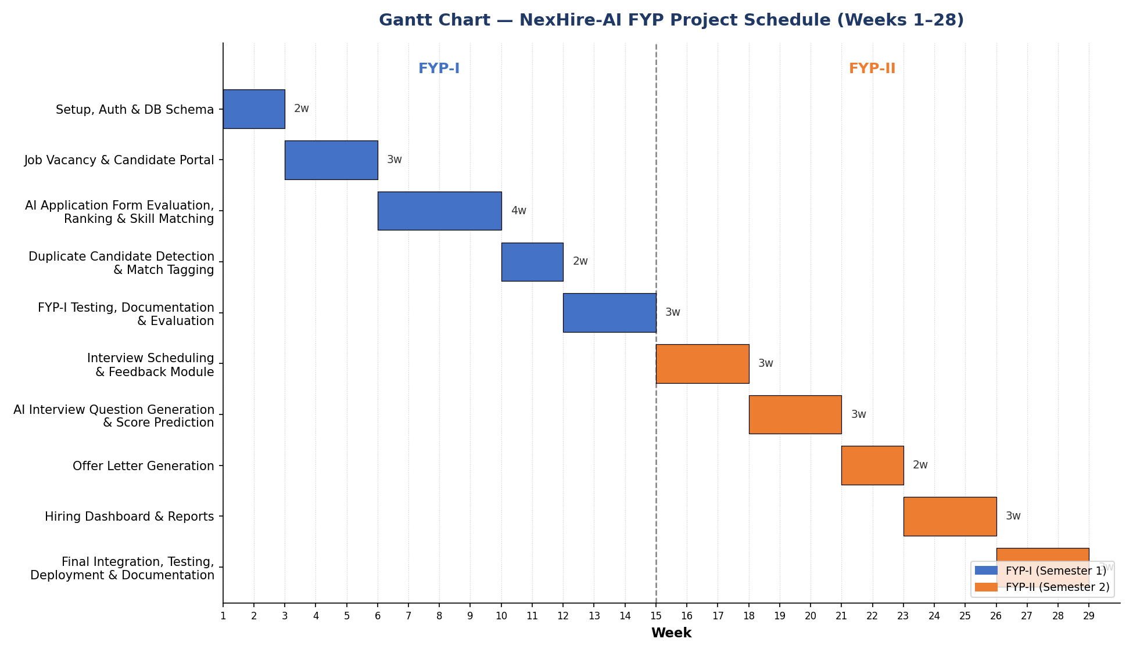
Figure 1: Gantt chart of the 28-week NexHire-AI project schedule (FYP-I and FYP-II).

13. Work Breakdown Structure
The work is broken into two semester-level WBS phases, each covering half of the milestones above and matching the schedule and Gantt chart in Section 12:

FYP-I Semester 1 WBS (Weeks 1–14)
- Phase 1 Setup, Auth & DB Schema: requirements finalization, database design, project scaffolding, HR/Candidate role authentication. (Weeks 1–2)
- Phase 2 Job Posting & Applications: vacancy CRUD with structured requirement fields, candidate signup/profile, dynamic application-form rendering and apply flow. (Weeks 3–5)
- Phase 3 AI Application Form Evaluation, Ranking & Skill Matching: application-form evaluation pipeline, skill-matching engine, requirement-fulfillment scoring, ranking algorithm. (Weeks 6–9)
- Phase 4 Duplicate Candidate Detection & Match Tagging: duplicate-candidate detection logic and Strong Match / Possible Match / Not a Fit tagging. (Weeks 10–11)
- Phase 5 FYP-I Testing, Documentation & Evaluation: unit/integration testing of the above modules, documentation. (Weeks 12–14)

FYP-II Semester 2 WBS (Weeks 15–28)
- Phase 6 Interview Scheduling & Feedback: scheduling, interviewer assignment, structured feedback, shortlist/reject actions. (Weeks 15–17)
- Phase 7 AI Interview Question Generation & Score Prediction: role-specific interview questions and candidate score-prediction widget. (Weeks 18–20)
- Phase 8 Offer Letter Generation: offer-letter templating and AI-drafted generation. (Weeks 21–22)
- Phase 9 Hiring Dashboard & Reports: hiring analytics, pipeline view, department-wise breakdown, monthly report export. (Weeks 23–25)
- Phase 10 Final Integration, Testing, Deployment & Documentation: end-to-end testing, deployment, final documentation, and FYP-II defense. (Weeks 26–28)
Deliverables: two Work Breakdown Structures, one per semester, each representing that semester's tasks, milestones, and timeline in detail, supported by the overall project workflow shown below:
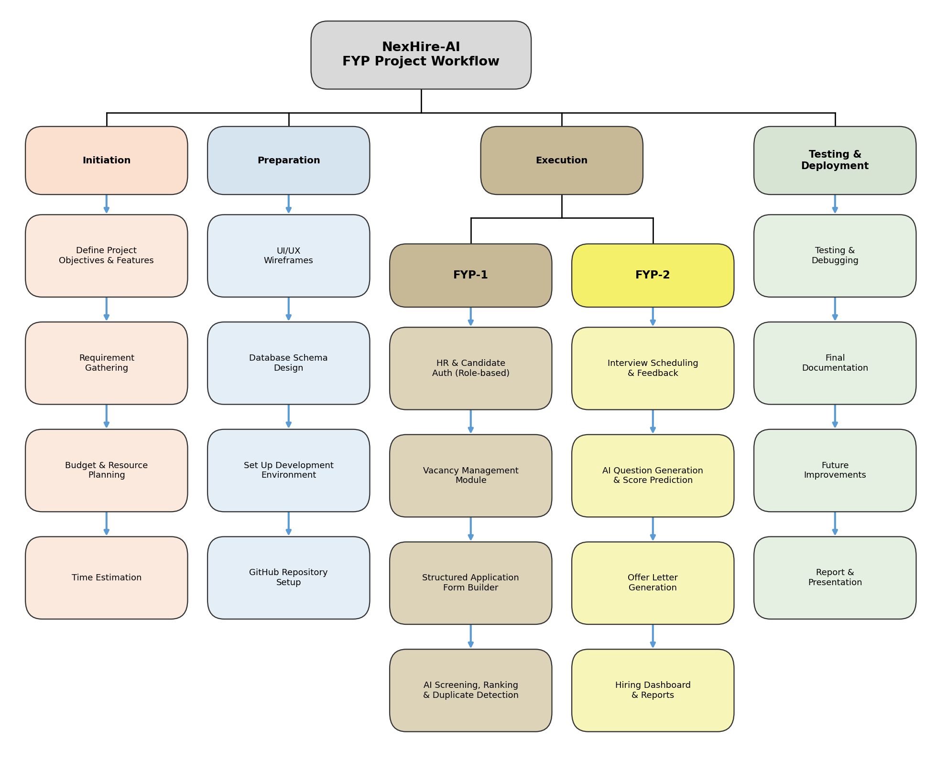
Figure 2: NexHire-AI project workflow, from initiation through testing and deployment.

14. References
[1] SZABIST University, Final Year Project Proposal Template, Faculty of Computing and Engineering Sciences, SZABIST Karachi Campus.
[2] M. Jones, J. Bradley, and N. Sakimura, JSON Web Token (JWT), RFC 7519, Internet Engineering Task Force (IETF), 2015.
[3] P. A. Grassi et al., Digital Identity Guidelines: Authentication and Lifecycle Management, NIST Special Publication 800-63B, National Institute of Standards and Technology.
[4] MySQL, MySQL 8.0 Reference Manual, Oracle Corporation.
[5] S. Bird, E. Klein, and E. Loper, Natural Language Processing with Python, O'Reilly Media, 2009.

