**IRevolution: A Data-driven Exploration of Apple’s Iphone Impact in India**

1. **INTRODUCTION** 
   1. **Overview**

The world has changed as a consequence of the increasing use of Smartphone. This smartphone will often in valuable insight into the transformative impact of India technological landscape and the lives of its consumer using advance data analytics techniques and analyzing large data set.

* 1. **Purpose**

In order to shed light on important factors like market penetration, customer performance, economics ramifications, and societal changes , this research report will performs a data driven invertigation of the impact of the iphone in india.

1. **Problem Definition and Design Thinking**
   1. **Empathy map**

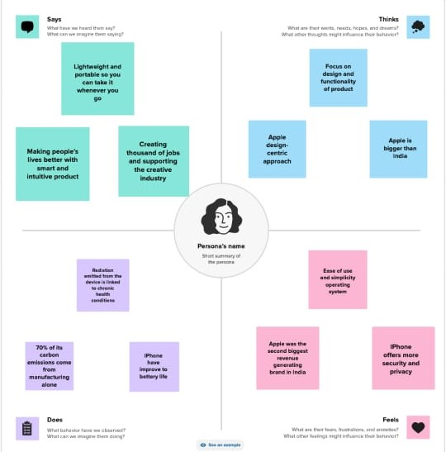

* 1. **Ideation & Brainstorming map**

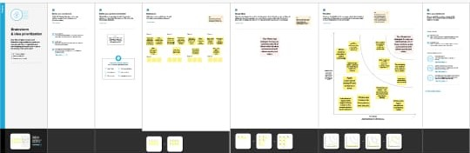

**3.RESULT**

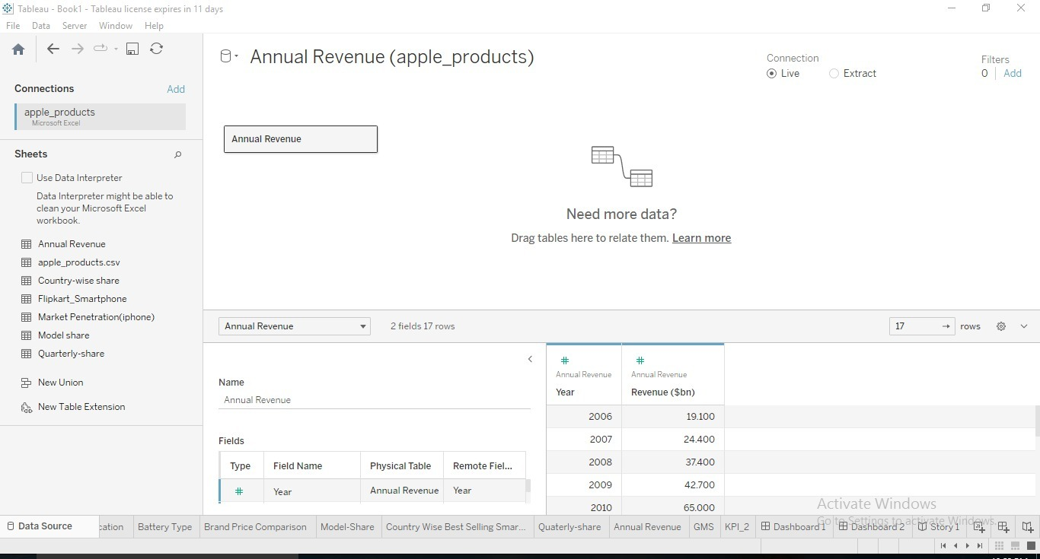

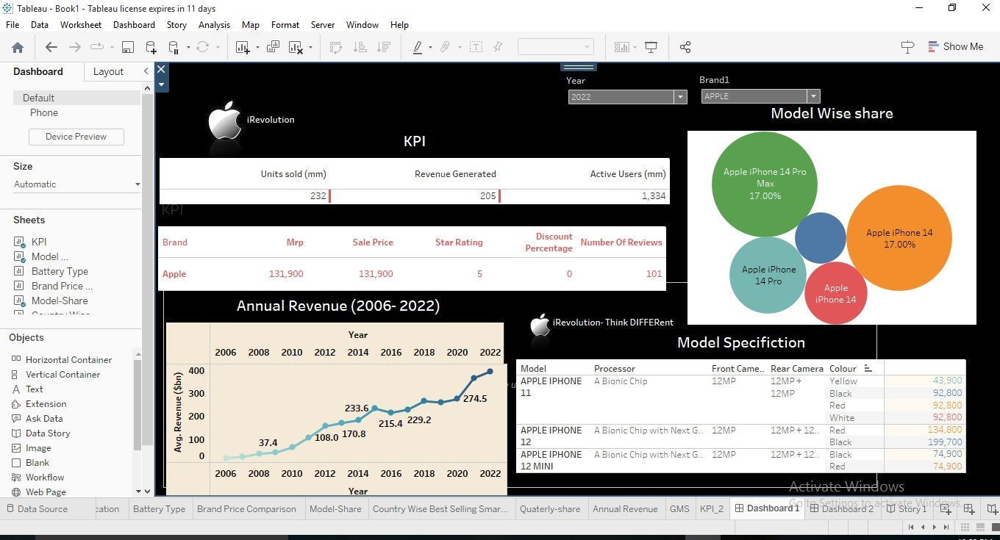

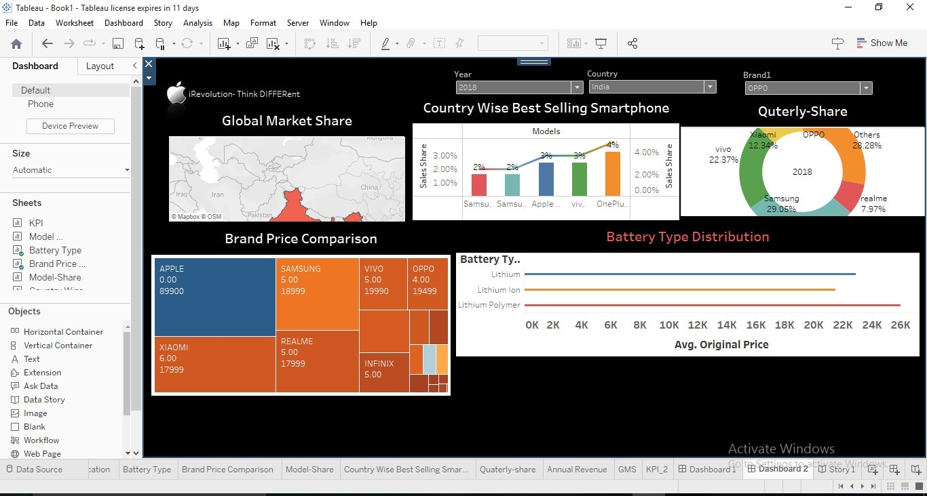

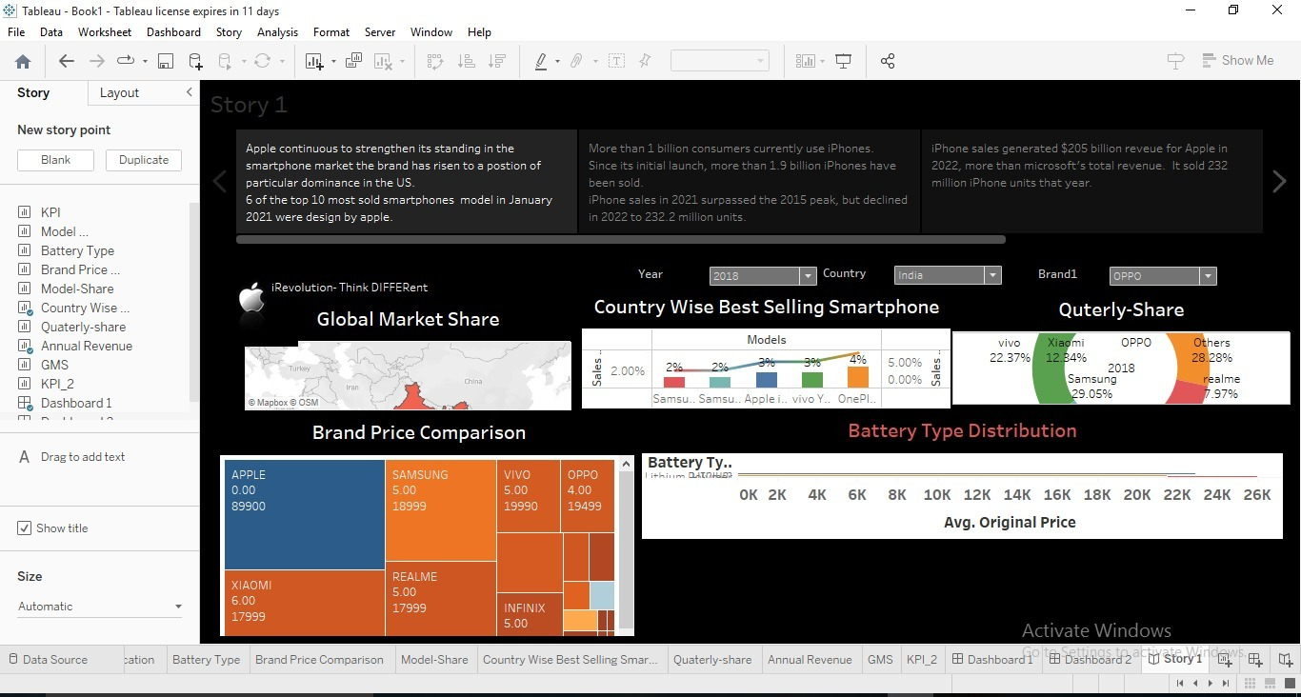

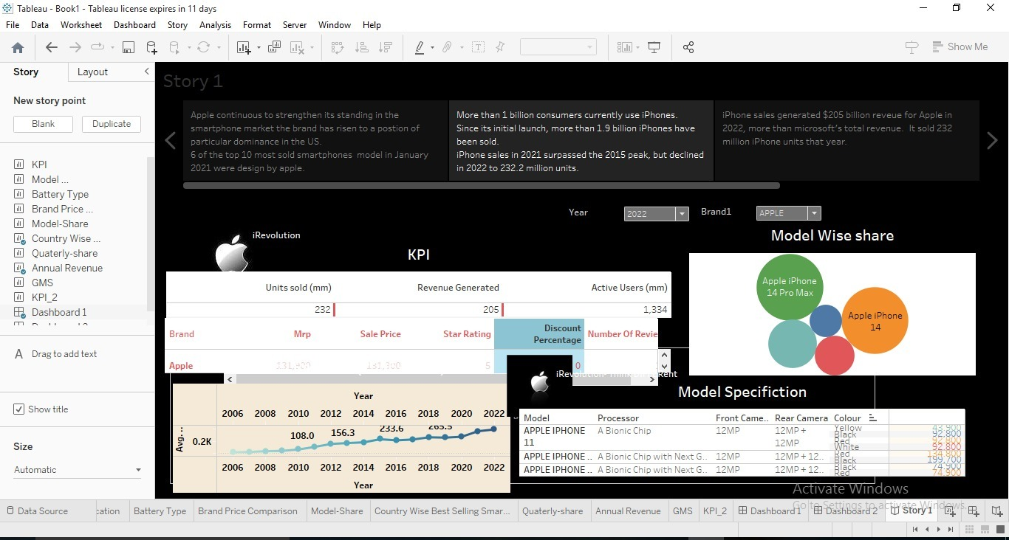

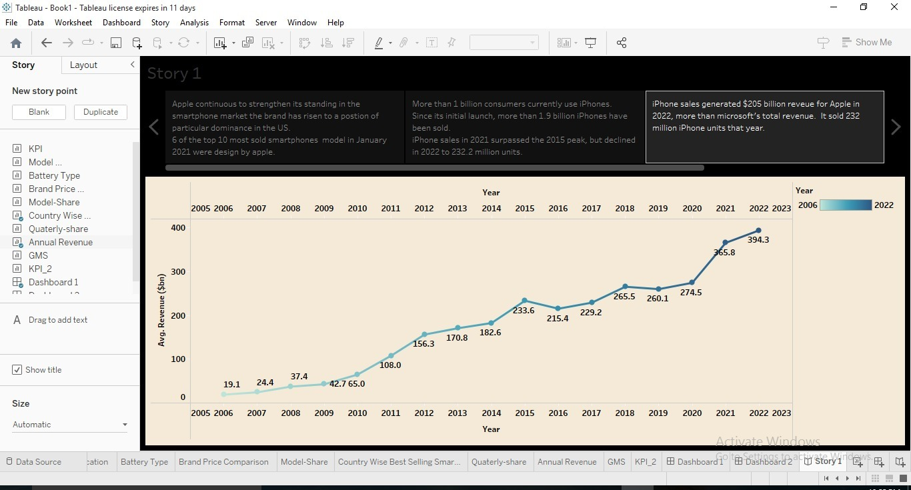

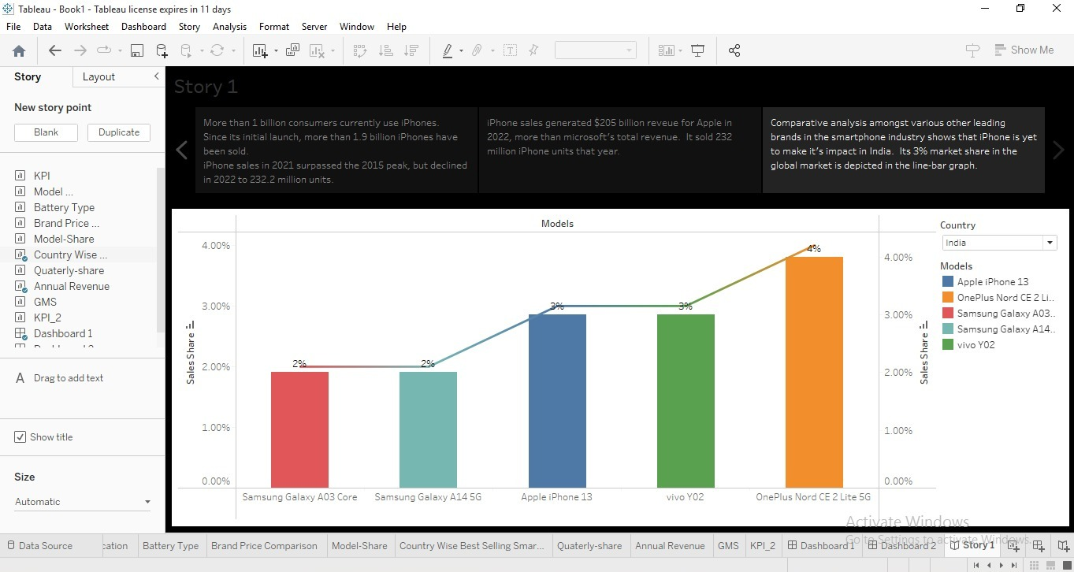

**4.ADVANTAGES & DISADVANTAGES**

* **Advantages-The iPhone is an ideal to us if you own other Apple products, uch as Mac computers, iPads and iPods. With Apple’s free iCloud service, the iPhone shares data, music, photos and contacts with all your other Apple products. It’s an added convenice that takes the hassle out of transferring data between products.**
* **The are several other features and advantages that makes iPhone must-have amoung users**
* **Disadvantages-The user software lacks a robust software experience, service like Apple Pay haven’t been lauched in India. The user experienceis still subpar, the Samsun pay and Google Pay have been operating in the region for while now**
* **The cost owning an iPhone is higher in India when compared to other countries**

**5 APPLICATION**

More people conduct all of their internet needs on their smartphone because you are able to download hundreds of apps ranging from calenders, to-do lists, emails, games, books, movies, and music. On my personl phone I have word, excel, and Powerpoint, I do not use them but if I left my computer at home I would be able to connect my phones toa laptop and conduct a presentation from it.

**6 CONCLUSION**

**It is apparent that the iphone was, and still, a remarkable invention of technological advancement.**

**7 FUTURE SCOPE**

**Scale up production in India by over five-fold to around $40 billon (about 3.32 lakh crore)**