**PROJECT REPORT**

**INDIA’S AGRICULTURAL CROP**

**PRODUCTION ANALYSIS**

**(1997 – 2021)**

**Submitted By**

**R. Aksha : 201930922203**

**X.K. Pushpa Anushya Bharathi : 202132517201**

**L. Shajiv : 202132517202**

**INTRODUCTION:**

**OVERVIEW:**

India’s production of food grains has been increasing every year, and India is among the top producers of several crops such as wheat, rice, pulses, sugarcane and cotton. It is the highest producer of milk and second highest producer of fruits and vegetables. In 2021, India contributed 25% to the world’s pulses production, the highest for any one country, 22% to the rice production and 13% to the wheat production. It also accounted for about 25% of the total quality of cotton produced, besides being the second highest exporter of cotton for the past several year.

**PURPOSE:**

Agriculture is the foundation of the Indian economy. The population of India mostly depends on agriculture for their livelihood and agriculture contributes to 40 percent of the total GDP of the country. The Farmers require ongoing education to stay aware of fast-moving developments in technology, science, business management, and an array of other skills and fields that affect agricultural operations.

**PROBLEM DEFINITION & DESIGN THINKING:**

**EMPATHY MAP:** 1

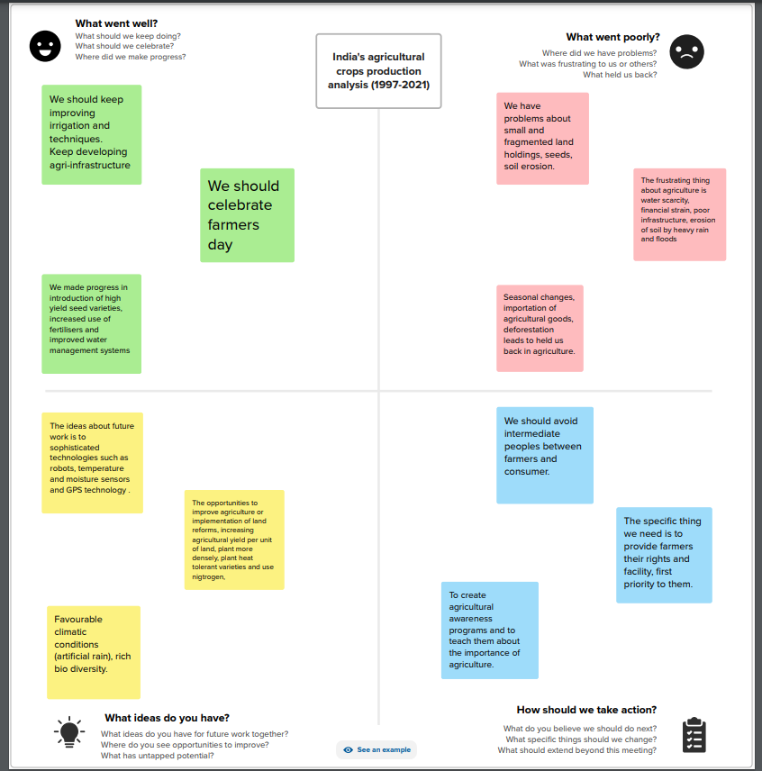

**IDEATION & BRAINSTORMING MAP:**

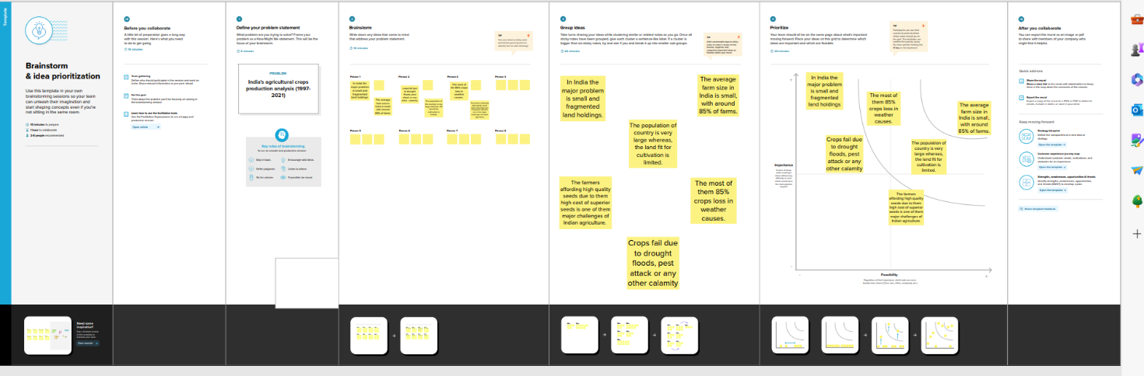

**RESULT:**

In this project we created the data visualization such as dashboard and story using the dataset provided.

**DASHBOARD 1:**

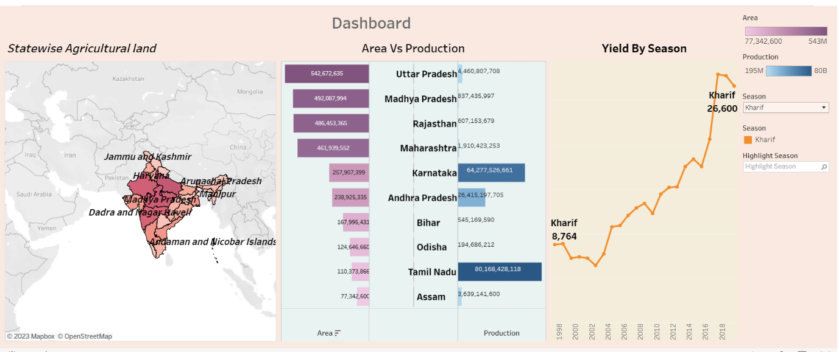

**DASHBOARD 2:**

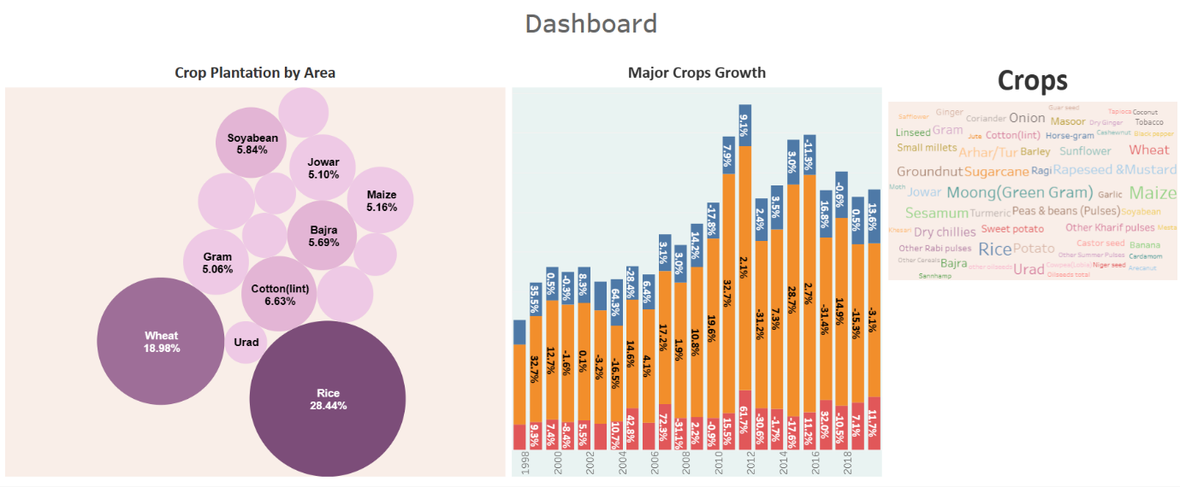

**DASHBOARD 3:**

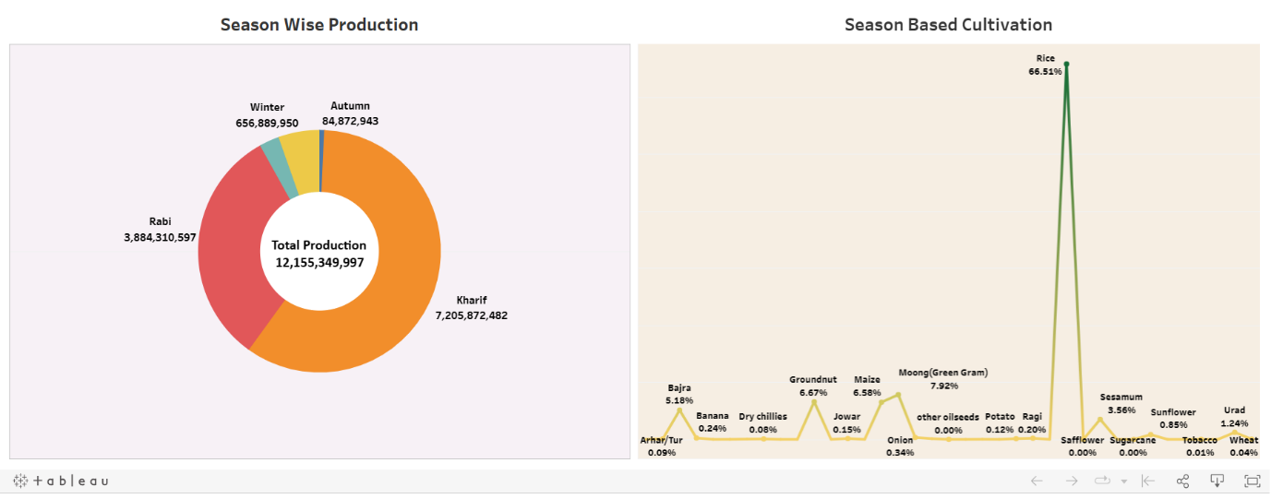

**STORY 1:**

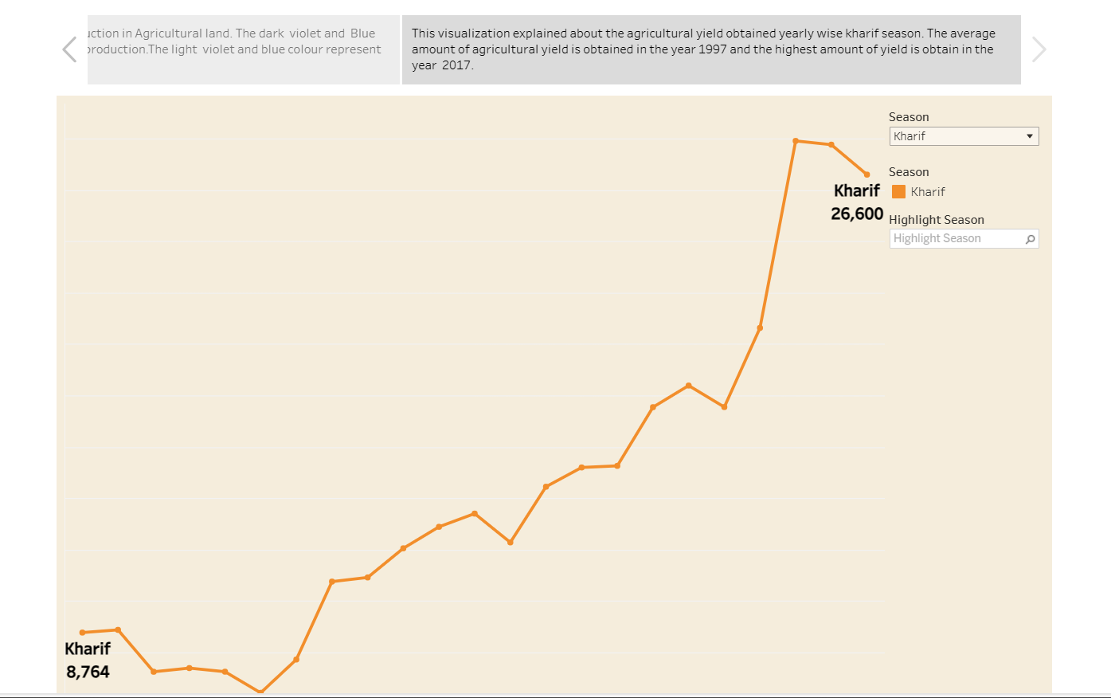

**STORY 2:**

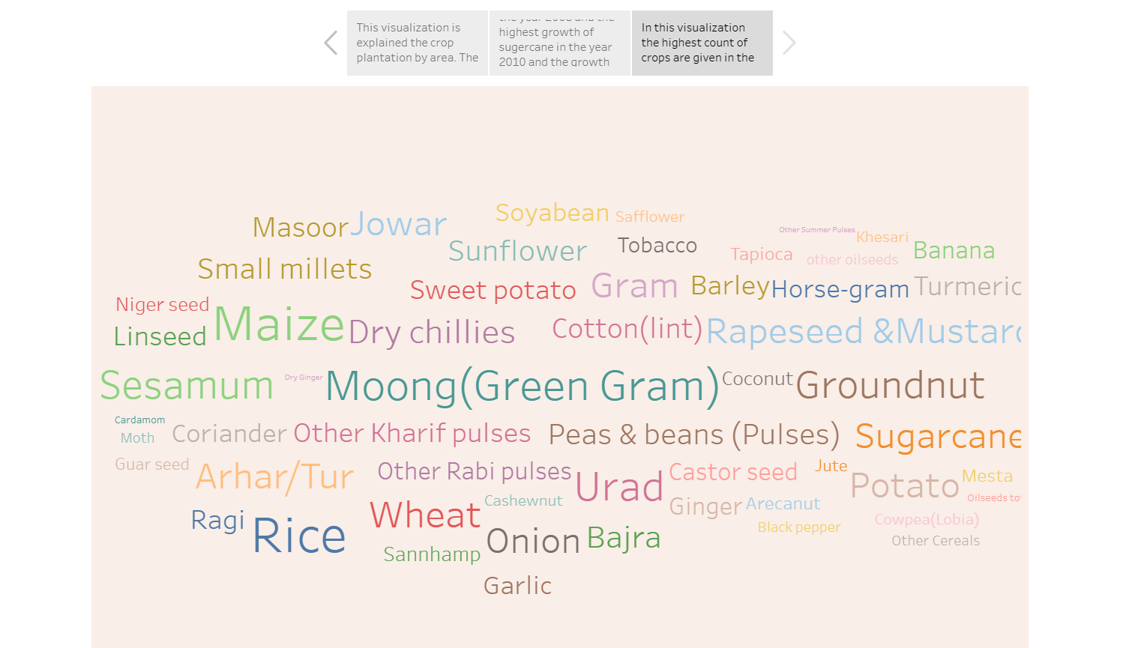

**STORY 3:**

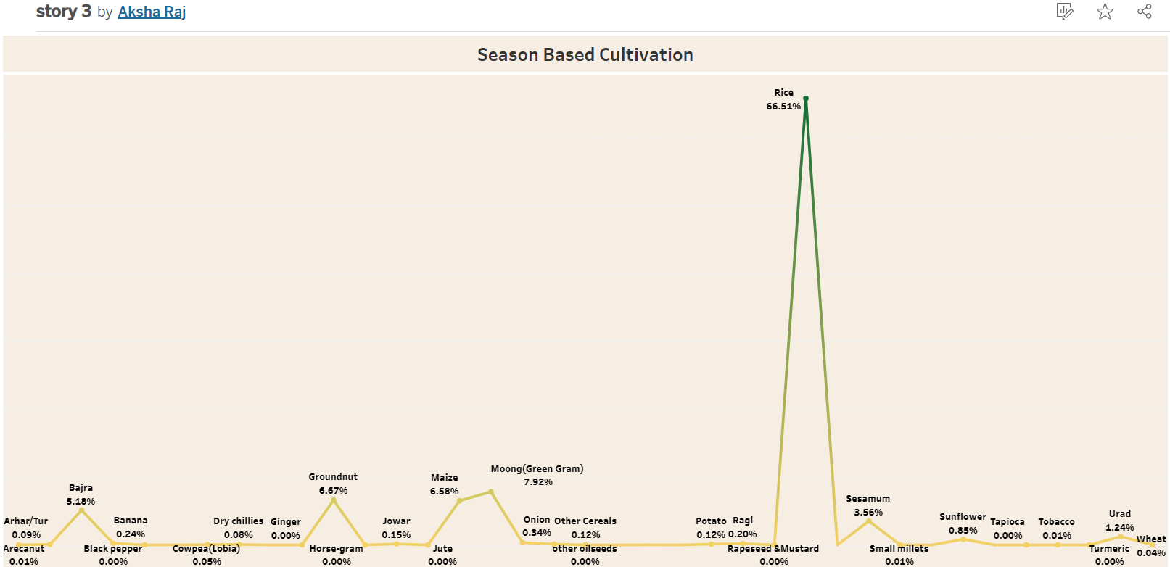

**ADVANTAGES AND DISADVANTAGES:**

**ADVANTAGES:**

Farmers no longer have to apply water, fertilizers, and pesticides uniformly across entire fields. Instead, they can use the minimum quantities required and target very specific areas, or even treat individual plants differently. Benefits include:

* Higher crop productivity
* Decreased use of water, fertilizer, and pesticides, which in turn keeps food prices down
* Reduced impact on natural [ecosystems](https://www.nifa.usda.gov/glossary#E)
* Less runoff of chemicals into rivers and groundwater
* Increased worker safety

In addition, robotic technologies enable more reliable monitoring and management of natural resources, such as air and water quality. It also gives producers greater control over plant and animal production, processing, distribution, and storage, which results in:

* Greater efficiencies and lower prices
* Safer growing conditions and safer foods
* Reduced environmental and ecological impact

**DISADVANTAGES:**

"Slow agricultural growth is a concern for policymakers as some two-thirds of India's people depend on rural employment for a living. Current agricultural practices are neither economically nor environmentally sustainable and India's yields for many agricultural commodities are low. Poorly maintained irrigation systems and almost universal lack of good extension services are among the factors responsible.

The biggest problem of farmers is the low price for their farm produce. A recent study showed that proper pricing based on energy of production and equating farming wages to Industrial wages may be beneficial for the farmers.

**APPLICATION:**

Here we are some simple and concise applications of analyzing India’s agriculture crop production data from the year 1997 to 2021.

**Policy planning:**

Assists policymakers in designing effective agricultural policies.

**Market insights:**

Offers insights for the traders and business in the agriculture sector.

**Climate adaptation:**

Aids in adapting farming practices to changing weather patterns.

**CONCLUSION:**

**Data collection & extraction:**

Connect dataset with tableau

Collect the dataset

**Data preparation:**

Prepare the date for visualizations

**Data visualizations:**

No of unique visualizations

**Dashboard:**

Responsive and design of dashboard

**Story:**

No of scenes of story

**FUTURE SCOPE:**

The future scope of India’s agriculture crop production analysis is vast and diverse, encompassing everything from sustainable farming practices to cutting-edge technology adoption and policy development. Leveraging historical data can be a cornerstone in addressing the challenges and opportunities in India agriculture in the years to come. Data analysis can inspire the creation of innovative agricultural technology solutions.