**HACKATHON – 2**

**SQL Script:**

CREATE DATABASE LibraryDB;

USE LibraryDB;

CREATE TABLE Books (

BookID INT PRIMARY KEY AUTO_INCREMENT,

Title VARCHAR(255),

Author VARCHAR(255),

Genre VARCHAR(100),

ISBN VARCHAR(20),

AvailableCopies INT

);

CREATE TABLE Members (

MemberID INT PRIMARY KEY AUTO_INCREMENT,

Name VARCHAR(255),

Email VARCHAR(255),

PhoneNumber VARCHAR(15)

);

CREATE TABLE Borrowing (

BorrowID INT PRIMARY KEY AUTO_INCREMENT,

BookID INT,

MemberID INT,

BorrowDate DATE,

DueDate DATE,

ReturnDate DATE,

FOREIGN KEY (BookID) REFERENCES Books(BookID),

FOREIGN KEY (MemberID) REFERENCES Members(MemberID)

);

INSERT INTO Books (Title, Author, Genre, ISBN, AvailableCopies) VALUES

('The Great Gatsby', 'F. Scott Fitzgerald', 'Fiction', '9780743273565', 3),

('1984', 'George Orwell', 'Dystopian', '9780451524935', 5);

INSERT INTO Members (Name, Email, PhoneNumber) VALUES

('Alice Johnson', 'alice@example.com', '555-1234'),

('Bob Smith', 'bob@example.com', '555-5678');

INSERT INTO Borrowing (BookID, MemberID, BorrowDate, DueDate) VALUES

(1, 1, '2025-04-01', '2025-04-15'),

(2, 2, '2025-04-03', '2025-04-17');

SELECT * FROM Books

**Query result:**

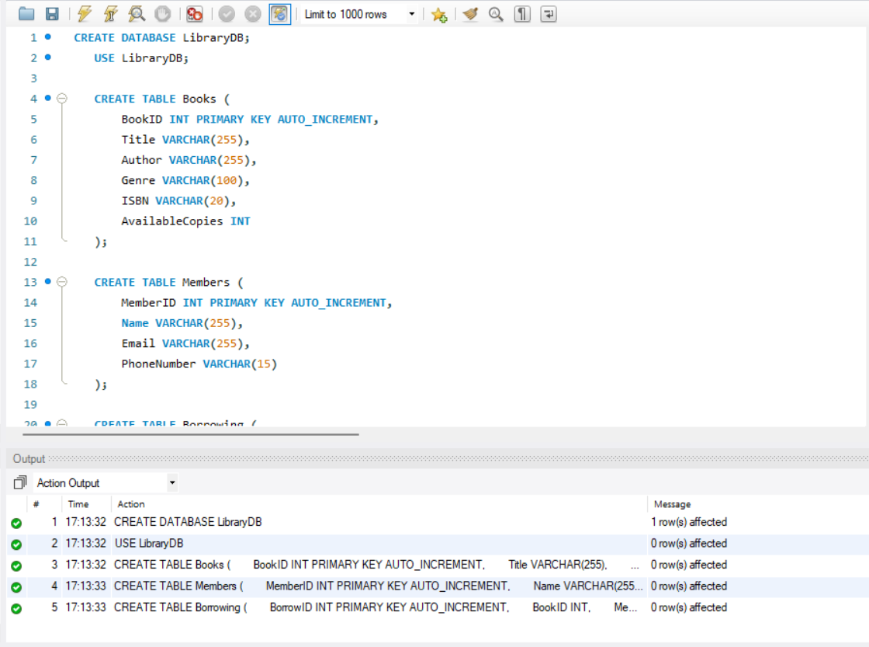

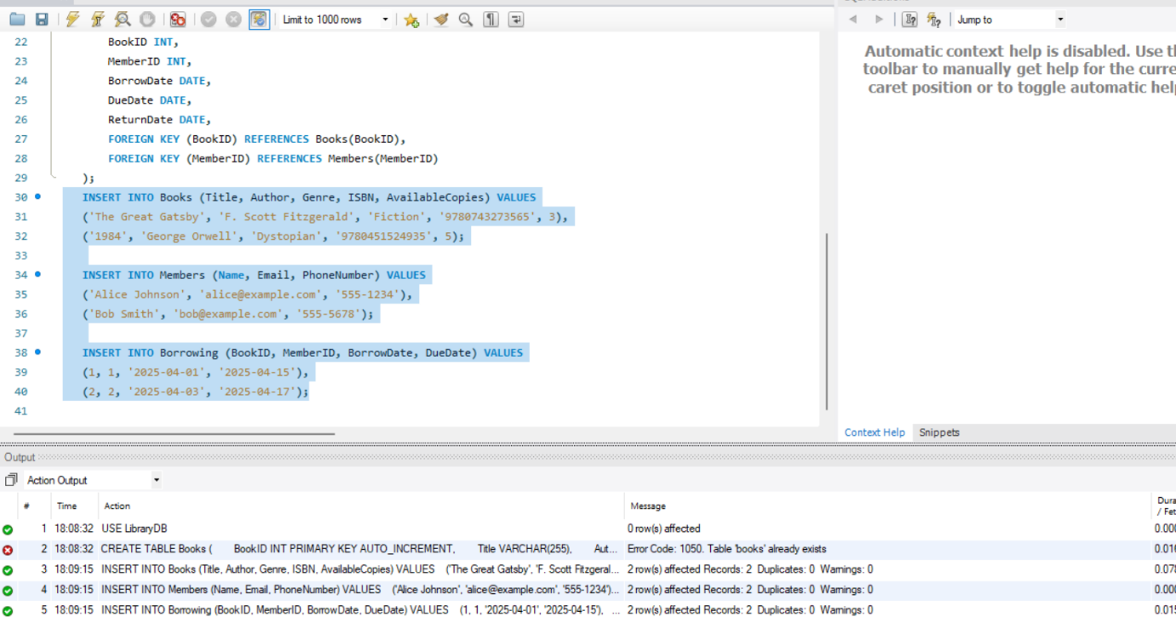

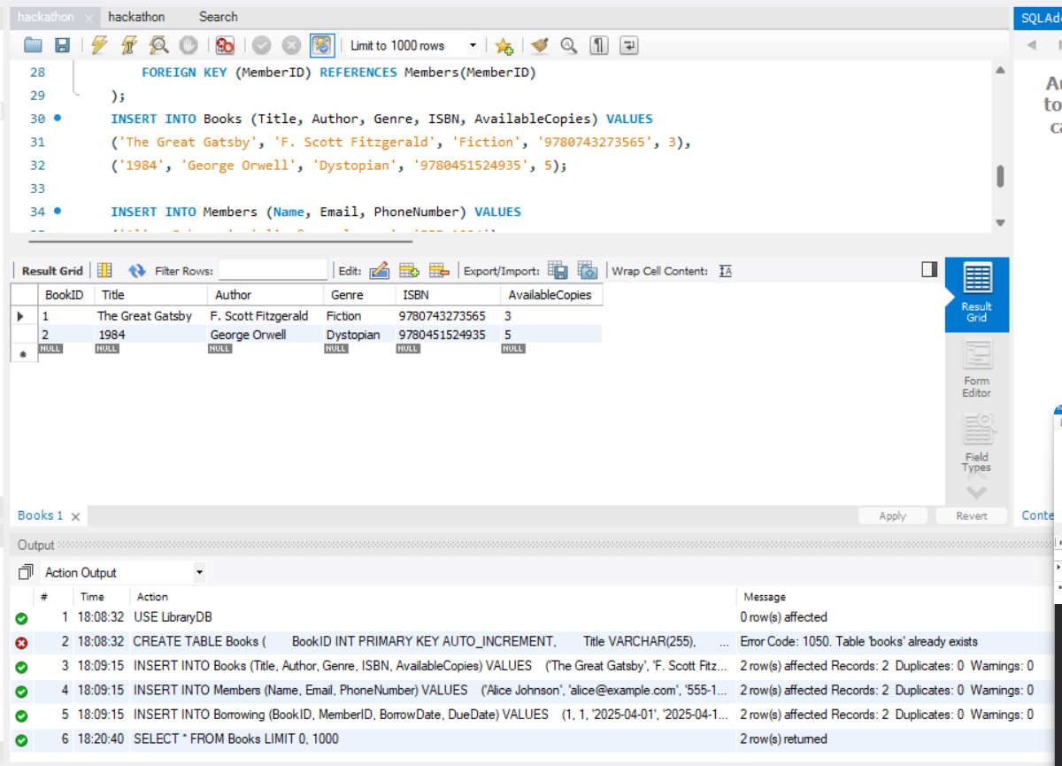

**ER Diagram:**

