Anthony Saieva (Narin)
UNI: an2804
Example 1:
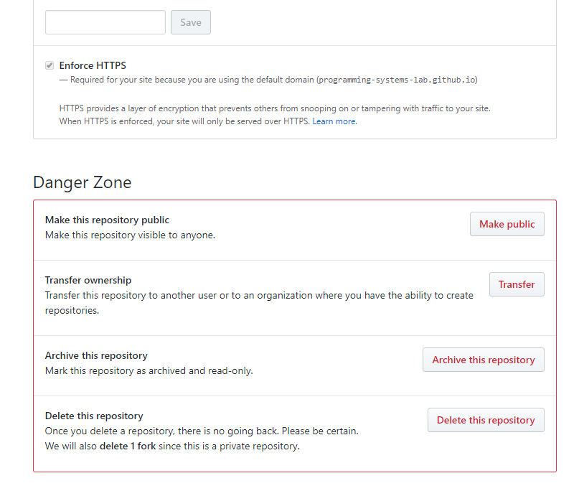

This is from github settings.
I think its a positive example of error prevention.

Github knows which actions can cause problems if used incorrectly and they clearly demarcate these in a red box labeled DANGER ZONE with a red theme. By intentionally separating and highlighting potentially dangerous actions from the rest it helps prevent the user from doing something by mistake. If someone does do anything by mistake these could have more serious consequences than other errors.

